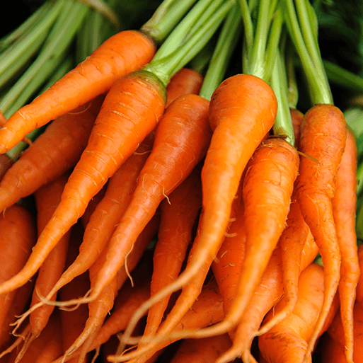

Orange Slices

* Arrange, paint, collage and draw a range of fruits and vegetables.
* Engage with a role play supermarket including signs and special offers, money and baskets for supermarket play.
* Ask the children to help you make a range of edible paints, by following the Edible paint recipes. Provide clean brushes, spoons, forks, syringes and squeezy bottles to encourage different mark making on plastic mats or trays.
* Provide washed potatoes and carrots and black marker pens. Encourage the children to draw faces and other features onto the vegetables to create characters.

Orange Slices

As part of this area of learning, we incorporate key festivities and significant occasions as they are met throughout the year.

* Can you eat a rainbow? Exploring the colours of healthy fruits and vegetables.
* Explore and inspect different fruits and vegetables that you might find in a supermarket
* Are all carrots orange? Explore the different varieties of carrots that are available.
* Discuss home time mealtime traditions. Compare similarities and differences. Talk about mealtimes in a range of cultures.
* Explore a range of exotic fruits. Encourage the children to observe the fruits and look for similarities and differences.
* Explore how some foods change during cooking. Begin by looking at the properties of pasta.



We follow a Power of Reading approach to learning, which places children’s literature at the heart of all learning (see separate MTP). Alongside this, we enrich the children’s learning experience through further texts linked to their topic theme.

* Provide a range of non-fiction books on the theme. Let the children explore and read the books independently.
* A range of whole class and enhanced provision activities linked to the book ‘Handa’s Surprise’.
* Read Pass the Jam, Jim by Kaye Umansky. Encourage the children to join in with the story, suggesting rhyming words and noticing the alliteration. Offer Rhyming word cards for the children to read and match. Make jam sandwiches, follow and write instructions.
* Read the story Oliver’s Vegetables by Vivian French. After reading the story, present the children with a basket of vegetables from the story. Give each child the Days of the week labels and Oliver’s garden picture cards, then invite them to match the vegetables to the right day.
* Tinned food label reading and writing.

Orange Slices

We follow the White Rose Scheme of Learning for maths, which offers clear progression to children’s learning (see separate MTP). Alongside this, we enrich the children’s learning experience through further mathematical learning experiences linked to the topic theme.

* Make toast with the children and leave it to cool. While waiting, share a range of shaped cookie cutters with the children.
* Offer table top, pan, bucket and balance scales for weighing a range of food items. Include baskets of fruit and vegetables, lentils, cereals and pasta for weighing and two hoops labelled ‘heavy’ and ‘light’ for sorting.

Orange Slices

Children will engage with a range of varied ‘Finger Gym’ activities to encourage fine motor, these will include skills linked to dressing and basic self-care. Further, there will be a high importance placed upon self-hygiene and handwashing throughout the school day.

In PE sessions we use ‘Get Set 4 PE’. This half term, the children will develop their fundamental movement skills through the topic of 'all about me'. Fundamental skills will include balancing, running, changing direction, jumping, hopping and travelling. Children will develop gross motor skills through a range of activities. They will learn how to stay safe using space, working independently and with a partner.

Orange Slices

* Talk to the children about foods that they eat for breakfast. Discuss ways that they could make healthier choices, such as having porridge or whole wheat cereal instead of sugary cereals. Try a range of healthy breakfast foods during the week.
* Children will work together to create a lovely, fresh salad.
* Hide pictures of different coloured foods around the indoor and outdoor space. Explain to the children that they need to work together in small groups to find food of a particular colour.

Orange Slices

* Sing (or whisper sing) and recite a range of food related songs and poems with the children. Include *Oranges and Lemons, One Potato Two Potato, Five Currant Buns* and, if you’re feeling brave, the tongue twister, *Betty Botter*.
* Show the children the video Are carrots orange? After watching the video, ask the children questions about things that they have seen. For example, ‘What colour are apples?’ and ‘Are carrots orange?’
* Can the children follow verbal instructions to make a fruit kebab?
* Collect a variety of food items and hide them in a bag. Choose one item and give the children some facts about it. Can they guess what it is?
* Put out a range of foods that appeal to the senses on a table top. Allow the children to explore the foods using their senses of smell, touch, sight and taste.
* Display a range of foods, including some that are healthy and some that are unhealthy. Ask ‘Which of these foods do you think are healthy?’ and ‘Which of these foods do you think are unhealthy?’ Encourage them to explain their choice and fill in a Please can I try this at home?

Orange Slices



