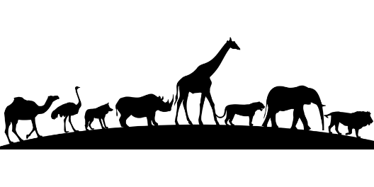 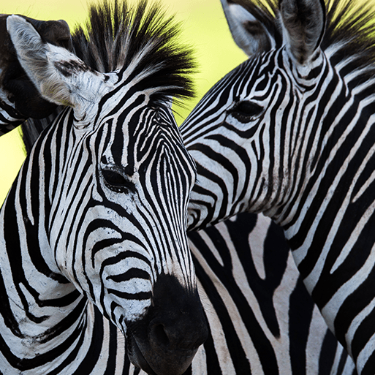

Orange Slices

We follow the White Rose Scheme of Learning for maths, which offers clear progression to children’s learning (see separate MTP). Alongside this, we enrich the children’s learning experience through further mathematical learning experiences linked to the topic theme.

* Using the Meerkat counting cards encourage the children to estimate then count how many meerkats are on each card. After counting, challenge the children to write the correct numeral to show how many are in each group.
* Create a bright and colourful display of African pattern work and fabrics. Talk to the children about the different shapes they can see, naming them where possible. Provide a range of different foam shapes for the children to create their own patterns, talking about and naming those that they select.



We follow a Power of Reading approach to learning, which places children’s literature at the heart of all learning (see separate MTP). Alongside this, we enrich the children’s learning experience through further texts linked to their topic theme.

* See Literacy MTP!

Orange Slices

Children will engage with a range of varied ‘Finger Gym’ activities to encourage fine motor, these will include skills linked to dressing and basic self-care. Further, there will be a high importance placed upon self-hygiene and handwashing throughout the school day.

In PE sessions we use ‘Get Set 4 PE’. This half term, the children will be taking part in a unit focused on ‘gymnastics’. In this unit, children will develop their basic gymnastic skills through the topic of 'animals and their habitats'. Children explore basic movements, creating shapes, balances, and jumps and begin to develop rocking and rolling. They show an awareness of space and how to use it safely and perform basic skills on both floor and apparatus. They copy, create, remember and repeat short sequences. They begin to understand using levels and directions when traveling and balancing.

Orange Slices

* Use a world map and Google Earth to show children where Africa is. Explore the continent. How vast? What is the landscape like? How many countries can they see? What are their names?
* Share the video ‘Guess who?’ with the children. After watching, ask the children to listen while you read the matching Clue cards. They can raise their hand or stand up when they think they know what animal it is.
* Ask the question ‘How are the lives of the Maasai people the same or different to yours?’ Allow time for the children to ask questions and give explanations about what they can see.
* Show the children photos from the project. ‘What have you learned? What did you enjoy learning about the most?

Orange Slices

As part of this area of learning, we incorporate key festivities and significant occasions as they are met throughout the year.

* Watch the video ‘A day in the life of a child in urban Kenya’ available on BBC Bitesize. Explain to the children that this video shows what it is like for children going to school in this part of Africa. After watching the video, encourage the children to talk about what they saw and how Nana’s school day is the same or different to theirs.
* Explore key Kenyan landmarks (including the Serengeti) and African Animals – especially the big 5.
* Animal camouflage – What is it? What is it for? How does this look for each animal?
* Zebra investigation - Explain that some scientists think that a zebra’s stripes help to keep insects away, stopping them from getting nasty bites and diseases. Explore this theory by experimenting brightly coloured paper and fabric.
* Whose baby? Display the Parent and baby animal cards on a whiteboard or similar. Begin by asking the children to match the pictures, so parent and baby are together, looking closely at similarities and differences between them.

Orange Slices

* Explore African dance, instruments and music.
* Explain that call and response songs are popular in parts of Africa. Call out names, chants and instructions and encourage the children to repeat them as a response. Learn the African call and response song Kye Kye Kule.
* Explore African masks that are worn during special ceremonies. Encourage the children to make a simple clay mask, using sticks or clay tools to carve into a tile.
* Explore African Jewellery making using paper plates, pasta and weaving techniques
* Explore the sunset in the Serengeti. Use paint to explore making a sunset scene. Explore using colours to blend and make other shades.
* Serengeti small world opportunity with animals and Kenyan landscape
* Role Play Enhancements: Safari Jeep role & Kenyan Market Role play

Orange Slices

* What’s your favourite animal? Using their knowledge and understanding of African animals, the children discuss and explore their favourite animal as a group.
* Share ‘The Lion Who Wanted to Love’ by Giles Andreae. Ask the children ‘How was Leo different to the other lions?’ and ‘Why didn’t the lions want Leo to be part of their pride?’ Encourage the children to give their views about how it feels to be left out. Give them time to talk about their experiences and think about how they can treat each other kindly and make sure nobody feels left out.

Orange Slices  
  


Pop Will Eat Itself