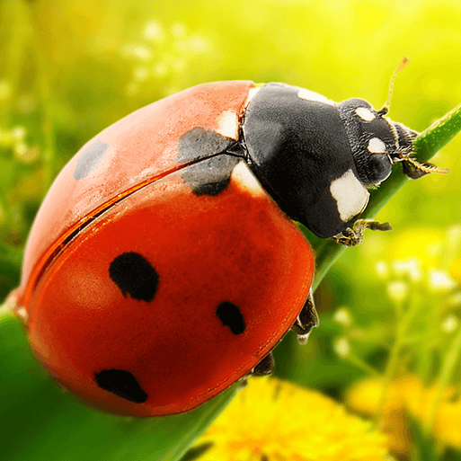

Orange Slices

* Provide baskets of natural materials such as logs, bark, pine cones, hay, sticks, leaves, stones and a range of man-made items, such as bricks with holes in, wooden boxes or pallets, flower pots, guttering, drinking straws, netting and string. Display a sign that says ‘Welcome to The Minibeast Hotel!’
* Provide paper plates with holes punched around the edge and in the centre. Demonstrate how to create a web-like effect, by weaving pipe cleaners or wool through the holes on the plate before challenging the children to create their own.
* Take the children outside to collect lots of different coloured and textured leaves. Show the children how to use a hole punch safely to make holes in the leaves. Use the punched-out leaf litter to make leaf confetti and put in bowls for sensory play.
* Using the Minibeast puppet templates encourage the children to paint, colour and add patterns to decorate. If using paint, provide the children with a selection of fine tipped brushes.
* Fill shallow containers with water and add brightly-coloured natural food colouring. Allow the children to dip a snail gently into the mixture, by holding its shell. After dipping the snail into the mix, show the children how to place the snail on white paper.

Orange Slices

  
   
Fancy Matter personal use

Orange Slices

We follow the White Rose Scheme of Learning for maths, which offers clear progression to children’s learning (see separate MTP). Alongside this, we enrich the children’s learning experience through further mathematical learning experiences linked to the topic theme.

* Provide the Ladybird counting cards (part 1), Ladybird counting cards (part 2) and Ladybird counting cards (part 3). Lay them out on a table top and ask the children to choose a card, and count the ladybird’s spots.
* Hide a variety of the Minibeast safari cards in the outside area. Tell the children how many you have hidden and challenge them to find them all. After finding each one, check how many more there are to find.
* Make colourful caterpillars of different lengths with the children using cubes, counters or beads. Encourage the children to compare the lengths of the various caterpillars they have made, by placing them next to each other and counting the number of items used. Ask ‘Which caterpillar is the longest?’ and ‘Which caterpillar is the shortest?’

Orange Slices

* Offer the children opportunities to care for nature including doing tasks such as watering the plants, chopping, peeling and putting out fruit to feed minibeasts, spraying the snail’s tank with water, topping up the wormery with vegetable peelings and monitoring the minibeast hotel.
* Watch video footage of real ants working together. Ask the children to work together as a team of ants to collect and carry objects or move a structure piece by piece along the line to a new location.



We follow a Power of Reading approach to learning, which places children’s literature at the heart of all learning (see separate MTP). Alongside this, we enrich the children’s learning experience through further texts linked to their topic theme.

* Share the story *Snail Trail* by Ruth Brown with the children. Before turning each page, encourage the children to predict where snail might go next. When reaching the last page, see if children can match where snail thought he was to where he actually was.
* Share the story *The Bad-Tempered Ladybird* by Eric Carle. After reading, create a story map with the children on a long roll of paperRead the story *Diary of a Spider* by Doreen Cronin to the children. Encourage the children to see how the spider in the story views the world and what kind of things he likes to do on a day-to-day basis.
* Read the story Superworm by Julia Donaldson to the children. After reading, ask the children ‘What do you know about worms?’ Allow the children time to share their ideas and record them on a whiteboard.
* Reading for pleasure: explore What the Ladybird Heard and Aaaarrgghh Spider!

Orange Slices

As part of this area of learning, we incorporate key festivities and significant occasions as they are met throughout the year.

* Visit a local park, woodland or garden to carry out a minibeast safari. Encourage the children to search for minibeasts that wriggle, crawl or fly, looking under logs, leaves, stones and in leaf litter.
* Provide a clear tank containing two or three garden snails, soil, leaves and slices of fruits or vegetables.
* Make a mini wormery in a plastic or glass container and display it indoors or outdoors. Instructions can be found online.
* Offer a range of wild or garden flowers and a variety of magnifiers for close observation.
* Set up a butterfly farm by buying a commercial butterfly kit..
* Ask the question ‘Why do ladybirds have spots?’ Look at pictures of other brightly-coloured minibeasts, such as butterflies, dragonflies, bees and beetles. Ask ‘how’ and ‘why’ questions to stimulate children’s scientific thinking, such as ‘Why are these beetles so brightly coloured?’ and ‘How does being green help these stick insects?
* Find out which foods minibeasts prefer. Place plates of different foods including bread, fruit, vegetables, cereals, cooked meat or fish, cheese or yoghurt in a sunny spot outside. Ask the children to predict the minibeasts’ favourite food. Let the children check the plates throughout the day to count any visiting minibeasts. Share the results. Were their predictions right?

Orange Slices

Children will engage with a range of varied ‘Finger Gym’ activities to encourage fine motor, these will include skills linked to dressing and basic self-care. Further, there will be a high importance placed upon self-hygiene and handwashing throughout the school day.

In PE sessions we use ‘Get Set 4 PE’. This half term, the children will develop their fundamental movement skills through the topic of ‘Ball Skills’. In this unit children will develop their ball skills through the topic of 'minibeasts'. Children will develop fundamental ball skills such as rolling and receiving a ball, throwing to a target, bouncing and catching, dribbling with feet and kicking a ball. Children will be able to develop their fine and gross motor skills though a range of game play using a variety of equipment. Children will be given opportunities to work independently and with a partner.

Orange Slices

* Read the story What the Ladybird Heard by Julia Donaldson. After reading, ask the children ‘Did you hear any words that rhyme?’ Allow time for them to share their ideas and examples and then read the book through again, encouraging them to join in. Display the Rhyming word cards from the story for the children to match and read. For example ‘hen, pen’ and ‘duck, cluck’.
* Read and sing a variety of action poems and songs on the theme of minibeasts. Rhymes might include, *Incy Wincy Spider*, *There’s a Worm at the Bottom of my Garden* and *Ladybird Ladybird*. Encourage the children to join in with the actions, predict the next lines and learn the poems by heart.
* Set up a ‘drainpipe’ using guttering or a cardboard tube and provide coloured cut out spiders. Give the children instructions for placing the spiders using prepositions such as under, on, next to and behind.
* Put Minibeast picture cards in envelopes – one per envelope. Working in a small group, give each child an envelope and ask them to open it without showing other children which minibeast they have. Taking it in turns, ask each child to describe their minibeast without using its name and see if others can guess it.