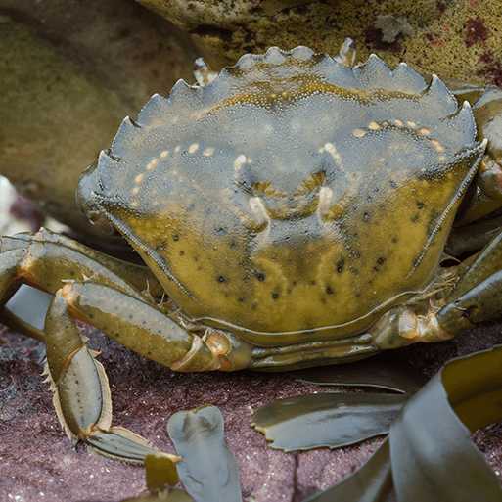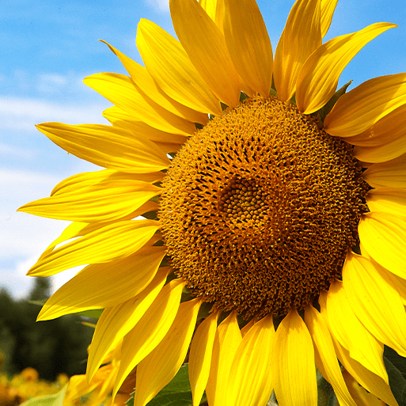

Orange Slices

We follow the White Rose Scheme of Learning for maths, which offers clear progression to children’s learning (see separate MTP). Alongside this, we enrich the children’s learning experience through further mathematical learning experiences linked to the topic theme.

* Place squished slices of watermelon flesh in zip-lock transparent bags. Display the question ‘Can you count the seeds?’
* Display the Numbered watermelon slices on a table top. Ask children to read the number on each slice and put the correct number of seeds on each one. Encourage children to match numeral and quantity correctly by counting out the ‘seeds’ one at a time.
* Search outside for shadows made by the summer sunshine. Show the children how to ‘draw around’ the shadow using chalk. Explore measuring the length of the shadows in different ways.
* Make 20 colourful jellyfish (using jelly in moulds). Put the jellyfish on saucers so the children can move them around the table top without spoiling the jelly. Use the jellyfish to pose a range of mathematical challenges for the children to solve.
* Challenge the children to work together to order shells or pebbles, from biggest to smallest. Ask questions such as ‘Which pebble is the biggest?’ then ‘How do you know?

Orange Slices

* Fill a small box, bucket or tin with a range of summery goodies. Write a label that says ‘Here’s a little box of sunshine to brighten up your day’. Open the box and talk about the contents, smelling and tasting certain objects and explaining why they make you feel happy.
* Encourage the children to interact kindly and appropriately in a variety of different role play provocations
* Explore a range of books that engage with themes that encourage discussion around PSED.

Orange Slices

Children will engage with a range of varied ‘Finger Gym’ activities to encourage fine motor, these will include skills linked to dressing and basic self-care. Further, there will be a high importance placed upon self-hygiene and handwashing throughout the school day.

In PE sessions we use ‘Get Set 4 PE’. This half term, the children will develop their fundamental movement skills through the topic of ‘Games’. In this unit, children will develop their understanding of playing games through the topic of 'transport'. Children will practise and further develop fundamental movement skills through games. They will also learn how to score and play by the rules, how to work with a partner and begin to understand what a team is, as well as learning how to behave when winning and losing.

Orange Slices

As part of this area of learning, we incorporate key festivities and significant occasions as they are met throughout the year.

* Signs of summer walk. Talk to them beforehand about things to look and listen for and things to smell and touch. Use the ‘Summer Spotting Sheet’.
* Display a weather chart with symbols for children to change daily. Provide easy-read thermometers to measure and record the temperature each day.
* Sow a variety of grass seed in different tubs or planters. Offer cans for watering.
* Water-themed obstacle course extravaganza for the children.
* Offer summer-themed play dough, made with flower scented essential oils. Challenge the children to work together to create a summer garden using the dough and flower-shaped cutters.
* Take a walk along the roadsides, meadows and hedgerows to find wildflowers and plants that are growing in the local environment. Provide children with a spotting sheet that includes the plants: daisy, dandelion, dock, poppy, buttercup, speedwell, cow parsley, nettle and red campion.
* Travel to the coast to explore the unique and fascinating world of the British seashore. Provide Seashore spotting sheets for children to record their observations and findings.
* Display a range of natural and man-made seashore objects, including driftwood, shells, pebbles, sand, seaweed, seawater, bottles, rope and netting.
* Ask your local fishmonger to donate seafood, such as crab, fish, prawns or mussels. Provide aprons, plastic gloves and hand lenses, then let the children investigate.



We follow a Power of Reading approach to learning, which places children’s literature at the heart of all learning (see separate MTP). Alongside this, we enrich the children’s learning experience through further texts linked to their topic theme.

* Inviting outdoor reading area featuring a range of ‘summer’ themed books
* Frozen cubes of food colouring and white paper for children to practice letter formation and word writing
* Explore the poem ‘What is Summer For?’ by Kate Williams. Then, challenge the children to match the Rhyming word cards.
* Share the book ‘*What Can You See in Summer?*’ by Sian Smith. Encourage the children to predict what object is at the end of each sentence using the pictures as clues. Read the book again, encouraging the children to join in with the text as it becomes more familiar.
* Make smoothie lollies! After enjoying the making and eating, ask the children to write instructions for how to make them.
* Share the book At the Beach by Roland Harvey. Explain that the story is written on postcards. Ask the children ‘Have you ever sent or received a postcard?’ Children to have a go writing postcards as part of CP.
* Listen to and join in with poems and rhymes about the seashore, especially those in Seaside Poems collected by Jill Bennett
* Share a good quality non-fiction book with a small group of children. By the Sea (Nature Walks) by Clare Collinson is a good example. Look at features such as the contents page and glossary and enjoy looking at illustrations, labels and captions. Can they find specific information?

Orange Slices

* Make summer-themed play dough in vibrant colours. Add a summery scent using vanilla essence or lemon zest. Offer scoops and cones for ice cream role play.
* Show children photographs of amazing sand sculptures and castles; there are plenty available online. Allow the children time to build their own sand castles.
* Provide a range of sunglasses, pictures or the real thing, for children to explore. Encourage them to look closely at their design and function. Ask the children to design a pair of sunglasses that they would like to wear. After drawing their designs, provide children with baskets of recycled materials to create their own.
* Make own bubble wands and explore the way that the wind blows bubbles!
* Display pictures of beach art made with pebbles, and baskets of pebbles for children to respond.
* Offer a range of seashells for the children to observe and handle. Ask them to look carefully and to draw what they can see including any shapes, patterns and textures.
* Challenge children to decorate flat white seashells using ultra-fine permanent marker pens in a range of different colours. Encourage them to think about making different types of patterns including spots, stripes and zig-zags.

Orange Slices



   


Orange Slices

* Share the book *summer is here!* by Heidi Pross Gray. Ask ‘What signs of summer did you see on your walk?’
* Fill a beach bag with a range of summer-themed items. Ask the children to name the items as you reveal them from the bag and say or show how they are used.
* Provide a range of summer fruits Allow the children time to explore them, feeling their textures and smelling their scents.
* Show the children the summertime fun images. Encourage the children to describe what is happening in the pictures and relate them to their own experiences.
* Place UV-reactive beads, wristbands or laces outside in a Tuff Tub. Invite the children to observe what happens when the beads, bands and laces are exposed to the Sun and explain what they think is happening.
* Show a conch shell to a small group of children. Ask if they know what it is then put it to your ear and listen carefully. Pass the shell to a child in the circle. Let them hold it to their ear, then pass it on.
* Print pictures of the children’s day at the seashore. Working in a small group, pass the photographs around the circle for the children to see. Ask questions to find out what they remember about the experience.
* Surprise the children with some whole crabs from the local fishmongers. Allow them time to observe the crabs and provide labelled diagrams for them to identify body parts, using the correct terminology.