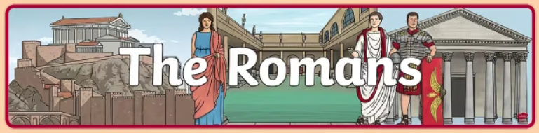

**Geography**

Use maps, atlases and satellite images to locate countries and describe features studied.

Understand why the Romans built new roads in Britain, know where some of the main roads ran from and to and know how the roads were made..

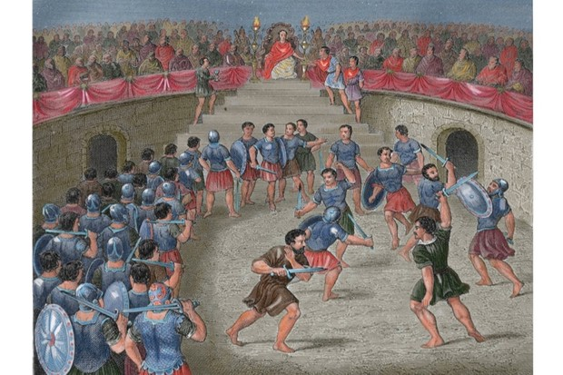

**Computing**

Use search technologies effectively to create a digital scrap book.

Take account of bias when researching information

Use a multi-media programme to present information about Arctic phenomena

**Art**

Investigating and designing Roman mosaics

Improve mastery of art and design techniques in painting and sketching.

**History**

We will be:

learning about the attempted invasion by Julius Caesar and the successful invasion and conquest by Claudius

learning about the resistance of Queen Boudicca and understanding different perspectives

describing who Emperor Hadrian was, say when, how and why he built a wall and explaining the features of the wall

learning about the religious beliefs and the gods and goddesses that the Romans worshipped

learning what the Roman baths were and know about the different amenities they contained

learning about daily life for the Romans

understanding what life was like for a member of the Roman Army

recognising what the Romans did for us