Can I use maps, including those online, to locate ‘Saxon shore forts’ and use my learning to answer questions?
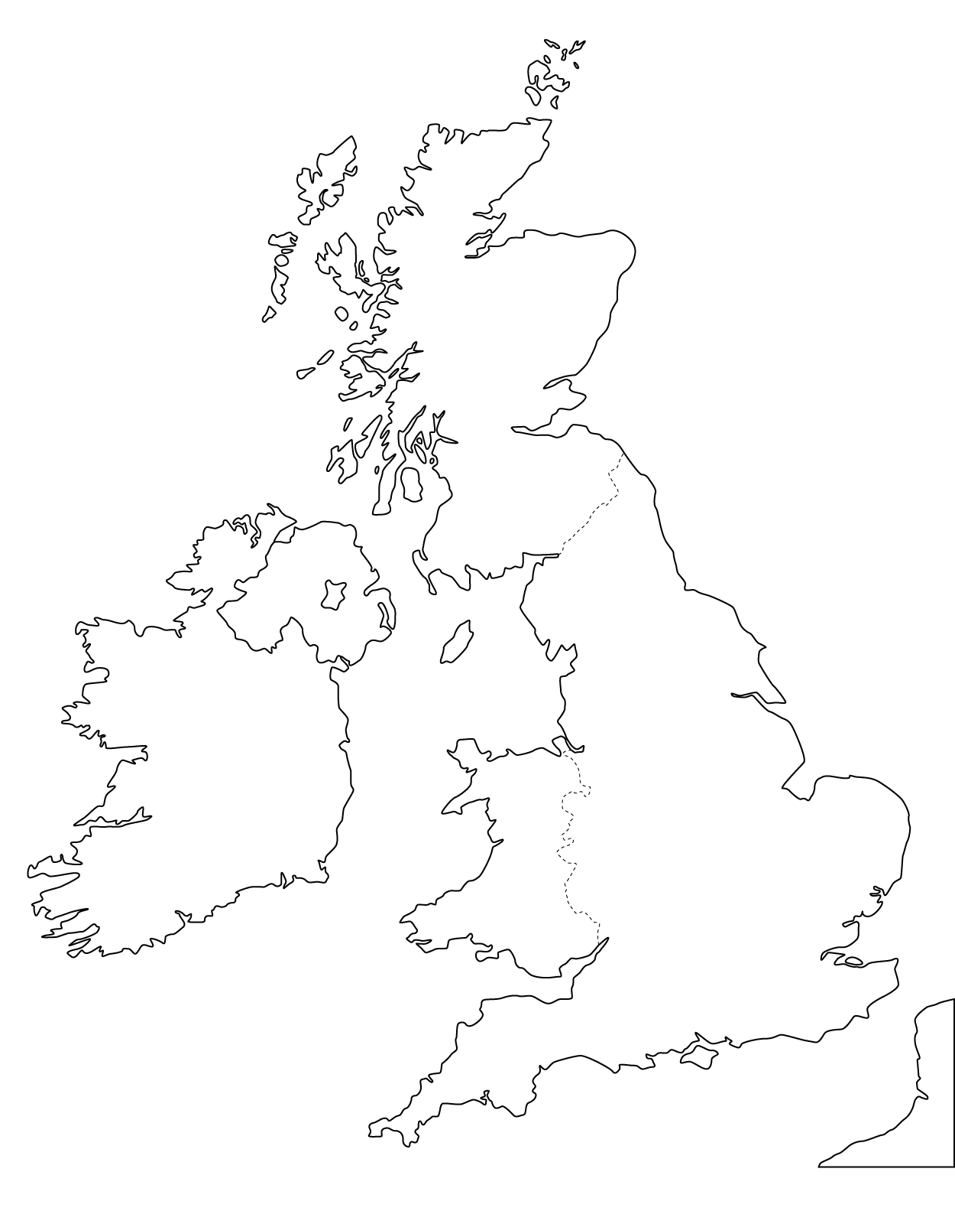 | Branodunum at Brancaster Estate  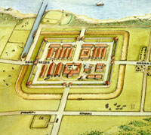  Branodunum is one of the eleven forts along the South and East coasts of England known as Saxon Shore Forts. The Romans built these forts during the 3rd century. At first they were used to protect and control shipping and trade around the coast; later they helped repel raiders from across the North Sea. They remained military garrisons for over 150 years before being abandoned when the Roman army withdrew from Britain.
How many forts are along the South and East coasts of England?
__________________________________________________________________________________
__________________________________________________________________________________
Who built the forts?
__________________________________________________________________________________
__________________________________________________________________________________
What were they first used for?
__________________________________________________________________________________
__________________________________________________________________________________
What were they later used for?
___________________________________________________________________________________________________________________________________________________________________
What is a ‘military garrison’?
__________________________________________________________________________________
__________________________________________________________________________________

