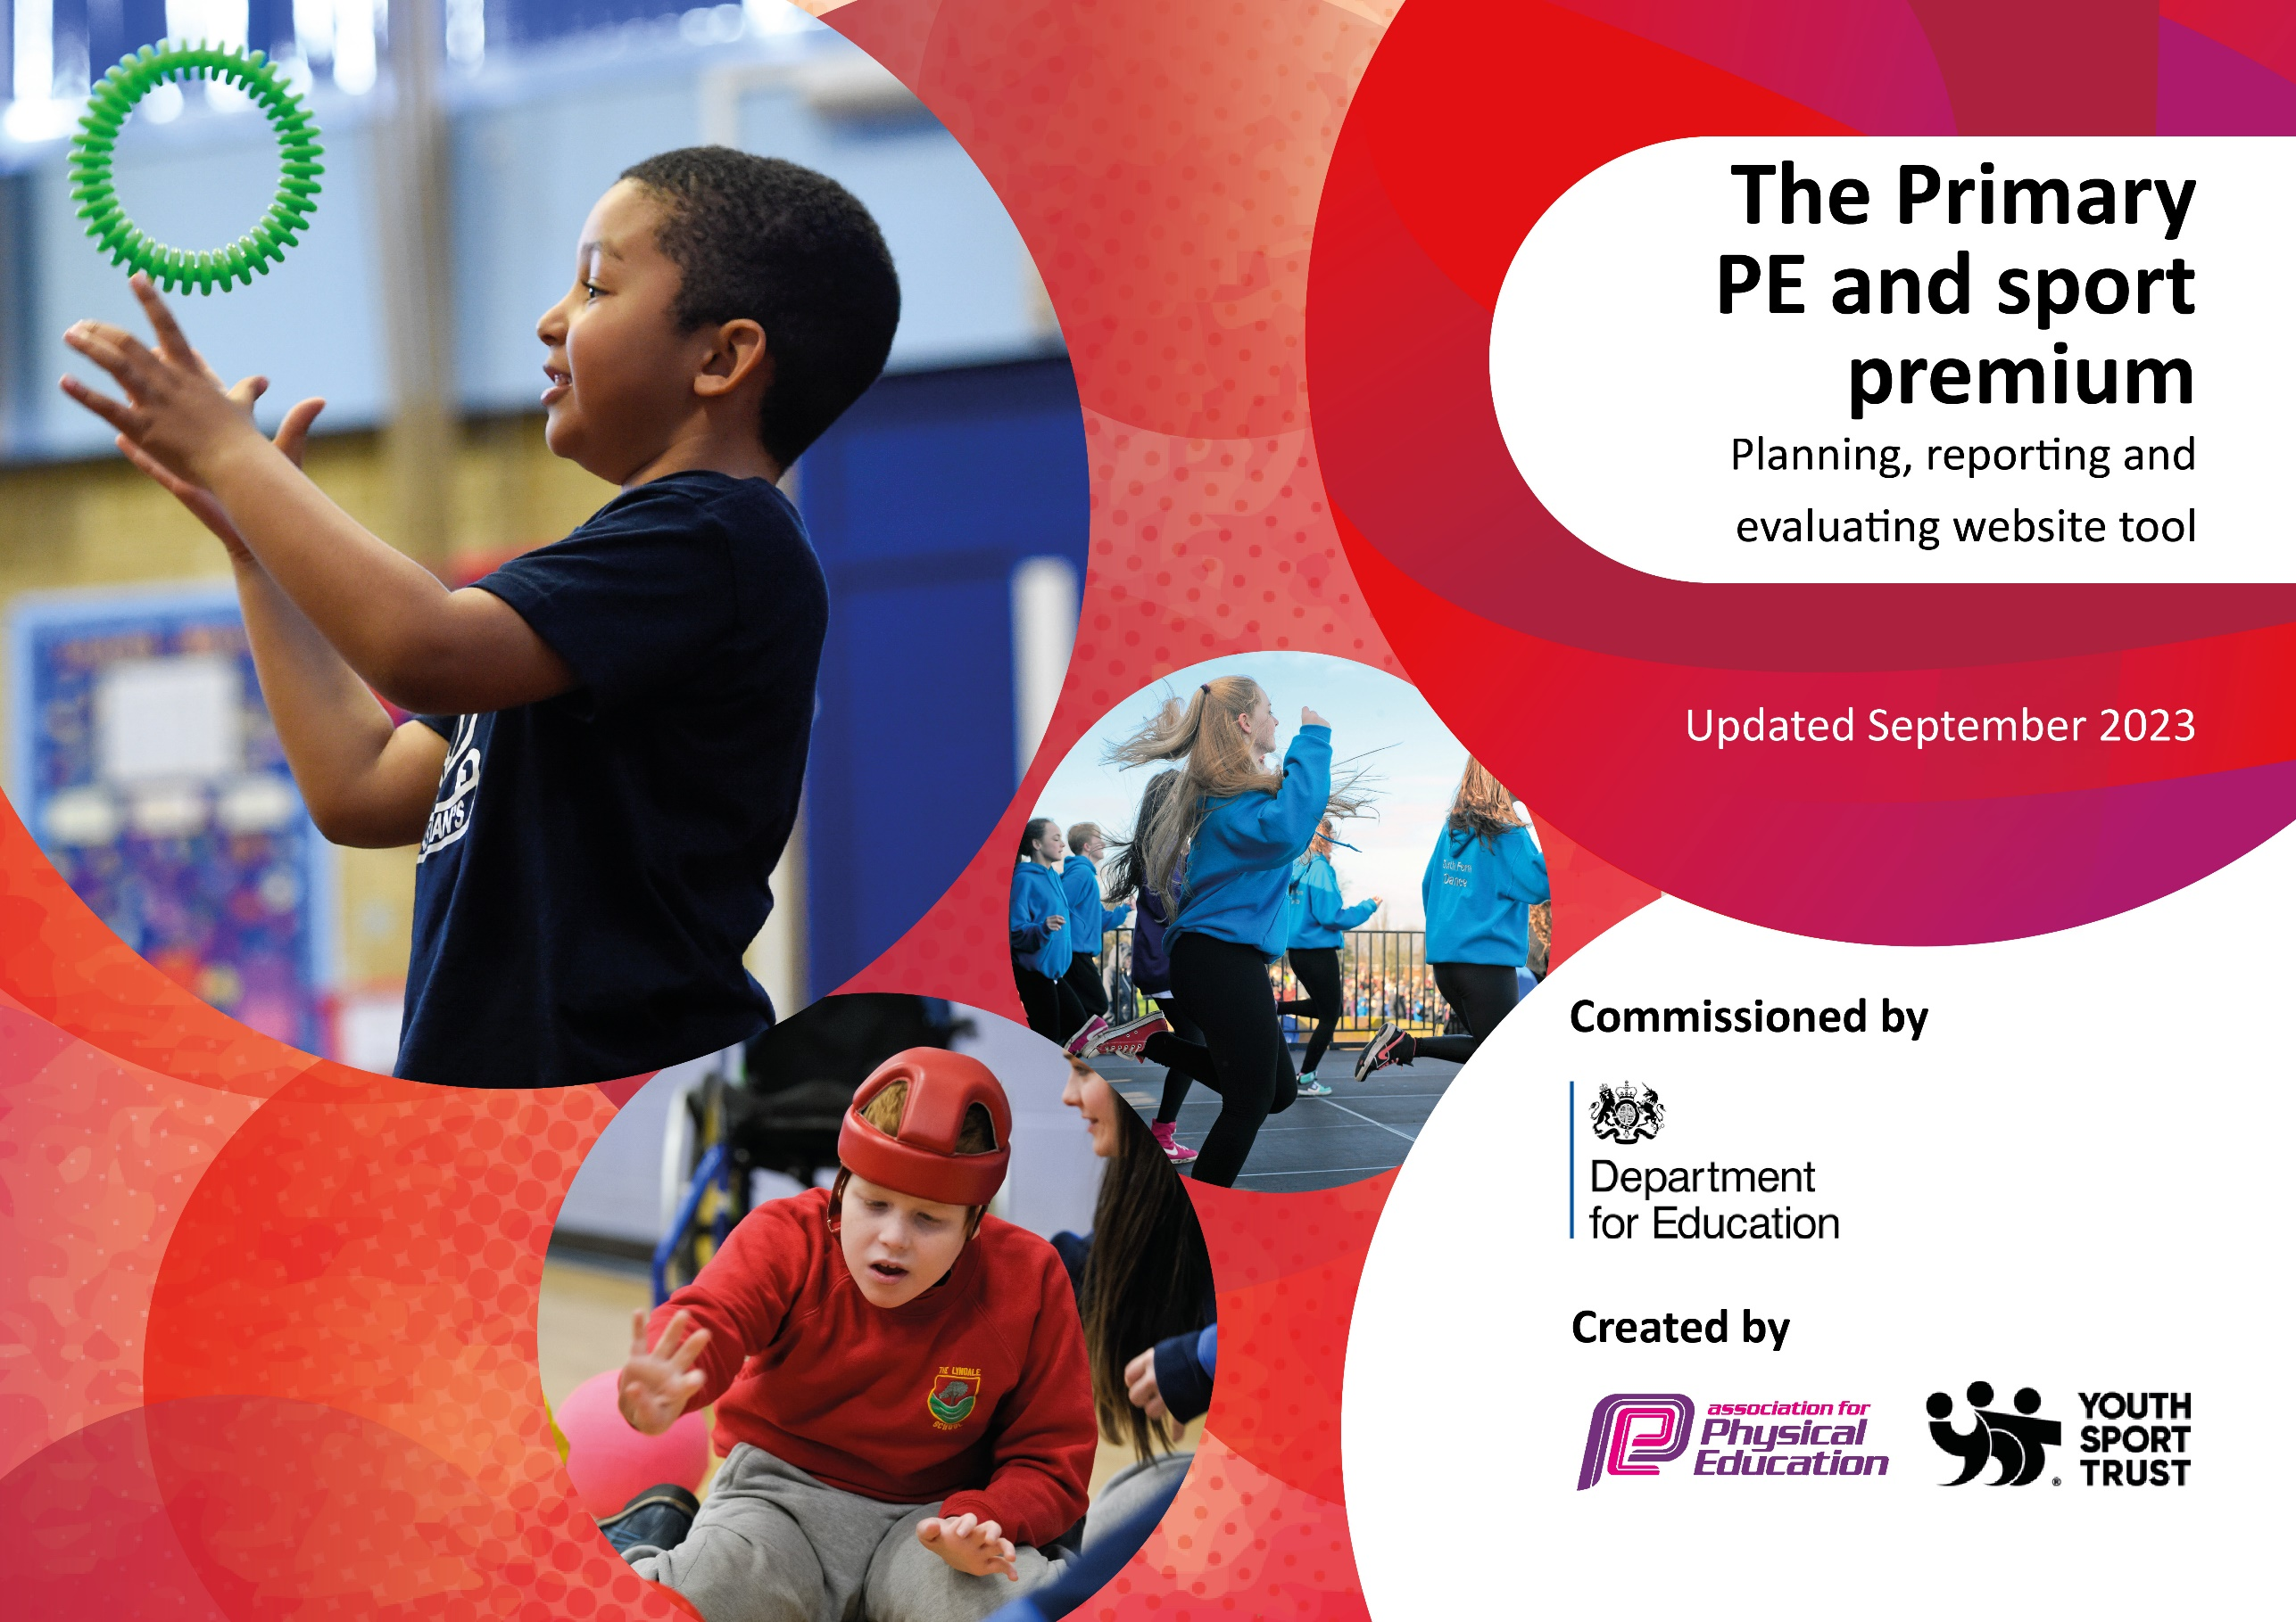

Review of last year’s spend and key achievements (2023/2024)

We recommend you start by reflecting on the impact of current provision and reviewing your previous spend.

Activity/Action | Impact | Comments
Sports Leaders trained to deliver activities during break times and lunch times  Sports Coach delivers lunch time clubs specifically targeting the least active children | - Sports Coach has been delivering lunch time clubs targeting less active pupils. There has been a good take up for these clubs.  - Year 5 children received Sports Force training.  - The school has provided a wide range of clubs including football, martial arts and multi-sports. These were well attended and some targeted invitation took place. | Provider will continue to target less active pupils.  In 2024-2025 CTO Sports will become the new school PE provider.  In 2024-2025, Sports Leaders will need retraining
Improve activity levels during lesson times and as a result improve/aid concentration for pupils (brain breaks) | - Staff provide opportunities for active brain breaks throughout the day to improve concentration and behaviour. | More staff to access and use these strategies for engaging pupils in active learning.  In 2024-2025, Year 4 will visit the Enquire Learning Trust Residential Centre in Whitby- this will be almost completely subsided by Enquire Learning Trust
Provide staff with the opportunity to work alongside sports trained staff member to increase their practical delivery and confidence.  Teachers and TAs to work with sports coach (TA) to upskill and improve confidence in PE delivery. | - Staff feel confident in delivering PE lessons that cater to a range of pupils.  - All staff who teach PE have received high-quality CPD from the PE subject lead and specially trained staff. This has improved the quality of teaching in PE further.  - The PE coach supports the school in providing a wide range of sports clubs, such as football and cricket. | Continue to deliver ongoing CPD to all staff. Ensure staff that are new to school receive 1-1 coaching to ensure confidence in PE delivery.  In 2024-2025, school will begin to offer breakfast clubs run by the PE coach.
Specialist coaches run engaging after school clubs  Bikeability for Year 5 pupils  Catch-Up Swimming Lessons for selected Year 4/5/6 pupils  Attendance at non-competitive events with SSP | - Clubs are full every half-term with a range of pupils attending clubs.  - Bikeability was delivered to Year 5 and Year 6 pupils across two days.  - Catch up swimming sessions were delivered twice in the year to raise the number of pupils able to swim 25m- 67% of children in Y6 can now competently swim 25m.  - SEN pupils have participated in events such as ‘Get Glowing’ throughout the year  - Children from across the school have access a range of sporting competitions and events over this school year. | Continue to participate in SEN-focused non-competitive events  School will work towards reaccreditation for the School Games Mark in 2024-2025  In 2024-2025, school needs to raise the profile of swimming with parents as a life skill.
Sports School Partnership Service Level Agreement + entry to sports competition | - School have worked with SSP to credit an audit of provision at the start of the year to support an action plan.  - School have worked with SSP to develop Sports Leaders in Year 5.  - School have attended a range of compete and develop competitions hosted by SSP. | Continue to develop the range of competitions and events that school attend.  In 2024-2025, Sports Leaders will need retraining

Key priorities and Planning
This planning template will allow schools to accurately plan their spending.

Action – what are you planning to do | Who does this action impact? | Key indicator to meet | Impacts and how sustainability will be achieved? | Cost linked to the action
Access NELincs SSP in conjunction with CTO Sports to:  - Give access to CPD for staff to improve their confidence, knowledge and skill in teaching high-quality PE lessons.  - Allow a group of Year 5 children to train as ‘Play Leaders’  - Give access to a range of competitive sporting competitions (and pay the transport costs for this)  - Provide support for the PE subject Lead | All teaching staff – as they will have high-quality CPD to improve their teaching  Pupils – as they will have access to competitions across the borough, and a group of Year 6 children will be trained as Play Leaders.  Subject Leader – as he will have regular support to ensure he leads the subject effectively. | 1 – Increased confidence, knowledge and skills of all staff in teaching PE and sport  2 – Engagement of all pupils in regular physical activity  3 – The profile of PE and sport is raised across the school as a tool for whole-school improvement  4 – Broader experience of a range of sports and physical activities offered to all pupils  5 – Increased participation in competitive sport | More pupils from across school will take part in competitive sport  CPD will mean that staff are continually upskilled in the teaching of PE  Year 5 Sports Leaders will be trained and working alongside existing Year 6 sports leaders. | £ 14,572 Teachers and TAs to work with sports coach (TA) to upskill and improve confidence in high-quality PE delivery.
Continue to implement the revised PE curriculum by:  • Using GetSet4PE PE as the core scheme of work – adapting Year 4/5 and Year 5 / 6 to reflect the mixed-age teaching.  • Continue the swimming curriculum so that it takes place in Year 4 with structured opportunity for catch up in Year 5 and 6 for those who do not meet the expected standard after Year 4. | Leaders and teachers – as they lead the activity and have ongoing CPD  Pupils:  - All pupils will experience an exceptional PE curriculum through two one-hour lessons per week, raising their achievement in the subject  - More children will achieve the expected standard in swimming by the end of KS2 | 1 – Increased confidence, knowledge and skills of all staff in teaching PE and sport  3 – The profile of PE and sport is raised across the school as a tool for whole-school improvement  4 – Broader experience of a range of sports and physical activities offered to all pupils | All pupils will have access to a progressive and well-sequenced OOA and teambuilding curriculum. Pupils will develop character skills in a progressive and deliberate way through the RESPECT framework. Continual training will mean that by the end of this academic year, staff will be experts in delivering the Commando Joe’s curriculum. | £413 GetSet4PE subscription  £1180 Swimming4schools instructors (£59 per pupil 20 pupils)  £590 Top up swimming lessons (£59 per pupil x10)
Continue to provide a wide-range of after-school clubs to engage more pupils in PE and sports including a Breakfast sports club | Pupils – as they will have access to a wide range of after-school sport clubs | 2 – Engagement of all pupils in regular physical activity  4 – Broader experience of a range of sports and physical activities offered to all pupils  5 – Increased participation in competitive sport | Pupils from groups in school who are less likely to take part in regular physical activity will be prioritised for access to the clubs, meaning that more pupils will engage in physical activity | £ 390 Cost of coaches for sports clubs
Continue to offer Bikeability sessions for Year 5 pupils through LincsInspire | Pupils – as they will have access to a wide range of after-school sport clubs | 1 – Increased confidence, knowledge and skills of all staff in teaching PE and sport  2 – Engagement of all pupils in regular physical activity | Increased number of children taking part in the programme  Increased number of children passing the assessment.  Increasing number of children cycling to school. | £255 LincsInspire  (30 x £8.50 per pupil)

Total Sports Premium Planned Spend: £17,430
Total Sports Premium Projected Income: £17,430.00

Key achievements 2024-2025
This template will be completed at the end of the academic year and will showcase the key achievements schools have made with their Primary PE and sport premium spending.

Activity/Action | Impact | Comments

Swimming Data
Meeting National Curriculum requirements for swimming and water safety.
Priority should always be given to ensuring that pupils can perform safe self-rescue even if they do not fully meet the first two requirements of the National Curriculum programme of study

Question | Stats: | Further context  Relative to local challenges
What percentage of your current Year 6 cohort can swim competently, confidently and proficiently over a distance of at least 25 metres? | 52%  Sep 24 | This is based upon end of Year 5 data
What percentage of your current Year 6 cohort can use a range of strokes effectively [for example, front crawl, backstroke, and breaststroke]? | 52%  Sep 24 | This is based upon end of Year 5 data

What percentage of your current Year 6 cohort are able to perform safe self-rescue in different water-based situations? | 52%  Sep 24 | This is based upon end of Year 5 data
If your schools swimming data is below national expectation, you can choose to use the Primary PE and sport premium to provide additional top-up sessions for those pupils that did not meet National Curriculum  requirements after the completion of core lessons. Have you done this? | Yes | Year 4 receive swimming sessions.  Due to pupil numbers in Year 4, we are able to offer top-up swimming lessons to pupils in Year 5 and 6 who did not meet the expected standard when they were in Year 4. This has improved our percentage of the current Year 6 cohort who can swim competently, confidently and proficiently over a distance of at least 25 meters to 67%. In our current Year 5 cohort, 52% of pupils can swim the 25m.
Have you provided CPD to improve the knowledge and confidence of staff to be able to teach swimming and water safety? | No | All swimming lessons are provided by fully qualified staff based at the pool. School staff support with building confidence in the pool

Head Teacher: | Mrs J Lowe
Subject Leader or the individual responsible for the Primary PE and sport premium: | Miss S Armstrong
Date: | September 2024
Signed off by:

