Can I use VIPERS skills to answer questions about Skara Brae?

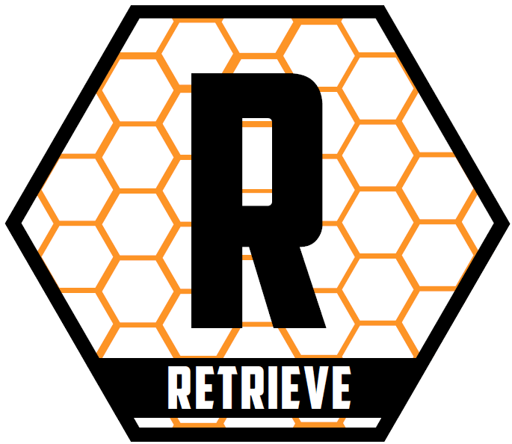 | Draw an arrow on the map and label Skara Brae. | 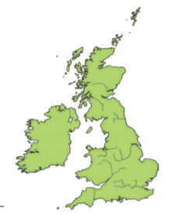
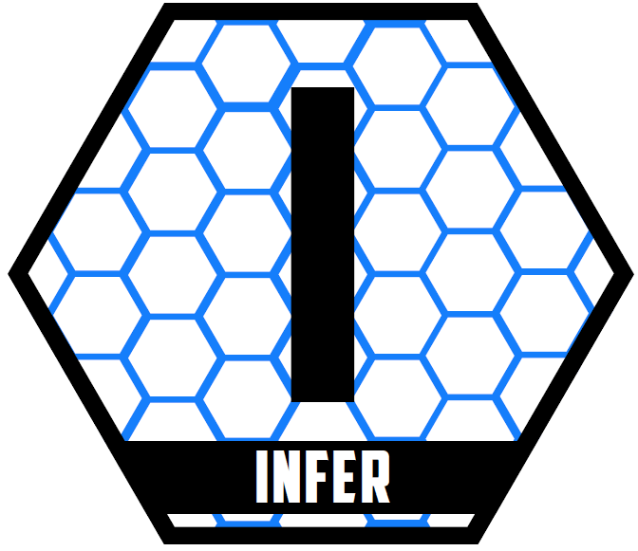 | What do you think House 7 was used for? Explain your reasoning. | _________________________________________________________________  __________________________________________________________________________________________________________________________________  _________________________________________________________________
 | What do you think House 8 was used for? Explain your reasoning. | _________________________________________________________________  ___________________________________________________________________________________________________________________________________________________________________________________________________
 | Describe one difference between earlier and later houses. | _________________________________________________________________  __________________________________________________________________________________________________________________________________
 | What was an advantage of a lower doorway? | _________________________________________________________________  __________________________________________________________________________________________________________________________________
 | What would you find in the centre of each house? | _________________________________________________________________  __________________________________________________________________________________________________________________________________
 | What might the roof have been made from? | _________________________________________________________________  _________________________________________________________________
 | What different items of furniture might have been in the homes? | _________________________________________________________________  __________________________________________________________________________________________________________________________________

