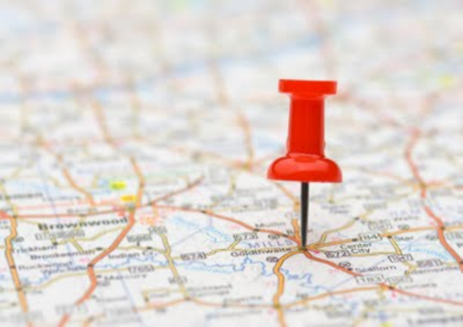

**Geography**

* Identify Europe on a world map
* Identify the location of the United Kingdom
* Explore other countries in Europe
* Identify the environmental regions of Europe
* Explore the physical features of two contrasting European regions
* Identify Europe's major cities
* Explore where people in Europe live
* Identify where Europe's natural resources are located
* Locate Scotland on a map of the United Kingdom and identify cities and regions
* Identify important physical characteristics of the country
* Describe land use in Scotland
* Locate Wales on a map of the United Kingdom and identify cities and regions
* Identify important physical characteristics of the country
* Explore how land use and physical features are different to Scotland.
* Locate Northern Ireland on a map of the United Kingdom and identify cities and regions
* Identify important physical characteristics of the country
* Explore how land use and physical features are different to Wales.
* Locate England on a map of the United Kingdom and identify cities and regions.
* Identify important physical characteristics of the country.
* Explore how land use and physical features are different to Northern Ireland.
* Locate the Northern and Southern hemispheres on a globe & explore countries in each one
* Describe the significance and importance of the equator & explore countries that the equator goes through
* Identify the Tropics of Cancer and Capricorn and review the latitude of different countries, including the UK
* Review why the time is different in different countries
* Explain the significance of the Greenwich Meridian and the date-line
* Review time zones around the world and the implications of this for human activity

**Computing**

Use search technologies effectively to create a digital scrap book.

Take account of bias when researching information

