**PSHE**

Discuss propaganda materials used during the war and how these presented evacuation to parents

Consider the different beliefs and values of leaders during the war

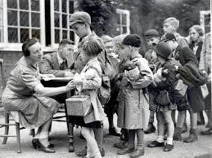



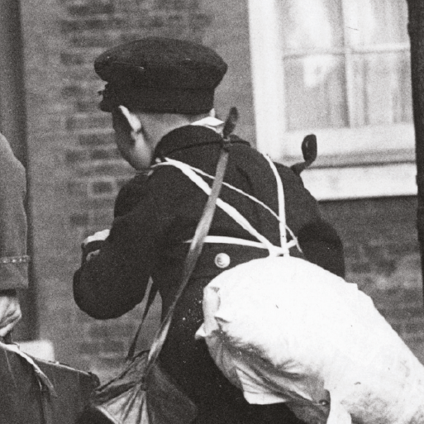

**Design Technology**

Find and make popular wartime food

Create a class recipe book for popular wartime food

Design and make a miniature Anderson shelter

.

**Geography**

Identify, geographically, where and why children were evacuated to certain areas.

Locate cities and ports that were bombed during the Blitz on a map of the UK and consider why these places were vulnerable to bombing

**Computing**

Use the Internet to find information about the Battle of Britain and create a digital timeline of events.

**History**

Learn about an aspect or theme in British history that extends pupils’ chronological knowledge beyond 1066.

Create from memory, a timeline from dates/details showing their knowledge and understanding of the era.

Consider the similarities and differences between German and Jewish children during the war.

Find out about the Blitz and what measures were taken to reduce the effects of bombing.

Find out what it was like going to school during the war.

Make connections between the past and present by comparing homes during the war and present day homes.