**Geography**

Use maps, atlases and satellite images to locate countries and describe features studied.

Identify the position and significance of latitude, longitude, Equator, Northern Hemisphere, Southern Hemisphere, the Tropics of Cancer and Capricorn, Arctic and Antarctic circle, Greenwich Meridian and time zones including day and night

Identify similarities and differences between the Arctic and Antarctic.

Explain how climate zones, biomes and vegetation belts affect the physical and human features of a place in the world.

Study and consider features of icebergs and other icy geological features such as ice shelves, ice sheets, sea ice and glaciers.

**Art**

Investigate and create Inuit art; block printing

Improve mastery of art and design techniques in painting and sketching.

**Computing**

Use search technologies effectively to create a digital scrap book.

Take account of bias when researching information

Use a multi-media programme to present information about Arctic phenomena

**Science**.

Describe how animals are adapted to their habitats in order to survive.

Construct food chains for a chosen animal from a frozen land

Research and find out about biodiversity of the Arctic and Antarctic and identify similarities and differences

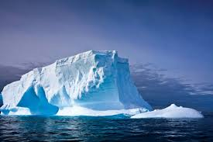

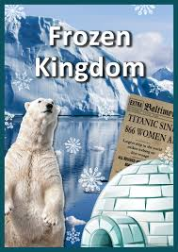

**History**

Create a timeline showing the history and development of polar exploration

Study an aspect of British History including Shackleton’s Journey and Captain Robert Scott

.