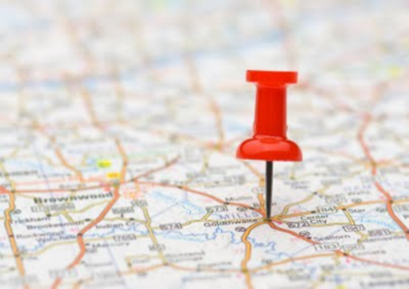

**Computing**

Use search technologies effectively to create a digital scrap book.

Take account of bias when researching information

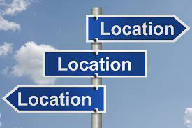

Celosia Golden

Celosia Golden

* Can I locate Scotland, Wales and Northern Ireland on a map of the UK and identify cities and regions?
* Can I identify physical characteristics of these country?
* Can I describe land use in Scotland, Wales and Northern Ireland?
* Can I locate England on a world map?
* Can I identify North America on a map?
* Can I identify the different countries in North America?
* Can I identify the environmental regions in North America?
* Can I explore the physical features of two contrasting North American regions?
* Can I identify North America’s major cities?
* Can I explore economic activity on the continent?
* Can I identify where North America’s natural resources are located?
* Can I explore climate in two regions of North America?
* Can I identify physical and human impact on climate?