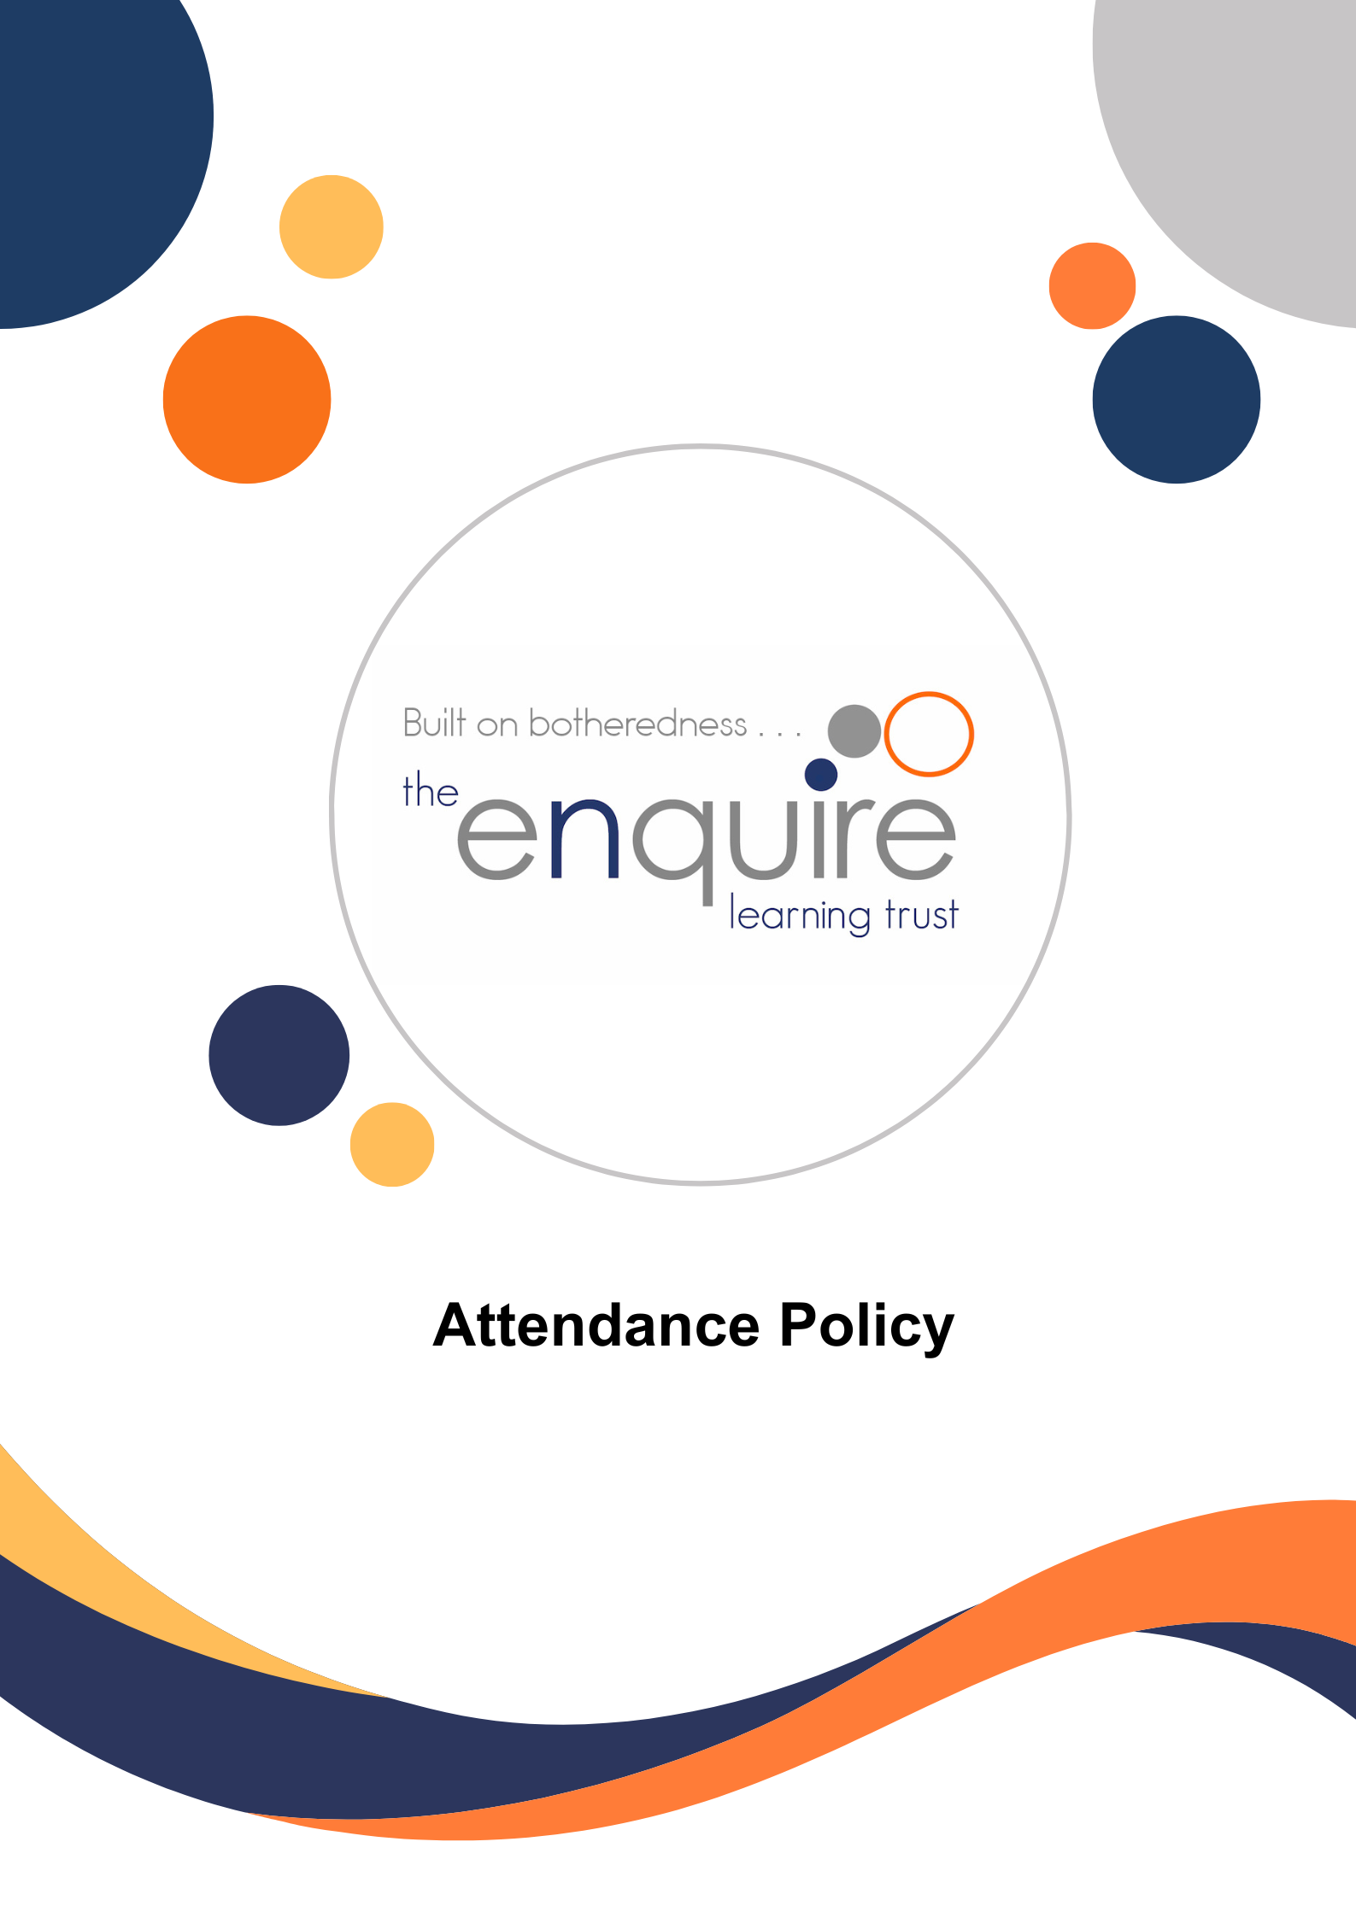

Breakfast and After School Club Policy


Rationale
The safety of pupils is our priority whilst they are in our care. Enfield Academy of New Waltham is committed to safeguarding and promoting the welfare of children and young people and expects all staff and volunteers to share this commitment. We aim to promote equality of opportunity and a positive attitude to all pupils and staff. Enfield Academy provides before and after school activities to cater for children who need wrap-around care. Our staff provide a range of indoor and outdoor activities when the weather and time of year allows.
Aims
The Breakfast and After School Club provides quality wrap-around care for pupils at Enfield Academy.
It aims to:
• Support working parents by providing before and after school childcare from 7.45 am until 8.45 am and from 3.15 pm until 6pm
• Provide planned play activities
• Offer the children breakfast each morning and a light snack at the end of the school day in a safe and friendly environment.
Breakfast Club
At Enfield we offer 2 breakfast club provisions: Wren Class for children aged 2-5 and ‘The Nest’ for children in Year 1-6. Children should enter Breakfast Club through the main reception. Children attending Breakfast Club will be offered a variety of breakfast options and given the choice of physical, constructive and mark making activities within a free flow environment. After Breakfast Club, children are escorted by a member of staff to their classrooms ready to begin their school day.
After School Club
At Enfield we offer 2 after school club provisions: The After School club for children aged 2-5 is located in Wren Class and the After School Club for children in Year 1-6 is in the ‘The Nest’.
All children are brought to After School Club by a member of staff. If your child attends an extra-curricular club after school, a member of staff will collect your child from the club when it finishes. Children have a range of activities, suitably adapted to different ages, available to them which are planned on a weekly basis. The children have access to the outdoor area, weather permitting. We ask, if possible, to send your children with appropriate clothing. Children will be offered a light snack and a drink after school, which is free flow throughout the session.
Collection from Wren Class: ages 2-5
Parents can gain access via the gate off Priors Green Car Park and there is a buzzer to press outside Wren Class.
Collection from the wraparound room: Year 1-6
Parents can gain access via the gate off Priors Green Car Park. Collection is from the rear playground- parents must knock on the door to gain a member of staffs attention.

Opening Times
Monday – Friday. The clubs run every day the school is open to children.
Breakfast Club is available from 7.45 am until 8.45 am.
The After School club is available from 3.15 until 6 pm.

Charges
Breakfast Club: £5.25 per session
After School Club: 3.15-4.15pm £5
3.15-5.15pm £8
3.15-6pm £9
Wrap Around Care is run by qualified Enfield Staff.
Bookings
Children aged from Nursery up until Year 6 are welcome to attend Breakfast Club and After School club. Due to a limited amount of spaces, and to ensure our staffing ratios are correct, in our After School Club we ask that children are booked via MCaS at least 72 hours in advance, to ensure that your child has a place. We understand, on occasion, this may not be possible so we can take bookings, via the school office, after this time, if space allows, with prior payment on MCaS.
Communication
We endeavour to ensure a two-way regular flow of communication between parents/carers, the teaching staff and the Breakfast and After School Club.
Cancellation
We ask that if your child/children are not attending, the school is informed as soon as possible. Full refunds will be given if cancellations are made, via MCaS at least 72 hours prior to the session taking place. Or via the school office, for Breakfast Club, the day before by 4 pm or for After School Club on the day before 9.30 am. Cancellations after these times will be charged at the full rate.
Un-booked sessions
We cannot accept any children who are not booked on in advance (72 hours notice) due to staffing ratios.
Behaviour
The Breakfast Club and After School Club expect the same high standard of behaviour as we do during the school day. We reserve the right to refuse a child who fails to meet these standards. If the behaviour of a child is unacceptable for the safe and efficient running of the club, parents will be informed.
Safeguarding and Health and Safety
The Breakfast and After School Club follow the policies and procedures of Enfield Academy. Staff are DBS checked and possess first aid qualifications.
Accidents and Emergencies
All accidents that happen during Breakfast Club of After School Club are recorded in the accident book. There is a first aid kit available in Wren Classroom and the wraparound room. If children have any medical conditions, staff are aware of the medication needed and where it is stored. Any accidents and emergencies will be notified to the parent/carer as soon as possible.
Medication
The Breakfast Club and After School Club follow the school’s policy on administering medication.
Equal Opportunities
We adhere to the schools Equal Opportunities Policy, we provide a welcoming and caring environment that respects, promotes and reflects cultural and social diversity.
Complaints
All complaints should follow the school’s complaint policy.
Review and Monitoring
Policy reviewed December 2024
Policy to be reviewed: December 2025

