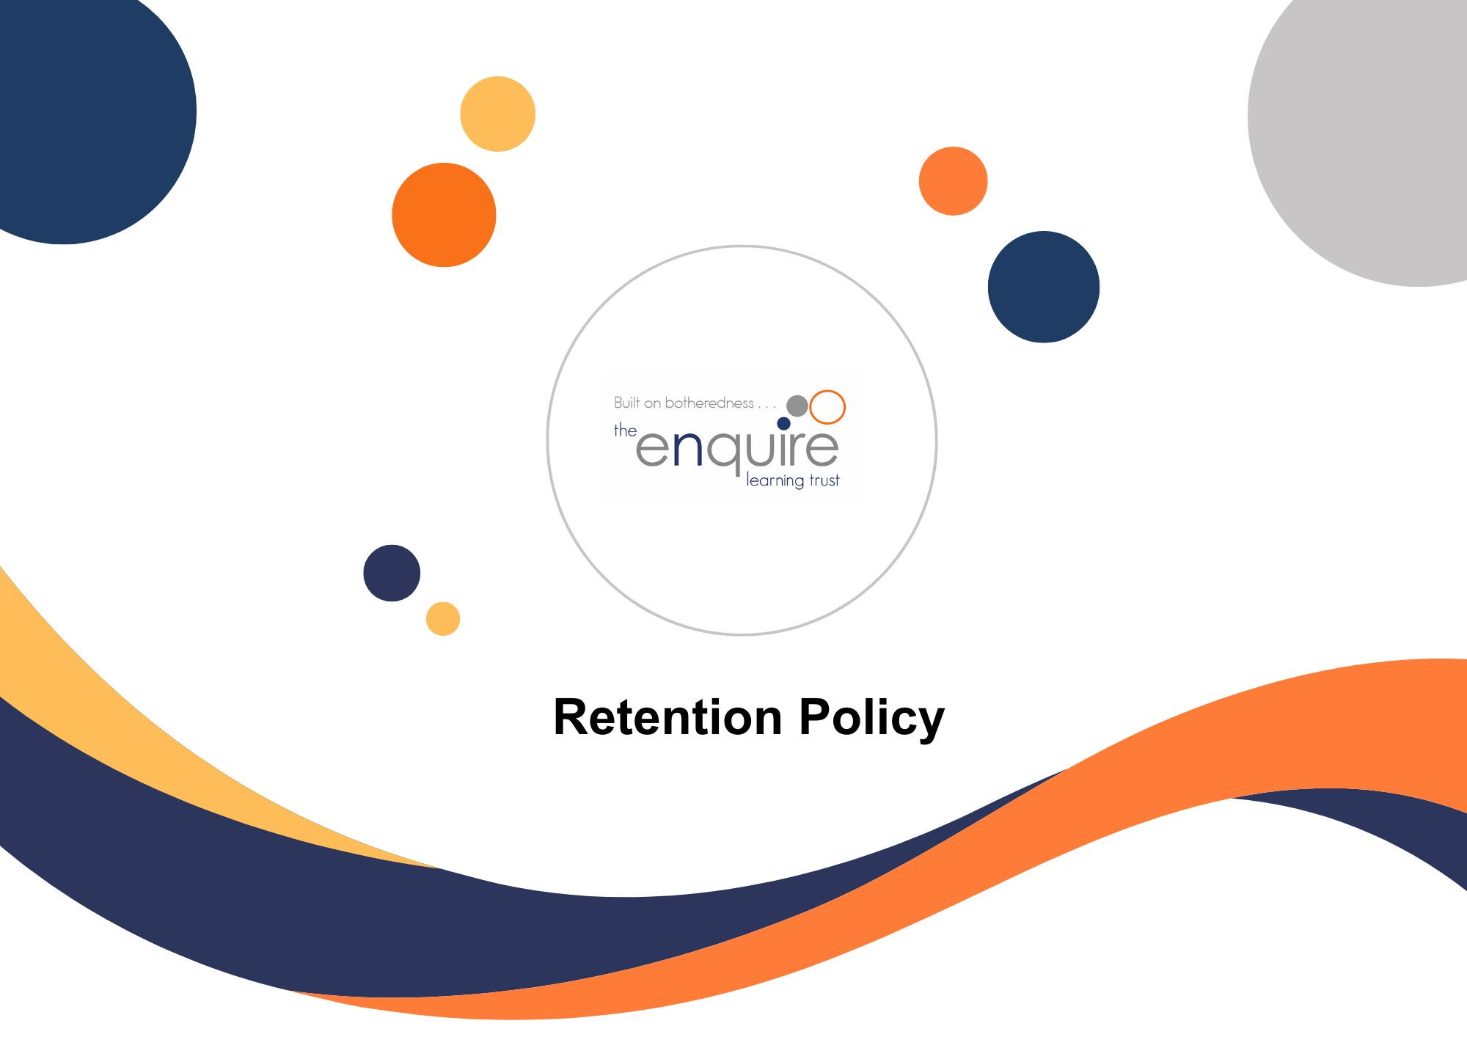
Contents

Section | Title | Page
1 | Administration (Operational) | 4
2 | Governance  - Governance  - Management Records  - DfE, LA and Government | 5
3 | Pupils  - Pupils including Safeguarding and SEN  - Educational Visits | 8
4 | Information Technology  - ICT  - CCTV | 11
5 | Finance | 12
6 | People  - HR  - Training | 13
7 | Estates  - Property  - Health & Safety | 16
8 | Catering  - Health & Safety | 19

Version History

Approved by: | Trustees
Last reviewed: | July 2025
Next review due by: | July 2026

Date | Author | Version | Comment
July 2024 | LT |  | Updated to new format
Sept 2024
Sept 2025 |  |  | Reviewed no changes
August 2026 |  |  | Currently under review

- ADMINISTRATION

Retention Schedule – Administration (Operational)
Files Description | UKGDPR | Basis for Retention | Retention Period | Action at End of Term
General files that do not fit another criteria. | Possibly | Best Practice | Current + 6 years | Secure disposal
Visitor Books / Signing in system | Yes | Best Practice | Current + 2 years | Secure disposal
Newsletters and circulars to staff, parents, and pupils | No | Best Practice | Current + 1 year | Disposal
School brochure/prospectus | No | Best practice | Current academic year + 1 year | Disposal
Privacy Notices | No | Best Practice | Current academic year | Disposal
PTA records | No | Financial Regulations | Current + 6 years | Secure Disposal

- GOVERNANCE

Retention Schedule – Governance
File Description | UKGDPR | Basis for Retention | Retention Period | Action at End of Term
Master Funding Agreement | No | Best Practice | For life of organise or when superseded | Archive
Articles of Association | No | Best Practice | For life of organisation | Archive
Supplementary Agreements | No | Best Practice | For life of organisation or superseded | Archive
Instruments of Government | No | Best Practice
Trust and endowments | No | Best Practice | Permanent | Archive
Scheme of Delegation | No | Best Practice | Until superseded | Secure Disposal
All records relating to the conversation from school to academy status | No | Best Practice | For life of organisation – to be stored by the academy | Secure Disposal
Agenda and minutes including attendance and supporting documents for meetings | Possibly | Best Practice | Current + 6 years | Secure Disposal
Records related to serving Members, Trustees, AIC members and Directors including register of business interest | Yes | Best Practice | Current + 1 year | Secure Disposal
Governance visit records | No | Best Practice | Current + 1 years | Secure Disposal
Annual Reports required by DfE | No | Education Regulation | Date of report + 10 years | Secure Disposal
Record of all elected AIC members | Yes | Best Practice | Current year | Secure Disposal
Policy Documents | No | Best Practice | Until superseded | Disposal
File Description | UKGDPR | Basis for Retention | Retention Period | Action at End of Term
Subject Access Requests | Yes | Best Practice | Request attached to pupil or staff file | Secure Disposal
FOI Request | No | Best Practice | Current + 6 Years | Secure Disposal
Data Breaches | Yes | Best Practice | Current +6 years | Secure Disposal

Retention Schedule – Management Records (Executive Team, Principal & Senior Management Teams)
File Description | UKGDPR | Basis for Retention | Retention Period | Action at End of Term
Minutes of the senior management team and other internal administrative bodies | Yes / No | Best Practice | Date of meeting + 6 years | Secure Disposal / Archive
Reports made by the Executive Team, Principal and management team | Yes / No | Best Practice | Date of meeting + 3 years | Secure Disposal / Archive
Professional development plans | Yes | Best Practice | Life of plan + 6 years | Secure Disposal
School development plan | No | Best Practice | Life of plan + 3 years | Disposal
Self-Evaluation Forms | Yes | Best Practice | Current year + 6 years | Secure Disposal
Records created by Principals, deputy principals, heads of year and other members of staff with administrative responsibilities | Yes / No | Best Practice | Closure of file + 6 years | Secure Disposal / Disposal as appropriate
Correspondence created by Principals, deputy principals, heads of year and other members of staff with administrative responsibilities | Yes / No | Best Practice | Date of correspondence + 3 years | Secure Disposal
Complaints | Yes | Best Practice | Date of last record + 3 years | Secure Disposal

Retention Schedule – DfE, LA and Government
File Description | UKGDPR | Basis for Retention | Retention Period | Action at End of Term
Attendance Returns | Yes | Best Practice | Current + 1 year | Secure Disposal
Secondary transfer sheets | Yes | Best Practice | Current + 2 years | Secure Disposal
School Census Return | Yes | Best Practice | Current + 3 year | Secure Disposal
Workforce Census Return | Yes | Best Practice | Current + 3 Year | Secure Disposal
Circulars from DfE or LA | No | Best Practice | Whilst required operationally | Disposal
HMI reports | No | Best Practice | Do no keep | Secure Disposal
OFSTED Report | No | Best Practice | Replace former report with new inspection report | Secure Disposal
Returns to central government | No | Best Practice | Current + 6 years | Secure Disposal

- PUPILS

Retention Schedule – Pupils including Safeguarding and SEN
File Description | UKGDPR | Basis for Retention | Retention Period | Action at End of Term
Attendance registers | Yes | School attendance | Date of register + 3 years | Secure Disposal
Pupil files | Yes | Best Practice | Retain for the period child is at school | Follow pupil
Examination records | No | Best Practice | Year of examination + 6 years | Secure Disposal
Examination records – internal | Yes | Best Practice | Year of examination + 6 year | Secure Disposal
SATs results | Yes | Best Practice | Record on pupil file. Composite data may be kept for up to 6 years to allow comparison | Follow pupil
SATs examination papers | Yes | Best Practice | Until appeals/validation process is completed | Secure Disposal
Child Protection information held on pupil file | Yes | KCSIE | If kept in pupil file then follow pupil records | Follow child
Child protection information held in Separate file | Yes | Education Act 2002 | File to follow child | Follow child
Correspondence relating to authorised absence | Yes | Best Practice | Date of Absence + 2 years | Secure Disposal
SEN Files, reviews and IEPs | Yes | Special Educational Needs and Disabilities Act 2001 | Retain for the time the pupil is at school | Follow pupil
Educational Health Care Plans | Yes | Special Educational Needs and Disabilities Act 2001 | Retain for the time the pupil is at school | Follow pupil
Proposed statement or amended statement | Yes | Special Educational Needs and Disabilities Act 2001 | Retain for the time the pupil is at school | Follow pupil
Advice and information to parents regarding educational needs | Yes | Special Educational Needs and Disabilities Act 2001 | Retain for the time the pupil is at school | Follow pupil
Accessibility Strategy | Yes | Special Educational Needs and Disabilities Act 2001 | Retain for the time the pupil is at school | Follow pupil
Reports from outside agencies | Yes | Best Practice | Whilst child attends school | Secure Disposal
Referral Forms | Yes | Best Practice | Whilst referral is current. Then file on pupil file | File on pupil file
All reports/referrals to be uploaded onto Bromcom/CPoms | Yes | Best Practice | Pupil file | File to follow child
Records relating to creation and implementation of Admission Policy | No | Schools Admissions Code | Life of Policy + 3 years | Secure Disposal
Admissions – if successful | Yes | Schools Admissions Code | Admission + 1 year | Secure Disposal
Unsuccessful admission (appeals) | Yes | Schools Admissions Code | Resolution + 1 year | Secure Disposal
Proof of address supplied by parent as part of the admissions process | Yes | Schools Admissions Code | Current + 1 year | Secure Disposal
Supplementary information form including additional information such as religion, medical conditions supplied as part of the admissions process for successful admissions | Yes | Best Practice | This information should be transferred with the pupil file | Secure Disposal
Supplementary information form for unsuccessful admissions | Yes | School Admissions Regulations | Until appeals process is completed | Secure Disposal
Admissions Register | Yes | School Admissions Code | Entry + 6 years | Secure Disposal
Academy Improvement Plan | No | Best Practice | Current + 6 years | Disposal
Schemes of work | No | Best Practice | Current + 6 year (it may be appropriate to review these records at the end of the retention period). | Secure Disposal
Mark Books | No/Yes | Best Practice |  | Secure Disposal
Homework Records | No | Best Practice |  | Secure Disposal
Timetables | No | Best Practice |  | Secure Disposal
Pupils work | Yes | Best Practice |  | Secure Disposal
PAN Reports | Yes | Best Practice | Current + 6 years | Secure Disposal
Self-Evaluation Form | Yes | Best Practice | Current + 6 years | Secure Disposal
Internal Moderation | Yes | Best Practice | Current + 6 year | Secure Disposal
External Moderation | Yes | Best Practice | Until superseded | Secure Disposal
Value Added and Contextual Data | Yes | Best Practice | Current + 6 Years | Secure Disposal
Multi purpose consent form | Yes | Best Practice | For period of time child is at school or until consent is remove | Secure Disposal
School Meal Register | Yes | Best Practice | Current + 3 years | Secure Disposal
School Meal Summary Sheet | No | Best Practice | Current + 3 years | Secure Disposal
Pupil Attendance Register | Yes | Best Practice | Date of Register + 3 years | Secure Disposal
Educational visits – financial records | Yes | Financial regulation | Current + 6 years | Secure Disposal
Permanent Exclusions | Yes | Best Practice | Current + 6 years | Secure Disposal
School Clubs – letters / permission slips | Yes | Best Practice | Secure disposal after club has finished unless there is a major incident. | Secure Disposal

Retention Schedule – Educational Visits
File Description | UKGDPR | Basis for Retention | Retention Period | Action at End of Term
Records created to obtain approval to run an educational visit outside the classroom | No | Health and Safety of Pupils on Educational Visits (1998) | Date of visit + 14 years | Secure Disposal
Parental consent for school trips where there has been NO MAJOR INCIDENT | Yes | Best Practice | Conclusion of the trip | Secure disposal
Parental consent for school trips where there has been A MAJOR INCIDENT | Yes | RIDDOR, OEAP Limitation Act 1980 | All permissions for ALL children that attended DOB of child/ren involved + 25 years | Secure disposal

- INFORMATION TECHNOLOGY

Retention Schedule – ICT
File Description | UKGDPR | Basis for Retention | Retention Period | Action at End of Term
Finance Data on Access and IMP Planner | Yes | Best Practice | Current + 6 years | Secure Disposal
Backup drivers for servers | Yes | Best Practice
MIS System – pupil records | Yes | Best Practice | Current + 1 year after child leaves | Secure deletion from Bromcom
MIS system – staff records | Yes | Best Practice | 6 years after the employee’s leaving date | Secure Deletion
Remote learning service i.e Class Dojo | Yes | Best Practice | Current + 6 years | Secure deletion
Assessment tools | Yes | Best Practice | Current + 6 years or life of contract | Secure Deletion
FSM electronic data | Yes | Best Practice | Current + 6 years | Secure Deletion

Retention Schedule - CCTV
File Description | UKGDPR | Basis for Retention | Retention Period | Action at End of Term
CCTV footage/recordings | Yes | Trust Policy | In line with each academy system. Best practice would be 30 days | Automatic deletion
CCTV footage (recorded copies) | Yes | Trust Policy | Closure of investigation + 1 year | Secure Disposal

- FINANCE

Retention Schedule – Finance
File Description | UKGDPR | Basis for Retention | Retention Period | Action at End of Term
Annual Accounts | No | Financial Regulations | Current year + 6 years | Disposal
Loans and Grants | No | Financial Regulations | Date of last payment on loan + 12 years | Secure Disposal
Contracts management monitoring records | No | Limitations Act | Current year + 2 years | Secure Disposal
Contracts under seal | No | Limitations Act | Contract completion date + 12 years | Secure Disposal
Contracts under signature | No | Limitations Act | Contract completion date + 6 years | Secure Disposal
Service Level Agreements | No | Financial Regulations | Until superseded | Secure Disposal
Copy orders | No | Financial Regulations | Current year + 2 years | Disposal
Budget reports / monitoring reports | Yes | Best practice | Current year + 3 years | Secure Disposal
Invoices, receipts, and other finance records | Yes | Financial Regulations | Current year + 6 years | Secure Disposal / Disposal as appropriate
Annual budgets and background paperwork | No | Best Practice | Current year + 6 years | Secure Disposal
Order books and requisitions | No | Financial Regulations | Current year + 6 years | Secure Disposal
Delivery notes | No | Financial Regulations | Current year + 6 years | Disposal
Debtor records | No | Limitations Act | Current year + 6 years | Secure Disposal
Free school meal registers | Yes | Financial Regulations | Current year + 6 years | Secure Disposal
Pupil Premium Fund records | Yes | Financial Regulations | Date pupil leaves establishment + 6 years | Secure Disposal

- PEOPLE

Retention Schedule – HR
File Description | UKGDPR | Basis for Retention | Retention Period | Action at End of Term
Job applications, interview notes and recruitment records of unsuccessful candidates | Yes | Limitation Act 1980 (Section 2) | 6 months after notifying unsuccessful candidates | Secure Disposal
Job applications, interview notes and recruitment records of successful candidates | Yes | Limitation Act 1980 (Section 2) | Add to staff personnel file and retain for 6 years after employment ceases | Secure Disposal
Written particulars of employment, contracts of employment and changes to terms and conditions | Yes | Limitation Act 1980 (Section 2) | Add to staff personnel file and retain for 6 years after employment ceases | Secure Disposal
Right to work | Yes | Home Office Guidance | Add to staff personnel file and retain for 6 years after employment ceases | Secure Disposal
Identification documents | Yes | Limitation Act 1980 (Section 2) | Add to staff personnel file and retain for 6 years after employment ceases | Secure Disposal
Immigration checks | Yes | Home Office Guidance and KCSIE | 6 years after termination of employment | Secure Disposal
DBS checks and disclosure of criminal record forms | Yes | DBS guidance 2023 and KCSIE | Do not keep copies | Secure Disposal
Staff personnel files | Yes | Limitation Act 1980 (Section 2) | While employment continues and 6 years after employment ceases. (This should be kept under review, if IICSA investigation is in place, this needs to remain in place until enquiries are completed) | Secure Disposal
File Description | UKGDPR | Basis for Retention | Retention Period | Action at End of Term
Disciplinary Proceedings | Yes | Where the warning relates to child protection issues (see below) | For non-child protection related disciplinary matters, remove records from personnel file after the retention period indicated in specific sections below as no longer active but maintain record in separate file for 6 years after employment ceases | Secure Disposal
Allegations of a child protection nature against a member of staff including where the allegation is unfounded | Yes | Employment Practices Code and Education Act 2002 Guidance | 10 years from the date of allegation or the person’s normal retirement age (whichever is longer). This should be kept under review and if IICSA investigation is in place, this should remain in place until enquiries are completed.  Records should be maintained in a separate file NOT on personnel files | Secure Disposal
Case not found |  | See above | If child protection – see above, otherwise destroy at conclusion of case | Secure Disposal
Annual Leave records | No | Best Practice | 6 years after the end of the Tax Year they relate to | Secure Disposal
Annual Appraisal and assessment records | Yes | Best Practice | Current year + 5 years | Secure Disposal
File Description | UKGDPR | Basis for Retention | Retention Period | Action at End of Term
Verbal Warning, Aide Memoire and Written Warning – Level 1 | Yes | ACAS Code of Practice | Date of warning + 6 months | Remove from personnel file as no longer active but maintain a record in a separate file for 6 years after employment ceases and then secure disposal.
Written Warning – Level 2 | Yes | ACAS Code of Practice | Date of warning + 12 months
Final Warning | Yes | ACAS Code of Practice | Date of warning + 18 months
Redundancy records | Yes | Best Practice | Date of redundancy + 6 years | Secure Disposal
Sickness absence monitoring | Yes | Best Practice | 3 years after the end of the Tax Year they relate to | Secure Disposal

Retention Schedule – Training
File Description | UKGDPR | Basis for Retention | Retention Period | Action at End of Term
Training – CPD | Yes | Best Practice | 6 years after employment ceases or length of time required by the professional body | Secure Disposal
Staff training relating to safeguarding or other child related training | Yes | Best Practice | 6 years after employment ceases, if IICSA investigation is in place, record needs to remain in place until enquiries are completed | Secure Disposal

- ESTATES

Retention Schedule – Property
File Description | UKGDPR | Basis for Retention | Retention Period | Action at End of Term
Title Deeds | No | Best Practice | Permanent | These should follow the property
Plans of Property | No | Best Practice | Permanent – retain in school whilst operational | To be transferred to new owner if building is leased, sold or archived
Leases | No | Best Practice | Expiry of lease + 6 years | Secure Disposal
Inventories of equipment and furniture | No | Best Practice | Current year + 6 years | Disposal
Burglary, theft and vandalism reports | Possibly | Best Practice | Current year + 6 years | Secure Disposal / Disposal as appropriate
Lettings | No | Best Practice | Current financial year + 3 years | Secure Disposal
All records relating to maintenance carried out by contractors | No | Financial Regulations | Current year + 6 years | Secure Disposal
In house maintenance log books | No | Best Practice | Last entry + 10 years | Secure Disposal
Contractor reports | No | Best Practice | Current year + 6 years | Secure Disposal

Retention Schedule – Health and Safety
File Description | UKGDPR | Basis for Retention | Retention Period | Action at End of Term
Accessibility Plans | Yes | Disability Discrimination Act | Current year + 6 years | Disposal
Health and Safety risk assessments | No | Best Practice | Current year + 3 years | Disposal
Health and Safety policy statements | No | Best Practice | Date of expiry + 3 years | Disposal
Any record relating to any reportable death, injury, disease or dangerous occurrence. | Yes | Best Practice | Date of incident + 3 years (if relate to child protection, they should be maintained for 24 years) | Review at the end of this period, in the case of serious injury leading to further action.
Records relating to accident / injury at work (Staff) | Yes | Best Practice | Date of incident + 12 years
Accident reporting (other adults) | Yes | Social security | Date of incident + 7 years | Secure Disposal
Accident reporting (children) | Yes | Social security | DOB + 25 years | Secure Disposal
Accident book | Yes | Social security | 3 years from last entry, completed pages must be kept secure with restricted access (DPA 2018 & GDPR) | Secure Disposal
COSHH | No | Control of Substances Hazardous to Health Regulations 2002 | Current + 40 years (where appropriate an additional retention period may be allocated) | Disposal
Incident reports | Yes |  | Current + 20 years | Secure Disposal
Process of monitoring areas where employees and persons are likely to have come in to contact with asbestos | No | Control of Asbestos at Work Regulations 2012 | Last action + 40 years | Secure Disposal
File Description | UKGDPR | Basis for Retention | Retention Period | Action at End of Term
Process of monitoring areas where employees and persons are likely to have come in to contact with radiation | No | The Ionising Radiation Regulations 2017 | 2 years from the date on which examination was made and records to include the condition of the equipment at the time of the examination (a copy to be maintained until person affected would have reached 75 years of age, but last action + 30 years minimum) | Secure Disposal
Fire precautions logbook | No | Best Practice | Current + 6 years | Secure Disposal

- CATERING

Retention Schedule – Health and Safety
File Description | UKGDPR | Basis for Retention | Retention Period | Action at End of Term
Allergen information | Yes
Menus | No
Allergen breaches | Yes |  | Current + 6 years | Secure Disposal

