



Enquire Learning Trust Application Pack

Higher Level Teaching Assistant
(Early Years)

ELTJUL2615



Contents:


1. The Enquire Learning Trust Visions, Values and Mission


2. Academy Information


3. Health and Wellbeing Package


4. Job Advert


5. Job Description


6. Person Specification

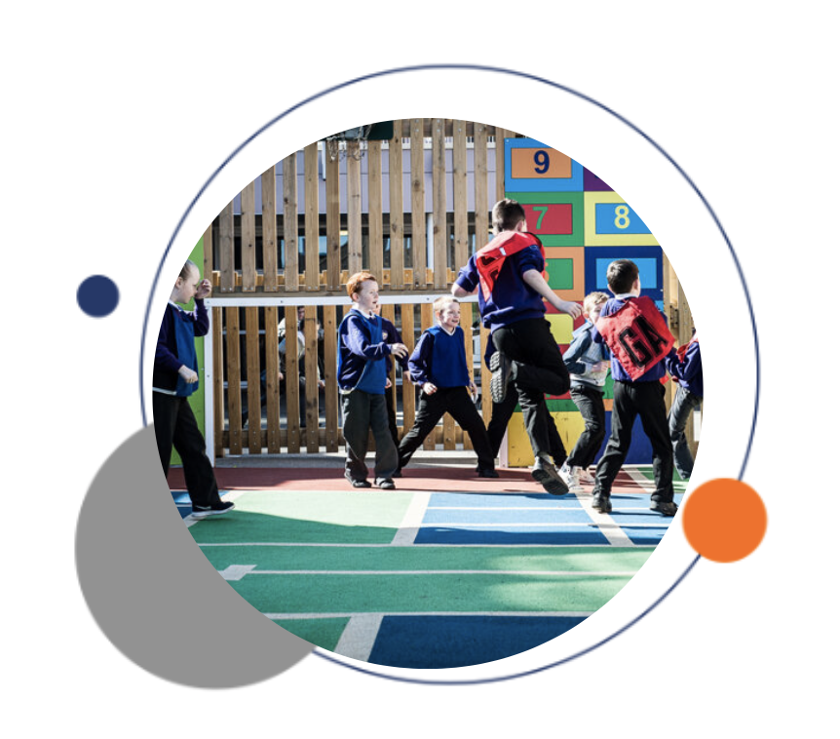


The Enquire Learning Trust

We are a multi-academy trust currently responsible for 32 academies in four clusters across the North of England; North East Lincolnshire, Hull, Manchester, Teesside and North Yorkshire.

We work in complete collaboration with each of our academies and place a strong emphasis on school-to-school support and learning. Our academies work in collaboration with one another, sharing both their talent and ideas with others, giving employees the opportunity to learn from individuals within our other academies.

We recognise that the most important assets we have are our employees, and for our academies to succeed we need to ensure we employ the very best people in every single role. Our core values and beliefs are consistent throughout all of our academies, and our keys to success are at the heart of everything we do.

Every role across the Trust is valued, appreciated and purposeful. We believe that the outcome of every role across the Trust should improve the education each of our learners receive. Whether teaching, support or leadership, every single role is vital to the success of our academies.

We also recognise that all of our academies are different, and we encourage individuality. Whilst we believe our academies should work together to support best practice and to share ideas, we don’t believe that implementing blanket priorities and objectives is pertinent to a successful academy, and we encourage autonomy for academy leaders wherever possible.

Values

- We believe that all learners can be powerful learners given access to extraordinary learning experiences. We want children and the academies they attend to be confident, successful and ambitious.
- We envisage a Trust where well led, highly skilled and committed professionals collaborate, learn and innovate together to ensure that all academies are successful and where all learners have access to effective and innovative provision that meets their needs and aspirations.
- We want to add value to achievement and raise standards. We also want to change lives. We know this requires our provision and our practice to be world-class – because of the distance we have to travel, we understand that good will not be good enough and that we need to develop a shared appreciation of excellence and then strive to enact this every day.
- We take learning seriously and work together to create a vibrant culture in which this can happen. We know that it’s what we do that counts and that our thinking must be visible in classrooms if it is to have leverage. Children are at the forefront of all that we do and aspire to do. We take serious steps to engage them, to hear their voice in authentic ways and then to use their insight and expertise to develop radical pedagogies that tap into their passions and interests and use the potential of emergent technologies.

Welholme Academy was originally opened in 1892 and we serve one of the oldest parts of Grimsby. We are a large primary Academy and a focal point for our community. We are very proud of our school's fine reputation and believe in celebrating the successes in our area.
Our aim is that Welholme Academy is a safe and nurturing place, where all children, staff and visitors feel welcome and valued and we believe that together we can achieve anything. Children learn best when they are happy and confident and we want every child to achieve the very best they can. We encourage them to challenge themselves and to be proud of all their achievements.
We offer a personalised approach to teaching and learning. Our curriculum is engaging and exciting. It is designed to interest the children and meet their needs so that all children are keen to come to school and keen to learn.
We know that children learn best when parents and school work closely together and we value your support to ensure every child has the very best opportunity to succeed. We look forward to working with you.
At Welholme Academy we believe that everything is possible within a culture of collaboration, resilience, nurture and high aspirations we have been entrusted with the very privileged role of giving our children the very best education we can offer. We endeavour to achieve this by developing the full potential of all our children.
Our aims are to be:
Collaborative - We believe in the importance of creating a network of supportive relationships, where pupils, teachers, parents/carers, governors and other adults involved in school life, work alongside each other to enhance the atmosphere of co-operation, trust and mutual respect. We strive to work and learn together.
Resilient - We believe that anything is possible and overcome challenges in the face of difficulty.
Nurturing - What our children bring to school with them is all they have. They are all unique! We strive to be inclusive and believe in the “art of the possible”. We champion children’s uniqueness and encourage them to believe they can achieve anything! We are a nurturing school and positive attitudes are promoted to create an environment in which sensitivity and tolerance are shown to each individual. Being inclusive is in the forefront of everything that we do here at Welholme.
Aspirational - Our staff have high expectations of themselves and our pupils. Our curriculum is broad, balanced and appropriate to the child’s needs and we must never forget that we are concerned with the holistic development of each child. We strive for excellence and encourage our children to take pride in everything they say and do.
Everyone at Welholme is a learner and we never give up on achieving our aspirations and dreams of unlocking everyone’s potential.
EAP Programme



The Trust offers a plan through Health Assured which provides access to valuable health and wellbeing services.​

Key Features:

- Unlimited access to 24/7 confidential telephone helpline
- Up to 10 sessions of face to face, telephone and online counselling
- Access to the portal and wisdom app
- Coverage for spouse/partner and dependants
- Medical information line including articles, webinars and podcasts
- Menopause Support access to other resources such as 'Menopause Matters'
- Access to Perks and Discounts
- Online and mobile access, anywhere and anytime
- Self-help guides, mood and wellness trackers

Higher Level Teaching Assistant (Early Years)

37 hours per week (8:15am -4pm plus 0.5 hour for weekly staff meetings, day may vary)
Term Time Plus 5 Days

NJC Scale 15-17, Pro-rata
Actual Salary approx.: £25,958-£26,821

Permanent,

To start ASAP

Closing Date: Monday5th Oct2026 @ 12pm
Interviews: W/C 12th October 2026

Are you an inspiring Early Years professional ready to shape something special? Welholme Academy, part of the Enquire Learning Trust, are offering a rare opportunity to appoint an outstanding Higher Level Teaching Assistant, with an appropriate Early Years qualification/experience, to lead our thriving nursery, under the supervision of our Foundation Stage Leader.

We are looking to appoint a positive, outstanding practitioner who:
- has a sound knowledge of the Early Years Foundation Stage Curriculum
- has drive, energy, ambition and high expectations for all
- is passionate about how children learn
- has the ability to make learning fun
- is able to work closely with the Early Years team to support progress
- is able to support children’s emotional and social well being
- is able to independently and manage own workload
- is ambitious for their career development

We can offer you:
- enthusiastic and keen children who love learning
- the opportunity to work as part of a team alongside talented and committed staff
- opportunities to build and develop your career in an innovative and forward-thinking environment
- access to professional development through the Enquire Learning Trust that is “built on botherdness”

The school is committed to safer recruitment practice and pre-employment checks will be undertaken before any appointment is confirmed. This post is subject to an enhanced disclosure from the Disclosure and Barring Service (DBS).
The school is also committed to safeguarding and promoting the welfare of children and young people and it expects staff and volunteers to share this commitment.

Visits to the academy would be warmly welcomed by appointment. Please contact the academy on 01472 230260 if you would like to arrange a visit.

https://www.enquirelearningtrust.org/job-vacancies

Job Description

JOB DESCRIPTION

Post Title: Higher Level Teaching Assistant (EYFS)

Grade: SCP 15 - 17

Responsible to: Working under the guidance of Teaching staff, Vice Principal and Principal.

Main Purpose

To work under the guidance of the Senior Leadership Team to play a key role in delivering high-quality early years education and care. This role involves leading practice within the nursery provision, supporting colleagues, and ensuring that children receive stimulating, safe, and developmentally appropriate experiences that supports their learning and development. To act as a role-model for best practice and contribute to continuous improvement across the setting.

Duties and Responsibilities

Support for pupils
- Plan, deliver, and evaluate high-quality learning experiences in line with the EYFS framework.
- Support children’s progress through targeted next steps and observations.
- Adapt activities to meet individual needs, including SEND requirements.
- Promote children’s independence, communication, and strong foundations.
- Build strong, trusting relationships with children and families.
- Maintain accurate learning journeys, assessments, and progress records.
- Engaging with families and professionals to ensure holistic care, including safeguarding and promoting health and well-being.
- Ensure effective supervision at mealtimes and that all dietary requirements are adhered to.

Higher Level Accountabilities

- Attend planning meetings when required and under the overall direction and guidance of the Early Years Lead and SLT, contribute to the short, medium and long term planning and preparation of lessons.

- Developing high-quality, enabling environments and tailored, play-based learning opportunities for children.

- Coach colleagues to improve practice, mentor new staff, and lead on specific areas of pedagogy.

- Implementing evidence-based changes in the setting and conducting small-scale research projects to improve outcomes.

Support the school

- Support the aims and ethos of the school.

- Set a good example in terms of dress, punctuality and attendance.

- Attend team and staff meetings.

- Undertake professional duties that may be reasonably assigned by the Principal

- Work within the framework of the school’s agreed policies and procedures.

- Be aware of and comply with policies and procedures relating to Child Protection, health, safety and security, confidentiality and data protection, reporting all concerns to an appropriate person in accordance with policy.

- Be proactive in matters relating to health and safety.

- Undertake relevant training.

Qualifications and Experience

- A full and relevant HLTA/ Level 4 qualification or relevant prior experience as a Level 3 or 4 EY practitioner. (e.g., NCFE CACHE Level 4 Certificate for the Early Years Advanced Practitioner)

- Strong knowledge of the Early Years Foundation Stage (EYFS) and child development.
- Understanding of principles of child development and learning processes.
- Proven ability to lead on operational aspects of a setting, such as planning or Special Educational Needs
- Full working knowledge of relevant policies/codes of practice and awareness of relevant legislation.
- Paediatric first aid qualification


Person Specification for Higher Level Teaching Assistant (Early Years)

 | Essential | Desirable
Qualifications and experience | - A relevant Early Years qualification (or be in training for)  - Good level of numeracy and literacy GCSE grades C/4+ in English Language and Maths; O levels or equivalent  - Experience of working with children in nursery or reception | - Paediatric First Aid  - Early Years CPD  - Willingness to undertake L4-6 EY qualification
Knowledge and understanding | - Good knowledge and understanding of the EYFS curriculum and guidance  - Sound understanding of the way in which children develop and of different developmental stages and the impact of experience on these developments  - Basic understanding of barriers to children’s learning and ways to remove these obstacles.  - Understanding of supporting children with their PRIME areas of learning.  - Understanding of how to support children with reading, writing and maths.  - Understanding of how to support children in transition phases  - To understand and value the role of parents and carers in supporting their children  - Good written and spoken English  - Awareness of and compliance with all child protection and safeguarding procedures and undergo regular training  - Use of basic ICT – computer, video, photocopier. | - Knowledge of a range of behaviour management strategies and techniques  - Phonics training and experience of delivering an early phonics programme or early phonic intervention.  - Experience of working with children with a range of SEND and delivering interventions (SEMH, Speech and Language, Communication and Interaction)  - Experience of working in partnership with parents and outside agencies
Skills | - Ability to manage whole nursery class, ensuring children are actively engaged in an outstanding learning experience  - Ability to build supportive relationships with adults and children  - Good organisational skills  - Ability to use initiative and retain professionalism.  - Positive approach to behaviour management  - Model acceptable behaviour  - Ability to liaise with external professionals to support individual children.  - Meet the expectations set out in the job description  - Effective team working
Personal characteristics | - Flexible approach  - Calmness  - Awareness of confidentiality  - Show Initiative  - Enthusiasm for role  - Reliable  - Have high expectations  - Nurturing Personality  - Friendly and approachable  - Curiosity and empathy
Equal opportunities | - Demonstrate awareness and understanding of the implication of equal opportunities, inclusion and multicultural education
References | - Positive recommendation in professional references | - Professional reference without reservations  - Strong positive examples of impact
Safeguarding | Springfield Primary Academy is committed to safeguarding and promoting the welfare of children and young people and expects all staff to share this commitment. An enhanced DBS check is required for all successful applicants.

The Enquire Learning Trust is committed to safeguarding and promoting the welfare of children and young people and expects all staff and volunteers to share this commitment. All ID and qualification checks will be made prior to appointment, as will online searches of candidates (Keeping Children Safe in Education 2023). Any offer of employment will be subject to receipt of a satisfactory Disclosure & Barring Service check and Disqualification by Association Disclosure.
DISCLOSURE AND BARRING AND RECRUITMENT CHECKS
The Trust is legally obligated to process an enhanced Disclosure and Barring Service (DBS) check before making appointments to relevant posts.
The DBS check will reveal both spent and unspent convictions, cautions, reprimands and final warnings, and any other information held by local police that’s considered relevant to the role. Any information that is “protected” under the Rehabilitation of Offenders Act 1974 (Exceptions) Order 1975 will not appear on a DBS certificate.
For posts in regulated activity, the DBS check will include a barred list check.
It is an offence to seek employment in regulated activity if you are on a barred list.
We’ll use the DBS check to ensure we comply with the Childcare Disqualification Regulations. It is an offence to provide or manage childcare covered by these regulations if you are disqualified.
Any data processed as part of the DBS check will be processed in accordance with data protection regulations and the trusts information governance policy which can be found on the website.
Please note this post is in regulated activity and exempt from the rehabilitation of Offenders Act 1974 and subject to satisfactory references and an enhanced DBS criminal records and barred list check for work with children. An online search may be undertaken as part of the recruitment process on information available in the public domain. Candidates should disclose anything that may be relevant in line with Keeping Children Safe in Education.

Any job offer will be conditional on the satisfactory completion of the necessary pre-employment checks. Only applicants who have been shortlisted will be asked for a self-declaration of their criminal record or information that would make them unsuitable for the position. Any convictions that are self-disclosed or listed on a DBS check will be considered on a case-by-case basis.

All documentation will be treated confidentially and processed in accordance with Data Protection regulations.

