



Enquire Learning Trust Application Pack

Level 3 Teaching Assistant
(Early Years)

ELTOCT2607



Contents:


1. The Enquire Learning Trust Visions, Values and Mission


2. Academy Information


3. Health and Wellbeing Package


4. Job Advert


5. Job Description


6. Person Specification

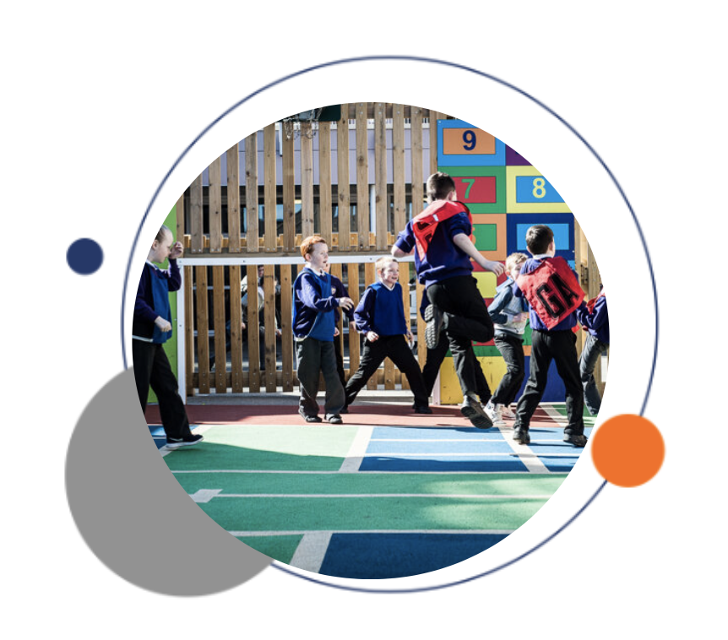


The Enquire Learning Trust

We are a multi-academy trust currently responsible for 32 academies in four clusters across the North of England; North East Lincolnshire, Hull, Manchester, Teesside and North Yorkshire.

We work in complete collaboration with each of our academies and place a strong emphasis on school-to-school support and learning. Our academies work in collaboration with one another, sharing both their talent and ideas with others, giving employees the opportunity to learn from individuals within our other academies.

We recognise that the most important assets we have are our employees, and for our academies to succeed we need to ensure we employ the very best people in every single role. Our core values and beliefs are consistent throughout all of our academies, and our keys to success are at the heart of everything we do.

Every role across the Trust is valued, appreciated and purposeful. We believe that the outcome of every role across the Trust should improve the education each of our learners receive. Whether teaching, support or leadership, every single role is vital to the success of our academies.

We also recognise that all of our academies are different, and we encourage individuality. Whilst we believe our academies should work together to support best practice and to share ideas, we don’t believe that implementing blanket priorities and objectives is pertinent to a successful academy, and we encourage autonomy for academy leaders wherever possible.

Values

- We believe that all learners can be powerful learners given access to extraordinary learning experiences. We want children and the academies they attend to be confident, successful and ambitious.
- We envisage a Trust where well led, highly skilled and committed professionals collaborate, learn and innovate together to ensure that all academies are successful and where all learners have access to effective and innovative provision that meets their needs and aspirations.
- We want to add value to achievement and raise standards. We also want to change lives. We know this requires our provision and our practice to be world-class – because of the distance we have to travel, we understand that good will not be good enough and that we need to develop a shared appreciation of excellence and then strive to enact this every day.
- We take learning seriously and work together to create a vibrant culture in which this can happen. We know that it’s what we do that counts and that our thinking must be visible in classrooms if it is to have leverage. Children are at the forefront of all that we do and aspire to do. We take serious steps to engage them, to hear their voice in authentic ways and then to use their insight and expertise to develop radical pedagogies that tap into their passions and interests and use the potential of emergent technologies.

Welholme Academy was originally opened in 1892 and we serve one of the oldest parts of Grimsby. We are a large primary Academy and a focal point for our community. We are very proud of our school's fine reputation and believe in celebrating the successes in our area.
Our aim is that Welholme Academy is a safe and nurturing place, where all children, staff and visitors feel welcome and valued and we believe that together we can achieve anything. Children learn best when they are happy and confident and we want every child to achieve the very best they can. We encourage them to challenge themselves and to be proud of all their achievements.
We offer a personalised approach to teaching and learning. Our curriculum is engaging and exciting. It is designed to interest the children and meet their needs so that all children are keen to come to school and keen to learn.
We know that children learn best when parents and school work closely together and we value your support to ensure every child has the very best opportunity to succeed. We look forward to working with you.
At Welholme Academy we believe that everything is possible within a culture of collaboration, resilience, nurture and high aspirations we have been entrusted with the very privileged role of giving our children the very best education we can offer. We endeavour to achieve this by developing the full potential of all our children.
Our aims are to be:
Collaborative - We believe in the importance of creating a network of supportive relationships, where pupils, teachers, parents/carers, governors and other adults involved in school life, work alongside each other to enhance the atmosphere of co-operation, trust and mutual respect. We strive to work and learn together.
Resilient - We believe that anything is possible and overcome challenges in the face of difficulty.
Nurturing - What our children bring to school with them is all they have. They are all unique! We strive to be inclusive and believe in the “art of the possible”. We champion children’s uniqueness and encourage them to believe they can achieve anything! We are a nurturing school and positive attitudes are promoted to create an environment in which sensitivity and tolerance are shown to each individual. Being inclusive is in the forefront of everything that we do here at Welholme.
Aspirational - Our staff have high expectations of themselves and our pupils. Our curriculum is broad, balanced and appropriate to the child’s needs and we must never forget that we are concerned with the holistic development of each child. We strive for excellence and encourage our children to take pride in everything they say and do.
Everyone at Welholme is a learner and we never give up on achieving our aspirations and dreams of unlocking everyone’s potential.
EAP Programme



The Trust offers a plan through Health Assured which provides access to valuable health and wellbeing services.​

Key Features:

- Unlimited access to 24/7 confidential telephone helpline
- Up to 10 sessions of face to face, telephone and online counselling
- Access to the portal and wisdom app
- Coverage for spouse/partner and dependants
- Medical information line including articles, webinars and podcasts
- Menopause Support access to other resources such as 'Menopause Matters'
- Access to Perks and Discounts
- Online and mobile access, anywhere and anytime
- Self-help guides, mood and wellness trackers

Level 3 Teaching Assistant (Early Years)

36 hours per week (8:15am -3:45pm)
Term Time Plus 5 Days

NJC Scale 6, Pro-rata
Actual Salary approx.: £22,584

Permanent, To start ASAP

Closing Date: 9th November 2026
Interviews: W/C 16th November 2026

Are you an inspiring Early Years professional ready to shape something special?

Welholme Academy, part of the Enquire Learning Trust, has an exciting opportunity for the right person to join our friendly Nurser team.
We are seeking to appoint an Level 3, Early years Teaching Assistant to support children within our Nursery setting.

The successful candidate will have an appropriate Early Years qualification/experience, that enables them to be part of our Nursery Team and will work under the supervision of both our Nursery and Early Years Leads.

The successful candidate will need to have high expectations of the children in their care and be flexible in their approach to working as part of a team.

The primary role of the post will be to support children within our Nursery area but the successful candidate may be expected to work throughout the Early Years Unit and other areas of the school.

The successful candidate will also be required to support the class teachers with general classroom preparation, work with groups of children and will be required to assist at lunchtimes and playtimes as well as undertaking any other duties required by the Principal.

What we can offer in return is enthusiastic and keen children who love learning, the opportunity to work as part of a team alongside talented and committed staff, opportunities to build and develop your career in an innovative and forward-thinking environment and access to professional development through the Enquire Learning Trust that is “built on botherdness”

The school is committed to safer recruitment practice and pre-employment checks will be undertaken before any appointment is confirmed. This post is subject to an enhanced disclosure from the Disclosure and Barring Service (DBS).
The school is also committed to safeguarding and promoting the welfare of children and young people and it expects staff and volunteers to share this commitment.

Visits to the academy would be warmly welcomed by appointment. Please contact the academy on 01472 329944 if you would like to arrange a visit.

https://www.enquirelearningtrust.org/job-vacancies

Job Description
Welholme Academy

JOB DESCRIPTION

Post Title: Level 3 Early Years Teaching Assistant (must hold a
recognised and relevant Early years qualification to count towards Nursery Ratios)

Grade: SCP 6

Responsible to: Working under the guidance of the Nursery and Early Years Leads.

Main Purpose:

To work under the guidance of Teaching staff to implement agreed work programmes with individuals / groups both within and out of the classroom. This may include the use of detailed and specialist knowledge in particular areas and will involve assisting the Teacher in the whole planning cycle and with the management / preparation of resources.
The post holder will deliver PPA sessions as timetabled.
The post holder may also supervise whole classes occasionally during the short-term absence of Teachers, when the primary focus will be to maintain good order and to keep pupils on task.
As Cover Supervisors, the post holder will need to respond to questions and generally assist pupils to undertake set activities.
The post holder may also oversee the Nursery on a regular basis, under the supervision of the Nursery Lead and the Foundation Stage Leader.

We are looking for a candidate who:

- Can form positive relationships with children, parents and staff
- Is able to use their initiative to support behaviour
- Has a proven track record of having a positive impact on children’s progress
- Is adaptable to situations and able to work effectively as part of a team
- Is an excellent communicator and role model
- Has good English/maths/computing skills
- Is a ‘can do’ person!
- Is resilient and flexible
- Is willing to make a positive contribution to the development of our school
- Aspires to be the very best version of themselves that they can be

We will offer you:
- Friendly and well-behaved children who are eager to learn.
- A well-established school where the whole team work together and support one another.
- A commitment to promoting staff’s emotional and physical well-being.
- Excellent opportunities for professional development.

Duties and Responsibilities:

- Support for pupils

- Use specialist (Curricular / Learning) skills / training / experience to support pupils.
- Assist with the development and implementation of PLPs.
- Establish productive working relationships with pupils, acting as a role model and setting high expectations.
- Promote the inclusion and acceptance of all pupils within the classroom.
- Support pupils consistently whilst recognising and responding to their individual needs.
- Encourage pupils to interact and work cooperatively with others and engage all pupils in activities.
- Promote independence and employ strategies to recognise and reward achievement of self-reliance.
- Provide feedback to pupils in relation to progress and achievement.
- Provide 1:1 SEN support as and when required.

2. Support for the Teacher
- Work with the Teacher to establish an appropriate learning environment.
- Work with the Teacher in lesson planning, evaluating and adjusting lesson / work plans as appropriate.
- Monitor and evaluate pupils’ responses to learning activities through observation and planned recording of achievements against pre-determined learning activities.
- Provide objective and accurate feedback and reports, as required, to the Teacher, on pupil achievement, progress and other matters, ensuring the availability of appropriate evidence.
- Be responsible for keeping and updating records, as agreed with the Teacher, contributing to reviews of systems / records as requested.
- Undertake marking of pupils’ work and accurately record achievement / progress as appropriate.
- Liaise sensitively and effectively with Parents / Carers as agreed with the Teacher within your role / responsibility and participate in feedback sessions / meetings with Parents / Carers.
- Provide general clerical / administrative support, e.g. produce worksheets for agreed activities etc.
- Attend and contribute to annual review meetings with parents and other professionals in order to support the monitoring and development of the child where appropriate.

3. Support for the Curriculum

Implement agreed learning activities / teaching programmes, adjusting
activities according to pupil responses / needs.
- Implement local and national learning strategies, e.g, Literacy, Numeracy, Early Years and make effective use of opportunities provided by other learning activities to support the development of relevant skills.
- Support the use of ICT in learning activities and develop pupils’ competence and independence in its use.
- Help pupils to access learning activities through specialist support.
- Determine the need for, prepare and maintain general and specialist equipment and resources.

- Support for the School

- Contribute to the overall ethos / aims of the academy.
- Be aware of and comply with policies and procedures relating to Child Protection, health, safety and security, confidentiality and data protection, reporting all concerns to an appropriate person in accordance with policy.
- Promote positive values, attitudes and good pupil behaviour, dealing promptly with conflict and incidents in line with school policy and encourage pupils to take responsibility for their own behaviour.
- Be aware of and support difference and ensure all pupils have equal access to opportunities to learn and develop.
- Establish constructive relationships and communicate with other agencies / professionals, in liaison with the Teacher, to support achievement and progress of pupils.
- Attend and participate in relevant meetings as required.
- Participate in training and other learning activities as required.
- Recognise own strengths and areas of expertise and use these to achieve and support others.
- Provide appropriate guidance and supervision and assist in the training and development of staff as appropriate.
- Supervise pupils on visits, trips and out of school activities as required.
- Respond to first aid issues as in line with school policy.

5. To cover during lunch-times:

- Supervise children, monitor their wellbeing and intervene to resolve non-routine issues using appropriate techniques and strategies to maintain behaviour standards.
- Resolve or report any areas of concern to ensure compliance with good practice.
- Intervene in serious pupil related incidents to ensure understanding and use appropriate responses to ensure compliance with behaviour standards and school policy.
- Identify and respond to pastoral concerns related to individual pupils.
- Care for children’s routine personal needs, maintaining dignity and respect and develop awareness of personal hygiene and cleanliness.
- Monitor pupils’ conduct and behaviour throughout lunch-time to resolve complex, difficult or challenging issues using appropriate techniques, skills strategies and routine sanctions to de-escalate potentially difficult situations or resolve conflict with individual and groups of pupils and establish, maintain or restore a safe and calm atmosphere conducive to learning and ensure the safety and wellbeing of pupils, staff and visitors.
- Duties may include dining room and hall supervision as well as playground cover.

General
Postholders will be required to possess the NVQ 3 for Early Years Teaching Assistants or an equivalent recognised and relevant early years qualification and experience, together with training in the relevant strategies (e.g., Literacy and / or particular curriculum or learning area such as bilingual, sign language, dyslexia, ICT, Maths, English, CACHE etc.)
Appropriate First Aid training will be required.

The following knowledge/skills will be required:
- Full working knowledge of relevant policies/codes of practice and awareness of relevant legislation.
- Working knowledge of national/foundation stage curriculum and other relevant learning programmes/strategies.
- Understanding of principles of child development and learning processes.
- Ability to relate well to children and adults.

PERSON SPECIFICATION FOR TA WORKING WITH NURSERY STAGE CHILDREN.

Criteria | Standard | Essential/Desirable | Measured by
Work Experience | - Experience of working in a school/educational setting | Essential | Application/Reference/Interview
Knowledge | - A Level 3 Early years Teaching Assistant qualification or equivalent recognized and relevant Early years qualification.  - Grade A-C in literacy and numeracy GCSE or equivalent qualification.  - Experience/qualification in working within an early years setting.  - Team Teach  - First Aid  - Previous experience of CPOMS. | Essential  Essential  Essential  Desirable  Desirable  Desirable | Application  Application  Application/Reference/Interview  Application/Reference/Interview  Application/Reference/Interview  Application/Reference/Interview
Skills | - An ability to manage challenging behaviour  - An ability to work with a range of agencies  - An ability to work using own initiative and also under direction of others  - An ability to work with parents/carers | Essential  Essential  Essentail  Essential | Application/Reference/Interview  Application/Reference  Reference/Interview  Application/Reference/Interview
Attitudes | - Ability to maintain confidentiality  - Keen to continue developing skills and knowledge  - Reliable  - Confident  - Self-motivating  - Willingness to work as part of a team  - Aspirational for our children  - Nurturing  - Commitment to upholding the Academy vision. | Essential  Essential  Essential  Essential  Essential  Essential  Essential  Essential  Essential | Interview/Reference  Interview/Reference  Interview/Reference  Interview/Reference  Interview/Reference  Interview/Reference  Interview/Reference  Interview/Reference  Interview/Reference

The Enquire Learning Trust is committed to safeguarding and promoting the welfare of children and young people and expects all staff and volunteers to share this commitment. All ID and qualification checks will be made prior to appointment, as will online searches of candidates (Keeping Children Safe in Education 2023). Any offer of employment will be subject to receipt of a satisfactory Disclosure & Barring Service check and Disqualification by Association Disclosure.
DISCLOSURE AND BARRING AND RECRUITMENT CHECKS
The Trust is legally obligated to process an enhanced Disclosure and Barring Service (DBS) check before making appointments to relevant posts.
The DBS check will reveal both spent and unspent convictions, cautions, reprimands and final warnings, and any other information held by local police that’s considered relevant to the role. Any information that is “protected” under the Rehabilitation of Offenders Act 1974 (Exceptions) Order 1975 will not appear on a DBS certificate.
For posts in regulated activity, the DBS check will include a barred list check.
It is an offence to seek employment in regulated activity if you are on a barred list.
We’ll use the DBS check to ensure we comply with the Childcare Disqualification Regulations. It is an offence to provide or manage childcare covered by these regulations if you are disqualified.
Any data processed as part of the DBS check will be processed in accordance with data protection regulations and the trusts information governance policy which can be found on the website.
Please note this post is in regulated activity and exempt from the rehabilitation of Offenders Act 1974 and subject to satisfactory references and an enhanced DBS criminal records and barred list check for work with children. An online search may be undertaken as part of the recruitment process on information available in the public domain. Candidates should disclose anything that may be relevant in line with Keeping Children Safe in Education.

Any job offer will be conditional on the satisfactory completion of the necessary pre-employment checks. Only applicants who have been shortlisted will be asked for a self-declaration of their criminal record or information that would make them unsuitable for the position. Any convictions that are self-disclosed or listed on a DBS check will be considered on a case-by-case basis.

All documentation will be treated confidentially and processed in accordance with Data Protection regulations.

