

Enquire Learning Trust Application Pack

Reference: ELTAPR2609

Premises Manager

Southcoates Primary Academy

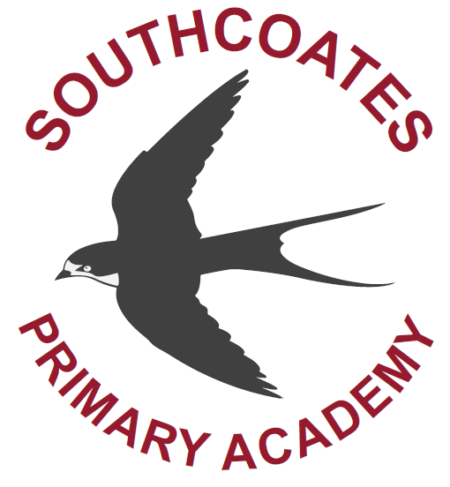



Contents:


1. The Enquire Learning Trust Visions, Values and Mission


2. Academy Information


3. EAP Programme


4. Job Advert


5. Job Description




-1-

The Enquire Learning Trust

We are a multi-academy trust currently responsible for 32 academies in four clusters across the North of England; North East Lincolnshire, Hull, Manchester, Teesside and North Yorkshire.
We work in complete collaboration with each of our academies and place a strong emphasis on school-to-school support and learning. Our academies work in collaboration with one another, sharing both their talent and ideas with others, giving employees the opportunity to learn from individuals within our other academies.
We recognise that the most important assets we have are our employees, and for our academies to succeed we need to ensure we employ the very best people in every single role. Our core values and beliefs are consistent throughout all of our academies, and our keys to success are at the heart of everything we do.
Every role across the Trust is valued, appreciated and purposeful. We believe that the outcome of every role across the Trust should improve the education each of our learners receive. Whether teaching, support or leadership, every single role is vital to the success of our academies.
We also recognise that all of our academies are different, and we encourage individuality. Whilst we believe our academies should work together to support best practice and to share ideas, we don’t believe that implementing blanket priorities and objectives is pertinent to a successful academy, and we encourage autonomy for academy leaders wherever possible.

Values
- We believe that all learners can be powerful learners given access to extraordinary learning experiences. We want children and the academies they attend to be confident, successful and ambitious.
- We envisage a Trust where well led, highly skilled and committed professionals collaborate, learn and innovate together to ensure that all academies are successful and where all learners have access to effective and innovative provision that meets their needs and aspirations.
- We want to add value to achievement and raise standards. We also want to change lives. We know this requires our provision and our practice to be world-class – because of the distance we have to travel, we understand that good will not be good enough and that we need to develop a shared appreciation of excellence and then strive to enact this every day.
- We take learning seriously and work together to create a vibrant culture in which this can happen. We know that it’s what we do that counts and that our thinking must be visible in classrooms if it is to have leverage. Children are at the forefront of all that we do and aspire to do. We take serious steps to engage them, to hear their voice in authentic ways and then to use their insight and expertise to develop radical pedagogies that tap into their passions and interests and use the potential of emergent technologies.

The Enquire Learning Trust is committed to promoting sustainability and environmental responsibility across all academies, in line with the DfE (Department for Education) Sustainability and Climate Change Strategy. We care deeply about creating school environments that positively contribute to the communities we serve. Our approach includes driving progress towards net zero carbon emissions, protecting biodiversity, and equipping our children with the knowledge and skills to build a sustainable future.

-2-
Southcoates Primary Academy

School Context and Background
Children have been learning at our school for over 100 years and Southcoates is part of the history of our community. We are proud of our history but look to the future and the part our pupils will play in it. Since joining the Enquire Learning Trust and becoming an academy in 2014 we have been able to focus on this more sharply – we want the very best for every child that enters our doors. We want to ensure they are prepared for the next step in their education and the world of work.
Southcoates Academy has high aspirations and expectations for every child, at the same time we maintain a caring family orientated culture. We work hard to meet the needs of all children. This is done by providing a calm, orderly environment in which every child is respected and valued.
We aim to help each child experience success and to reach their full potential by providing the highest standard of education and care. Our academy adopts a 'whole academy approach' to special educational needs. All staff work to ensure inclusion of all pupils. The academy is committed to ensuring that pupils with special educational needs can fulfil their potential and achieve optimal educational outcomes.
Vision Statement
Southcoates Primary Academy: Supportive, Positive, Achieving
At Southcoates Primary Academy, we deliver a bespoke curriculum that provides tailored opportunities and experiences, developing curious minds and a passion for learning.
Our immersive and thought-provoking curriculum is delivered in a safe and supportive environment which encourages every child to flourish and strive for excellence.
A collaborative approach to learning ensures that school is a nurturing place of enjoyment. Our school community work together to empower children to develop excellent learning behaviours for life.
Ofsted
Our Academy’s last Ofsted inspection/report (March 2023) validated a ‘Good’ outcome and acknowledged that ‘leaders have implemented an ambitious curriculum’ and ‘teachers use assessment effectively’. The Ofsted report also endorsed that: ‘Pupils are proud to attend Southcoates Primary Academy, ‘Staff have high expectations of pupils’, ‘Pupils feel safe in school and behave well in lessons and around school’, ‘The school works in partnership with parents and carers to the benefit of pupils in their development and learning’ and ‘Classrooms are calm environments that enable pupils, including those with special educational needs and/or disabilities, to concentrate and learn’.
Curriculum Organisation and Intent
At Southcoates Primary Academy, we have devised the SPA Curriculum: a knowledge-based curriculum in line with the knowledge promoted in the National Curriculum (both declarative and procedural). We have chosen to deliver this knowledge through a whole school themed approach:
All children from the Early Years through to Y6 study the same theme, with the knowledge taught being appropriate to their age group. Each phase has their own focus within each whole school theme, as outlined in the Long-Term Plan.
The curriculum reflects the requirements of the National Curriculum. In addition to this, we have built the SPA Curriculum around the key themes (Safe Behaviours / Positive Role Models / Awareness of the World), that we feel hold a great importance for the children of Southcoates.
Safeguarding
At Southcoates Primary Academy, ensuring the safety of children is paramount.
We do this by:
- providing a safe environment in which the children can learn
- listening to what children tell us
- identifying children who are suffering or likely to suffer significant harm and taking appropriate action with the aim of making sure that they are kept safe both at home and in the education setting.
To achieve this objective, we:
- identify instances where there are grounds for concern about a child’s welfare and initiate or take appropriate action to keep them safe.
- contribute to effective partnership working between all those involved in providing services for our children.
- aim to prevent unsuitable people from working with children.
- promote safe practice and challenge any poor or unsafe practice.

-3-

EAP Programme



The Trust offers a plan through Health Assured which provides access to valuable health and wellbeing services.​

Key Features:

- Unlimited access to 24/7 confidential telephone helpline
- Up to 10 sessions of face to face, telephone, and online counselling
- Access to the portal and wisdom app
- Coverage for spouse/partner and dependants
- Medical information line including articles, webinars, and podcasts
- Menopause Support access to other resources such as 'Menopause Matters'
- Access to Perks and Discounts
- Online and mobile access, anywhere and anytime
- Self-help guides, mood, and wellness trackers

-4-
Job Title: Premises Manager
Reference Number: ELTAPR2609
Working Hours: 37.50 hours
Working Weeks: 52
Annual Leave Entitlement: aligned to the NJC Terms and Conditions
Salary Scale Range: NJC SCP 15 to 21
Contract Type: Permanent
Start Date: 1 June 2026
Location: Southcoates Primary Academy, Southcoates Lane, HULL HU9 3TW

About us
Our academy is a 1.5-form entry school, and we currently have 331 pupils on roll; this includes 39 FTE place Nursery provision for 2-, 3- and 4-year-olds. As part of The Enquire Learning Trust, we work collaboratively with other academies and share best practice to enhance provision and transform the culture of learning and teaching.
The staff and Academy Improvement Committee are committed to ensuring that the children enjoy their learning, feel safe and are well cared for within an environment of mutual respect, where the views and opinions of the whole school community are valued.

About the role
We are looking for a motivated, enthusiastic, and organised individual to join Southcoates Primary Academy as our new Premises Manager. The role of Premises Manager is both wide-ranging and dynamic, requiring someone who can confidently embrace its complexity and thrive in a fast-paced, supportive environment.

What we are looking for
We are seeking to appoint a knowledgeable, reliable, and highly skilled Premises Manager who can work closely with the Principal, Business Manager, all stakeholders and the Multi-Academy Trust’s Estates Team, to ensure the smooth daily running of our academy. The role requires taking full responsibility for the upkeep, safety and security of the school premises, ensuring that all facilities are maintained to the highest standards. Full details of the responsibilities, duties and tasks, skills and functions are detailed in the Job Description (please see Section 5).

This is an exciting opportunity for the right person with the following qualities:
- Excellent communication and interpersonal skills with the ability to liaise confidently with staff, contractors, stakeholders and the wide school community.
- Experience of planning and coordinating maintenance, contract management and commitment to ensuring the school site is safe, secure, well-maintained and compliant with Health and Safety Regulations.
- Ability to work methodically, accurately and with attention to detail, aligned to a proactive, solution focused and positive ‘’can do’ approach.
- Shares our vision and values and is committed to achieving the very best outcomes for all children.
- Ability to contribute to a safe, inclusive environment that nurtures pupils’ social, emotional and academic development.
- Ability to demonstrates flexibility and a positive attitude in response to change.
- Ability to demonstrate initiative and a genuine passion for making a difference.

What we can offer
Membership of the East Riding Pension Scheme
Opportunities for development and progression
Employee Assistance Programme provided by Health Assured
Cycle to Work Scheme
Lifestyle savings

For more information, please contact:

Ms Kerry Storer (Academy Business Manager) either by telephoning 01482 701407 or by email admin@southcoates.hull.sch.uk

Visits to the school are warmly welcomed and can be arranged by contacting the school office.

How to apply

You can apply for this position by visiting The Enquire Learning Trust

Closing date and time: Friday 8 May 2026 at 12.00 noon
Shortlisting: Week commencing 11 May 2026
Interview Date: Week commencing 18 May 2026

DBS/Safeguarding Statement
The Enquire Learning Trust is committed to safeguarding and promoting the welfare of children, young people and vulnerable adults and expects all staff and volunteers to share this commitment. As this post involves access to children or vulnerable adults, the successful applicant will be required to obtain an Enhanced Disclosure from the DBS.

-5-
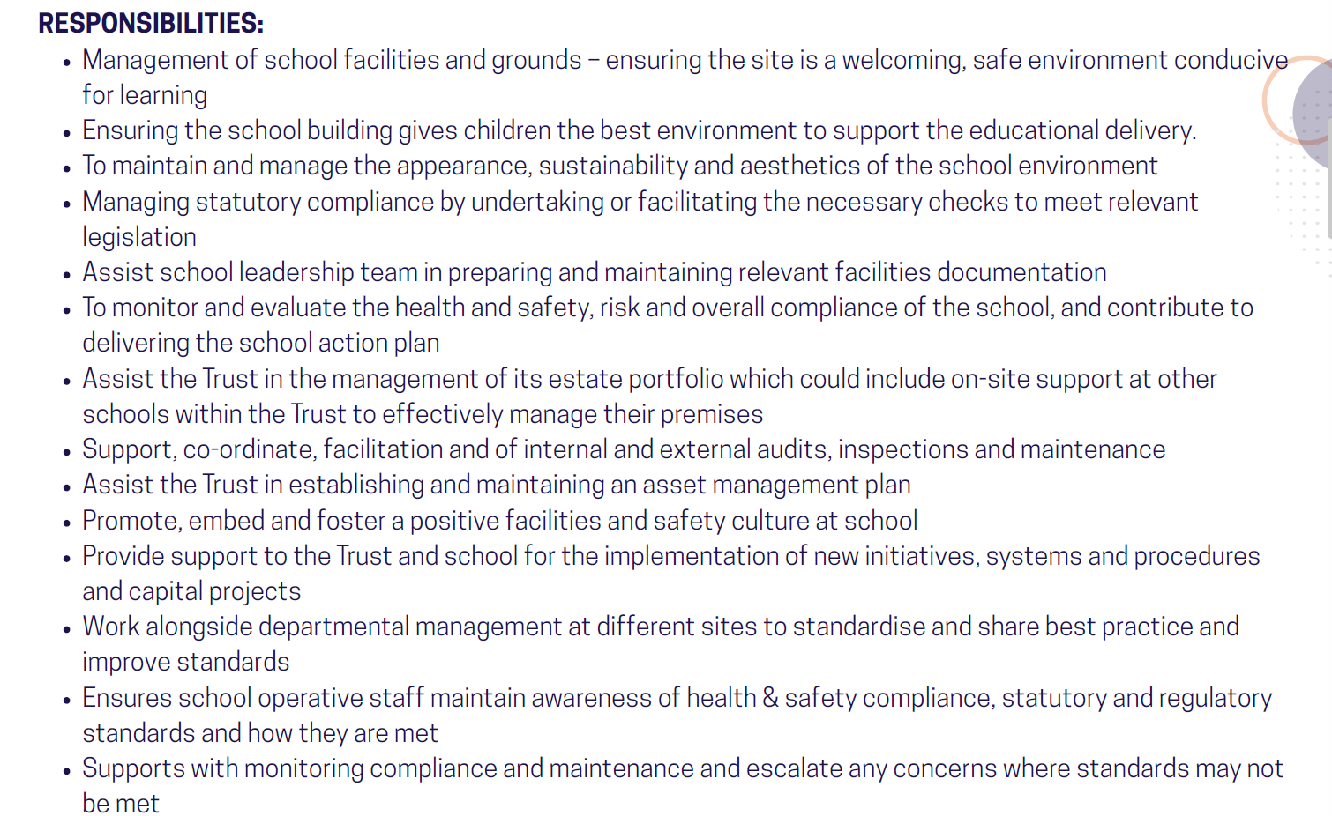
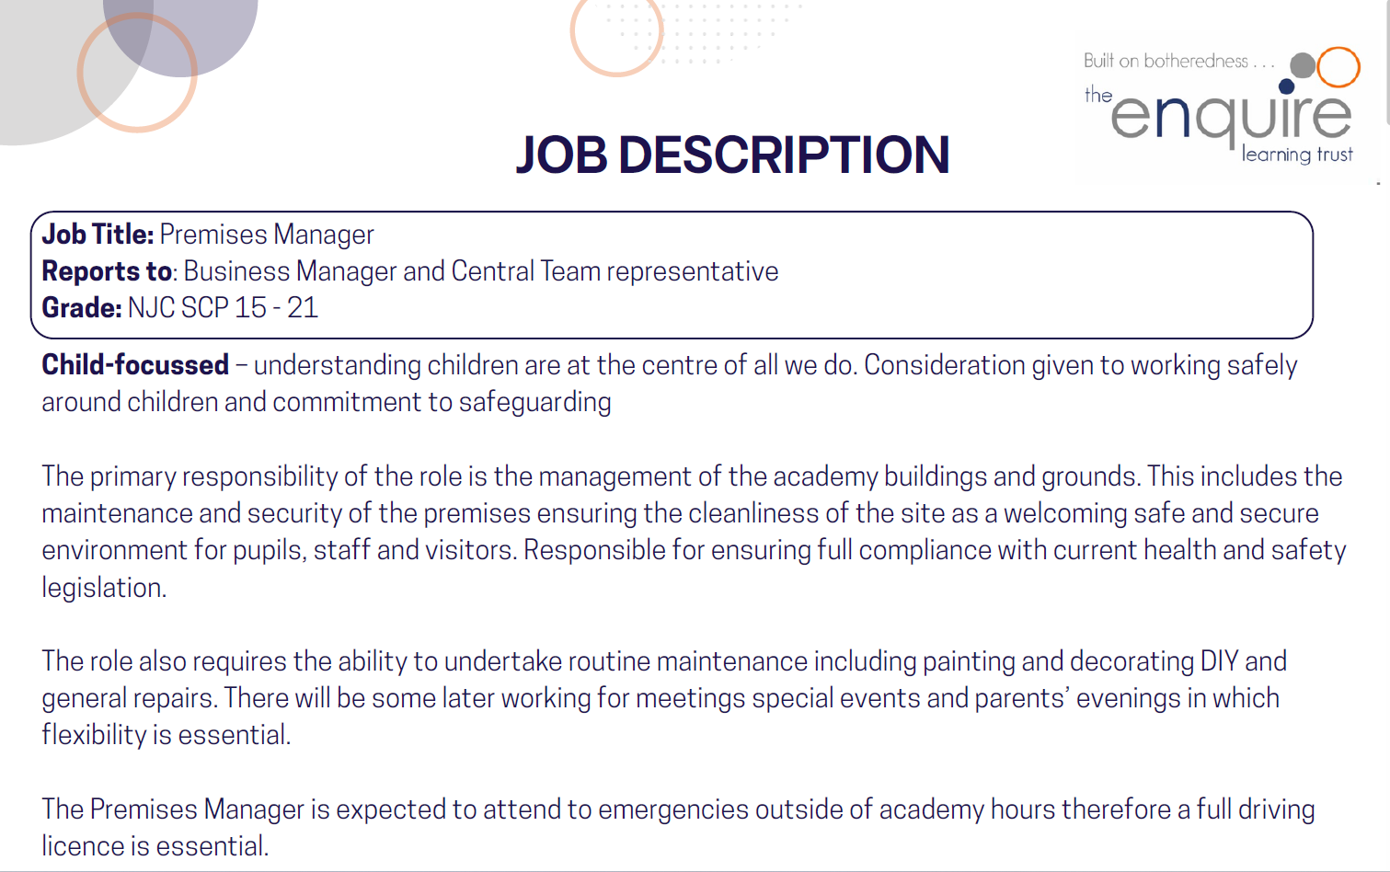

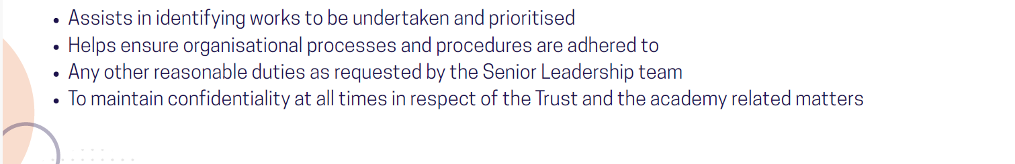

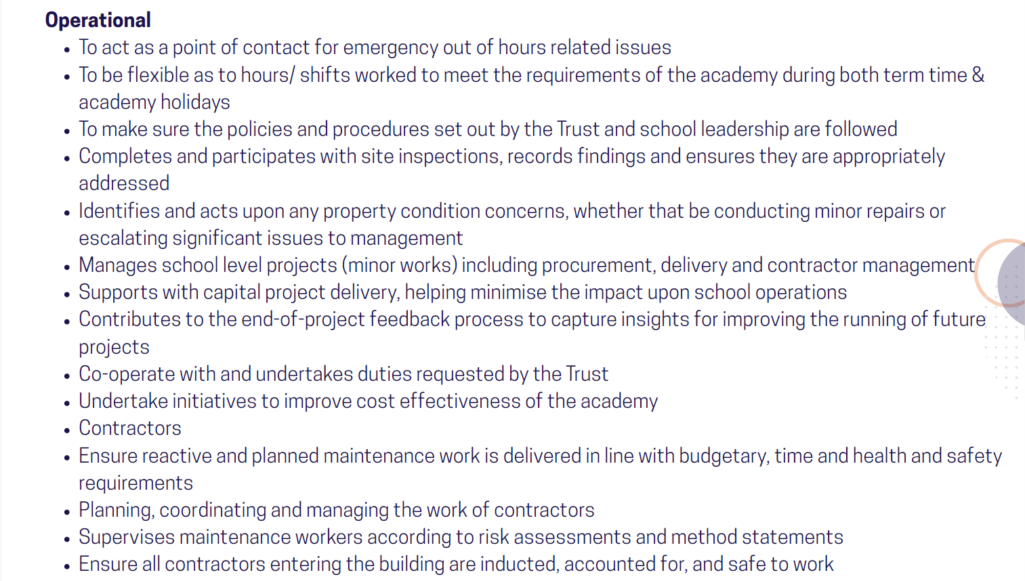
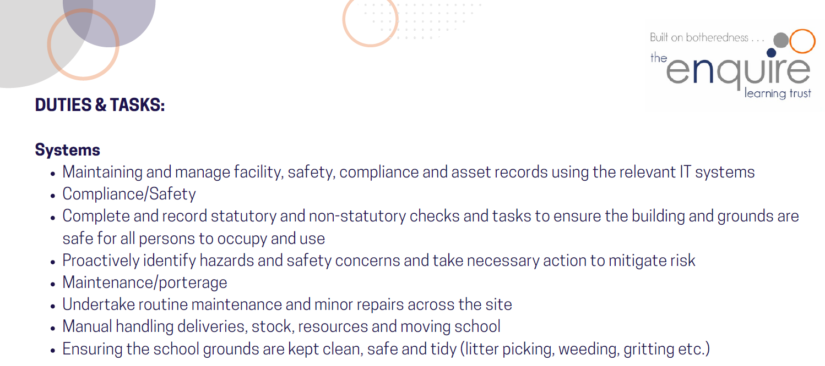

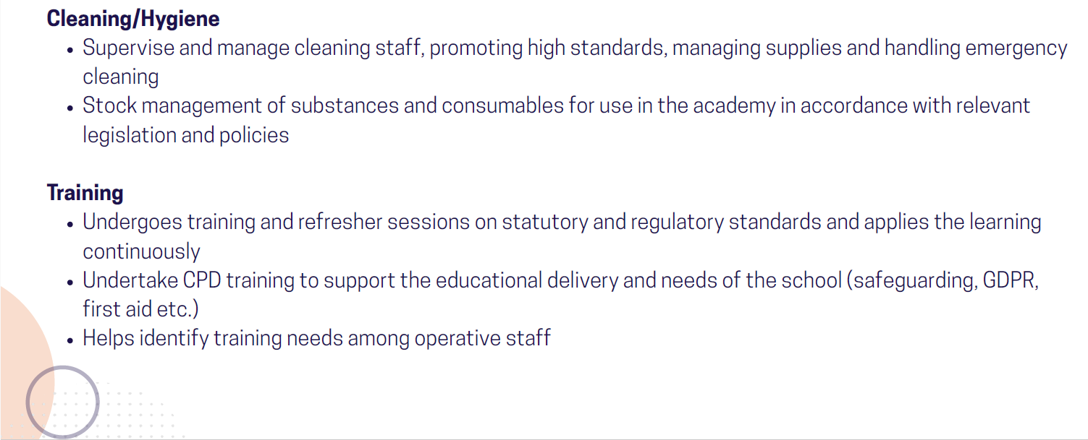
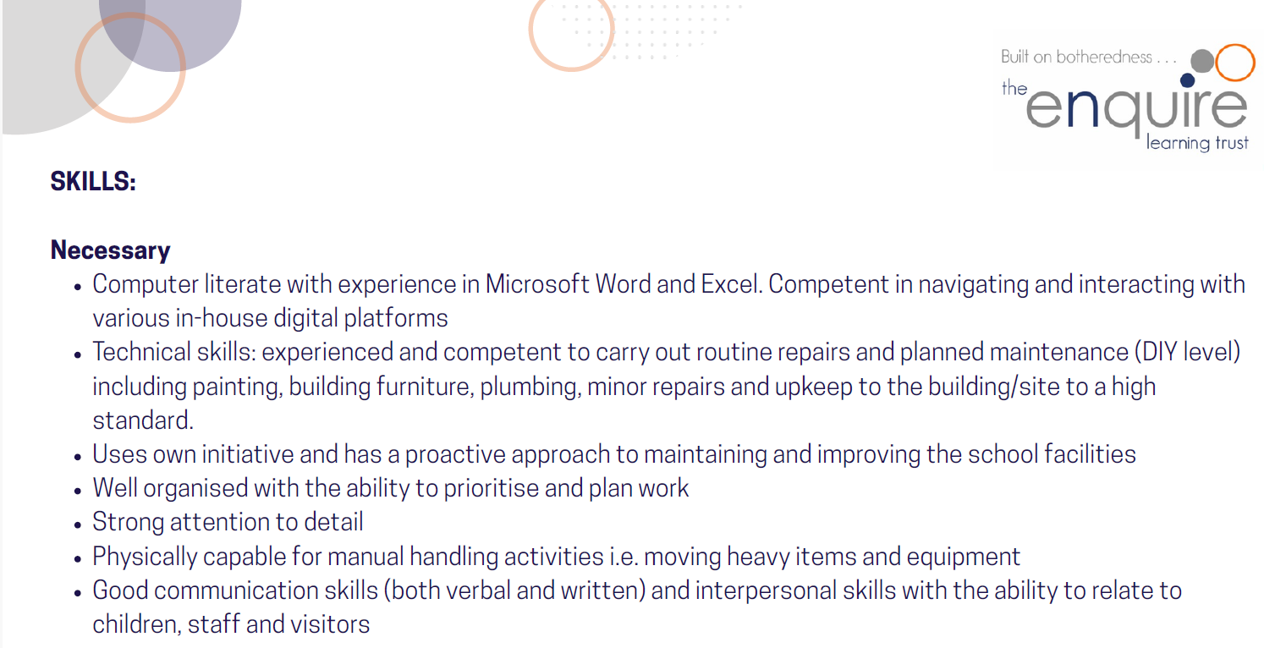
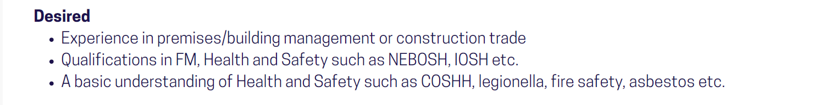
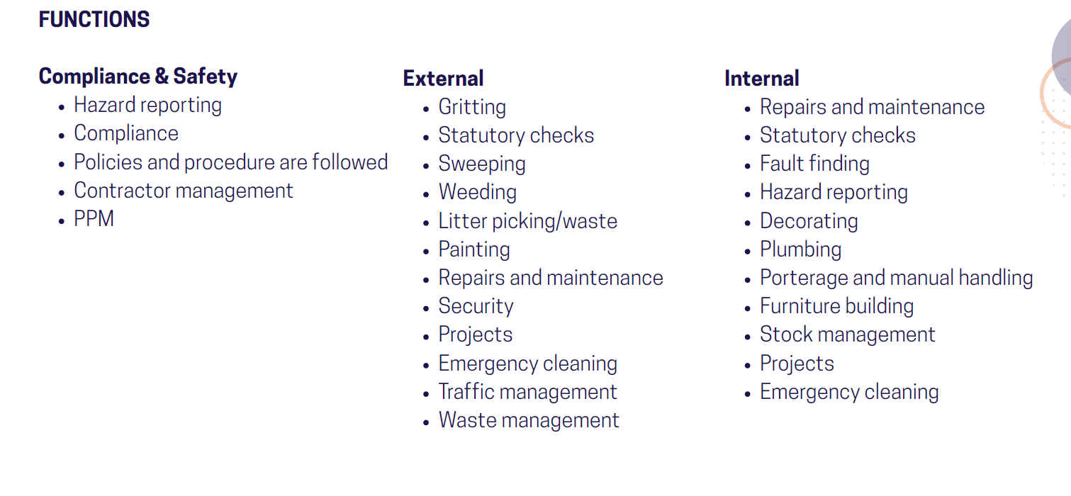

Contact Details:
Southcoates Primary Academy
Southcoates Lane
HULL
HU9 3TW
Principal: Mr T A Libera
Telephone: 01482 701407
Email: admin@southcoates.hull.sch.uk
The Enquire Learning Trust is committed to safeguarding and promoting the welfare of children and young people and expects all staff and volunteers to share this commitment. All ID and qualification checks will be made prior to appointment, as will online searches of candidates (Keeping Children Safe in Education 2023). Any offer of employment will be subject to receipt of a satisfactory Disclosure & Barring Service check and Disqualification by Association Disclosure.

DISCLOSURE AND BARRING AND RECRUITMENT CHECKS
The Trust is legally obligated to process an enhanced Disclosure and Barring Service (DBS) check before making appointments to relevant posts.
The DBS check will reveal both spent and unspent convictions, cautions, reprimands and final warnings, and any other information held by local police that is considered relevant to the role. Any information that is “protected” under the Rehabilitation of Offenders Act 1974 (Exceptions) Order 1975 will not appear on a DBS certificate.
For posts in regulated activity, the DBS check will include a barred list check.
It is an offence to seek employment in regulated activity if you are on a barred list.
We will use the DBS check to ensure we comply with the Childcare Disqualification Regulations. It is an offence to provide or manage childcare covered by these regulations if you are disqualified.
Any data processed as part of the DBS check will be processed in accordance with data protection regulations and the trusts information governance policy which can be found on the website.
Please note this post is in regulated activity and exempt from the rehabilitation of Offenders Act 1974 and subject to satisfactory references and an enhanced DBS criminal records and barred list check for work with children. An online search may be undertaken as part of the recruitment process on information available in the public domain. Candidates should disclose anything that may be relevant in line with Keeping Children Safe in Education.

Any job offer will be conditional on the satisfactory completion of the necessary pre-employment checks. Only applicants who have been shortlisted will be asked for a self-declaration of their criminal record or information that would make them unsuitable for the position. Any convictions that are self-disclosed or listed on a DBS check will be considered on a case-by-case basis.

All documentation will be treated confidentially and processed in accordance with Data Protection regulations

