

Enquire Learning Trust Application Pack

Cleaner
ELTJUN2642

Yarm Primary School
Spitalfields
Yarm
TS15 9HF



Contents:



2. Academy Information


3. EAP Programme


4. Job Advert


5. Job Description


6. Person Specification


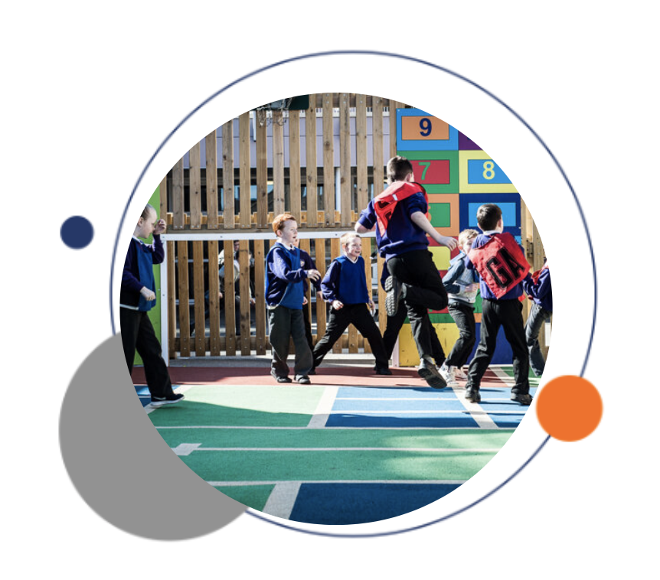

The Enquire Learning Trust

We are a multi-academy trust currently responsible for 32 academies in four clusters across the North of England; North East Lincolnshire, Hull, Manchester, Teesside and North Yorkshire.

We work in complete collaboration with each of our academies and place a strong emphasis on school-to-school support and learning. Our academies work in collaboration with one another, sharing both their talent and ideas with others, giving employees the opportunity to learn from individuals within our other academies.

We recognise that the most important assets we have are our employees, and for our academies to succeed we need to ensure we employ the very best people in every single role. Our core values and beliefs are consistent throughout all of our academies, and our keys to success are at the heart of everything we do.

Every role across the Trust is valued, appreciated and purposeful. We believe that the outcome of every role across the Trust should improve the education each of our learners receive. Whether teaching, support or leadership, every single role is vital to the success of our academies.

We also recognise that all of our academies are different, and we encourage individuality. Whilst we believe our academies should work together to support best practice and to share ideas, we don’t believe that implementing blanket priorities and objectives is pertinent to a successful academy, and we encourage autonomy for academy leaders wherever possible.

Values

- We believe that all learners can be powerful learners given access to extraordinary learning experiences. We want children and the academies they attend to be confident, successful and ambitious.
- We envisage a Trust where well led, highly skilled and committed professionals collaborate, learn and innovate together to ensure that all academies are successful and where all learners have access to effective and innovative provision that meets their needs and aspirations.
- We want to add value to achievement and raise standards. We also want to change lives. We know this requires our provision and our practice to be world-class – because of the distance we have to travel, we understand that good will not be good enough and that we need to develop a shared appreciation of excellence and then strive to enact this every day.
- We take learning seriously and work together to create a vibrant culture in which this can happen. We know that it’s what we do that counts and that our thinking must be visible in classrooms if it is to have leverage. Children are at the forefront of all that we do and aspire to do. We take serious steps to engage them, to hear their voice in authentic ways and then to use their insight and expertise to develop radical pedagogies that tap into their passions and interests and use the potential of emergent technologies.



Yarm Primary School

At Yarm Primary, the adults in school work together to secure the best.
At Yarm Primary School, we are ambitious for our pupils to be great learners who are curious, confident to take risks and rise to challenges as they develop independence.
We support and challenge our pupils to make connections across their learning experiences to broaden and deepen understanding.
We believe that we can support children in reaching their targets, whatever their personal challenges through our authentic inclusive ethos and developing dynamic curriculum.
We place emphasis on supporting and celebrating the whole child by addressing their broader needs including mental health & wellbeing and creating safe environments where risks can be taken to enhance learning.
We value community and collaboration in securing great outcomes for our children, as they are equipped for life; whatever obstacles and opportunities they meet.

‘The best that school can get!’
‘The most supportive teachers.’
‘Everyone cares about all the pupils a lot.’
‘It has built self-confidence in me.’
‘I have always enjoyed school, and now they’ve got me ready for the next level…’
Y6 ‘Leavers’

EAP Programme



The Trust offers a plan through Health Assured which provides access to valuable health and wellbeing services.​

Key Features:

- Unlimited access to 24/7 confidential telephone helpline
- Up to 10 sessions of face to face, telephone and online counselling
- Access to the portal and wisdom app
- Coverage for spouse/partner and dependants
- Medical information line including articles, webinars and podcasts
- Menopause Support access to other resources such as 'Menopause Matters'
- Access to Perks and Discounts
- Online and mobile access, anywhere and anytime
- Self-help guides, mood and wellness trackers

Cleaner
Reference Number ELTJUN2642

Working Hours: 15 per week - AM and PM hours are available
Working Weeks: Term time only plus 5 days
Salary Scale Range: NJC 3
Contract Type: Permanent
Start Date: 1st September 2026
Location: Yarm Primary School, Spitalfields, Yarm, TS15 9HF

Closing date: Monday 6th July
Interview date: Monday 13th July

PURPOSE OF JOB:
To undertake a full range of cleaning duties using domestic and industrial cleaning equipment to ensure all areas of the academy are maintained to a specified quality standard.

MAIN RESPONSIBILITIES:
Clean floor spaces in teaching, communal and office areas using appropriate techniques and equipment e.g. mops, sweeps, spray cleans, machine scrub, dry, buff and suction clean.

Clean all internal surface areas e.g. walls, windows, work surfaces and sanitary appliances using appropriate techniques, equipment and materials e.g. washing; dusting; damp wiping; polishing and cleaning.

Empty wastepaper bins and remove waste to a designated area.

Undertake other cleaning duties e.g. carpet and upholstery valeting, stain, chewing gum and graffiti removal, de-scaling sanitary appliances.

Undertake routine equipment safety checks, cleaning, maintenance and storage e.g. waste removal and filter cleaning.

Replenish sanitary and hygiene supplies e.g. soap, hand towels and toilet rolls.

Designated time to take responsibility to manage turnover of resources and stock.

Ensure that all cleaning storage areas across school are well maintained and kept clean and tidy.

Report faults, damage, breakages, vandalism or any issue that may affect or impact on routine education activity.

Maintain appropriate levels of security in all working areas to ensure confidentiality, safety and maintain site security

CONTACTS AND RELATIONSHIPS
The majority of work will be undertaken outside of classroom hours with some contact with pupils or other members of staff.

The postholder will have occasional direct and indirect contact with teaching and other support staff related to routine aspects of the work.

DECISIONS
Discretion – Most activities and tasks have well defined working practices that are undertaken within a clearly defined routine. Advice guidance and information is readily available at all times on any non-routine issues.

Consequences – Consequences of any decisions made would have a very limited impact and work output could be subject to monitoring.

RESOURCES
The postholder has responsibility for the routine cleaning and maintenance of equipment and the reporting of damage, faults or repair work.

WORK ENVIRONMENT
Work Demands – Work tasks usually remain consistent but may be subject to emergency or occasional variation.

Physical Demands –Walking, bending, stretching and lifting to undertake the cleaning tasks described will form a significant part of the job.

Working Conditions – The majority of work is undertaken indoors except for the carrying of rubbish to disposal point. The post will involve some exposure to disagreeable conditions e.g. toilet cleaning, cleaning up after sickness or accident and maintenance of equipment.
Work Context – Work involves some contact with pupils. The postholder uses various cleaning materials and chemicals in accordance with the Trust’s Health & Safety standards and procedures.

KNOWLEDGE AND SKILLS
Ability to use, clean and maintain a full range of industrial and domestic cleaning equipment and materials.

Good understanding of the operational practices and working methods and work schedules involved.

Understanding and awareness of the related Health & Safety issues associated with cleaning materials, equipment and premises.

Basic communication skills.

Ability to maintain appropriate levels of security in all working areas.

GENERAL
  - Other Duties - The duties and responsibilities in this job description are not restrictive and the postholder may be required to undertake any other duties which may be required from time to time. Any such duties should not however substantially change the general character of the post.

  - Equal Opportunities - The postholder must carry out his / her duties with full regard to the Trust’s Equal Opportunities policy.

  - Health and Safety - The postholder must carry out his / her duties with full regard to the Trust’s Health and Safety Procedures.

PERSON SPECIFICATION

SCHOOL CLEANER

 | Essential | Desirable
Experience of cleaning work |  | 
Working in an educational environment
Use practical skills to improve site and buildings
Deal with emergencies and situations in a positive and systematic manner
Work alone and achieve productive outcomes
Reduce risk
Develop more effective and efficient ways of working
Communicate effectively with school users at all levels and achieve productive outcomes
Read safety instructions and measure accurately
Understand importance of Health and Safety
Knowledge of COSHH requirements
Ability to follow school procedures
Flexibility to meet changing needs of school
Positive references regarding honesty & reliability

Training in specific areas will be provided

For Information:

Essential Requirement - without which the candidate would be unable to carry out the duties of the post.

Desirable Features - which would normally enable the successful candidate to perform the duties and tasks better and more efficiently than one who did not have the qualifications, training, experience, etc.

Yarm Primary School
Spitalfields, Yarm, TS15 9HF

Principal: Jill Wood

Telephone: 01642 782731
Email: yarm@yarmprimary.org.uk

The Enquire Learning Trust is committed to safeguarding and promoting the welfare of children and young people and expects all staff and volunteers to share this commitment. All ID and qualification checks will be made prior to appointment, as will online searches of candidates (Keeping Children Safe in Education 2023). Any offer of employment will be subject to receipt of a satisfactory Disclosure & Barring Service check and Disqualification by Association Disclosure.

DISCLOSURE AND BARRING AND RECRUITMENT CHECKS
The Trust is legally obligated to process an enhanced Disclosure and Barring Service (DBS) check before making appointments to relevant posts.
The DBS check will reveal both spent and unspent convictions, cautions, reprimands and final warnings, and any other information held by local police that’s considered relevant to the role. Any information that is “protected” under the Rehabilitation of Offenders Act 1974 (Exceptions) Order 1975 will not appear on a DBS certificate.
For posts in regulated activity, the DBS check will include a barred list check.
It is an offence to seek employment in regulated activity if you are on a barred list.
We’ll use the DBS check to ensure we comply with the Childcare Disqualification Regulations. It is an offence to provide or manage childcare covered by these regulations if you are disqualified.
Any data processed as part of the DBS check will be processed in accordance with data protection regulations and the trusts information governance policy which can be found on the website.
Please note this post is in regulated activity and exempt from the rehabilitation of Offenders Act 1974 and subject to satisfactory references and an enhanced DBS criminal records and barred list check for work with children. An online search may be undertaken as part of the recruitment process on information available in the public domain. Candidates should disclose anything that may be relevant in line with Keeping Children Safe in Education.

Any job offer will be conditional on the satisfactory completion of the necessary pre-employment checks. Only applicants who have been shortlisted will be asked for a self-declaration of their criminal record or information that would make them unsuitable for the position. Any convictions that are self-disclosed or listed on a DBS check will be considered on a case-by-case basis.

All documentation will be treated confidentially and processed in accordance with Data Protection regulations

