

Enquire Learning Trust Application Pack

Teaching Assistant 2 yr old Provision

High Clarence Primary Academy
Port Clarence Road
TS2 1SY

Reference: ELTJUL2610



Contents:

1. The Enquire Learning Trust Visions, Values and Mission


2. Academy Information


3. EAP Programme


4. Job Advert


5. Job Description


6. Person Specification

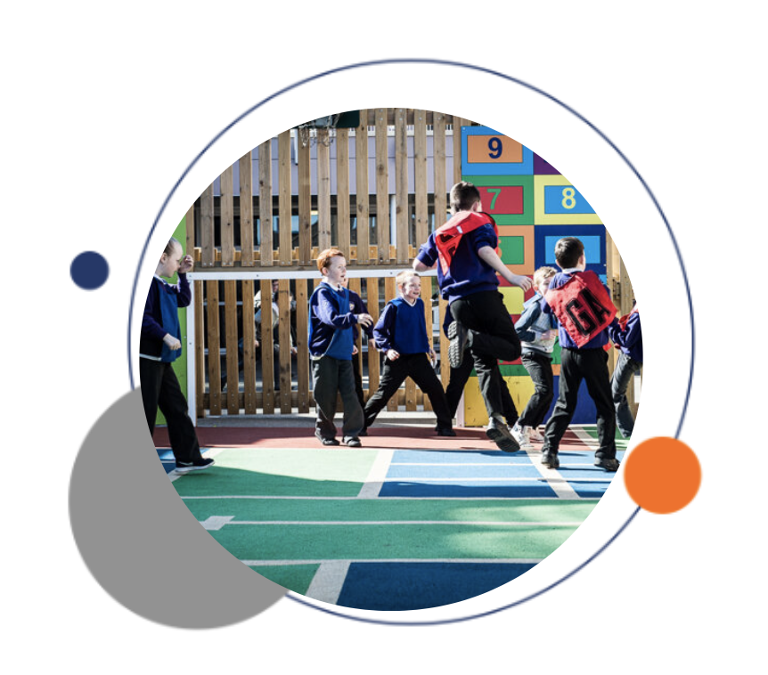


The Enquire Learning Trust

We are a multi-academy trust currently responsible for 32 academies in four clusters across the North of England; North East Lincolnshire, Hull, Manchester, Teesside and North Yorkshire.

We work in complete collaboration with each of our academies and place a strong emphasis on school-to-school support and learning. Our academies work in collaboration with one another, sharing both their talent and ideas with others, giving employees the opportunity to learn from individuals within our other academies.

We recognise that the most important assets we have are our employees, and for our academies to succeed we need to ensure we employ the very best people in every single role. Our core values and beliefs are consistent throughout all of our academies, and our keys to success are at the heart of everything we do.

Every role across the Trust is valued, appreciated and purposeful. We believe that the outcome of every role across the Trust should improve the education each of our learners receive. Whether teaching, support or leadership, every single role is vital to the success of our academies.

We also recognise that all of our academies are different, and we encourage individuality. Whilst we believe our academies should work together to support best practice and to share ideas, we don’t believe that implementing blanket priorities and objectives is pertinent to a successful academy, and we encourage autonomy for academy leaders wherever possible.

Values

- We believe that all learners can be powerful learners given access to extraordinary learning experiences. We want children and the academies they attend to be confident, successful and ambitious.
- We envisage a Trust where well led, highly skilled and committed professionals collaborate, learn and innovate together to ensure that all academies are successful and where all learners have access to effective and innovative provision that meets their needs and aspirations.
- We want to add value to achievement and raise standards. We also want to change lives. We know this requires our provision and our practice to be world-class – because of the distance we have to travel, we understand that good will not be good enough and that we need to develop a shared appreciation of excellence and then strive to enact this every day.
- We take learning seriously and work together to create a vibrant culture in which this can happen. We know that it’s what we do that counts and that our thinking must be visible in classrooms if it is to have leverage. Children are at the forefront of all that we do and aspire to do. We take serious steps to engage them, to hear their voice in authentic ways and then to use their insight and expertise to develop radical pedagogies that tap into their passions and interests and use the potential of emergent technologies.

High Clarence is a small primary school situated in Port Clarence, Stockton.
Our school values are at the heart of our school; Happiness, Ambition, Resilience, Healthiness and Respect and they are reflected in all that we do.
High Clarence is a great place to work. Staff wellbeing isn’t a token gesture at High Clarence – taking care of each other is who we are. And, as part of the Enquire Learning Trust, we offer exceptional professional development opportunities and effective partnership working.
Our aim is that High Clarence Academy is a safe and nurturing place, where all children, staff and visitors feel welcome and valued and believe that together we can achieve anything. Children learn best when they are happy and confident and we want every child to achieve the very best they can. We encourage them to challenge themselves and to be proud of all their achievements.
We offer a personalised approach to teaching and learning. Our curriculum is engaging and exciting. It is designed to interest the children and meet their needs so that all children are keen to come to school and keen to learn.
We know that children learn best when parents and school work closely together and we value your support to ensure every child has the very best opportunity to succeed. We look forward to working with you.
The Academy will endeavour to raise the achievement and aspirations of every child through our 5 school values.
Happiness: We have a strong emphasis on happiness in school and this is encouraged at a personal, class, school and community level.
Ambition: We have the highest expectations of ourselves and others, and foster self-belief and pride in our community.
Resilience: Children’s resilience and hunger for learning leads to celebrated success.
Healthiness: We show positive attitudes towards mental health, thinking positively and staying healthy. Fitness is not only physical health, but also mental health.
Respect: We are polite, kind, tolerant of others and show empathy for all members of the community.
School works with the community in order to help children and their families encompass the values of spiritual, social, moral and cultural development. Through ensuring effective teaching of SMSC, school will actively promote the fundamental British values of democracy, the rule of law, individual liberty, mutual respect of and tolerance of different faiths, cultures and beliefs, including those of no faith.
Safeguarding is a strong feature in school and ensures everybody works together for the well-being of the children and their families.
Our future lies in our youth; in nurturing an educated, engaged, caring and empowered generation of young people.

EAP Programme



The Trust offers a plan through Health Assured which provides access to valuable health and wellbeing services.​

Key Features:

- Unlimited access to 24/7 confidential telephone helpline
- Up to 10 sessions of face to face, telephone and online counselling
- Access to the portal and wisdom app
- Coverage for spouse/partner and dependants
- Medical information line including articles, webinars and podcasts
- Menopause Support access to other resources such as 'Menopause Matters'
- Access to Perks and Discounts
- Online and mobile access, anywhere and anytime
- Self-help guides, mood and wellness trackers

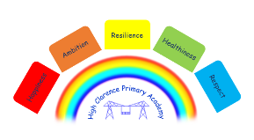


High Clarence Academy
Two Year old Provision Level 3 Teaching Assistant
Reference: ELTJUL2610
Job Categories: | Teaching Assistant Level 3
Job Type: | Permanent
Salary: | Grade NJC 12 £11,515.59 TTO+2 days
Hours: | 17.5 Hours per week
Start Date: | September 2026

About us
High Clarence Academy is a small primary school situated in Port Clarence, Stockton.
Our school values are at the heart of our school; Happiness, Ambition, Resilience, Healthiness and Respect and they are reflected in all that we do.
High Clarence is a great place to work. Staff wellbeing isn’t a token gesture at High Clarence – taking care of each other is who we are. And, as part of the Enquire Learning Trust, we offer exceptional professional development opportunities and effective partnership working.

About the role
We are seeking a suitably qualified and experienced Teaching Assistant to join our friendly, supportive, and caring Early Years team. The successful candidate will lead our morning Two-Year-Old Provision, working with up to five children each day in a nurturing and stimulating environment.
The role involves supporting young children to learn and develop through play, exploration, and positive interactions, helping them to build confidence, independence, and key early learning skills. Working closely with colleagues and families, you will contribute to providing high-quality early years education and care that meets the individual needs of every child.
This is an excellent opportunity for someone who is passionate about early childhood development and committed to creating engaging learning experiences for our youngest learners.

What we are looking for
The successful applicant will be reliable, adaptable and enthusiastic, with a positive attitude and the ability to engage actively in a wide range of activities. They will demonstrate initiative, be well organised, and have a genuine passion for supporting young children in their learning and development.
We are seeking to appoint a highly motivated and energetic professional who:

- Holds a Level 3 Early Years qualification.
- Has successful experience of working in an Early Years setting.
- Has experience of supporting children with Special Educational Needs and Disabilities (SEND).
- Is committed to working collaboratively as part of a team.
- Is caring, compassionate and dedicated to making a positive difference to children's lives.
- Is highly organised and proactive in their approach to work.
- Has excellent communication and interpersonal skills.
- Is committed to providing a safe, nurturing and inclusive learning environment where every child can thrive.
What we can offer
Membership of – Tyne and Wear Pension Fund in partnership with Teesside Pension Fund
Opportunities for development and progression
Employee Assistance Programme provided by Health Assured
Cycle to Work Scheme
Lifestyle savings

Working arrangements

8.30 a.m. – 12 midday Monday to Friday
For more information, please contact (Sue Wastell, Academy Business Manager, s.wastell@highclarenceacademy.org 01642 561237

Visits to school are welcome please contact the school office on 01642 561237 to arrange.

How to apply

You can apply for this position by visiting The Enquire Learning Trust

Closing date and time: Wednesday, 22nd July 2026
Interview Date: Thursday, 23rd July 2026

DBS/Safeguarding Statement
The Enquire Learning Trust is committed to safeguarding and promoting the welfare of children, young people and vulnerable adults and expects all staff and volunteers to share this commitment. As this post involves access to children or vulnerable adults, the successful applicant will be required to obtain an Enhanced Disclosure from the DBS

JOB DESCRIPTION

SCHOOL: High Clarence Primary Academy

POST TITLE: Two Year Old Provision Teaching Assistant Level 3

GRADE: NJC 12

HOURS: 17.5 hrs Per week Mon-Friday

REPORTS TO: EYFS Team Leader

Purpose of the Post:

To lead the day-to-day running of the two-year-old provision within the academy, under the guidance of the EYFS leader. This includes ensuring the environment is stimulating, inviting and safe, and being a role model for other staff in the setting.

Duties and Responsibilities:

1. Assist and deliver learning programmes in context of the Statutory Framework for the Early Years Foundation Stage, ensuring standards of safe practice and confidentiality by developing a high quality, consistent service that enables every child to make progress and supports them to learn, develop and be healthy and safe.

2. As part of the key worker role, provide a secure foundation, delivering a challenging learning and development opportunities that are planned around the needs and interests of each individual child, including children with diverse and complex needs and are reviewed and assessed regularly to measure progression.

3. Work in partnership with parents, carers, other settings, colleagues and partner agencies to identify areas of need, including the Early Help Strategy, signpost/refer to supportive services and engage families in their children’s learning and development, ensuring the sharing of information.

4. Ensure that the environment promotes and provides equality of opportunity, reflects diversity and supports anti-discriminatory practice to meet the needs of all children and their families, ensuring they are included and supported.

5. Follow the academy policies and procedures to ensure highest standards of safe practice and confidentiality, in accordance with Safeguarding Children guidelines and procedures for working together.

6. To ensure standards are maintained, which include health and safety, hygiene and general cleanliness of room and equipment.

7. In relation to children’s learning, seek-out and maintain appropriate training.

8. To attend, participate and contribute to regular staff meetings, training, supervisions and appraisals.

The post holder may reasonably be expected to undertake other duties commensurate with the level of responsibility that may be allocated from time to time.

PERSON SPECIFICATION

SCHOOL: High Clarence Primary Academy

POST TITLE: Teaching Assistant Level 3 – Two Year Old Provision Lead

GRADE: NJC 12

 | Essential | Desirable
QUALIFICATIONS/  TRAINING: | - NVQ Level 3 or equivalent qualification in relevant discipline OR appropriate experience, preferably as a Teaching Assistant  - Willingness to participate in relevant training and development opportunities  - Paediatric First Aid training or willingness to undertake this when provided by the academy. | - Basic Food Hygiene certificate
EXPERIENCE: | - Recent and relevant experience of working with two-year-old children within an EYFS setting.  - Experience of working within the EYFS statutory framework. | - Experience in different EYFS settings.
SKILLS/  KNOWLEDGE: | - Good knowledge of child development to support children’s learning, development and care.  - Understanding of key worker systems and record keeping.  - Ability to relate well to children and adults  - Ability to work effectively within a team environment, understanding classroom roles and responsibilities  - Ability to build effective working relationships with all pupils and colleagues  - Ability to promote a positive ethos and role model positive attributes  - Ability to work with children at all levels regardless of specific individual need and identify learning styles as appropriate  - Ability to adapt own approach in accordance with pupils needs  - Experience of resources preparation to support learning programmes  - Excellent communication and listening skills  - Be able to maintain confidentiality  - The ability to manage behaviour of children in a positive and supportive manner  - Knowledge of safeguarding and Keeping Children Safe in Education. | - Equal Opportunities and recognising the nature of the diverse school community  - Understanding of basic technology – computer, video, photocopier etc  - Working knowledge of relevant policies/codes of practice/legislation
PERSONAL AND PROFESSIONAL ATTRIBUTES: | - Flexible  - Calm, friendly, approachable and professional manner  - A commitment to working as part of the whole school team and supporting the vision and aims of the school  - High expectations of all pupils; respect for their social, cultural, linguistic, religious and ethnic backgrounds; and commitment to raising their educational achievements  - Ability to build and maintain successful relationships with pupils; treat them consistently, with respect and consideration, and demonstrate concern for their development as learners  - Demonstrate and promote the positive value, attitudes and behaviour they expect from the pupils with whom they work  - Ability to liaise sensitively and effectively with parent and carers, recognising their role in pupils learning  - Able to improve their own practice through observations, evaluation and discussion with colleagues.

Contact Details:
High Clarence Primary
Port Clarence Road
Middlesbrough
TS2 1SY

Principal: Mrs Nicola Caraher
email: highclarence@highclarenceacademy.org

Telephone: 01642 561237

The Enquire Learning Trust is committed to safeguarding and promoting the welfare of children and young people and expects all staff and volunteers to share this commitment. All ID and qualification checks will be made prior to appointment, as will online searches of candidates (Keeping Children Safe in Education 2023). Any offer of employment will be subject to receipt of a satisfactory Disclosure & Barring Service check and Disqualification by Association Disclosure.

DISCLOSURE AND BARRING AND RECRUITMENT CHECKS
The Trust is legally obligated to process an enhanced Disclosure and Barring Service (DBS) check before making appointments to relevant posts.
The DBS check will reveal both spent and unspent convictions, cautions, reprimands and final warnings, and any other information held by local police that’s considered relevant to the role. Any information that is “protected” under the Rehabilitation of Offenders Act 1974 (Exceptions) Order 1975 will not appear on a DBS certificate.
For posts in regulated activity, the DBS check will include a barred list check.
It is an offence to seek employment in regulated activity if you are on a barred list.We’ll use the DBS check to ensure we comply with the Childcare Disqualification Regulations. It is an offence to provide or manage childcare covered by these regulations if you are disqualified.Any data processed as part of the DBS check will be processed in accordance with data protection regulations and the trusts information governance policy which can be found on the website.
Please note this post is in regulated activity and exempt from the rehabilitation of Offenders Act 1974 and subject to satisfactory references and an enhanced DBS criminal records and barred list check for work with children. An online search may be undertaken as part of the recruitment process on information available in the public domain. Candidates should disclose anything that may be relevant in line with Keeping Children Safe in Education.

Any job offer will be conditional on the satisfactory completion of the necessary pre-employment checks. Only applicants who have been shortlisted will be asked for a self-declaration of their criminal record or information that would make them unsuitable for the position. Any convictions that are self-disclosed or listed on a DBS check will be considered on a case-by-case basis.

All documentation will be treated confidentially and processed in accordance with Data Protection regulations.

