

Enquire Learning Trust Application Pack

Dowson’s Den Care Club Assistant

Reference Number: ELTJUN2634

Dowson Primary Academy
Marlborough Road, Gee Cross
SK14 5HU
0161 366 0177



Contents:



2. Academy Information


3. EAP Programme


4. Job Advert


5. Job Description


6. Person Specification




The Enquire Learning Trust

We are a multi-academy trust currently responsible for 32 academies in four clusters across the North of England; North East Lincolnshire, Hull, Manchester, Teesside and North Yorkshire.

We work in complete collaboration with each of our academies and place a strong emphasis on school-to-school support and learning. Our academies work in collaboration with one another, sharing both their talent and ideas with others, giving employees the opportunity to learn from individuals within our other academies.

We recognise that the most important assets we have are our employees, and for our academies to succeed we need to ensure we employ the very best people in every single role. Our core values and beliefs are consistent throughout all of our academies, and our keys to success are at the heart of everything we do.

Every role across the Trust is valued, appreciated and purposeful. We believe that the outcome of every role across the Trust should improve the education each of our learners receive. Whether teaching, support or leadership, every single role is vital to the success of our academies.

We also recognise that all of our academies are different, and we encourage individuality. Whilst we believe our academies should work together to support best practice and to share ideas, we don’t believe that implementing blanket priorities and objectives is pertinent to a successful academy, and we encourage autonomy for academy leaders wherever possible.

Values

- We believe that all learners can be powerful learners given access to extraordinary learning experiences. We want children and the academies they attend to be confident, successful and ambitious.
- We envisage a Trust where well led, highly skilled and committed professionals collaborate, learn and innovate together to ensure that all academies are successful and where all learners have access to effective and innovative provision that meets their needs and aspirations.
- We want to add value to achievement and raise standards. We also want to change lives. We know this requires our provision and our practice to be world-class – because of the distance we have to travel, we understand that good will not be good enough and that we need to develop a shared appreciation of excellence and then strive to enact this every day.
- We take learning seriously and work together to create a vibrant culture in which this can happen. We know that it’s what we do that counts and that our thinking must be visible in classrooms if it is to have leverage. Children are at the forefront of all that we do and aspire to do. We take serious steps to engage them, to hear their voice in authentic ways and then to use their insight and expertise to develop radical pedagogies that tap into their passions and interests and use the potential of emergent technologies.

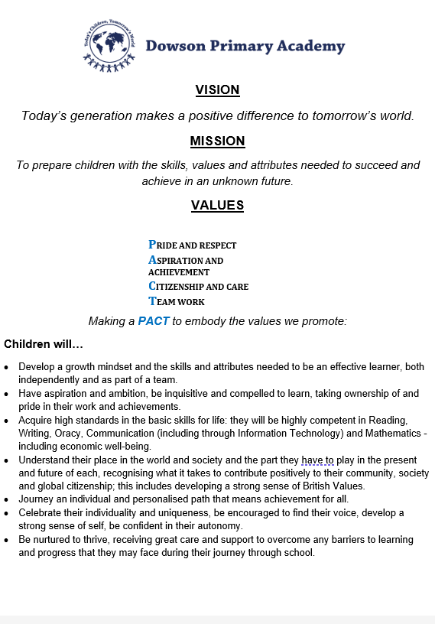

EAP Programme



The Trust offers a plan through Health Assured which provides access to valuable health and wellbeing services.​

Key Features:

- Unlimited access to 24/7 confidential telephone helpline
- Up to 10 sessions of face to face, telephone and online counselling
- Access to the portal and wisdom app
- Coverage for spouse/partner and dependants
- Medical information line including articles, webinars and podcasts
- Menopause Support access to other resources such as 'Menopause Matters'
- Access to Perks and Discounts
- Online and mobile access, anywhere and anytime
- Self-help guides, mood and wellness trackers

Dowson’s Den Care Club Assistant
Reference Number: ELTJUN2634

Working Hours: 28
Working Weeks: 52
Salary Scale Range: NJC SCP 3-4
Contract Type: Permanent
Start Date: ASAP
Location: Dowson Primary Academy, Marlborough Road, Gee Cross, SK14 5HU

About us
Dowson is a friendly, happy, 2 form entry Primary School spread across a three-building site with wonderful grounds and resources to offer. We are fully extended and run our own Before and After School and Holiday Club. The successful candidate would be joining a large staff team with a mix of skills and experience, which values flexibility, teamwork and a good sense of humour.

About the role
Dowson Primary Academy requires a Dowson’s Den Assistant to commence work as soon as possible.

You will be responsible to the Academy Business Manager and Team Leader and be required to work within a team to provide structured and fun activities and nurturing of our children within the Extended school provision, which encompasses breakfast club, after school club, holiday club, wrap around care and parent & toddler group.
What we can offer
Membership of GMPF Pension Scheme
Opportunities for development and progression
Employee Assistance Programme provided by Health Assured
Cycle to Work Scheme
Lifestyle savings

Working arrangements
The hours are an average over the year with term time hours being lower and holiday time hours being higher. The hours are not set, they are on a rota basis.

For more information, please contact Nicola Lane (Academy Business Manager)
0161 366 0177 / n.lane@dowsonprimary.com

Details of visits to school are welcome please contact the school office.
How to apply
You can apply for this position by visiting The Enquire Learning Trust

Closing date and time: Monday 13th July - Midday
Interview Date: Wednesday 15th July Time TBC
DBS/Safeguarding Statement
The Enquire Learning Trust is committed to safeguarding and promoting the welfare of children, young people and vulnerable adults and expects all staff and volunteers to share this commitment. As this post involves access to children or vulnerable adults, the successful applicant will be required to obtain an Enhanced Disclosure from the DBS

POSITION: | Dowson’s Den Care Club Assistant
REPORTS TO: | Business Manager
GRADE: | NJC 3 – 4
HOURS: | Average of 28 hours per week  (rota annual hours 1456)

Key Role/Functions

The fundamental part of the role will be providing care and nurture to the children who attend Dowson’s Den extended care provision and wrap around care. The role will also involve building relationships with the community and playing a role in the extended school provision of parent and toddler.

You must be willing to work as part of an excellent team on a rota basis. You will be contracted for an average of 28 hours per week, 1456 hours per annum. This is usually operated by working below the 28 hours during term time and above in the holidays, however the annual hours will equate to 28 hours per week.

You will be responsible for record keeping, communicating with staff and parents and must possess a minimum of level 2 childcare qualifications and basic ICT skills.

Specific Duties and Responsibilities
- To adhere to the club’s policies, procedures, aims and objectives.
- To be involved in supporting the team leader with a programme of activities.
- To provide safe, creating and appropriate play activities.
- To work as part of a team, supporting one another at all times.
- To undertake relevant training as deemed necessary.
- To build strong parental engagement and be a friendly and approachable staff member at all times.
- To provide full care for the children including school drop off and collection.
- To be willing to undertake food hygiene training in order that the planned snacks can be prepared for the children.
- To administer first aid and communicate in line with procedures with parents and other staff members as necessary.
- To promote the development of opportunities to further out of school care for children locally.

Customer care
- To treat pupils, parents, staff, visitors and contractors with care, consideration and courtesy in accordance with the academy’s ethos and values.

- To help support the promotion of parental engagement of the extended school provision in order to support the team leader and Academy business manager in growing the club.

- To present high standards of personal appearance in accordance with the academy’s ethos and values.

- To promote a favourable image of the Trust and the academy to all users of Dowson’s Den care provision

Other
- To maintain confidentiality at all times in respect of the Trust and the academy related matters.

- To be flexible as to hours/ shifts worked to meet the requirements of the academy during both term time & academy holidays.

- Any other reasonable duties as directed by the Team Leader, Business Manager, Head of Academy and Senior Leadership team.



POST TITLE: Dowson’s Den Assistant
PERSON SPECIFICATION

MINIMUM ESSENTIAL REQUIREMENTS | METHOD OF ASSESSMENT
Qualifications and Experience
- 5 GCSE passes/ NVQ Certificates  - Minimum Level 2 childcare qualification  - First Aid qualification | D  E  D | A/C  A/C  A/C
Skills and Knowledge
- Strong organisational and time management skills and ability to cope with conflicting demands  - Commitment to high standards of care  - Ability to work as part of a team  - Ability to motivate others and ensure priorities are met  - Ability to respond calmly to emergencies  - Able to use initiative and work pro-actively to solve problems | E  E  E  D  E  E | A/I  A/I  A/I  A/I  A/I  A/I
Personal Characteristics
- Ability to respond to advice and guidelines and to follow set procedures  - Desire and willingness to learn new skills  - Clean and well presented  - Calm & pleasant manner, and sense of humour  - Trustworthy, reliable and punctual  - Observe confidences and show discretion | E  E  E  E  E  E | A/I  A/I  A/I  A/I  A/I  A/I
Other
- Willingness to sometimes adjust working arrangements to meet changed circumstances | E | A/I

E = Essential D = Desirable
A = Application I = Interview C = Certificate

Dowson Primary Academy is committed to safeguarding and promoting the welfare of children and young people and expects all staff to share this commitment. Any offer of employment will be subjected to receipt of a satisfactory enhanced disclosure from the Disclosure Barring Service.

Contact Details:

School Name : Dowson Primary Academy
Marlborough Road, Gee Cross, Hyde, SK14 5HU

Principal: Mrs K Thornburn

Telephone: 0161 366 0177
Email: n.lane@dowsonprimary.com

The Enquire Learning Trust is committed to safeguarding and promoting the welfare of children and young people and expects all staff and volunteers to share this commitment. All ID and qualification checks will be made prior to appointment, as will online searches of candidates (Keeping Children Safe in Education 2023). Any offer of employment will be subject to receipt of a satisfactory Disclosure & Barring Service check and Disqualification by Association Disclosure.

DISCLOSURE AND BARRING AND RECRUITMENT CHECKS
The Trust is legally obligated to process an enhanced Disclosure and Barring Service (DBS) check before making appointments to relevant posts.
The DBS check will reveal both spent and unspent convictions, cautions, reprimands and final warnings, and any other information held by local police that’s considered relevant to the role. Any information that is “protected” under the Rehabilitation of Offenders Act 1974 (Exceptions) Order 1975 will not appear on a DBS certificate.
For posts in regulated activity, the DBS check will include a barred list check.
It is an offence to seek employment in regulated activity if you are on a barred list.
We’ll use the DBS check to ensure we comply with the Childcare Disqualification Regulations. It is an offence to provide or manage childcare covered by these regulations if you are disqualified.
Any data processed as part of the DBS check will be processed in accordance with data protection regulations and the trusts information governance policy which can be found on the website.
Please note this post is in regulated activity and exempt from the rehabilitation of Offenders Act 1974 and subject to satisfactory references and an enhanced DBS criminal records and barred list check for work with children. An online search may be undertaken as part of the recruitment process on information available in the public domain. Candidates should disclose anything that may be relevant in line with Keeping Children Safe in Education.

Any job offer will be conditional on the satisfactory completion of the necessary pre-employment checks. Only applicants who have been shortlisted will be asked for a self-declaration of their criminal record or information that would make them unsuitable for the position. Any convictions that are self-disclosed or listed on a DBS check will be considered on a case-by-case basis.

All documentation will be treated confidentially and processed in accordance with Data Protection regulations

