

Enquire Learning Trust Application Pack

Teacher

Reference Number: ELTMAY2609

Laceby Acres Academy
Swiftsure Crescent
Grimsby
DN345QN



Contents:



2. Academy Information


3. EAP Programme

4. Job Advert


5. Job Description



6. Person Specification




The Enquire Learning Trust

We are a multi-academy trust currently responsible for 32 academies in four clusters across the North of England; North East Lincolnshire, Hull, Manchester, Teesside and North Yorkshire.

We work in complete collaboration with each of our academies and place a strong emphasis on school-to-school support and learning. Our academies work in collaboration with one another, sharing both their talent and ideas with others, giving employees the opportunity to learn from individuals within our other academies.

We recognise that the most important assets we have are our employees, and for our academies to succeed we need to ensure we employ the very best people in every single role. Our core values and beliefs are consistent throughout all of our academies, and our keys to success are at the heart of everything we do.

Every role across the Trust is valued, appreciated and purposeful. We believe that the outcome of every role across the Trust should improve the education each of our learners receive. Whether teaching, support or leadership, every single role is vital to the success of our academies.

We also recognise that all of our academies are different, and we encourage individuality. Whilst we believe our academies should work together to support best practice and to share ideas, we don’t believe that implementing blanket priorities and objectives is pertinent to a successful academy, and we encourage autonomy for academy leaders wherever possible.

Values

- We believe that all learners can be powerful learners given access to extraordinary learning experiences. We want children and the academies they attend to be confident, successful and ambitious.
- We envisage a Trust where well led, highly skilled and committed professionals collaborate, learn and innovate together to ensure that all academies are successful and where all learners have access to effective and innovative provision that meets their needs and aspirations.
- We want to add value to achievement and raise standards. We also want to change lives. We know this requires our provision and our practice to be world-class – because of the distance we have to travel, we understand that good will not be good enough and that we need to develop a shared appreciation of excellence and then strive to enact this every day.
- We take learning seriously and work together to create a vibrant culture in which this can happen. We know that it’s what we do that counts and that our thinking must be visible in classrooms if it is to have leverage. Children are at the forefront of all that we do and aspire to do. We take serious steps to engage them, to hear their voice in authentic ways and then to use their insight and expertise to develop radical pedagogies that tap into their passions and interests and use the potential of emergent technologies.

The Enquire Learning Trust is committed to promoting sustainability and environmental responsibility across all academies, in line with the DfE (Department for Education) Sustainability and Climate Change Strategy. We care deeply about creating school environments that positively contribute to the communities we serve. Our approach includes driving progress towards net zero carbon emissions, protecting biodiversity, and equipping our children with the knowledge and skills to build a sustainable future.

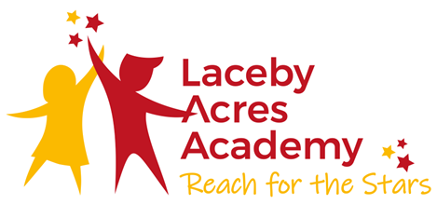

Reach for the Stars!

We aim to ensure that pupils leave Laceby Acres Academy having a sense of their own special individuality. Our children are taught to challenge self imposed restrictions. They are encouraged to foster high aspirations and develop positive self esteem, enabling them to leave our school secure in the knowledge that the world is at their feet.

We motivate and inspire pupils through creative teaching which is innovative and well paced.

We endeavour to remove barriers to learning and expect that children in our community reach their full potential judged upon a range of measures including national standards.

At our school, we teach pupils to take responsibility for their own actions; children understand that they have choices and learn to evaluate the consequences of the decisions they make.

All members of the school, including pupils, parents, staff and governors, recognise that they hold a stake in our school and the wider community. We are all committed to establishing a life-long love of learning, enabling our children to take their place confidently within a rapidly changing world.

Our Aims

Creativity: We aim to have the freedom to be able to enjoy, express feelings and seek solutions.

Enjoyment: We aim to have fun and feel enthusiastic at school.

Responsibility: We aim to develop independence enabling us to take ownership of our own learning.

Compassion: We aim to develop trust and respect between everybody in our school.

Co-operation: We aim to work together to achieve an overall purpose.

EAP Programme



The Trust offers a plan through Health Assured which provides access to valuable health and wellbeing services.​

Key Features:

- Unlimited access to 24/7 confidential telephone helpline
- Up to 10 sessions of face to face, telephone and online counselling
- Access to the portal and wisdom app
- Coverage for spouse/partner and dependants
- Medical information line including articles, webinars and podcasts
- Menopause Support access to other resources such as 'Menopause Matters'
- Access to Perks and Discounts
- Online and mobile access, anywhere and anytime
- Self-help guides, mood and wellness trackers

Teacher
Reference Number ELTMAY2609
Working Hours: 32.5
Working Weeks: 52
Salary Scale Range: MPS 1-6
Contract Type: Permanent
Start Date: September 2026 (Training days on August 27th and 28th)
Location (school name and address): Laceby Acres Academy, Swiftsure Crescent, Grimsby, DN345QN

About us
Our aim is that our school is a happy, friendly, safe place where children and staff feel welcome and valued; a place where all members of the school community care about each other and are kind to each other; a place where behaviour is excellent and where everybody takes pride in whatever they do.

About the role This is a great opportunity for the right candidate to play a significant role in shaping the future of the children at Laceby Acres Primary Academy while developing skills, knowledge and pedagogy alongside experienced and talented colleagues.

We are looking for someone who:
- Is enthusiastic and committed to learning
- Has high expectations to ensure ‘every single pupil succeeds no matter what’
- Has excellent knowledge of the Primary curriculum
- Can contribute to a climate where children and adults feel safe and thrive
- Is committed to the philosophy of collaboration within the academy and across the Trust
- Is dedicated to fostering excellent relationships with children, parents and staff

In return, we can offer you;
- An opportunity to work in the Enquire Learning Trust that is ‘built on botheredness’
- A brilliant team of colleagues and an SLT dedicated to supporting and caring for staff
- An ethos of high expectations and mutual respect where every pupil and adult knows they are valued and well cared for
- Access to an extensive network of academies that continually work to improve learning
- Access to high quality CPD within the local hub, as well as Trust wide training and support

All teachers work within the statutory conditions of employment set out in their Enquire Learning Trust contract.

For more information, please contact – Mrs Caroline Patterson
Details of visits to school are welcome please contact the school office on 01472 320601 to arrange.

How to apply
You can apply for this position by visiting The Enquire Learning Trust
Closing date and time: Friday 15th May 2026 at 4pm
Interview Date: Wednesday 20th May 2026

DBS/Safeguarding Statement
The Enquire Learning Trust is committed to safeguarding and promoting the welfare of children, young people and vulnerable adults and expects all staff and volunteers to share this commitment. As this post involves access to children or vulnerable adults, the successful applicant will be required to obtain an Enhanced Disclosure from the DBS

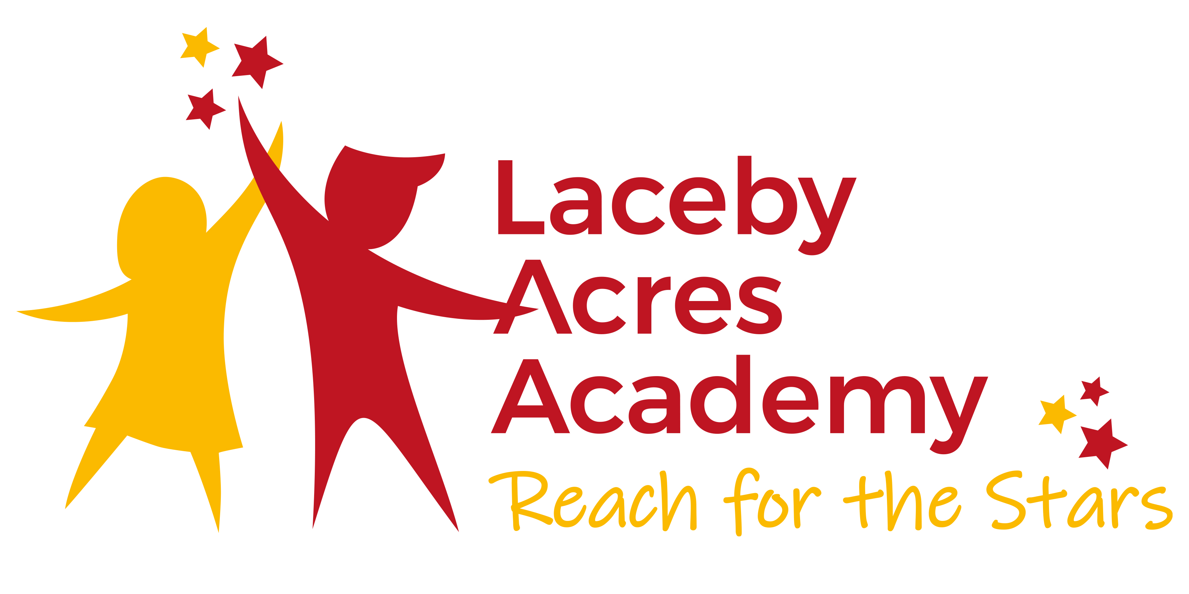
- JOB DESCRIPTION

- Job Title: Teacher
- Location: Class based
- Reporting to: Head of School, Executive Principal

- Post Title: Teacher
- Teaching Standards
- Teachers make the education of their pupils their first concern, and are accountable for achieving the highest possible standards in work and conduct. Teachers act with honesty and integrity; have strong subject knowledge, keep their knowledge and skills as teachers up-to-date and are self-critical; forge positive professional relationships; and work with parents in the best interests of their pupils.
- Accountability
- Teachers are accountable for the standards and achievement within the class/ability groups and co-ordinating or managing the work of support staff
- All teachers are subject to the conditions of employment set out annually in the School Teachers’ Pay and Conditions Document. These detail the professional and particular duties required of teachers, together with requirements for management time, working time, guaranteed planning and preparation time. The school complies with these requirements in order to make reasonable demands of teachers.

- A Teacher Must:

- Set High Expectations which Inspire, Motivate & Challenge Pupils:
- Establish a safe and stimulating environment for pupils, rooted in mutual respect.
- Set goals that stretch and challenge pupils of all backgrounds, abilities and dispositions.
- Demonstrate consistently the positive attitudes, values and behaviour which are expected of pupils.

- Promote Good Progress & Outcomes by Pupils:
- Be accountable for pupils’ attainment, progress and outcomes.
- Plan teaching to build on pupils' capabilities and prior knowledge.
- Guide pupils to reflect on the progress they have made and their emerging needs.
- Demonstrate knowledge and understanding of how pupils learn and how this impacts on teaching.
- Encourage pupils to take a responsible and conscientious attitude to their own work and study.

- Demonstrate Good Subject & Curriculum Knowledge
- Have a secure knowledge of the relevant subject(s) and curriculum areas, foster and maintain pupils’ interest in the subject, and address misunderstandings
- Demonstrate a critical understanding of developments in the subject and curriculum areas, and promote the value of scholarship
- Demonstrate an understanding of and take responsibility for promoting high standards of literacy, articulacy and the correct use of Standard English, whatever the teacher’s specialist subject
- If teaching early reading, demonstrate a clear understanding of systematic synthetic phonics
- If teaching early mathematics, demonstrate a clear understanding of appropriate teaching strategies.

- Plan & Teach Well Structured Lessons
- Impart knowledge and develop understanding through effective use of lesson time
- Promote a love of learning and children’s intellectual curiosity
- Set homework and plan other out-of-class activities to consolidate and extend the knowledge and understanding pupils have acquired
- Reflect systematically on the effectiveness of lessons and approaches to teaching
- Contribute to the design and provision of an engaging curriculum within the relevant subject area(s).

- Adapt Teaching to Respond to the Strengths & Needs of All Pupils
- Know when and how to differentiate appropriately, using approaches which enable pupils to be taught effectively
- Have a secure understanding of how a range of factors can inhibit pupils’ ability to learn, and how best to overcome these
- Demonstrate an awareness of the physical, social and intellectual development of children, and know how to adapt teaching to support pupils’ education at different stages of development
- Have a clear understanding of the needs of all pupils, including those with special educational needs; those of high ability; those with English as an additional language; those with disabilities; and be able to use and evaluate distinctive teaching approaches to engage and support them.

- Make Accurate & Productive Use of Assessment
- Know and understand how to assess the relevant subject and curriculum areas, including statutory assessment requirements
- Make use of formative and summative assessment to secure pupils’ progress
- Use relevant data to monitor progress, set targets, and plan subsequent lessons
- Give pupils regular feedback, both orally and through accurate marking, and encourage pupils to respond to the feedback.

- Manage Behaviour Effectively To Ensure a Good & Safe Learning Environment
- Have clear rules and routines for behaviour in classrooms, and take responsibility for promoting good and courteous behaviour both in classrooms and around the school, in accordance with the school’s behaviour policy
- Have high expectations of behaviour, and establish a framework for discipline with a range of strategies, using praise, sanctions and rewards consistently and fairly
- Manage classes effectively, using approaches which are appropriate to pupils’ needs in order to involve and motivate them
- Maintain good relationships with pupils, exercise appropriate authority, and act decisively when necessary.

- Fulfil Wider Professional Responsibilities
- Make a positive contribution to the wider life and ethos of the school
- Develop effective professional relationships with colleagues, knowing how and when to draw on advice and specialist support
- Deploy support staff effectively
- Take responsibility for improving teaching through appropriate professional development, responding to advice and feedback from colleagues
- Communicate effectively with parents with regard to pupils’ achievements and well-being.

- Personal & Professional Conduct
- A teacher is expected to demonstrate consistently high standards of personal and professional conduct.
- Teachers uphold public trust in the profession and maintain high standards of ethics and behaviour, within and outside school, by:
- Treating pupils with dignity, building relationships rooted in mutual respect, and at all times observing proper boundaries appropriate to a teacher’s professional position
- Having regard for the need to safeguard pupils’ well-being, in accordance with statutory provisions
- Showing tolerance of and respect for the rights of others
- Not undermining fundamental British values, including democracy, the rule of law, individual liberty and mutual respect, and tolerance of those with different faiths and beliefs
- Ensuring that personal beliefs are not expressed in ways which exploit pupils’ vulnerability or might lead them to break the law.
- Teachers must have proper and professional regard for the ethos, policies and practices of the school in which they teach, and maintain high standards in their own attendance and punctuality.
- Teachers must have an understanding of, and always act within, the statutory frameworks, which set out their professional duties and responsibilities.

Person Specification – Teacher
Grade:
 | Essential | Desirable | Evidence
Qualifications | Qualified Teacher Status  Degree | Continued Professional Development | Application Form  Interview
Experience | Proven ability as a good or outstanding practitioner or the capability to become outstanding | Key Stage 1 / 2 teaching experience | Application Form  Interview
Professional Knowledge, Understanding and Skills | Understand what constitutes good and outstanding teaching and learning  The ability to plan clearly differentiated sequences of lessons, which meet the needs of all learners  An understanding of how to develop excellent relationships with children so that they feel safe when being challenged  Having the very highest of expectations of children  Understand the concept of ‘beautiful work’ | Able to develop and promote independent learning in the classroom  The understanding of how to create an outstanding learning environment within the classroom and around the school in order to support and extend learning | Application Form  Interview  Lesson Observation
Curriculum | Excellent subject knowledge across the curriculum  Able to use AFL techniques confidently in all subjects in the curriculum. | An understanding of how to use all areas of the curriculum to improve learning in maths, reading and writing | Application Form  Interview  Lesson Observation
Professional Values | High expectations of yourself, other members of staff and children  Reflective practitioner willing and able to develop own teaching and to contribute to our professional learning community  A commitment to the personal welfare and safeguarding of children | Willing to help provide extra-curricular activities and first hand learning experiences | Application Form  Interview  References
Personal Qualities | Total commitment to and an enthusiasm for teaching and learning  Reflective and forward thinking with the ambition to become the very best teacher possible  A believer in teamwork  A well organised teacher, who is able to prioritise  Ability to communicate effectively at all levels | Ability to lead others in the delivery of the curriculum  A willingness to collaborate both within and beyond the school to improve the quality of provision | Letter of application  Interview  Reference.

Contact Details:

Laceby Acres Academy
Swiftsure Crescent
Grimsby
North East Lincolnshire
DN345QN
Executive Principal: Mrs C Patterson

Telephone: 01472 320601
Email: office@lacebyacres.org
The Enquire Learning Trust is committed to safeguarding and promoting the welfare of children and young people and expects all staff and volunteers to share this commitment. All ID and qualification checks will be made prior to appointment, as will online searches of candidates (Keeping Children Safe in Education 2023). Any offer of employment will be subject to receipt of a satisfactory Disclosure & Barring Service check and Disqualification by Association Disclosure.

DISCLOSURE AND BARRING AND RECRUITMENT CHECKS
The Trust is legally obligated to process an enhanced Disclosure and Barring Service (DBS) check before making appointments to relevant posts.
The DBS check will reveal both spent and unspent convictions, cautions, reprimands and final warnings, and any other information held by local police that’s considered relevant to the role. Any information that is “protected” under the Rehabilitation of Offenders Act 1974 (Exceptions) Order 1975 will not appear on a DBS certificate.
For posts in regulated activity, the DBS check will include a barred list check.
It is an offence to seek employment in regulated activity if you are on a barred list.
We’ll use the DBS check to ensure we comply with the Childcare Disqualification Regulations. It is an offence to provide or manage childcare covered by these regulations if you are disqualified.
Any data processed as part of the DBS check will be processed in accordance with data protection regulations and the trusts information governance policy which can be found on the website.
Please note this post is in regulated activity and exempt from the rehabilitation of Offenders Act 1974 and subject to satisfactory references and an enhanced DBS criminal records and barred list check for work with children. An online search may be undertaken as part of the recruitment process on information available in the public domain. Candidates should disclose anything that may be relevant in line with Keeping Children Safe in Education.

Any job offer will be conditional on the satisfactory completion of the necessary pre-employment checks. Only applicants who have been shortlisted will be asked for a self-declaration of their criminal record or information that would make them unsuitable for the position. Any convictions that are self-disclosed or listed on a DBS check will be considered on a case-by-case basis.

All documentation will be treated confidentially and processed in accordance with Data Protection regulations

