

Enquire Learning Trust Application Pack

After School Club Assistant

Reference Number: ELTJUN2625

Laceby Acres Academy
Swiftsure Crescent
Grimsby
DN345QN



Contents:



2. Academy Information


3. EAP Programme

4. Job Advert


5. Job Description



6. Person Specification




The Enquire Learning Trust

We are a multi-academy trust currently responsible for 32 academies in four clusters across the North of England; North East Lincolnshire, Hull, Manchester, Teesside and North Yorkshire.

We work in complete collaboration with each of our academies and place a strong emphasis on school-to-school support and learning. Our academies work in collaboration with one another, sharing both their talent and ideas with others, giving employees the opportunity to learn from individuals within our other academies.

We recognise that the most important assets we have are our employees, and for our academies to succeed we need to ensure we employ the very best people in every single role. Our core values and beliefs are consistent throughout all of our academies, and our keys to success are at the heart of everything we do.

Every role across the Trust is valued, appreciated and purposeful. We believe that the outcome of every role across the Trust should improve the education each of our learners receive. Whether teaching, support or leadership, every single role is vital to the success of our academies.

We also recognise that all of our academies are different, and we encourage individuality. Whilst we believe our academies should work together to support best practice and to share ideas, we don’t believe that implementing blanket priorities and objectives is pertinent to a successful academy, and we encourage autonomy for academy leaders wherever possible.

Values

- We believe that all learners can be powerful learners given access to extraordinary learning experiences. We want children and the academies they attend to be confident, successful and ambitious.
- We envisage a Trust where well led, highly skilled and committed professionals collaborate, learn and innovate together to ensure that all academies are successful and where all learners have access to effective and innovative provision that meets their needs and aspirations.
- We want to add value to achievement and raise standards. We also want to change lives. We know this requires our provision and our practice to be world-class – because of the distance we have to travel, we understand that good will not be good enough and that we need to develop a shared appreciation of excellence and then strive to enact this every day.
- We take learning seriously and work together to create a vibrant culture in which this can happen. We know that it’s what we do that counts and that our thinking must be visible in classrooms if it is to have leverage. Children are at the forefront of all that we do and aspire to do. We take serious steps to engage them, to hear their voice in authentic ways and then to use their insight and expertise to develop radical pedagogies that tap into their passions and interests and use the potential of emergent technologies.

The Enquire Learning Trust is committed to promoting sustainability and environmental responsibility across all academies, in line with the DfE (Department for Education) Sustainability and Climate Change Strategy. We care deeply about creating school environments that positively contribute to the communities we serve. Our approach includes driving progress towards net zero carbon emissions, protecting biodiversity, and equipping our children with the knowledge and skills to build a sustainable future.

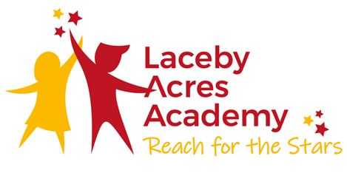

Vision Statement

Reach for the Stars!

We aim to ensure that pupils leave Laceby Acres Academy having a sense of their own special individuality. Our children are taught to challenge self imposed restrictions. They are encouraged to foster high aspirations and develop positive self esteem, enabling them to leave our school secure in the knowledge that the world is at their feet.

We motivate and inspire pupils through creative teaching which is innovative and well paced.

We endeavour to remove barriers to learning and expect that children in our community reach their full potential judged upon a range of measures including national standards.

At our school, we teach pupils to take responsibility for their own actions; children understand that they have choices and learn to evaluate the consequences of the decisions they make.

All members of the school, including pupils, parents, staff and governors, recognise that they hold a stake in our school and the wider community. We are all committed to establishing a life-long love of learning, enabling our children to take their place confidently within a rapidly changing world.

Our Aims

Creativity: We aim to have the freedom to be able to enjoy, express feelings and seek solutions.

Enjoyment: We aim to have fun and feel enthusiastic at school.

Responsibility: We aim to develop independence enabling us to take ownership of our own learning.

Compassion: We aim to develop trust and respect between everybody in our school.

Co-operation: We aim to work together to achieve an overall purpose.

EAP Programme



The Trust offers a plan through Health Assured which provides access to valuable health and wellbeing services.​

Key Features:

- Unlimited access to 24/7 confidential telephone helpline
- Up to 10 sessions of face to face, telephone and online counselling
- Access to the portal and wisdom app
- Coverage for spouse/partner and dependants
- Medical information line including articles, webinars and podcasts
- Menopause Support access to other resources such as 'Menopause Matters'
- Access to Perks and Discounts
- Online and mobile access, anywhere and anytime
- Self-help guides, mood and wellness trackers

Job Title After School Club Assistant
Reference Number ELTJUN2625/

Working Hours:11.25
Working Weeks:Term time only
Salary Scale Range: NJC point 6
Contract Type: Permanent
Start Date:01/09/2026
Location (school name and address):Laceby Acres Academy, Swiftsure Crescent, Grimsby, DN345QN

About us
Reach for the Stars
We motivate and inspire pupils through creative teaching which is innovative and well paced.

About the role
To be responsible for the development and daily running of the Club, providing a safe and caring environment in line with relevant statutory guidance, where children 5-11 years of age can enjoy a range of play, learning and leisure activities.

What we are looking for

Someone who is passionate about all aspects of childcare and education, and able to bring new ideas to the role. You will need to have a caring and dynamic approach, as well as an ability to lead and motivate staff.

What we can offer

Membership of – ERPF
Opportunities for development and progression
Employee Assistance Programme provided by Health Assured
Cycle to Work Scheme
Lifestyle savings

Working arrangements

3.30pm – 5.45pm, Monday - Friday

For more information, please contact (Caroline Patterson, Executive Principal 01472 320601 office@lacebyacres.org)

Details of visits to school are welcome please contact the school office on 01472 320601 to arrange.

How to apply

You can apply for this position by visiting The Enquire Learning Trust

Closing date and time: 10th July 2026 at 10pm
Interview Date: w/c 13th July 2026

DBS/Safeguarding Statement
The Enquire Learning Trust is committed to safeguarding and promoting the welfare of children, young people and vulnerable adults and expects all staff and volunteers to share this commitment. As this post involves access to children or vulnerable adults, the successful applicant will be required to obtain an Enhanced Disclosure from the DBS

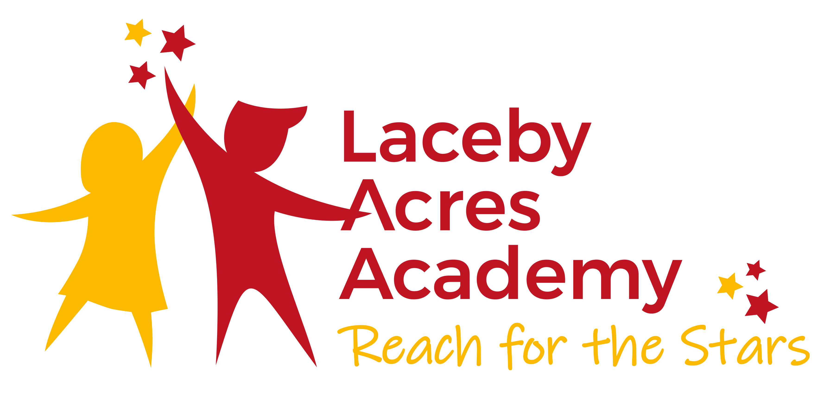

JOB DESCRIPTION

Post Title: After School Club Assistant.
Level 2/3 Teaching Assistant qualification, Childcare or Playworker equivalent

Grade: SCP 6

Responsible to: Principal.

Main Purpose:

To be responsible for the development and daily running of the Club, providing a safe and caring environment in line with relevant statutory guidance, where children 5-11 years of age can enjoy a range of play, learning and leisure activities.

To organise a daily routine that meets the emotional, social, physical and intellectual needs of the children.

To build links and work in partnership with parents, carers and professionals to promote the well-being of the children.

The role may require the administration of medicine and or first aid.

Duties and Responsibilities:

To undertake the daily running of the Club, working with all staff to ensure and provide care, play opportunities and activities in a homely, nurturing and safe environment, with regard to the individual development needs of the children and to prepare and provide drinks and snacks as appropriate.

To work as part of a small team of staff to deliver high quality creative play opportunities in a safe and caring environment.

To liaise with the Academy with regard to the needs of the children who attend the club.

To liaise with parents to encourage parental involvement and support of the After School Club.

To maintain all records relating to the management of the club, taking registers and administering medication and first aid as needed, ensuring confidentiality and data protection of the children, their families and members of staff.

To carry out administration procedures, record keeping, ordering and purchasing, in accordance with the academy’s systems.
To identify any potential child protection issues related to specific children or to the overall running of the club, liaising with the school’s Designated Child Protection Lead and other professionals as appropriate in order to safeguard and promote the welfare of our children.

To meet children’s individual medical needs as required.

To develop and maintain good communication with the Principal and with parents/carers.

To consult with parents, carers and children on the ongoing evaluation of the quality of the provision and to regularly undertake self-evaluation of the club.

PERSON SPECIFICATION

You will need to be:

Someone who is passionate about all aspects of childcare and education, and able to bring new ideas to the role. You will need to have a caring and dynamic approach, as well as, an ability to lead and motivate staff.

Qualification and other required skills | Essential | Desirable
Level 2 Teaching Assistant qualification, Childcare or Play work equivalent | X
Excellent communication skills | X
Recent experience of working with children ages 5-11 years of age. | X
Good organisational skills | X
Reliable | X
Knowledge of policies and procedures relating to child protection, health and safety, equal opportunities and confidentiality | X
Ability to provide and facilitate an inclusive, safe and creative play environment | X
Paediatric First Aid Certificate |  | X
Diabetic Training |  | X
Basic Food Hygiene Certificate |  | X
Ability to plan effectively and respond to unplanned circumstances using initiative, sound judgement and common sense | X
To be willing to undertake further training as required | X
To work as part of a small team of staff and work as an integral part of that team | X
To be willing to prepare and provide drinks and snacks as appropriate. | x

Laceby Acres Academy
Swiftsure Crescent
Grimsby
DN345QN
Executive Principal: Caroline Patterson

Telephone: 01472 320601
Email: office@lacebyacres.org
The Enquire Learning Trust is committed to safeguarding and promoting the welfare of children and young people and expects all staff and volunteers to share this commitment. All ID and qualification checks will be made prior to appointment, as will online searches of candidates (Keeping Children Safe in Education 2023). Any offer of employment will be subject to receipt of a satisfactory Disclosure & Barring Service check and Disqualification by Association Disclosure.

DISCLOSURE AND BARRING AND RECRUITMENT CHECKS
The Trust is legally obligated to process an enhanced Disclosure and Barring Service (DBS) check before making appointments to relevant posts.
The DBS check will reveal both spent and unspent convictions, cautions, reprimands and final warnings, and any other information held by local police that’s considered relevant to the role. Any information that is “protected” under the Rehabilitation of Offenders Act 1974 (Exceptions) Order 1975 will not appear on a DBS certificate.
For posts in regulated activity, the DBS check will include a barred list check.
It is an offence to seek employment in regulated activity if you are on a barred list.
We’ll use the DBS check to ensure we comply with the Childcare Disqualification Regulations. It is an offence to provide or manage childcare covered by these regulations if you are disqualified.
Any data processed as part of the DBS check will be processed in accordance with data protection regulations and the trusts information governance policy which can be found on the website.
Please note this post is in regulated activity and exempt from the rehabilitation of Offenders Act 1974 and subject to satisfactory references and an enhanced DBS criminal records and barred list check for work with children. An online search may be undertaken as part of the recruitment process on information available in the public domain. Candidates should disclose anything that may be relevant in line with Keeping Children Safe in Education.

Any job offer will be conditional on the satisfactory completion of the necessary pre-employment checks. Only applicants who have been shortlisted will be asked for a self-declaration of their criminal record or information that would make them unsuitable for the position. Any convictions that are self-disclosed or listed on a DBS check will be considered on a case-by-case basis.

All documentation will be treated confidentially and processed in accordance with Data Protection regulations

