

Enquire Learning Trust Application Pack

Level 2 Teaching Assistant

Reference Number: ELTJUN2625

Laceby Acres Academy
Swiftsure Crescent
Grimsby
DN345QN



Contents:



2. Academy Information


3. EAP Programme

4. Job Advert


5. Job Description



6. Person Specification




The Enquire Learning Trust

We are a multi-academy trust currently responsible for 32 academies in four clusters across the North of England; North East Lincolnshire, Hull, Manchester, Teesside and North Yorkshire.

We work in complete collaboration with each of our academies and place a strong emphasis on school-to-school support and learning. Our academies work in collaboration with one another, sharing both their talent and ideas with others, giving employees the opportunity to learn from individuals within our other academies.

We recognise that the most important assets we have are our employees, and for our academies to succeed we need to ensure we employ the very best people in every single role. Our core values and beliefs are consistent throughout all of our academies, and our keys to success are at the heart of everything we do.

Every role across the Trust is valued, appreciated and purposeful. We believe that the outcome of every role across the Trust should improve the education each of our learners receive. Whether teaching, support or leadership, every single role is vital to the success of our academies.

We also recognise that all of our academies are different, and we encourage individuality. Whilst we believe our academies should work together to support best practice and to share ideas, we don’t believe that implementing blanket priorities and objectives is pertinent to a successful academy, and we encourage autonomy for academy leaders wherever possible.

Values

- We believe that all learners can be powerful learners given access to extraordinary learning experiences. We want children and the academies they attend to be confident, successful and ambitious.
- We envisage a Trust where well led, highly skilled and committed professionals collaborate, learn and innovate together to ensure that all academies are successful and where all learners have access to effective and innovative provision that meets their needs and aspirations.
- We want to add value to achievement and raise standards. We also want to change lives. We know this requires our provision and our practice to be world-class – because of the distance we have to travel, we understand that good will not be good enough and that we need to develop a shared appreciation of excellence and then strive to enact this every day.
- We take learning seriously and work together to create a vibrant culture in which this can happen. We know that it’s what we do that counts and that our thinking must be visible in classrooms if it is to have leverage. Children are at the forefront of all that we do and aspire to do. We take serious steps to engage them, to hear their voice in authentic ways and then to use their insight and expertise to develop radical pedagogies that tap into their passions and interests and use the potential of emergent technologies.

The Enquire Learning Trust is committed to promoting sustainability and environmental responsibility across all academies, in line with the DfE (Department for Education) Sustainability and Climate Change Strategy. We care deeply about creating school environments that positively contribute to the communities we serve. Our approach includes driving progress towards net zero carbon emissions, protecting biodiversity, and equipping our children with the knowledge and skills to build a sustainable future.

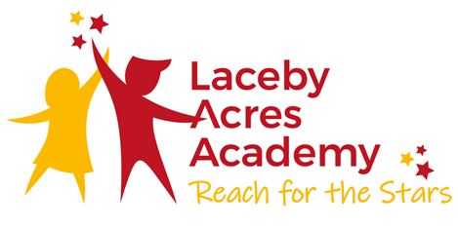

Vision Statement

Reach for the Stars!

We aim to ensure that pupils leave Laceby Acres Academy having a sense of their own special individuality. Our children are taught to challenge self imposed restrictions. They are encouraged to foster high aspirations and develop positive self esteem, enabling them to leave our school secure in the knowledge that the world is at their feet.

We motivate and inspire pupils through creative teaching which is innovative and well paced.

We endeavour to remove barriers to learning and expect that children in our community reach their full potential judged upon a range of measures including national standards.

At our school, we teach pupils to take responsibility for their own actions; children understand that they have choices and learn to evaluate the consequences of the decisions they make.

All members of the school, including pupils, parents, staff and governors, recognise that they hold a stake in our school and the wider community. We are all committed to establishing a life-long love of learning, enabling our children to take their place confidently within a rapidly changing world.

Our Aims

Creativity: We aim to have the freedom to be able to enjoy, express feelings and seek solutions.

Enjoyment: We aim to have fun and feel enthusiastic at school.

Responsibility: We aim to develop independence enabling us to take ownership of our own learning.

Compassion: We aim to develop trust and respect between everybody in our school.

Co-operation: We aim to work together to achieve an overall purpose.

EAP Programme



The Trust offers a plan through Health Assured which provides access to valuable health and wellbeing services.​

Key Features:

- Unlimited access to 24/7 confidential telephone helpline
- Up to 10 sessions of face to face, telephone and online counselling
- Access to the portal and wisdom app
- Coverage for spouse/partner and dependants
- Medical information line including articles, webinars and podcasts
- Menopause Support access to other resources such as 'Menopause Matters'
- Access to Perks and Discounts
- Online and mobile access, anywhere and anytime
- Self-help guides, mood and wellness trackers

Job Title (Level 2 Teaching Assistant)
Reference Number ELTJUN262

Working Hours:23.75
Working Weeks:Term time +5
Salary Scale Range: NJC point 3
Contract Type: Permanent
Start Date:01/09/2026
Location (school name and address):Laceby Acres Academy, Swiftsure Crescent, Grimsby, DN345QN

About us

To include basic information about the school and benefits of working there including school values and ethos.

About the role

To include general information about the position, who it is working with / supporting. Overview of responsibilities and day to day tasks.

What we are looking for

Key attributes, detail level of experience and skill required.

What we can offer

Membership of – relevant pension scheme
Opportunities for development and progression
Employee Assistance Programme provided by Health Assured
Cycle to Work Scheme
Lifestyle savings

Working arrangements

10.15am – 3.30pm, Monday - Friday

For more information, please contact (Caroline Patterson, Executive Principal 01472 320601 office@lacebyacres.org)

Details of visits to school are welcome please contact the school office on 01472 320601 to arrange.

How to apply

You can apply for this position by visiting The Enquire Learning Trust

Closing date and time: 10th July 2026 12pm
Interview Date: w/c 13th July 2026

DBS/Safeguarding Statement
The Enquire Learning Trust is committed to safeguarding and promoting the welfare of children, young people and vulnerable adults and expects all staff and volunteers to share this commitment. As this post involves access to children or vulnerable adults, the successful applicant will be required to obtain an Enhanced Disclosure from the DBS

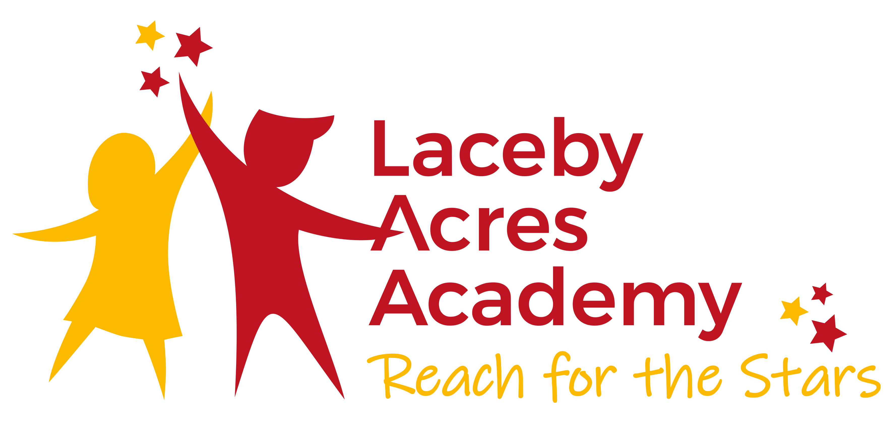

Level 2 Teaching Assistant
24.75hrs Term time +5

Job Title L2 Teaching Assistant

Location Laceby Acres Academy

Salary Grade SCP 3

Reporting to Executive Principal

- Job Purpose
- To supports Teachers in the smooth running of the setting
- To deliver high standards of care, child development for children in a welcoming, caring and safe environment.
- To comply with all regulatory requirements and Frameworks.
- To ensure the safety of all children through clear Safeguarding policies and procedures.

- Relationships

- Develop and maintain positive relationships with children, colleagues and parents/carers.

- Main Duties

- To support children’s learning and to share in the care and wellbeing of the children throughout the school.
- Provide targeted support to enhance learning for children with a range of needs: SEMH, Speech and Language difficulties, motor difficulties, social interaction and communication difficulties.
- To support individual and small groups of children in the curriculum to accelerate their learning.
- Support in the development and maintenance of appropriate planning, observation, and assessment procedures
- Has some knowledge of SEND and experience of working with SEND children (e.g. ASD, ADHD, attachment and trauma difficulties, specific learning difficulties, sensory/physical needs)
- To carry out specific administrative/ procedural tasks to support the running of the setting.
- Work as part of a team and assist Teachers to ensure quality education for the children.
- To promote the development of language and speech, including providing additional support to children with special needs or to bilingual learners, by working alongside the class teacher.
- Work or play with individuals/small groups of children by planning and carrying out relevant activities that accelerate and raise the level of achievement for all pupils involved in all areas of the curriculum, under the guidance of Teachers.
- Assist the Classroom by receiving instructions directly from professional or specialist support staff involved in the children’s education. These may involve social workers, health visitors, language support staff, speech therapists, educational psychologists and physiotherapists.
- Assist with the departure of children at the end of sessions.
- Assist with always maintaining good discipline throughout the setting, following procedures. When directed escort and supervise children on planned visits/journeys.
- Assist and attend with events e.g. stay and play, home visits, parents’ meetings, concerts and festivals
- Works in partnership with colleagues, within an agreed system of supervision, to deliver learning activities, and interventions.
- Uses own initiative to assess and evaluate pupils’ needs and leads the delivery of learning activities by application of specific skills, knowledge and experience with and of pupils and area of curriculum.
- Follows all school policies and procedures, in particular: Health, Safety and Security Policy, Child Protection Policy, Behaviour Management Policy, Inclusion Policy, Equalities Policy and Data Protection Policy
- Participates as required in the settings performance management and supervision systems and take part in appropriate training and development activities
- Makes appropriate use of ICT and adhere to policies relating to it within their work and in line with the school’s systems of working

- Safeguarding
- Report any concerns about the safety or wellbeing of pupils, staff and adults within the school, as well as members of their families, including children.
- Employees should be aware of their roles & responsibilities to both prevent and respond appropriately to abuse. They should undertake the safeguarding training required for their role.
- Be aware of suspected or actual cases of child abuse, referring such matters to the appropriate designated person for further action.

- Health and Safety

- Support children’s eating needs, encouraging children to eat and drink when required.
- Record and communicate children’s daily eating and toileting habits where applicable.
- Ensure effective supervision at mealtimes and that all dietary requirements are adhered to.
- Always maintain a clean and safe environment both inside and outside.
- All employees have a responsibility under the Health and Safety at Work Act 1974 for their own health, safety and welfare and to ensure that the agreed safety procedures are carried out to provide a safe environment for other employees and anyone else that may be affected by the carrying out of their duties.
- All staff have a responsibility to identify and report risks, hazards, incidents, accidents and near misses promptly, in accordance with our Health and Safety Policy.
- All staff must be familiar with emergency procedures in their workplace.

- Other responsibilities

CREATIVITY & INNOVATION
- Monitors and is responsive to pupil learning and behaviour at all times; requires forward thinking and the use of fresh ideas to encourage pupils to learn.
- Monitors and is responsive to pupils’ personal needs and communication which will require creativity and innovation when reviewing learning plans in light of changing circumstances.
- Communicates effectively with teachers, other professionals and parents whenever the need arises and recognises the need to communicate.
- Based on their knowledge and understanding of pupils, needs and responses to learning, contributes actively to the planning and review of the differentiated curriculum and individual education plans/individual behaviour plans by recommending changes in targets or provision to the teacher.
- Provides advisory support and contributes to the professional development of colleagues in relation to their specialist area of expertise.
- Participates in the design of classroom and school displays.

DECISIONS – discretion and consequences
- Recognises when it is necessary to implement agreed de-escalation strategies to minimise risk of pupils’ behaviour becoming disruptive or dangerous. Always follow the school Behaviour Policy.
- Takes action to meet pupils’ needs as they arise to avoid undue physical or mental stress.
- Communicates information effectively to teachers, other professionals and parents whenever the need arises.
- Recognise and act when necessary to make adjustments to planned activities in order to enable a pupil to access the curriculum fully and make progress.
- Responds to on-the-spot incidents requiring immediate attention/decisions on/off school premises and/or without direct contact with a senior member of staff.
- Make decisions regarding staffing issues relevant to the supervisory responsibilities of the teaching assistant team.

- Working Environment

Work demands
Need to implement activities in lessons as planned also working to other deadlines. Work may be subject to some change and interruption e.g. unplanned absences of staff and children, unexpected visits by parents and professionals and when supervisory duties are called for.

Physical demands
Involves mainly supervising children but may have sustained periods of physical activity, involving bending, crouching, lifting, walking and running, when meeting pupils’ personal care needs, physical interventions with pupils, moving children with physical disabilities, following approved procedures.

Working conditions
Majority of work is Classroom based. May involve outside activities e.g. forest school, off-site educational activities in all weather conditions as required. May also involve visits to the home.

Work context
Risk of verbal abuse and physical harm from a minority of pupils and members of the public who behave aggressively.
Risk of injury from moving and handling pupils with physical disabilities and caring for and working with small children.
Risk of exposure to bodily fluids when assisting incontinent children with their personal hygiene.
Risk of infection when dealing with unwell children.



Laceby Acres Academy
Teaching Assistant Level 2
Personal Specification

 | Essential | Desirable | Method of assessment
Qualifications | - Full and Relevant Level 2 qualification.  https://www.gov.uk/guidance/check-an-early-years-qualification  - Must hold a suitable Level 2 English qualification (equivalent to a GCSE at grade C or above); to be included in ratios. Functional Skills Level 2 can be used as an alternative to GCSEs.  - Willingness to attend Paediatric First Aid course (if not already in possession of this qualification).  - Willingness to undertake professional and personal development. | - Full First Aid qualification  - Excellent Maths skills. | Application  Certificates  Interview
Knowledge and experience | - Experience of supporting learning  - General understanding of curriculum and guidance.  - Secure knowledge of child development.  - Understanding of supporting children with their PRIME areas of learning.  - Understanding of how to support children with reading, writing and maths.  - Experience delivering an early maths programme.  - Understanding of children’s developmental milestones and support required  - Use of basic ICT – computer, video, photocopier.  - Basic understanding of barriers to children’s learning and ways to remove these obstacles.  - Awareness of legislation relating to safeguarding procedures. | - Experience of working with children with a range of SEND and delivering interventions (SEMH, Speech and Language, Communication and Interaction)  - Understanding of assessing and tracking progress  - Experience of working in partnership with parents and outside agencies  - Experience of following a key worker approach | Application  Interview  References
Skills | - Ability to build relationships with children and adults.  - Ability to work with an individual or group  - Effective communication with colleagues and children  - Good organisational skills  - Ability to use initiative and retain professionalism.  - Positive approach to behaviour management  - Model acceptable behaviour  - Ability to liaise with external professionals in order to support individual children.  - Meet the expectations set out in the job description  - Effective team working |  | Application  Interview  References
Personal characteristics | - Flexible approach  - Calmness  - Awareness of confidentiality  - Show initiative  - Enthusiasm for role  - Reliable  - Have high expectations  - Nurturing Personality |  | Interview  Referees

Laceby Acres Academy
Swiftsure Crescent
Grimsby
North East Lincolnshire
DN34 5QN

Executive Principal: Caroline Patterson

Telephone: 01472 320601
Email: office@lacebyacres.org

The Enquire Learning Trust is committed to safeguarding and promoting the welfare of children and young people and expects all staff and volunteers to share this commitment. All ID and qualification checks will be made prior to appointment, as will online searches of candidates (Keeping Children Safe in Education 2023). Any offer of employment will be subject to receipt of a satisfactory Disclosure & Barring Service check and Disqualification by Association Disclosure.

DISCLOSURE AND BARRING AND RECRUITMENT CHECKS
The Trust is legally obligated to process an enhanced Disclosure and Barring Service (DBS) check before making appointments to relevant posts.
The DBS check will reveal both spent and unspent convictions, cautions, reprimands and final warnings, and any other information held by local police that’s considered relevant to the role. Any information that is “protected” under the Rehabilitation of Offenders Act 1974 (Exceptions) Order 1975 will not appear on a DBS certificate.
For posts in regulated activity, the DBS check will include a barred list check.
It is an offence to seek employment in regulated activity if you are on a barred list.
We’ll use the DBS check to ensure we comply with the Childcare Disqualification Regulations. It is an offence to provide or manage childcare covered by these regulations if you are disqualified.
Any data processed as part of the DBS check will be processed in accordance with data protection regulations and the trusts information governance policy which can be found on the website.
Please note this post is in regulated activity and exempt from the rehabilitation of Offenders Act 1974 and subject to satisfactory references and an enhanced DBS criminal records and barred list check for work with children. An online search may be undertaken as part of the recruitment process on information available in the public domain. Candidates should disclose anything that may be relevant in line with Keeping Children Safe in Education.

Any job offer will be conditional on the satisfactory completion of the necessary pre-employment checks. Only applicants who have been shortlisted will be asked for a self-declaration of their criminal record or information that would make them unsuitable for the position. Any convictions that are self-disclosed or listed on a DBS check will be considered on a case-by-case basis.

All documentation will be treated confidentially and processed in accordance with Data Protection regulations

