

Enquire Learning Trust Application Pack

Level 3 Early Years Practitioner

Reference Number: ELTJUN2650

Keelby Primary Academy
Mannor Street
Keelby
DN41 8EF



Contents:



2. Academy Information


3. EAP Programme


4. Job Advert


5. Job Description


6. Person Specification

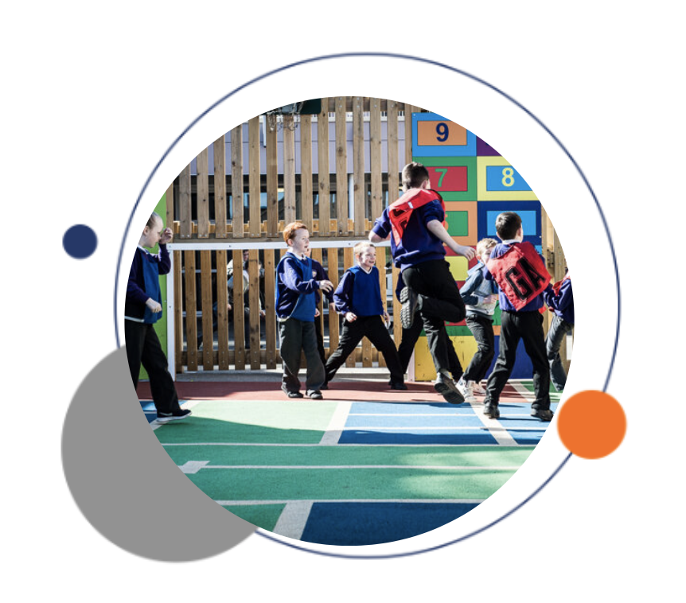


The Enquire Learning Trust

We are a multi-academy trust currently responsible for 32 academies in four clusters across the North of England; North East Lincolnshire, Hull, Manchester, Teesside and North Yorkshire.

We work in complete collaboration with each of our academies and place a strong emphasis on school-to-school support and learning. Our academies work in collaboration with one another, sharing both their talent and ideas with others, giving employees the opportunity to learn from individuals within our other academies.

We recognise that the most important assets we have are our employees, and for our academies to succeed we need to ensure we employ the very best people in every single role. Our core values and beliefs are consistent throughout all of our academies, and our keys to success are at the heart of everything we do.

Every role across the Trust is valued, appreciated and purposeful. We believe that the outcome of every role across the Trust should improve the education each of our learners receive. Whether teaching, support or leadership, every single role is vital to the success of our academies.

We also recognise that all of our academies are different, and we encourage individuality. Whilst we believe our academies should work together to support best practice and to share ideas, we don’t believe that implementing blanket priorities and objectives is pertinent to a successful academy, and we encourage autonomy for academy leaders wherever possible.

Values

- We believe that all learners can be powerful learners given access to extraordinary learning experiences. We want children and the academies they attend to be confident, successful and ambitious.
- We envisage a Trust where well led, highly skilled and committed professionals collaborate, learn and innovate together to ensure that all academies are successful and where all learners have access to effective and innovative provision that meets their needs and aspirations.
- We want to add value to achievement and raise standards. We also want to change lives. We know this requires our provision and our practice to be world-class – because of the distance we have to travel, we understand that good will not be good enough and that we need to develop a shared appreciation of excellence and then strive to enact this every day.
- We take learning seriously and work together to create a vibrant culture in which this can happen. We know that it’s what we do that counts and that our thinking must be visible in classrooms if it is to have leverage. Children are at the forefront of all that we do and aspire to do. We take serious steps to engage them, to hear their voice in authentic ways and then to use their insight and expertise to develop radical pedagogies that tap into their passions and interests and use the potential of emergent technologies.

The Enquire Learning Trust is committed to promoting sustainability and environmental responsibility across all academies, in line with the DfE (Department for Education) Sustainability and Climate Change Strategy. We care deeply about creating school environments that positively contribute to the communities we serve. Our approach includes driving progress towards net zero carbon emissions, protecting biodiversity, and equipping our children with the knowledge and skills to build a sustainable future.
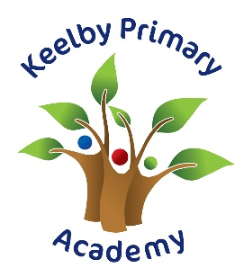

Keelby Primary Academy

Keelby Primary Academy is an exciting place! We were graded 'Good' by OFSTED in May, 2023 and continue to improve in pursuit of excellence!

We want all our children to feel happy and secure in school and every effort is made by all the staff to create a happy atmosphere where each child is shown respect and care, allowing them to develop their personalities. We strive to create a learning environment where every child is able to reach their full potential and achieve the highest of standards.

The staff at Keelby, are caring, dedicated and experienced! They aim to achieve the very best from your child, whether it be educationally, morally, spiritually or physically. The fulfilment of this aim can be seen in the children, who are well behaved, respectful, and have an excellent attitude to learning.

Our Mission Statement

Keelby Primary Academy provides a stimulating environment where curiosity is welcomed, enquiry encouraged, and an excitement of learning is fostered. We are committed to maximising the skills and talents of our learning community and to developing lifelong learners. We enable each child to feel pride in their efforts and to have confidence in their own abilities. We promote understanding, tolerance, fairness and respect for self, others and the environment and encourage collaborative learning and independence skills. Together we are striving to ensure Keelby Primary Academy is an exceptional school of which staff, children, parents and the community are proud of, where all are welcomed and feel safe, secure and valued.

Our Strategic Vision

Together, we are striving to be an exceptional school of which staff, children, parents and the community are proud, and where all are welcomed, feel safe, secure and valued.
To ensure that all learners exceed their potential spiritually, academically, socially and emotionally and develop a real love for learning
To provide a stimulating learning environment, an inspiring and challenging enquiry based curriculum which stimulates and supports high quality learning and empowers our children to become independent and creative thinkers.
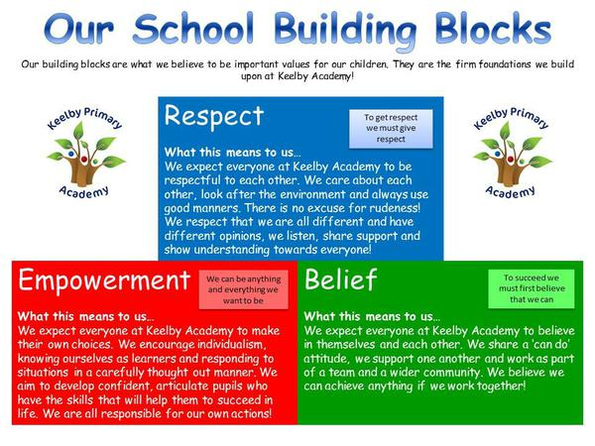

EAP Programme



The Trust offers a plan through Health Assured which provides access to valuable health and wellbeing services.​

Key Features:

- Unlimited access to 24/7 confidential telephone helpline
- Up to 10 sessions of face to face, telephone and online counselling
- Access to the portal and wisdom app
- Coverage for spouse/partner and dependants
- Medical information line including articles, webinars and podcasts
- Menopause Support access to other resources such as 'Menopause Matters'
- Access to Perks and Discounts
- Online and mobile access, anywhere and anytime
- Self-help guides, mood and wellness trackers

Post Title: L3 Early Years Practitioner

Status: Permanent

Weekly Hours 35 hours per week
TTO + 5 days

Salary Scale: NJC SP 6
A rare and exciting opportunity has arisen for the right person to join our friendly team here at Keelby Primary Academy. We are seeking to appoint an Early Years Practitioner to support children within our Nursery setting.
We are looking for a candidate who:
- Can form positive relationships with children, parents and staff
- Is able to use their initiative to support behaviour
- Has a proven track record of having a positive impact on children’s progress
- Is adaptable to situations and able to work effectively as part of a team
- Is an excellent communicator and role model
- Has good English/maths/computing skills
- Is a ‘can do’ person!
- Is resilient and flexible
- Is willing to make a positive contribution to the development of our school
- Aspires to be the very best version of themselves that they can be
We will offer you:
- Delightful and well-behaved children who are eager to learn.
- A well-established school where the whole team work together and support one another.
- A commitment to promoting staff’s emotional and physical well-being.
- Excellent opportunities for professional development.
The post will commence on Tuesday 1st September, 2026
Visits to the school are welcomed!

DBS/Safeguarding Statement
The Enquire Learning Trust is committed to safeguarding and promoting the welfare of children, young people and vulnerable adults and expects all staff and volunteers to share this commitment. As this post involves access to children or vulnerable adults, the successful applicant will be required to obtain an Enhanced Disclosure from the DBS

Closing Date: Wednesday 15th July at 12pm Interview Date: Monday 20th July

Contact Details:

Executive Principal: Mrs A Atkin Head of School: Miss T Whiting
School Business Manager: Mrs E Sparling Telephone: 01469 560366

Email: enquiries@keelby.lincs.sch.uk Website: https://www.keelby.lincs.sch.uk/

How to apply
You can apply for this position by visiting The Enquire Learning Trust

JOB DESCRIPTION

POST TITLE: L3 Early Years Practitioner

REPORTS TO: Executive Principal and Head of School

- PURPOSE OF JOB:

To provide support for our children in the EYFS, the teacher and the school in order to raise Standards of achievement for all children.
To provide inclusive continuous provision and learning opportunities for all children attending the nursery.
To support pupils’ learning, including those with SEN; to work with other staff to further pupils’ independence, impact on learning and to ensure all pupils have equal access to the curriculum. The postholder will also perform other related practical duties to support learning.
Ensure that children are engaged in appropriate activity and intervene to maintain behaviour standards and ensure wellbeing, safety and welfare.

- MAIN RESPONSIBILITIES
- Implement and deliver the EYFS curriculum in accordance with the children’s social, emotional, physical and intellectual needs.
- To keep informative, accurate and up to date records and assessments, including records of progress and any behavioural and developmental reports.
- To work within the setting’s policies and procedures.
- To respond to each child’s need for individual care and attention and provide a high level of care and supervision that will enhance the children’s general health and well-being.
- To act as a Key Person to a group of children and to ensure their needs are reflected in the planning of routines and activities.
- To support the work of other staff in their role as key person as required.
- To liaise closely with parents and carers as a Key Person: informing parents of their children’s progress and encouraging them to become involved in their children’s learning.
- To be aware of children’s special educational needs and disabilities, and work with other staff and external agencies to support these children effectively.
- To liaise and work in partnership with other agencies, both statutory and voluntary where appropriate.
- To promote positive values, attitudes and good child behaviour, dealing promptly with conflict and incidents in line with established policy and encouraging children to take responsibility for their own behaviour.
- To undertake any reasonable duties as directed by the Early Years Leader
- Assist in the presentation of displays in the learning environment to enhance the learning experience and celebrate the achievements of pupils and provide information.
- Participate in and support educational visits and outings to enhance the learning experience.
- Attend training to support and contribute to on-going professional development.

- SUPERVISION/MANAGEMENT OF PEOPLE

No direct supervisory responsibility other than familiarisation of procedures to colleagues.

- CONTACTS AND RELATIONSHIPS

EYFS Team and Teachers – to support the Nursery Lead in the planning, preparation and delivery of a broad and balanced curriculum relevant to individual needs.

Assist the Nursery Lead in preparing materials, reporting pupils’ progress and supporting learning activities.

Pupils – to support, assist and enable them to access the curriculum and develop social and independence skills to their fullest ability.

Other staff – to work as part of a team with all pupil related staff to keep them informed of areas of concern and pupils needs, particularly when handing over at the end of a session.

- DECISION

Discretion - The degree of discretion for the postholder is limited.
The postholder will determine routine decisions taken from a range of known options. Non routine decisions where the outcome is unclear will be discussed with the class teacher.
Any areas of concern related to child protection issues must be immediately reported to the Safeguarding Lead.
Consequences - The postholder works under the direction and supervision of the Early Years Lead . Any decisions will have a limited short term effect for the pupil and on the education provision within the school.
Constructive and effective support of the pupil can enhance the pupils' academic development.

- RESOURCES

Shared responsibility for teaching materials and equipment.

- WORK ENVIRONMENT

Work Demands

The postholder will normally work within an agreed routine which may vary dependent upon the needs/behaviour of pupils.
The postholder works within an established policy framework with the discretion to respond to changes in circumstances (e.g. wet playtime)

Physical Demands

Physical effort may be required in assisting pupils with daily routines, e.g. personal needs, lifting and handling of basic equipment, setting out classrooms and learning environments.

Working Conditions

The post holder will work within the School environment with some periods of outdoor activity when supervising pupil activities

Work Context

The post is predominantly classroom based and some risk is posed to the personal safety of the postholder. There will be some lifting of equipment. In some instances there may be a risk of infection from exposure to pupils' bodily fluids.

- KNOWLEDGE AND SKILLS

See person specification
- GENERAL
Other Duties - The duties and responsibilities in this job description are not restrictive and the postholder may be required to undertake any other duties which may be required from time to time. Any such duties should not however substantially change the general character of the post.
Equal Opportunities - The postholder must carry out his / her duties with full regard to the Trust’s Equal Opportunities policy.
Health and Safety - The postholder must carry out his / her duties with full regard to the Trust’s Health and Safety Procedures.

Contact details for school:

Mrs. E. Sparling (Business Manager) 01469 560366 – e.sparling@keelby.lincs.sch.uk

PERSON SPECIFICATION

You will need to be:

Someone who is passionate about all aspects of childcare and education, and able to bring new ideas to the role. You will need to have a caring and dynamic approach, as well as, an ability to lead and motivate staff.

Qualification and other required skills | Essential | Desirable
- Experience of working with pupils in the Early Years | X
- Level 3 in Child Care and Education or equivalent qualification | X
- Paediatric first aid qualification |  | X
- Enhanced DBS. | X
- GCSE English & maths grade C or above or equivalent | X
- Sound understanding of child development and of children’s needs and current legislation relevant to the Early Years. | X
- Excellent interpersonal, oral and written communication skills | X
- Ability to work with children demonstrating a range of needs (including behaviour issues) either individually or within a small group situation | X
- Strong time management skills and ability to prioritise workload. | X
- Ability to work effectively as a member of a team | X
- Computer literacy, including experience using Word (or similar) for reports and tablets | X
- Caring attitude and a friendly, flexible approach | X
- Able to work on own initiative and influence good practice though own example. | X

The Enquire Learning Trust is committed to safeguarding and promoting the welfare of children and young people and expects all staff and volunteers to share this commitment. All ID and qualification checks will be made prior to appointment, as will online searches of candidates (Keeping Children Safe in Education 2023). Any offer of employment will be subject to receipt of a satisfactory Disclosure & Barring Service check and Disqualification by Association Disclosure.

DISCLOSURE AND BARRING AND RECRUITMENT CHECKS
The Trust is legally obligated to process an enhanced Disclosure and Barring Service (DBS) check before making appointments to relevant posts.
The DBS check will reveal both spent and unspent convictions, cautions, reprimands and final warnings, and any other information held by local police that’s considered relevant to the role. Any information that is “protected” under the Rehabilitation of Offenders Act 1974 (Exceptions) Order 1975 will not appear on a DBS certificate.
For posts in regulated activity, the DBS check will include a barred list check.
It is an offence to seek employment in regulated activity if you are on a barred list.
We’ll use the DBS check to ensure we comply with the Childcare Disqualification Regulations. It is an offence to provide or manage childcare covered by these regulations if you are disqualified.
Any data processed as part of the DBS check will be processed in accordance with data protection regulations and the trusts information governance policy which can be found on the website.
Please note this post is in regulated activity and exempt from the rehabilitation of Offenders Act 1974 and subject to satisfactory references and an enhanced DBS criminal records and barred list check for work with children. An online search may be undertaken as part of the recruitment process on information available in the public domain. Candidates should disclose anything that may be relevant in line with Keeping Children Safe in Education.

Any job offer will be conditional on the satisfactory completion of the necessary pre-employment checks. Only applicants who have been shortlisted will be asked for a self-declaration of their criminal record or information that would make them unsuitable for the position. Any convictions that are self-disclosed or listed on a DBS check will be considered on a case-by-case basis.

All documentation will be treated confidentially and processed in accordance with Data Protection regulations.

