

Enquire Learning Trust Application Pack

KS2 Teachers – 2 Vacancies
Reference Number: ELTMAY2616 & 2617

Harrow Gate Academy
Piper Knowle Road
Stockton on Tees
TS19 8DE
01642 673984



Contents:



2. Academy Information


3. EAP Programme


4. Job Advert


5. Job Description


6. Person Specification




The Enquire Learning Trust

We are a multi-academy trust currently responsible for 32 academies in four clusters across the North of England; North East Lincolnshire, Hull, Manchester, Teesside and North Yorkshire.

We work in complete collaboration with each of our academies and place a strong emphasis on school-to-school support and learning. Our academies work in collaboration with one another, sharing both their talent and ideas with others, giving employees the opportunity to learn from individuals within our other academies.

We recognise that the most important assets we have are our employees, and for our academies to succeed we need to ensure we employ the very best people in every single role. Our core values and beliefs are consistent throughout all of our academies, and our keys to success are at the heart of everything we do.

Every role across the Trust is valued, appreciated and purposeful. We believe that the outcome of every role across the Trust should improve the education each of our learners receive. Whether teaching, support or leadership, every single role is vital to the success of our academies.

We also recognise that all of our academies are different, and we encourage individuality. Whilst we believe our academies should work together to support best practice and to share ideas, we don’t believe that implementing blanket priorities and objectives is pertinent to a successful academy, and we encourage autonomy for academy leaders wherever possible.

Values

- We believe that all learners can be powerful learners given access to extraordinary learning experiences. We want children and the academies they attend to be confident, successful and ambitious.
- We envisage a Trust where well led, highly skilled and committed professionals collaborate, learn and innovate together to ensure that all academies are successful and where all learners have access to effective and innovative provision that meets their needs and aspirations.
- We want to add value to achievement and raise standards. We also want to change lives. We know this requires our provision and our practice to be world-class – because of the distance we have to travel, we understand that good will not be good enough and that we need to develop a shared appreciation of excellence and then strive to enact this every day.
- We take learning seriously and work together to create a vibrant culture in which this can happen. We know that it’s what we do that counts and that our thinking must be visible in classrooms if it is to have leverage. Children are at the forefront of all that we do and aspire to do. We take serious steps to engage them, to hear their voice in authentic ways and then to use their insight and expertise to develop radical pedagogies that tap into their passions and interests and use the potential of emergent technologies.

The Enquire Learning Trust is committed to promoting sustainability and environmental responsibility across all academies, in line with the DfE (Department for Education) Sustainability and Climate Change Strategy. We care deeply about creating school environments that positively contribute to the communities we serve. Our approach includes driving progress towards net zero carbon emissions, protecting biodiversity, and equipping our children with the knowledge and skills to build a sustainable future.


Harrow Gate Primary is a two-form entry primary school, welcoming pupils between the ages of 2 and 11. Our school thrives on the unique contributions each child brings, creating a joyful and harmonious environment for both learning and working. Guided by our mission statement— ‘The academy will endeavour to raise the achievement and aspirations of every child’—this principle is at the heart of everything we do at Harrow Gate.

Learning is our core mission, and we are dedicated to fostering a culture of challenge and growth within a safe and supportive environment. Here, everyone is encouraged to be helpful, considerate, and respectful of one another. We emphasize making learning connections clear and present challenges that inspire our pupils to develop resilience, independence, and persistence. We want our children to explore ideas, reason, explain, and justify their thinking, equipping them to make informed decisions and embrace lifelong learning. These skills are not only crucial for their education but also contribute to their overall safety and well-being.

Our school is characterised by positive relationships and attitudes, creating an ethos where learning together becomes an enjoyable and rewarding experience for all. I am privileged to lead a school that is truly unique in its character and spirit.

At Harrow Gate Primary Academy, we celebrate and embrace all forms of achievement, reflecting our commitment to inclusion and unity. We consistently strive for the highest standards across all areas of the curriculum, guided by our core values of Achievement, Resilience, and Trust. These values inspire every child to reach their full potential.

To fulfil our mission statement, we believe in three core values, which we base our whole school around. We call these values 'the ART of Harrow Gate Primary Academy'

Achievement: Children meet the challenge and high expectations in learning through dynamic engagement.

Resilience: Children are courageous and passionate in their approach to learning, which fosters self-belief and pride.

Trust: The Harrow Gate family work as a team with honesty, respect, loyalty and effective communication to ensure success for all.

EAP Programme



The Trust offers a plan through Health Assured which provides access to valuable health and wellbeing services.​

Key Features:

- Unlimited access to 24/7 confidential telephone helpline
- Up to 10 sessions of face to face, telephone and online counselling
- Access to the portal and wisdom app
- Coverage for spouse/partner and dependants
- Medical information line including articles, webinars and podcasts
- Menopause Support access to other resources such as 'Menopause Matters'
- Access to Perks and Discounts
- Online and mobile access, anywhere and anytime
- Self-help guides, mood and wellness trackers

KS2 Teachers – 2 Vacancies
ELTMAY2616 & 2617

Working Hours: 32.5 hrs
Working Weeks: 52 weeks
Salary Scale Range: Main Pay Scale / ECTS encouraged to apply
Contract Type: Fixed Term

Start Date: 1st September 2026

Location: Piper Knowle Road
Stockton on Tees
TS19 8DE
About us
Harrow Gate Primary Academy is a well-established primary school located in Hardwick, Stockton-on-Tees, serving children aged 2–11. The academy is part of the Enquire Learning Trust, a collaborative network of schools that promotes high-quality teaching, professional development, and shared expertise.
The school is recognised for its inclusive and supportive environment, where every child is valued and encouraged to succeed. Its mission is “to raise the achievement and aspirations of every child,” a principle that underpins all aspects of school life.
Harrow Gate Primary Academy was judged ‘Good’ overall by Ofsted (June 2024), with ‘Outstanding’ for personal development, reflecting its strong commitment to pupils’ wellbeing, behaviour, and growth.

Values and Ethos
The academy’s ethos is rooted in positive relationships, inclusion, and high expectations. Strong, trusting relationships between pupils, staff, and families are seen as essential to both wellbeing and academic success.
The school is guided by its core values, known as the “ART” of Harrow Gate:

Achievement – encouraging all children to meet high expectations and engage fully in their learning.
Resilience – developing confident, determined learners who show perseverance and pride.
Trust – fostering teamwork, honesty, respect, and strong communication across the school community.

These values are embedded in daily practice and reflected in a culture where pupils feel safe, supported, and motivated to reach their full potential.

Benefits of Working at Harrow Gate Primary Academy
Working at Harrow Gate Primary Academy offers a range of professional and personal benefits:
Supportive and collaborative environment – staff work within a strong team ethos, placing children at the centre of everything they do.
Strong leadership and professional development – access to continuous professional development and opportunities through the Enquire Learning Trust.
Positive school culture – a welcoming, inclusive, and community-focused environment that values staff wellbeing and contribution.
Focus on relationships and wellbeing – an emphasis on nurturing positive relationships, which enhances both staff satisfaction and pupil outcomes.
Modern facilities and resources – well-equipped learning environments supporting high-quality teaching and learning. Additional benefits – access to pension schemes, mentoring, and a strong sense of belonging within a “family” atmosphere.
Harrow Gate Primary Academy is a forward-thinking, inclusive school with a clear moral purpose: to ensure every child achieves their potential. Its commitment to strong relationships, high expectations, and continuous improvement makes it not only an excellent place for pupils to learn, but also a rewarding and supportive environment in which to work.

About the role
We are looking to appoint an ambitious, reflective and highly committed Key Stage 2 Teacher who is passionate about delivering high-quality education for all. This role offers an opportunity to make a significant impact within a nurturing and inclusive school, where every child is supported to thrive academically, socially and emotionally.

At the heart of this role is a deep commitment to adaptive teaching, ensuring that all pupils—including those with SEND, pupils from diverse backgrounds, and our growing EAL community—can access a rich and meaningful curriculum. You will use a range of evidence-informed strategies to remove barriers to learning and provide ambitious outcomes for every child.

Key Responsibilities
- Plan and deliver engaging, well-sequenced lessons that reflect current educational research and best practice, ensuring teaching is consistently effective and responsive
- Employ adaptive teaching approaches to meet the diverse needs of all learners, including pupils with SEND and those learning English as an additional language
- Use ongoing formative and summative assessment to inform teaching, close gaps and accelerate progress
- Create a safe, inclusive and stimulating classroom environment where children feel valued, respected and motivated to learn
- Demonstrate a strong personal drive to build positive, nurturing relationships with pupils, fostering trust, confidence and a sense of belonging
- Uphold the highest standards of safeguarding, ensuring the safety and wellbeing of all pupils is paramount at all times

Inclusion and Pupil Support
- Work closely with colleagues, families and external agencies to support pupils with additional needs or vulnerabilities, implementing recommendations effectively
- Develop and maintain constructive relationships with parents and carers, including those who may be harder to engage, ensuring clear and supportive communication
- Promote equality, diversity and inclusion across all aspects of school life

Collaboration and Leadership
- Work collaboratively within a team, contributing positively to a supportive and high-performing staff culture
- Effectively deploy and manage support staff within the classroom to maximise pupil outcomes
- Contribute to curriculum development, school improvement priorities and wider school initiatives
- Engage in professional dialogue and coaching to support both your own development and that of colleagues

Digital and Forward-Thinking Practice
- Make effective and innovative use of ICT to enhance teaching and learning, in line with a forward-thinking digital strategy
- Use digital tools to support engagement, assessment and accessibility for all pupils
Professional Expectations
- Demonstrate a commitment to continuous professional development, keeping up to date with research and developments in education
- Maintain high expectations of pupil behaviour, achievement and personal development
- Contribute fully to the wider life of the school, including meetings, events and enrichment opportunities

We Are Looking For a Teacher Who:
- Has recent experience teaching in Key Stage 2 (Year 3 or Year 5 desirable)
- Has a strong understanding of the KS2 curriculum and how children learn
- Is passionate about raising attainment and improving life chances for all pupils
- Can successfully meet the needs of a diverse cohort, including SEND and EAL learners
- Demonstrates a commitment to high-quality teaching and continuous professional development
- Builds positive relationships and creates a safe, nurturing learning environment
- Is resilient, reflective and motivated to go above and beyond for children
- Works effectively as part of a team and establishes strong relationships with pupils, parents, staff and governors
- Is committed to the school’s ethos, vision and values

We want to hear from teachers who are ambitious, dedicated and ready to make a real difference. If you share our commitment to ensuring every child succeeds, we would love you to join our Harrow Gate team.

What we can offer
- A school full of wonderful children who make us proud every day
- A real commitment to the well-being of both children and staff
- A supportive senior leadership team who are keen to help you succeed.
- We are well resourced, have fantastic facilities and school grounds
- Great parents that are very supportive of the work that we do here
- A play-based learning environment where children’s well-being and involvement is paramount
- Lots of opportunities for personal development
- A warm and welcoming atmosphere where we value innovation, creative thinking and we are all enthusiastic learners
- Membership of – relevant pension scheme
- Opportunities for development and progression
- Employee Assistance Programme provided by Health Assured
- Cycle to Work Scheme
- Lifestyle savings

Working arrangements
Monday to Friday
For more information, please contact
Visits to school welcomed. Please contact Sam Scott – 01642 673984 to arrange a convenient time
How to apply
You can apply for this position by visiting The Enquire Learning Trust

Closing date and time: Thursday 11th June 2026 at 15:00
Interview Date: Friday 19th June 2026
DBS/Safeguarding Statement
The Enquire Learning Trust is committed to safeguarding and promoting the welfare of children, young people and vulnerable adults and expects all staff and volunteers to share this commitment. As this post involves access to children or vulnerable adults, the successful applicant will be required to obtain an Enhanced Disclosure from the DBS


Job Description

Title and Grade of post | Teacher  MPS
Status of  Post | Classroom teacher
Job Purpose | - To carry out the professional duties of a teacher as circumstances may require and in accordance with the academy’s policies under the direction of the principal  - To ensure the safety of all children through clear Safeguarding policies and procedures.
Reporting to | This post holder is accountable to the Principal and the Vice Principal.  The post holder is also expected to interact with colleagues on a professional level in order to promote a mutual understanding of the schools vision and values.
Health and Saftey | So far as is reasonably practicable, the Teacher must ensure that safe working practices are adopted by employees and in all premises/work areas, to maintain a safe working environment for employees and service users. These are defined in the Corporate Health, Safety and Welfare policy, Department Policies and Codes of Practice.
Main Expectations of the role
- Liaison with the teaching and non-teaching staff of the school, parents, children, advisers and other professionals
- Take responsibility for a class of children determined on an annual basis by the Principal and in accordance with the duties listed below
- To carry out the professional duties covered by the latest School Teachers’ Pay and Conditions Document. To undertake duties in line with the professional standards for qualified teachers and uphold the professional code of the General Teaching Council for England.
- Teach a class of pupils, and ensure that planning, preparation, recording, assessment and reporting meet their varying learning and social needs;
- Maintain the positive ethos and core values of the school, both inside and outside the classroom.
- Promote the school’s mission statement.
- Contribute to constructive team-building amongst teaching and non-teaching staff, parents and governors;
- To assist in the development of appropriate curriculum resources, schemes of work, marking policies and teaching strategies in the curriculum area and key stage
- To contribute to the achievement of the school’s development plan and its implementation.
- To plan and prepare lessons.
- To contribute to the whole school’s planning activities.
- To be innovative and lead in teaching developments that will improve teaching and learning across the whole school.

As a Class Teacher:
- Implement agreed school policies and guidelines;
- Support initiatives decided by the Principal and staff;
- Plan appropriately to meet the needs of all pupils, through differentiation of tasks and teaching approaches
- Be able to set clear targets, based on prior attainment, for pupils’ learning;
- Provide a stimulating classroom environment, where resources can be accessed appropriately by all pupils;
- Keep appropriate and efficient records, integrating formative and summative assessment into planning;
- Work with school leaders to track the progress of individual children and intervene where pupils are not making progress;
- Report to parents on the development, progress and attainment of pupils;
- Promote the school’s code of conduct amongst pupils, in accordance with the school's behaviour policy;
- Participate in meetings which relate to the school's management, curriculum, administration or organisation;
- Communicate and co-operate with specialists from outside agencies;
- Make effective use of ICT to enhance learning and teaching
- Lead, organise and direct support staff within the classroom;
- Participate in the performance management system for the appraisal of their own performance, or that of other teachers

Curriculum Leader Responsibilities: (if appropriate)
- Develop own expertise in leadership subject areas
- To keep abreast of the above subject areas through research, CPD etc
- To act as a consultant to other staff, including the Principal
- To produce in consultation with colleagues written policies and guidance; and lead staff in the discussion of policy and guidance
- To oversee the effective use of curriculum resources in the subject areas detailed above
- Ensure ‘Best Value’ in the procurement of curriculum resources in the subject areas detailed above
- Ensure legal compliance with statutory curriculum guidance in the above subjects
- Coach colleagues to ensure good practice in the allocated subject area(s)
- Monitor and assist in the evaluation of the delivery of the allocated subject area(s) across the school
- Network and liaise with colleagues in other schools to ensure equity and continuity in subject areas

Other responsibilities
- Further develop own professional knowledge and skills by attending relevant courses, reading to keep abreast of current educational thinking and participating fully in school staff development.
- Be aware of, and work according to, the National Professional Standards for School Teachers.
- Attend meetings in accordance with school policy and lead such meetings as required.
- Take whole school / Key Stage assemblies.

Person Specification
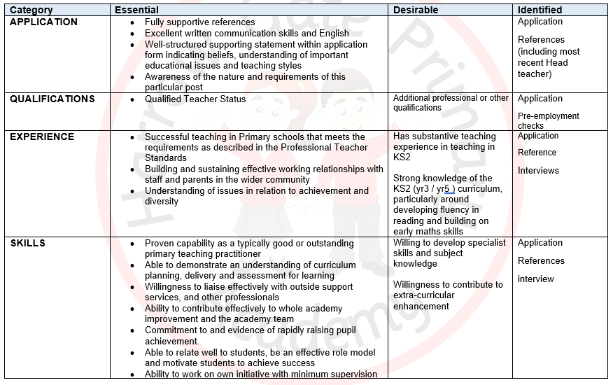
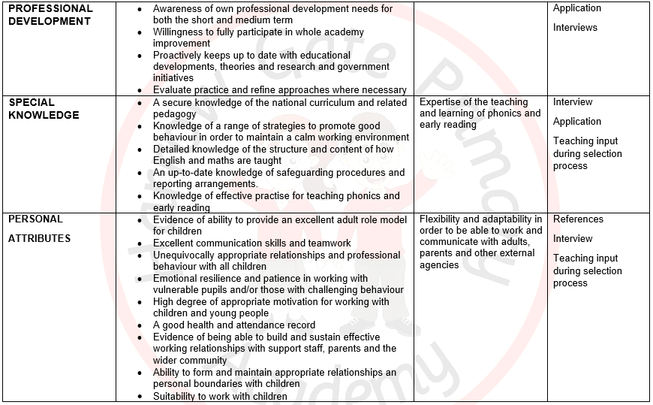

Contact Details:
Harrow Gate Primary Academy
Piper Knowle Road
Stockton-On-Tees
TS19 8DE
Principal: Mrs Vicky Galt
Telephone: 01642 673984
Email: i.dobson@harrowgateacademy.org ( Business Manager)

The Enquire Learning Trust is committed to safeguarding and promoting the welfare of children and young people and expects all staff and volunteers to share this commitment. All ID and qualification checks will be made prior to appointment, as will online searches of candidates (Keeping Children Safe in Education 2023). Any offer of employment will be subject to receipt of a satisfactory Disclosure & Barring Service check and Disqualification by Association Disclosure.

DISCLOSURE AND BARRING AND RECRUITMENT CHECKS
The Trust is legally obligated to process an enhanced Disclosure and Barring Service (DBS) check before making appointments to relevant posts.
The DBS check will reveal both spent and unspent convictions, cautions, reprimands and final warnings, and any other information held by local police that’s considered relevant to the role. Any information that is “protected” under the Rehabilitation of Offenders Act 1974 (Exceptions) Order 1975 will not appear on a DBS certificate.
For posts in regulated activity, the DBS check will include a barred list check.
It is an offence to seek employment in regulated activity if you are on a barred list.
We’ll use the DBS check to ensure we comply with the Childcare Disqualification Regulations. It is an offence to provide or manage childcare covered by these regulations if you are disqualified.
Any data processed as part of the DBS check will be processed in accordance with data protection regulations and the trusts information governance policy which can be found on the website.
Please note this post is in regulated activity and exempt from the rehabilitation of Offenders Act 1974 and subject to satisfactory references and an enhanced DBS criminal records and barred list check for work with children. An online search may be undertaken as part of the recruitment process on information available in the public domain. Candidates should disclose anything that may be relevant in line with Keeping Children Safe in Education.

Any job offer will be conditional on the satisfactory completion of the necessary pre-employment checks. Only applicants who have been shortlisted will be asked for a self-declaration of their criminal record or information that would make them unsuitable for the position. Any convictions that are self-disclosed or listed on a DBS check will be considered on a case-by-case basis.

All documentation will be treated confidentially and processed in accordance with Data Protection regulations

