

Enquire Learning Trust Application Pack

Reception Teacher

ELTJUN2622

Harrow Gate Academy
Piper Knowle Road
Stockton on Tees



Contents:



2. Academy Information


3. EAP Programme


4. Job Advert


5. Job Description


6. Person Specification




The Enquire Learning Trust

We are a multi-academy trust currently responsible for 32 academies in four clusters across the North of England; North East Lincolnshire, Hull, Manchester, Teesside and North Yorkshire.

We work in complete collaboration with each of our academies and place a strong emphasis on school-to-school support and learning. Our academies work in collaboration with one another, sharing both their talent and ideas with others, giving employees the opportunity to learn from individuals within our other academies.

We recognise that the most important assets we have are our employees, and for our academies to succeed we need to ensure we employ the very best people in every single role. Our core values and beliefs are consistent throughout all of our academies, and our keys to success are at the heart of everything we do.

Every role across the Trust is valued, appreciated and purposeful. We believe that the outcome of every role across the Trust should improve the education each of our learners receive. Whether teaching, support or leadership, every single role is vital to the success of our academies.

We also recognise that all of our academies are different, and we encourage individuality. Whilst we believe our academies should work together to support best practice and to share ideas, we don’t believe that implementing blanket priorities and objectives is pertinent to a successful academy, and we encourage autonomy for academy leaders wherever possible.

Values

- We believe that all learners can be powerful learners given access to extraordinary learning experiences. We want children and the academies they attend to be confident, successful and ambitious.
- We envisage a Trust where well led, highly skilled and committed professionals collaborate, learn and innovate together to ensure that all academies are successful and where all learners have access to effective and innovative provision that meets their needs and aspirations.
- We want to add value to achievement and raise standards. We also want to change lives. We know this requires our provision and our practice to be world-class – because of the distance we have to travel, we understand that good will not be good enough and that we need to develop a shared appreciation of excellence and then strive to enact this every day.
- We take learning seriously and work together to create a vibrant culture in which this can happen. We know that it’s what we do that counts and that our thinking must be visible in classrooms if it is to have leverage. Children are at the forefront of all that we do and aspire to do. We take serious steps to engage them, to hear their voice in authentic ways and then to use their insight and expertise to develop radical pedagogies that tap into their passions and interests and use the potential of emergent technologies.

The Enquire Learning Trust is committed to promoting sustainability and environmental responsibility across all academies, in line with the DfE (Department for Education) Sustainability and Climate Change Strategy. We care deeply about creating school environments that positively contribute to the communities we serve. Our approach includes driving progress towards net zero carbon emissions, protecting biodiversity, and equipping our children with the knowledge and skills to build a sustainable future.



Harrow Gate Primary is a two-form entry primary school, welcoming pupils between the ages of 2 and 11. Our school thrives on the unique contributions each child brings, creating a joyful and harmonious environment for both learning and working. Guided by our mission statement— ‘The academy will endeavour to raise the achievement and aspirations of every child’—this principle is at the heart of everything we do at Harrow Gate.

Learning is our core mission, and we are dedicated to fostering a culture of challenge and growth within a safe and supportive environment. Here, everyone is encouraged to be helpful, considerate, and respectful of one another. We emphasize making learning connections clear and present challenges that inspire our pupils to develop resilience, independence, and persistence. We want our children to explore ideas, reason, explain, and justify their thinking, equipping them to make informed decisions and embrace lifelong learning. These skills are not only crucial for their education but also contribute to their overall safety and well-being.

Our school is characterised by positive relationships and attitudes, creating an ethos where learning together becomes an enjoyable and rewarding experience for all. I am privileged to lead a school that is truly unique in its character and spirit.

At Harrow Gate Primary Academy, we celebrate and embrace all forms of achievement, reflecting our commitment to inclusion and unity. We consistently strive for the highest standards across all areas of the curriculum, guided by our core values of Achievement, Resilience, and Trust. These values inspire every child to reach their full potential.

To fulfil our mission statement, we believe in three core values, which we base our whole school around. We call these values 'the ART of Harrow Gate Primary Academy'

Achievement: Children meet the challenge and high expectations in learning through dynamic engagement.

Resilience: Children are courageous and passionate in their approach to learning, which fosters self-belief and pride.

Trust: The Harrow Gate family work as a team with honesty, respect, loyalty and effective communication to ensure success for all.

EAP Programme



The Trust offers a plan through Health Assured which provides access to valuable health and wellbeing services.​

Key Features:

- Unlimited access to 24/7 confidential telephone helpline
- Up to 10 sessions of face to face, telephone and online counselling
- Access to the portal and wisdom app
- Coverage for spouse/partner and dependants
- Medical information line including articles, webinars and podcasts
- Menopause Support access to other resources such as 'Menopause Matters'
- Access to Perks and Discounts
- Online and mobile access, anywhere and anytime
- Self-help guides, mood and wellness trackers

Reception Teacher
ELTJUN2622

Salary Scale Range: Main Pay Scale (ECTs welcome to apply)
Contract Type: Fixed Term (in the first instance)
Start Date: September 2026
Location: Piper Knowle Road
Stockton on Tees
TS19 8DE

About us
Harrow Gate Primary Academy is a well-established primary school located in Hardwick, Stockton-on-Tees, serving children aged 2–11. The academy is part of the Enquire Learning Trust, a collaborative network of schools that promotes high-quality teaching, professional development, and shared expertise.
The school is recognised for its inclusive and supportive environment, where every child is valued and encouraged to succeed. Its mission is “to raise the achievement and aspirations of every child,” a principle that underpins all aspects of school life.
Harrow Gate Primary Academy was judged ‘Good’ overall by Ofsted (June 2024), with ‘Outstanding’ for personal development, reflecting its strong commitment to pupils’ wellbeing, behaviour, and growth.

Values and Ethos
The academy’s ethos is rooted in positive relationships, inclusion, and high expectations. Strong, trusting relationships between pupils, staff, and families are seen as essential to both wellbeing and academic success.
The school is guided by its core values, known as the “ART” of Harrow Gate:

Achievement – encouraging all children to meet high expectations and engage fully in their learning.
Resilience – developing confident, determined learners who show perseverance and pride.
Trust – fostering teamwork, honesty, respect, and strong communication across the school community.

These values are embedded in daily practice and reflected in a culture where pupils feel safe, supported, and motivated to reach their full potential.

Benefits of Working at Harrow Gate Primary Academy
Working at Harrow Gate Primary Academy offers a range of professional and personal benefits:
Supportive and collaborative environment – staff work within a strong team ethos, placing children at the centre of everything they do.
Strong leadership and professional development – access to continuous professional development and opportunities through the Enquire Learning Trust.
Positive school culture – a welcoming, inclusive, and community-focused environment that values staff wellbeing and contribution.
Focus on relationships and wellbeing – an emphasis on nurturing positive relationships, which enhances both staff satisfaction and pupil outcomes.
Modern facilities and resources – well-equipped learning environments supporting high-quality teaching and learning.
Additional benefits – access to pension schemes, mentoring, and a strong sense of belonging within a “family” atmosphere.

Harrow Gate Primary Academy is a forward-thinking, inclusive school with a clear moral purpose: to ensure every child achieves their potential. Its commitment to strong relationships, high expectations, and continuous improvement makes it not only an excellent place for pupils to learn, but also a rewarding and supportive environment in which to work.

About the role
Reception Teacher – Role Overview
The Reception Teacher plays an essential role in supporting the early development of children, typically aged 4–5 years. The position centres on establishing a welcoming, nurturing, and stimulating classroom environment where children can grow socially, emotionally, physically, and academically through a blend of play-based learning and structured teaching activities, in line with the Early Years Foundation Stage (EYFS) framework.
The role requires close collaboration with the Early Years team, the adjacent reception class teacher, and teaching assistants. By working together, staff are able to share expertise and provide consistent support for each child's development. Additionally, the role involves regular engagement with parents, carers, and the wider school team. This collective approach ensures that each child’s individual needs are met and helps to foster positive relationships that contribute to every pupil’s progress and wellbeing.

Who the Role Works With / Supports
Reception pupils (Early Years Foundation Stage – EYFS)
Teaching assistants and reception support staff
The Early Years Leader / SENCO (Special Educational Needs Coordinator)
Other primary school teachers and leadership team
Parents, carers, and external professionals (e.g. speech therapists, health visitors)

Key Responsibilities
Planning & Teaching
Plan and deliver engaging, age-appropriate lessons in line with the EYFS framework
Provide a mix of structured teaching and child-led play opportunities
Promote early literacy, numeracy, communication, and social skills
Implement Little Wandle Letters and Sounds to support phonics development
Use Little Wandle Letters and Sounds handwriting programme to enhance fine motor skills and letter formation
Deliver Mastering Number sessions to build firm mathematical understanding
Embed strong foundational skills consistently across the setting to ensure children’s readiness for future learning

Child Development & Assessment
Observe, assess, and record children’s progress and development
Identify and support children with additional needs
Maintain accurate records and contribute to individual learning profiles

Environment & Care
Create a safe, inclusive, and stimulating classroom environment
Ensure safeguarding, health, and safety policies are followed at all times
Support children’s personal, social, and emotional development

Behaviour & Wellbeing
Promote positive behaviour and encourage independence
Support children in developing confidence, resilience, and social skills

Communication
Build strong partnerships with parents/carers, providing regular updates on progress
Work collaboratively with colleagues and external agencies

Day-to-Day Tasks
Setting up learning areas and activities before the school day
Organising and planning for effective use of additional staff
Greeting children and supporting their transition into the setting
Delivering whole class and group teaching sessions
Facilitating play-based learning indoors and outdoors
Observing and interacting with children to support development
Managing routines and transitions across the day
Recording observations and updating assessment records
Communicating with parents at pick-up or through school systems
Attending staff meetings or planning sessions

The Reception Teacher role is dynamic and rewarding, combining teaching, care, and developmental support. It requires patience, creativity, strong communication skills, and a genuine passion for early childhood education.

What we are looking for
Are you a Reception Teacher who truly understands how young children learn, develop, and flourish?

We are seeking a dedicated and knowledgeable early years professional who puts child development at the forefront of their practice. This role is ideal for someone who takes pleasure in working with our youngest pupils, values the significance of nurturing relationships, and recognises that every moment—whether indoors or outdoors—is an opportunity for meaningful learning.

You will collaborate closely with a supportive team of practitioners, parents, and external professionals to establish a caring, inclusive, and ambitious environment. Here, children’s individual progress and aspirations are thoughtfully encouraged. Working in partnership with families and agencies is at the heart of our ethos: these strong relationships ensure a holistic understanding of each child and enable them to thrive academically, socially, and emotionally.

Our academy belongs to the Enquire Learning Trust, a large and supportive network of successful primary schools across the North of England. We are located on a substantial housing development in the north of Stockton-On-Tees, with a significant number of pupils eligible for the Pupil Premium and children with a variety of complex and additional needs.

Our school ethos is focused on children achieving well and enjoying their learning, with relationships at its core. To realise this vision, it is vital that all adults foster an environment where every child feels valued and secure, where opportunities in life are enhanced for all, and where pupils leave us equipped to build meaningful and caring relationships as they grow.
We welcome applications from Reception Teachers who are enthusiastic and willing to go the extra mile to enrich the lives of our pupils. An excellent understanding of the Early Years curriculum and child development, outstanding classroom abilities, the right motivation, resilience, and a commitment to ongoing learning are essential qualities for anyone seeking to join our Harrow Gate team.

We are looking for a Reception teacher who:
- Has recent experience (within the past two years) of teaching in the Early Years Foundation Stage;
- Possesses a genuine passion for early childhood education and development;
- Supports children to become confident, independent thinkers and inquisitive learners;
- Can appreciate and respond sensitively to the unique needs of every child;
- Is devoted to placing children at the centre of all decisions and actions;
- Is committed to delivering high standards in teaching and classroom practice;
- Will embrace our ethos, vision, and values wholeheartedly;
- Is able to work effectively as part of a team and forge positive relationships with pupils, parents, governors, and staff;

What we can offer
- A school full of wonderful children who make us proud every day
- A real commitment to the well-being of both children and staff
- A supportive senior leadership team who are keen to help you succeed.
- We are well resourced, have fantastic facilities and school grounds
- Great parents that are very supportive of the work that we do here
- A play-based learning environment where children’s well-being and involvement is paramount
- Lots of opportunities for personal development
- A warm and welcoming atmosphere where we value innovation, creative thinking and we are all enthusiastic learners
- Membership of – relevant pension scheme
- Opportunities for development and progression
- Employee Assistance Programme provided by Health Assured
- Cycle to Work Scheme
- Lifestyle savings

Working arrangements
Term Time only plus 5 inset days
Monday to Friday

For more information, please contact

Visits to school welcomed. Please contact Sam Scott – 01642 673984 to arrange a convenient time

How to apply

You can apply for this position by visiting The Enquire Learning Trust

Closing date and time: Thursday 2nd July at 15:00
Interview Date: Monday 6th July

DBS/Safeguarding Statement
The Enquire Learning Trust is committed to safeguarding and promoting the welfare of children, young people and vulnerable adults and expects all staff and volunteers to share this commitment. As this post involves access to children or vulnerable adults, the successful applicant will be required to obtain an Enhanced Disclosure from the DBS


Job Description

Title and Grade of post | Teacher  Full Time  MPS
Status of  Post | Reception Classroom teacher
Job Purpose | - To carry out the professional duties of a teacher as circumstances may require and in accordance with the academy’s policies under the direction of the principal  - To ensure the safety of all children through clear Safeguarding policies and procedures.
Reporting to | This post holder is accountable to the Principal and EYFS leader.  The post holder is also expected to interact with and lead colleagues on a professional level in order to promote a mutual understanding of the schools vision and values.
Health and Saftey | So far as is reasonably practicable, the Teacher must ensure that safe working practices are adopted by employees and in all premises/work areas, to maintain a safe working environment for employees and service users. These are defined in the Corporate Health, Safety and Welfare policy, Department Policies and Codes of Practice.
Main Expectations of the role
- Liaison with the teaching and non-teaching staff of the school, Governors, Parents, Children, Advisers and other Professionals
- Take responsibility for a class of children determined on an annual basis by the Principal and in accordance with the duties listed below
- To carry out the professional duties covered by the latest School Teachers’ Pay and Conditions Document. To undertake duties in line with the professional standards for qualified teachers and uphold the professional code of the General Teaching Council for England.
- Teach a class of pupils, and ensure that planning, preparation, recording, assessment and reporting meet their varying learning and social needs;
- Maintain the positive ethos and core values of the school, both inside and outside the classroom;
- Promote the school’s mission statement.
- Contribute to constructive team-building amongst teaching and non-teaching staff, parents and governors;
- To assist in the development of appropriate syllabuses, resources, schemes of work, marking policies and teaching strategies in the Curriculum Area and key stage
- To contribute to the achievement of the school’s development plan and its implementation.
- To plan and prepare lessons.
- To contribute to the whole school’s planning activities.
- To be innovative and lead in teaching developments that will improve teaching and learning across the whole school.
As a Class Teacher:
- Implement agreed school policies and guidelines;
- Support initiatives decided by the Principal and staff;
- Plan appropriately to meet the needs of all pupils, through differentiation of tasks;
- Be able to set clear targets, based on prior attainment, for pupils’ learning;
- Provide a stimulating classroom environment, where resources can be accessed appropriately by all pupils;
- Keep appropriate and efficient records, integrating formative and summative assessment into planning;
- Work with school leaders to track the progress of individual children and intervene where pupils are not making progress;
- Report to parents on the development, progress and attainment of pupils;
- Promote the school’s code of conduct amongst pupils, in accordance with the school's behaviour policy;
- Participate in meetings which relate to the school's management, curriculum, administration or organisation;
- Communicate and co-operate with specialists from outside agencies;
- Make effective use of ICT to enhance learning and teaching
- Lead, organise and direct support staff within the classroom;
- Participate in the performance management system for the appraisal of their own performance, or that of other teachers

Curriculum Leader Responsibilities:
- Develop own expertise in leadership subject areas
- To keep abreast of the above subject areas through research, CPD etc
- To act as a consultant to other staff, including the Principal
- To produce in consultation with colleagues written policies and guidance; and lead staff in the discussion of policy and guidance
- To oversee the effective use of curriculum resources in the subject areas detailed above
- Ensure ‘Best Value’ in the procurement of curriculum resources in the subject areas detailed above
- Ensure legal compliance with statutory curriculum guidance in the above subjects
- Coach colleagues to ensure good practice in the allocated subject area(s)
- Monitor and assist in the evaluation of the delivery of the allocated subject area(s) across the school
- Network and liaise with colleagues in other schools to ensure equity and continuity in subject areas

Other responsibilities
- Further develop own professional knowledge and skills by attending relevant courses, reading to keep abreast of current educational thinking and participating fully in school staff development.
- Be aware of, and work according to, the National Professional Standards for School Teachers.
- Attend meetings in accordance with school policy and lead such meetings as required.
- Prepare and present reports and other forms of high quality communication, as required, e.g. to governors, Trust, parents, outside agencies.

Person Specification
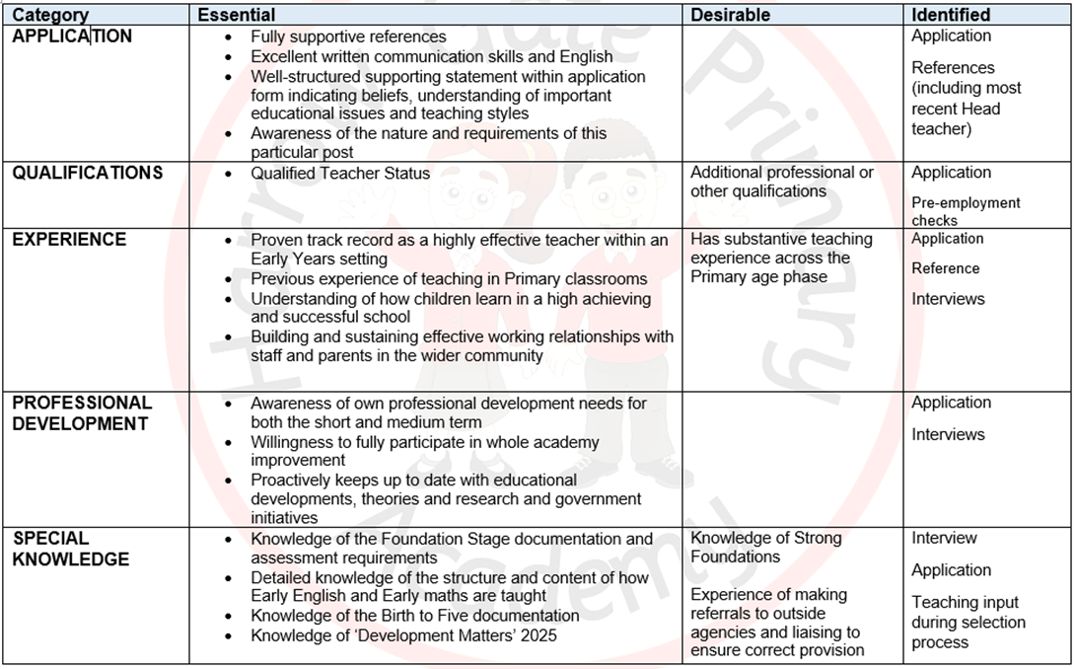
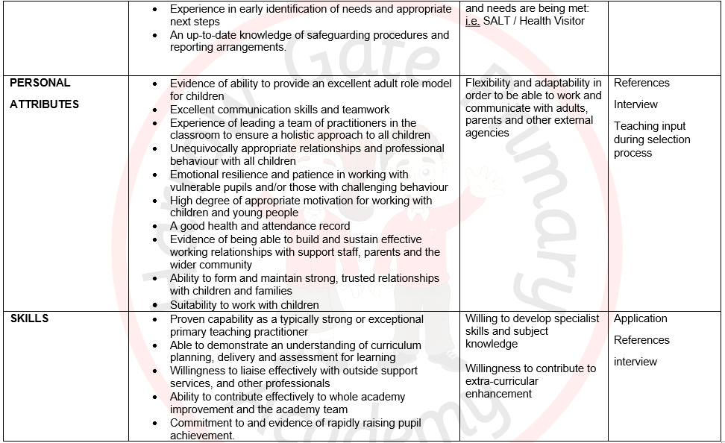

Contact Details:
Harrow Gate Primary Academy
Piper Knowle Road
Stockton-On-Tees
TS19 8DE
Principal: Mrs Vicky Galt
Telephone: 01642 673984
Email: i.donson@harrowgateacademy.org ( Business Manager)

The Enquire Learning Trust is committed to safeguarding and promoting the welfare of children and young people and expects all staff and volunteers to share this commitment. All ID and qualification checks will be made prior to appointment, as will online searches of candidates (Keeping Children Safe in Education 2023). Any offer of employment will be subject to receipt of a satisfactory Disclosure & Barring Service check and Disqualification by Association Disclosure.

DISCLOSURE AND BARRING AND RECRUITMENT CHECKS
The Trust is legally obligated to process an enhanced Disclosure and Barring Service (DBS) check before making appointments to relevant posts.
The DBS check will reveal both spent and unspent convictions, cautions, reprimands and final warnings, and any other information held by local police that’s considered relevant to the role. Any information that is “protected” under the Rehabilitation of Offenders Act 1974 (Exceptions) Order 1975 will not appear on a DBS certificate.
For posts in regulated activity, the DBS check will include a barred list check.
It is an offence to seek employment in regulated activity if you are on a barred list.
We’ll use the DBS check to ensure we comply with the Childcare Disqualification Regulations. It is an offence to provide or manage childcare covered by these regulations if you are disqualified.
Any data processed as part of the DBS check will be processed in accordance with data protection regulations and the trusts information governance policy which can be found on the website.
Please note this post is in regulated activity and exempt from the rehabilitation of Offenders Act 1974 and subject to satisfactory references and an enhanced DBS criminal records and barred list check for work with children. An online search may be undertaken as part of the recruitment process on information available in the public domain. Candidates should disclose anything that may be relevant in line with Keeping Children Safe in Education.

Any job offer will be conditional on the satisfactory completion of the necessary pre-employment checks. Only applicants who have been shortlisted will be asked for a self-declaration of their criminal record or information that would make them unsuitable for the position. Any convictions that are self-disclosed or listed on a DBS check will be considered on a case-by-case basis.

All documentation will be treated confidentially and processed in accordance with Data Protection regulations

