



Enquire Learning Trust Application Pack

Teaching Assistant (Level 2)

32.5 hours per week
Term Time Only Plus 5 Days

Permanent,

NJC SCP 3, Pro-rata

To start Sept 2026

ELTJUN2604



Contents


1. The Enquire Learning Trust Visions, Values and Mission


2. Academy Information


3. Health and Wellbeing Package


4. Job Advert


5. Job Description


6. Person Specification

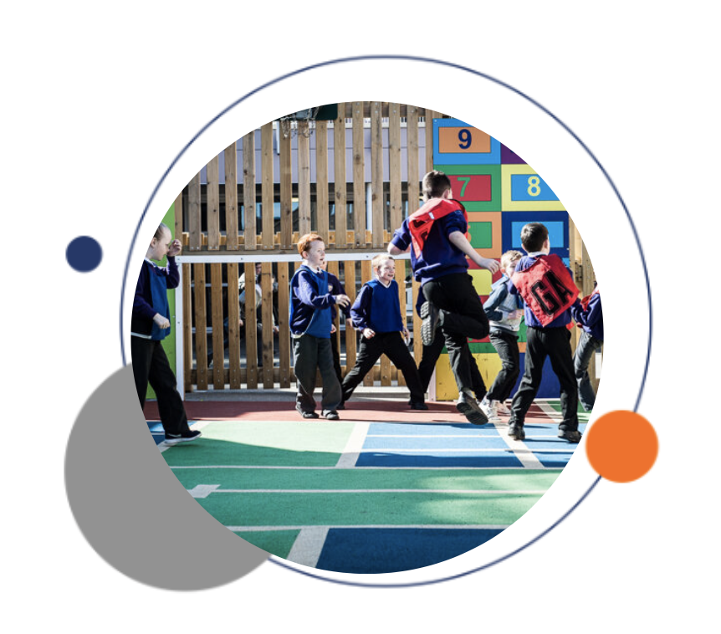


The Enquire Learning Trust

We are a multi-academy trust currently responsible for 32 Academies in four clusters across the North of England; North East Lincolnshire, Hull, Manchester, Teesside and North Yorkshire.

We work in complete collaboration with each of our academies and place a strong emphasis on school-to-school support and learning. Our academies work in collaboration with one another, sharing both their talent and ideas with others, giving employees the opportunity to learn from individuals within our other academies.

We recognise that the most important assets we have are our employees, and for our academies to succeed we need to ensure we employ the very best people in every single role. Our core values and beliefs are consistent throughout all of our academies, and our keys to success are at the heart of everything we do.

Every role across the Trust is valued, appreciated and purposeful. We believe that the outcome of every role across the Trust should improve the education each of our learners receive. Whether teaching, support or leadership, every single role is vital to the success of our academies.

We also recognise that all of our academies are different, and we encourage individuality. Whilst we believe our academies should work together to support best practice and to share ideas, we don’t believe that implementing blanket priorities and objectives is pertinent to a successful academy, and we encourage autonomy for academy leaders wherever possible.

Values

- We believe that all learners can be powerful learners given access to extraordinary learning experiences. We want children and the academies they attend to be confident, successful and ambitious.
- We envisage a Trust where well led, highly skilled and committed professionals collaborate, learn and innovate together to ensure that all academies are successful and where all learners have access to effective and innovative provision that meets their needs and aspirations.
- We want to add value to achievement and raise standards. We also want to change lives. We know this requires our provision and our practice to be world-class – because of the distance we have to travel, we understand that good will not be good enough and that we need to develop a shared appreciation of excellence and then strive to enact this every day.
- We take learning seriously and work together to create a vibrant culture in which this can happen. We know that it’s what we do that counts and that our thinking must be visible in classrooms if it is to have leverage. Children are at the forefront of all that we do and aspire to do. We take serious steps to engage them, to hear their voice in authentic ways and then to use their insight and expertise to develop radical pedagogies that tap into their passions and interests and use the potential of emergent technologies.

Welholme Academy was originally opened in 1892 and we serve one of the oldest parts of Grimsby. We are a large primary Academy and a focal point for our community. We are very proud of our school's fine reputation and believe in celebrating the successes in our area.
Our aim is that Welholme Academy is a safe and nurturing place, where all children, staff and visitors feel welcome and valued and we believe that together we can achieve anything. Children learn best when they are happy and confident and we want every child to achieve the very best they can. We encourage them to challenge themselves and to be proud of all their achievements.
We offer a personalised approach to teaching and learning. Our curriculum is engaging and exciting. It is designed to interest the children and meet their needs so that all children are keen to come to school and keen to learn.
We know that children learn best when parents and school work closely together and we value your support to ensure every child has the very best opportunity to succeed. We look forward to working with you.
At Welholme Academy we believe that everything is possible within a culture of collaboration, resilience, nurture and high aspirations we have been entrusted with the very privileged role of giving our children the very best education we can offer. We endeavour to achieve this by developing the full potential of all our children.
Our aims are to be:
Collaborative - We believe in the importance of creating a network of supportive relationships, where pupils, teachers, parents/carers, governors and other adults involved in school life, work alongside each other to enhance the atmosphere of co-operation, trust and mutual respect. We strive to work and learn together.
Resilient - We believe that anything is possible and overcome challenges in the face of difficulty.
Nurturing - What our children bring to school with them is all they have. They are all unique! We strive to be inclusive and believe in the “art of the possible”. We champion children’s uniqueness and encourage them to believe they can achieve anything! We are a nurturing school and positive attitudes are promoted to create an environment in which sensitivity and tolerance are shown to each individual. Being inclusive is in the forefront of everything that we do here at Welholme.
Aspirational - Our staff have high expectations of themselves and our pupils. Our curriculum is broad, balanced and appropriate to the child’s needs and we must never forget that we are concerned with the holistic development of each child. We strive for excellence and encourage our children to take pride in everything they say and do.
Everyone at Welholme is a learner and we never give up on achieving our aspirations and dreams of unlocking everyone’s potential.

Teaching Assistant (Level 2)
32.5 hours per week
Term Time Only plus 5 Days
Permanent,

NJC SCP 3, Pro-rata

To start Sept 2026

Welhome Academy are looking to recruit an experienced Level 2 Teaching Assistant to join our team.
The successful candidate will be required to support the class teachers with general classroom preparation, work with groups of children and will be required to assist at lunchtimes and playtimes as well as undertaking any other duties required by the Principal.
We are looking for:
- A suitably skilled Level 2 Teaching Assistant who believes in striving for the very best for all our children.
- Someone who is highly motivated, a team player and passionate about raising academic achievements and nurturing the well-being of all children at our school
- You will value the importance of developing positive learning interactions that provide success for all children and impact positively on self-esteem.
- You will be patient, focussed, and organised.
- You will be flexible and remain positive when changes are needed at short notice
We can offer:
- A supportive team.
- Children who are happy, welcoming and keen to learn.
- A chance to be part of our school’s journey to help all children to reach their potential.
- As part of the Enquire Learning Trust, we enjoy excellent networking opportunities, curricular innovation, support and excellent CPD.
- C2W Scheme
- Wellbeing scheme
- Pension

As part of the Welholme Academy Team you will play an important part in ensuring a caring and safe environment for all while ensuring our Academy Aims and Aspirations are met.
Interested candidates are welcome to visit the academy. Please call the school office on 01472 329944 to arrange.

Welholme Academy is committed to safeguarding and promoting the welfare of all children. This appointment will be subject to safer recruitment procedures and a full enhanced DBS check and references will be taken up.
Online Application forms are available via the Enquire Learning Trusts website:

https://www.enquirelearningtrust.org/job-vacancies
Closing Date: Monday 6th July 2026 @ 12pm / Thursday 16th July 2026

Job Description
Position: Level 2 Teaching Assistant

Job Description Teaching Assistant Level 2

Responsible to: Working under the guidance of Teaching staff, Vice Principal and Principal.

Role:
- Support access to learning by working under the supervision of teaching staff to implement agreed work programmes with individual/groups both within and out of the classroom.
- Assisting the Teacher in the whole planning cycle and with the management/preparation of resources.
- Provide support in the management of pupils and resources.

Experience:
- Working with or caring for children within the relevant age range.
- Working with pupils with additional needs.

Qualifications:
- Level 2 Teaching Assistant qualification or equivalent experience
- Grade A-C in literacy and numeracy GCSE’s (or equivalent qualification)
- Willingness to participate in training, performance management and self-evaluation of learning needs and actively seek learning opportunities.
- Training in relevant learning strategies and/or in a particular curriculum or learning area.

Knowledge/Skills:
- Ability to relate well to children and adults.
- Ability to work constructively as part of a team, understanding classroom roles and responsibilities and own role within these.
- Ability to use relevant technology.
- Ability to use ICT effectively in order to support learning and create resources.
- General understanding of national/foundation stage curriculum and other relevant learning programmes.
- Basic understanding of child development and learning.
- Ability to undertake first aid training
- Ability to undertake Team Teach training

Main duties and responsibilities:

- To primarily support children. This will involve working with small groups and one to one under the supervision of the teacher to deliver programmes of work and implement support plans.
- Assist colleagues with routine clerical tasks.
- Give regular feedback on children’s progress to the class teacher and file pupil records.
- Meet pastoral and physical needs under the guidance of the class teacher.
- Accompany teachers and pupils on educational visits.
- Display work under the direction of the teacher.
- Maintain high standards of health and safety at all times.
- Be aware of child protection procedures and report to the relevant member of staff any concerns.
- Maintain good relationships with colleagues and work together as a team.
- Assist in the supervision of classroom and outdoor activities under the guidance of the class teacher.
- Under guidance of class teacher help children to overcome barriers to learning including, e.g. behaviour management strategies, Team Teach, medical and health and safety procedures.
- Participate in appropriate meetings and training activities.
- Administer first aid following appropriate training.
- Supervise children during morning break and at lunchtimes.
- Support the use of ICT in learning activities and encourage pupils’ competence, safety and independence in its use.
- Contribute to the development of lesson plans.
- Be responsible for keeping and updating records, information and data.
- Assist in the implementation of appropriate behaviour management strategies.
- Monitor and evaluate pupil responses to learning activities through observation and planned recording of achievement against predetermined learning objectives.
- Maintain confidentiality at all times and to observe the General Data Protection Regulations.
- Carry out any other duties that may reasonably be regarded as within the nature of the duties, responsibilities and grade of this post.

PERSON SPECIFICATION

Criteria | Standard | Essential/Desirable | Measured by
Work Experience | - Experience of working in an school/educational setting | Essential | Application/Reference/Interview
Knowledge | - A Level 2 Teaching Assistant qualification or equivalent experience  - Grade A-C in literacy and numeracy GCSE or equivalent qualification.  - Experience/qualification in working with children with social, emotional and mental health needs and/or communication and interaction difficulties.  - Team Teach  - First Aid  - Previous experience of CPOMS. | Essential  Essential  Desirable  Desirable  Desirable  Desirable | Application  Application  Application/Reference/Interview  Application/Reference/Interview  Application/Reference/Interview  Application/Reference/Interview
Skills | - An ability to manage challenging behaviour  - An ability to work with a range of agencies  - An ability to work using own initiative and also under direction of others  - An ability to work with parents/carers | Essential  Essential  Essentail  Essential | Application/Reference/Interview  Application/Reference  Reference/Interview  Application/Reference/Interview
Attitudes | - Ability to maintain confidentiality  - Keen to continue developing skills and knowledge  - Reliable  - Confident  - Self-motivating  - Willingness to work as part of a team  - Aspirational for our children  - Nurturing  - Commitment to upholding the Academy vision. | Essential  Essential  Essential  Essential  Essential  Essential  Essential  Essential  Essential | Interview/Reference  Interview/Reference  Interview/Reference  Interview/Reference  Interview/Reference  Interview/Reference  Interview/Reference  Interview/Reference  Interview/Reference

