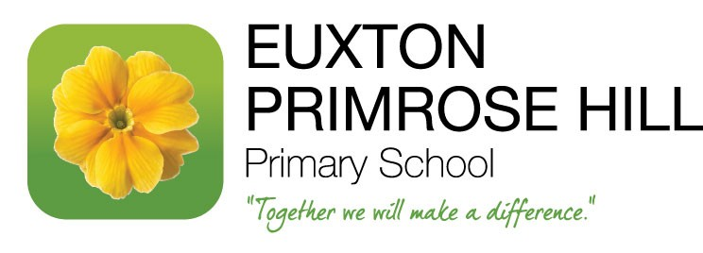
Autumn Term Curriculum Letter – Year 1 Cedar
Dear Parents / Carers of Cedar Class,
Welcome back after the summer break. Below is a brief outline of the areas we will be covering in the various subjects over this term along with useful timetable information and homework guidelines.
During our daily English lessons this term we will investigate a variety of different texts along with phonic, word and sentence work. We will be focusing upon stories with familiar settings, captions labels and lists and writing poetry about Autumn.
Our reading target this term is set at 30 home reads by Monday 16th December. Please ensure that the reading record is signed to avoid any confusion, especially when changing books. Please can I take this opportunity to express how important it is to read with your child on a regular basis as this not only supports them during literacy lessons but all aspects of the curriculum.
Maths lessons will focus on reading, writing and counting numbers up to 20 and beyond. We will also be covering lots of place value work, addition, subtraction, problem solving activities and 3-D and 2-D shapes!
In our Science lessons, we will learn about everyday materials and we will be investigating the properties of different materials. We will also be looking at the seasons, in particular changes we will see in the autumn.
Computing lessons will focus on developing programming skills using iPad apps and programming the BeeBots to move in different directions. The children will also be learning how to keep safe online.
Toys will be the focus for History lessons. We will be looking at our favourite toys today and those from the past and making comparisons – we may even ask if parents/ grandparents could send in their favourite toys!
During DT lessons the children will be making cards with moving pictures using mechanisms.

PSHE will give the opportunity for the children to discuss themselves, their emotions and the choices they make.
Exploring beat, rhythm and pitch will be the focus of our Music sessions during the Autumn term.
Art lessons will develop our mark making skills in drawing and creating light and dark when painting.
Forest school Mrs JotJeko will be delivering a series of cross-curricular lessons using the outdoor environment to enhance learning. These sessions will take place on a Tuesday afternoon. All waterproof clothing and wellies will be kept in school and they will be sent home at the end of each half term, to be washed and returned.
Multi-skills, dance and gymnastics are all on the menu for PE lessons this term. The PE sessions will take place on
Tuesday and Thursday – please ensure that your child comes in their P.E kit on these days.
RE lessons will focus on Christianity and Islam, looking at God, others and the world in both religions.
You can have a huge impact on how your child develops both in confidence and ability by encouraging them to read and practice independent self-help skills such as zipping up coats, tying shoelaces, being responsible for remembering personal belongings. (Please ensure all items are labelled).
Books will be changed and given out on a Friday. Digital copies of the books and the corresponding word lists are available on SHOWBIE.
On occasions children may be asked to bring something in to support their work in class or to find an answer to a question.
Birthday books – Usually birthday books are donated to the school library. This year, we are asking for donations for our class libraries to further enhance our curriculum. In Year 1 we would appreciate books by the authors:
Tom Pervical
Benji Davies
Eric Carle
Sue Hendra
Mairi Hedderwick
Jill Murphy
As you can see, it is certainly going to be a busy term but an interesting and varied one! If you have any questions or feel you have a particular expertise or interest in any of the above topics please let me know. I hope you have found this information useful and please do not hesitate to contact me if you have any queries.
Mrs Hacking.

