Please insert your school letterhead

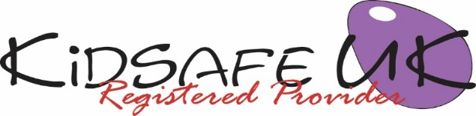

KidSafe UK EYFS Session 1 of 6: Introduction

Dear Parents/Carers

The KidSafe Early Years Foundation Stage (EYFS) programme has started today in your child’s class. The purpose of the EYFS programme is to develop your child’s ability to recognise unsafe situations and to take action to protect themselves.

Over the next few weeks the children will be looking at the following areas:

Trust; self-confidence and self-esteem; feelings/talking about our feelings; dealing with bullying; communication skills and saying ‘No’; computer/internet safety; age ratings on DVDs and computer games; how it feels to hear arguing.

As parents/carers you are your child’s most important people in helping to ensure their safely. After each session we will send home a letter telling you what we did during the session so that you can talk to them about what they’ve been doing.

Today, the KidSafe educator introduced themselves and played some getting to know you games with the children. These included talking about how children already keep themselves safe and the meaning of trust. Children were helped to become more aware of their feelings so that if they are sad, scared or worried they will have the vocabulary to voice those feelings. We called these sad, scared or worried feelings ‘yukky feelings.’

We welcome any comments you or your child have in relation to this session.

Yours sincerely,

Head teacher
Visit KidSafe at www.KidSafeuk.co.uk or follow us on Facebook  and Twitter 

KidSafe UK based in Cumbria has no association with Kidsafe Limited based in Stockport

© Copyright A V Webb & J K Walker 2018 licensed exclusively to KidSafe UK

