Please insert your school letterhead

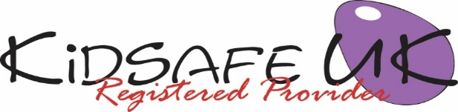

KidSafe UK EYFS Session 2 of 6: Yukky feelings

Dear Parents/Carers,

In today’s session we helped children become more aware of their feelings. We did group work to find out what makes children feel sad, scared and worried and what happens to their bodies when they are sad, scared or worried.

We gave a name for all these feelings - ‘yukky feelings’. Children now have a word to describe how they are feeling if anything makes them feel sad, scared or worried.

Please take this opportunity to talk with your child about today’s session and encourage them to tell you about what they have learnt and enjoyed in today’s KidSafe.

We welcome any comments you or your child have in relation to this session.

Yours sincerely,

Head teacher

Visit KidSafe at www.KidSafeuk.co.uk or follow us on Facebook  and Twitter 

KidSafe UK based in Cumbria has no association with Kidsafe Limited based in Stockport

© Copyright A V Webb & J K Walker 2018 licensed exclusively to KidSafe UK

