Please insert your school letterhead

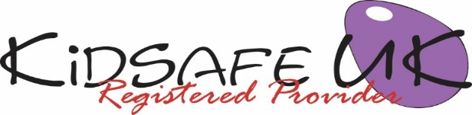

KidSafe UK EYFS Session 3 of 6: Bullying

Dear Parents/Carers,

In today‘s KidSafe session we talked about different types of bullying and what actualy makes something bullying. We gave our puppet, KS, a scenario where he was being bullied. KS had ‘yukky feelings’ (he felt sad, scared and worried) and the children came up with ways to help him.

Please take the time to talk to your child about today‘s KidSafe and please encourage them to tell you about what they have enjoyed and learnt in KidSafe .

We welcome any comments you or your child have in relation to this session.

Yours sincerely,

Head teacher

Visit KidSafe at www.KidSafeuk.co.uk or follow us on Facebook  and Twitter 

KidSafe UK based in Cumbria has no association with Kidsafe Limited based in Stockport

© Copyright A V Webb & J K Walker 2018 licensed exclusively to KidSafe UK

