Please insert your school letterhead

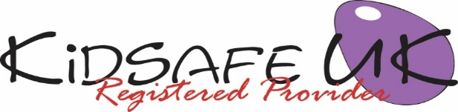

KidSafe UK EYFS Session 4 of 6:

Voice, telling trusted grown-ups and rules to keep our private places safe

Dear Parents/Carers,

Today in KidSafe we taught the children how to use their voices to say ‘No’ to any situation that may cause them to have ‘yukky feelings’ (when they are sad, scared or worried). Whilst we always encourage children to be respectful, it is sometimes necessary for children to break the rules and say ‘No’ when they are faced with situations that make them feel ‘yukky’ or scared.

We introduced a simple set of rules for children to help keep their private places safe.

We also encouraged the children to think about trusted grown-ups that they could talk to if they had a ‘yukky feeling’.

Please take the time to talk to your child about today’s KidSafe and encourage them to tell you what they have learnt or enjoyed.

We welcome any comments you or your child have in relation to this session.

Yours sincerely,

Head teacher
Visit KidSafe at www.KidSafeuk.co.uk or follow us on Facebook  and Twitter 

KidSafe UK based in Cumbria has no association with Kidsafe Limited based in Stockport

© Copyright A V Webb & J K Walker 2018 licensed exclusively to KidSafe UK

