Please insert your school letterhead

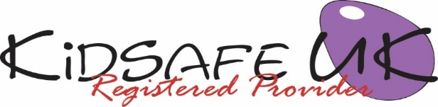

KidSafe UK EYFS Session 6 of 6: Evaluation

Dear Parents/Carers,

Today was the last KidSafe session. We have re-capped on the previous five sessions and the children have helped to evaluate what they had learnt and what they had enjoyed about the KidSafe programme. We talked about how it feels to hear arguing. We reinforced the main messages of the KidSafe programme: if anything makes them feel ‘yukky‘ that they can say ‘No‘, walk away and tell a trusted grown-up.

Each child received a certificate of participation. In approximately two months time they will have a re-cap session of the EYFS programme. When your child is in late year one upwards they will participate in the full KidSafe programme.

Please take this opportunity to talk with your child about the KidSafe programme to assess what they have learnt and enjoyed. If you would like to please give any feedback on the KidSafe programme to your KidSafe educator.

Yours sincerely,

Head teacher

Visit KidSafe at www.KidSafeuk.co.uk or follow us on Facebook  and Twitter 

KidSafe UK based in Cumbria has no association with Kidsafe Limited based in Stockport

© Copyright A V Webb & J K Walker 2018 licensed exclusively to KidSafe UK

