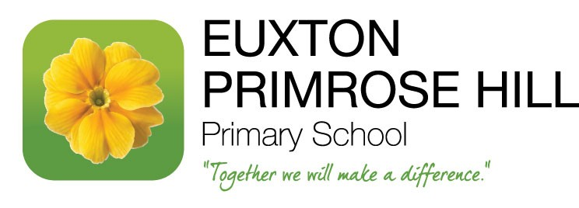
Autumn Term Curriculum Letter – Year 6 K2
Dear Parents/Carers of Year 6 K2 Class,
Welcome to the start of a new school year here at Primrose Hill. We’re so pleased to welcome the children back to school and hope they’re as excited as we are! Year 6 is a very special year and we look forward to working with you and your child during their final year at Primrose; we have a fantastic curriculum planned and we look forward to sharing your child’s successes with you as the year goes by. Outlined below, is an overview of the curriculum we have planned for the Autumn Term.

During our daily English lessons this term, we will continue to investigate a variety of different texts and genres, along with grammar work involving developing the use of a variety of sentence structures and appropriate punctuation. Please can I take this opportunity to express how important it is that your child reads on a regular basis. We recommend reading with your child three times a week. Each child in class has chosen their very own ‘Primrose Pathways’ book, which they can choose to read either at home or school. Once they have finished this, they need to upload a video review of the text to Showbie.
We are following the White Rose Maths learning scheme, which provides the children with the opportunity to learn age specific objectives, whilst practising reasoning and problem solving. Our focus this term will include consolidation of key concepts, alongside new concepts as part of the Year 6 curriculum. The topics to be covered within this term include: Place Value, Addition, Subtraction, Multiplication and Division, Fractions and Ratio.
+ = - x ÷ + = - x ÷ + = - x ÷ + = - x ÷
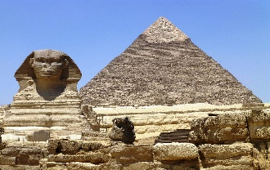
The Ancient Egyptians will be one of the main themes of class work this term. Using a combination of sources, we will begin to understand key achievements from this period in history. We will identify where the civilisation fits within a timeline and look at reasons for settlement near the Nile. In addition, our work will explore what daily life was like and the hierarchical system within society, including beliefs. As part of this topic, we will be visiting Liverpool Museum.
This Photo by Unknown Author is licensed under CC BY-SA
In Science this half term, we will be exploring ‘Electricity’. This will culminate in the creation of our own controllable vehicles in DT. Within our second unit, animals including humans, the children will explore the main functions of the heart and Circulatory System within the human body.
PSHE sessions will provide the children with the opportunity to explore keeping and staying safe, being responsible and Money Management. These are all important skills as we move towards high school and independence.
In R.E. the children will be learning about Hinduism and Christianity, particularly focusing on the aspect of journeys.
In our PE lessons, we will be covering Invasion Games and Gymnastics. These sessions will take place on Tuesdays and Thursdays, so could you please ensure your child comes to school in their full PE kits for these days – we will be going outside for some sessions so leggings or jogging bottoms are advisable for the later part of this term.
In Art during the Autumn term, we will be focussing on mark making and portraits. This will involve drawing our own portrait and creating a digitally altered version.
The children will continue with their French lessons; this term will focus on ‘Describing myself and others’ as we continue to build on our phonetic and linguistic knowledge.
Spellings will be tested on Friday mornings. The term’s spelling list has been uploaded to Showbie for your child to use when practising their spellings at home.
As you can see, it is certainly going to be a busy Autumn term in Year 6, but an interesting and varied one! If you have a particular expertise or interest in any of the above topics, please let me know. We look forward to working with you – ‘Together we will make a difference’
Best wishes,
Miss Burns

