

# 

# Mathematics Policy

## Evergreen Pupil Referral Unit

## 2025

|  |  |
| --- | --- |
| **Current Author:** | D Taylor - Head of School |
| **Person Responsible for the Policy:** | D. Taylor- Head of School |
| **Policy Start** | September 2025 |
| **Policy Review** | September 2027 |

**Evergreen Mathematics Policy**

**1. Intent**

The 2014 National Curriculum for Maths aims to ensure that all children:

* Become fluent in the fundamentals of Mathematics
* Are able to reason mathematically
* Can solve problems by applying their Mathematics

At Evergreen, our mathematics curriculum is carefully designed with our children’s diverse needs at the forefront. Many of the children who join us come from a variety of schools, academies, and settings, and often carry a negative view of themselves, the curriculum, and education in general. These children arrive from all parts of the city, and in some cases, even beyond, bringing with them a wide range of experiences with different curriculums, teaching styles, and expectations.

Evergreen provides short-term placements for children who have been excluded or at risk of exclusion. Given this, our initial focus often revolves around addressing specific areas such as the child’s attitudes, behaviour, and/or attendance. In the early stages, assess needs, set objectives and offer tailored support that reflects the reason for their placement, their individual needs, and the duration of their stay with us.

To meet the wide-ranging needs of our children, the teaching and learning of our curriculum must be flexible, personalised, and adaptive. We recognise that many of our children will eventually return to new schools, where they will face even more differences and expectations. Therefore, it is crucial that their time at Evergreen equips them with not only a mathematical knowledge but also the ability to navigate the various educational settings they may encounter.

At Evergreen, our staff are committed to helping children to understand the relevance of mathematics in the wider world, and to developing the confidence to apply their mathematical skills in a variety of contexts. We strive to foster a new love of mathematics, encouraging curiosity and helping children recognise the importance of the subject and how it can be beneficial for them. Above all, we want all our children to find joy and success in mathematics, and to be able to develop skills and knowledge in with confidence.

Therefore, our mathematics curriculum has to:

* Engage and inspire children who may have lost their love for learning. We aim to re-engage those who have disengaged by offering effective teaching that caters to children entering at various points during the year, at different academic levels, and with different starting points and areas of study.
* Develop and reinforce positive behaviours and personal dispositions. Through new ways of learning and building relationships, we help children break old habits and adopt positive behaviours. This ensures that when children return to mainstream schools or move on to the next stage of their education, they do so equipped with the skills and attitudes needed to engage with new challenges.
* Enable exploration of the world through a curriculum that is accessible, exciting, and experiential. Our approach helps shift children’s self-perception as learners, supporting progress from their starting point with a clear focus on developing mathematical skills and understanding.
* Identify and address gaps in knowledge, skills, behaviours, and dispositions. We assess where children may be struggling and work to inspire, motivate, and support them in bridging these gaps. This approach builds on the strengths and talents they already possess, helping them to re-engage with learning.
* Provide adaptable teaching for children who may stay at Evergreen for varying lengths of time, from as little as 12 weeks or longer. We ensure that all children, regardless of their length of stay, receive meaningful and effective learning experiences.
* To support the reintegration of all our children—whether back into mainstream education or onward to specialised provision—it is essential that our curriculum aligns with the objectives and outcomes of the National Curriculum. This ensures that children are prepared for future success, whatever their next step may be.

**2. Implementation of the Curriculum**

At Evergreen, we recognise that most children enter with diverse starting points, often accompanied by negative views and low self-esteem, particularly in mathematics. Previous experiences may have diminished their engagement and confidence in the subject. To address this, our approach to teaching mathematics is tailored to ensure both accessibility and engagement for every Child.

In line with the National Curriculum, we strive to make mathematics accessible to all learners. Our staff provide targeted support for those who need it while challenging the further development of mathematic skills and knowledge. At Evergreen, we are committed to helping children rediscover the joy of mathematics, building the essential connections that enable them to become more fluent, confident, and capable mathematicians.

While Evergreen delivers a broad and balanced curriculum, we understand that many of our children may not be able to engage with it in its entirety. This may be due to their individual academic needs, attitudes toward learning, attendance challenges, or future transition onwards into the next stage of their learning journey. Our curriculum is adapted to meet these varying needs, with a focus on reigniting children’s passion for learning, motivating them, and helping them make the most of their time at Evergreen.

Staff at Evergreen work to help children understand the critical role mathematics plays in their future academic progress, everyday life, and long-term success.

These guiding principles and features define how we implement our curriculum and highlight our commitment to supporting each child's learning journey.

These principles and features characterise this approach and convey how our curriculum is implemented:

**High expectations for all Children**: Teachers maintain a strong belief that every child is capable of achieving high standards in mathematics, according to their ability.

**Focus on building positive learning behaviours**: Significant time is dedicated to developing children’s learning behaviours, dispositions, and confidence. This foundational work supports the development of key mathematical knowledge and skills necessary for future learning.

**Bridging gaps before moving forward**: Teachers ensure that any gaps in understanding are addressed before progressing to the next part of the curriculum. This approach helps children build confidence and competence in their skills.

**Early identification and timely intervention**: If a child struggles to grasp a concept or procedure, it is quickly identified, and targeted intervention is provided to help them move forward without falling behind.

**Emphasising structure and connections:** Patterns are highlighted, enabling children to develop a deeper understanding of how different concepts connect and build on each other and how they connect to their world.

**Adapted, sequenced lessons**: Teachers carefully design and adapt lessons to clearly outline the new mathematical content, key concepts, challenging areas, and a well-structured progression of learning, tailored to children’s needs and behaviours.

**Interactive teaching:** In a typical lesson, children engage in interactive exchanges, including questioning, brief tasks, explanations, demonstrations, and discussions that promote active participation and deeper understanding.

**Practice and consolidation:** Varied activities are designed to build fluency while reinforcing the underlying mathematical concepts.

**Questioning and regular assessment:** Teachers use targeted questioning to assess both conceptual and procedural understanding. Regular assessments are conducted to identify children who may require additional support.

**Supporting development of mathematical vocabulary:** Children receive support to share their mathematical reasoning, help to express their thought processes and grasp of mathematical vocabulary.

**Support the retention of key facts:** Children are supported to develop their understanding and recall of facts, such as multiplication tables and addition facts.

To ensure consistency and progression throughout the curriculum, the school utilises and adapts the nationally recognised White Rose Maths scheme. This curriculum is designed to be cumulative, meaning that once a topic is introduced, it is revisited in various contexts. For example, the concept of place value is reinforced through addition, subtraction, multiplication, and division. A significant emphasis is placed on number, with the majority of teaching time dedicated to reinforcing number skills, ensuring students build strong foundational competencies.

Lessons are planned to integrate concrete, pictorial and abstract representations of mathematical concepts and procedures, facts and patterns, with opportunities to reason and problem-solve. When new concepts are introduced, children have the opportunity to engage and explore with concrete objects and manipulatives to deepen their understanding.

Mathematical topics are taught in blocks, allowing children to develop mastery of skills and knowledge over time. These blocks are broken down into smaller, manageable steps to support better comprehension and help our children nurture positive attitudes towards mathematics.

**3. Impact**

Many of our children arrive at Evergreen with the belief that they cannot succeed in mathematics, often due to previous negative experiences, these preconceptions can contribute to underperformance.

Our teaching is guided by regular and ongoing assessments, which inform teaching and intervention strategies, ensuring that each child receives the support they need to succeed and develop their confidence positive learning behaviours towards maths.

Upon arrival at Evergreen, children undergo baseline assessments, providing valuable insights into their mathematical abilities, as well as their attitudes towards learning, and behaviour. These assessments are outlined in more detail in Evergreen’s Assessment Policy.

Following baseline assessments, personalised objectives are set for each child and assessed against a skills continuum using Mapping and Assessing Personal Progress (MAPPS). Every child is given three specific mathematics targets. These targets are aligned with National Curriculum outcomes and are reviewed regularly. If a child's stay at the PRU is extended, they are re-baselined, and new objectives are set to ensure continued progress.

This approach allows staff to directly address the specific learning needs of each child, helping to bridge gaps in understanding and reducing barriers to further progress. By targeting these gaps, children are better positioned to access the curriculum, making their current and onward learning journey more successful.

|  |  |
| --- | --- |
| **Impact** | |
| The key measure of impact will be the progress made by pupils from their individual starting points. Methods for assessment are outlined in our assessment policy.  We will further evaluate the impact of our curriculum by using the methods outlined in the table below. | |
| **Intent** | **Measure** |
| Develop, maintain and reinforce positive behaviours and personal dispositions by showing children new ways of getting on in learning and relationships and by breaking old habits and behaviours. | Observations, moderation and review  Head Reports  Pupil Progress Meetings  MAPPS/Data  PASS/ Pupil Voice  Attendance  Destinations  Governor visits  Work scrutiny  Attendance |
| To inspire and motivate and support children to bridge gaps in learning and re-engage children by building on the talents and skills children already have. | Observations, moderation and review  Head Reports  Pupil Progress Meetings  MAPPS/Data  PASS/ Pupil Voice  Attendance  Destinations  Governor visits  Work scrutiny  Attendance |
| Enable children to explore their world through an accessible, fulfilling and exciting, experiential curriculum. | Curriculum opportunities and experiences  Observations, moderation and review  Head Reports  Pupil Progress Meetings  MAPPS/Data  PASS/ Pupil Voice  Attendance  Destinations  Governor visits  Work scrutiny  Attendance |
| To support a change in children's self-perception as learners and enable progress from their individual starting point with a focus on facilitating the development of English and Mathematics. | Curriculum opportunities and experiences  Observations, moderation and review  Head Reports  Pupil Progress Meetings  MAPPS/Data  PASS/ Pupil Voice  Attendance  Destinations  Work scrutiny  Attendance |

**4. Teaching and Learning**

At Evergreen, we are committed to nurturing children’s mathematical skills and knowledge by incorporating daily mathematics teaching and providing opportunities for hands-on exploration through concrete, pictorial, and abstract representations. This approach helps children build a deeper understanding of key concepts, procedures, facts, and patterns in mathematics. To further enhance their learning and mastery, we align our teaching with the five big ideas developed by the National Centre for Excellence in Teaching Mathematics (NCETM) in 2017.

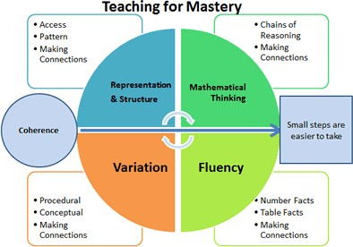

The five big ideas are:

**Coherence:** Lessons are broken down into smaller and connected steps that gradually unfold the concept, providing access for all children and leading to the use of the concept in a range of contexts.

**Representation and Structure:**Representations are used in lessons to show mathematical structures so that children can understand patterns and concepts.

**Mathematical Thinking:** Children are supported to think about what they are doing and the reasons behind what they are learning**.** Children are given the opportunity to think about their learning, reason with it and discussed with others to develop and retain knowledge and skills.

**Fluency:** Children are given the opportunity to recall facts, procedures, contexts and representations of mathematics.

**Variation:** Children are given the opportunity to learn in more than one way, to draw attention to aspects, and to develop a better understanding of what is being learnt.

So that mathematics teaching and learning remains consistent, the school utilises and adapts the White Rose Maths scheme. Using White Rose provides our children with the opportunity to:

* Recognise and use connections and mathematical ideas.
* Understand how mathematical ideas interconnect and build on one another.
* Recognise and apply mathematics in different contexts.
* Provided models and calculation methods that children can use.

Teachers will carefully assess when to introduce new content based on the level of fluency demonstrated by each child. They will ensure that students have a solid understanding before progressing further.

Additionally, where appropriate, teachers will provide opportunities for extra practice and targeted feedback during marking, focusing on building students' confidence and fostering their success in mathematics.

**5. Planning and Resources**

The use of manipulatives objects is an integral part of the White Rose Maths scheme which incorporates the concrete–pictorial–abstract pedagogy:

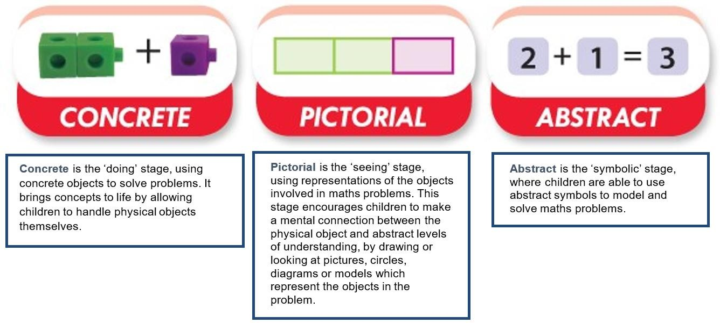

Teachers have access to the White Rose Maths Interactive Teaching Resources, which are designed to help model strategies and demonstrate the use of concrete resources, manipulatives, and other mathematical tools to support student learning.

The school also subscribes to the White Rose Maths Premium Resource Centre, providing teachers with access to a wide range of visual resources, including adaptable lesson slides. Additionally, it offers small step planning guidance, as well as reasoning and problem-solving questions that accompany each step, helping to inform and enhance lesson delivery.

**6. Assessment**

**Assessment for Learning:**

Children receive feedback through teacher assessment, both orally and through written feedback.

**Formative Assessment:**

Short-term assessment is a feature of each lesson. Observations and careful questioning enable teachers to adjust lessons and brief other adults in the class if necessary.

At the end of each blocked unit of work, White Rose Maths ‘End of Unit Assessment’ may be used and the outcome of this may be used by the teacher to ensure that any identified gaps in understanding are identified. Teacher will also assess through GL assessments which inform MAPPS and PASS assessments made as to the extent that each child has achieved the expectation.

Assessment data in maths is reviewed throughout the year to inform, progress of individuals and identified groups, interventions to further address gaps and to ensure that provision remains well-informed and to inform whole school and subject development priorities for the next school year.

**6. Organisation**

The school has adopted a blocked curriculum approach to the teaching of Mathematics. This approach allows children to focus more deeply on each specific area of mathematics, enabling them to develop a stronger, more secure understanding over time. It is also designed to support progression to a greater depth of understanding.

Each subsequent block reinforces and consolidates prior learning, ensuring that children regularly practice key skills and begin to see how different mathematical concepts are interconnected. For example, after completing a block on multiplying two-digit numbers, a following block on area and shape might provide opportunities for children to apply their understanding of multiplication when calculating the area of shapes with two-digit length and width dimensions.

At Evergreen, base teachers use White Rose Maths, adapting it as needed to suit their class’s needs. Children record their work in exercise books and respond to questions accordingly. They may also use their maths books to note key number facts and represent mathematical concepts visually.

Short-term planning is carried out on a weekly basis. Teachers also adapt, plan, and source additional activities to provide extra support where needed and offer further challenges for children who are ready to deepen their learning.

**7. Equal Opportunities**

Evergreen is committed to ensuring the active participation and progress of all children in their learning.

Every child will be given equal opportunities to reach their highest potential, regardless of their current attainment, gender, ethnicity, social or cultural background, home language, or any other factors that might influence their participation or the progress they are capable of making.

**8. Inclusion**

Evergreen is dedicated to providing a broad and balanced curriculum that allows all children to succeed and achieve their best within it. Staff will adapt the curriculum to meet the diverse abilities of our students, ensuring that each child has the opportunity to thrive. We will closely monitor and identify any children or groups who are underachieving and take appropriate steps to address their needs in collaboration with the SENCo.

Children’s difficulties and misconceptions will be identified through immediate formative assessment and addressed with timely interventions, often through individual or small group support, either later in the same day or within the lesson itself.

**9. Moderation and Leadership of Maths**

The Leadership Team and the Academy Council are responsible for monitoring the impact of the school’s mathematics curriculum, focusing on both academic progress and social outcomes.

The Head of School manages the day-to-day organisation of the curriculum. Given the small staff size, class teachers are responsible for monitoring the impact of learning and ensuring the curriculum is fully covered within their designated base. They review curriculum planning for their base to ensure all children receive the full requirements of the National Curriculum, are given opportunities to spark their curiosity, and are consistently challenged to apply and deepen their learning.

Senior leaders and teachers collaborate to inspire learning in each individual base and closely monitor how teaching is delivered. Senior leaders review long-term and medium-term planning to ensure that appropriate teaching strategies are in place. They are also responsible for overseeing the effective use of resources. Curriculum monitoring for each base is conducted by teachers, with full support from senior leaders. Together, they identify strengths and areas for further development in each base