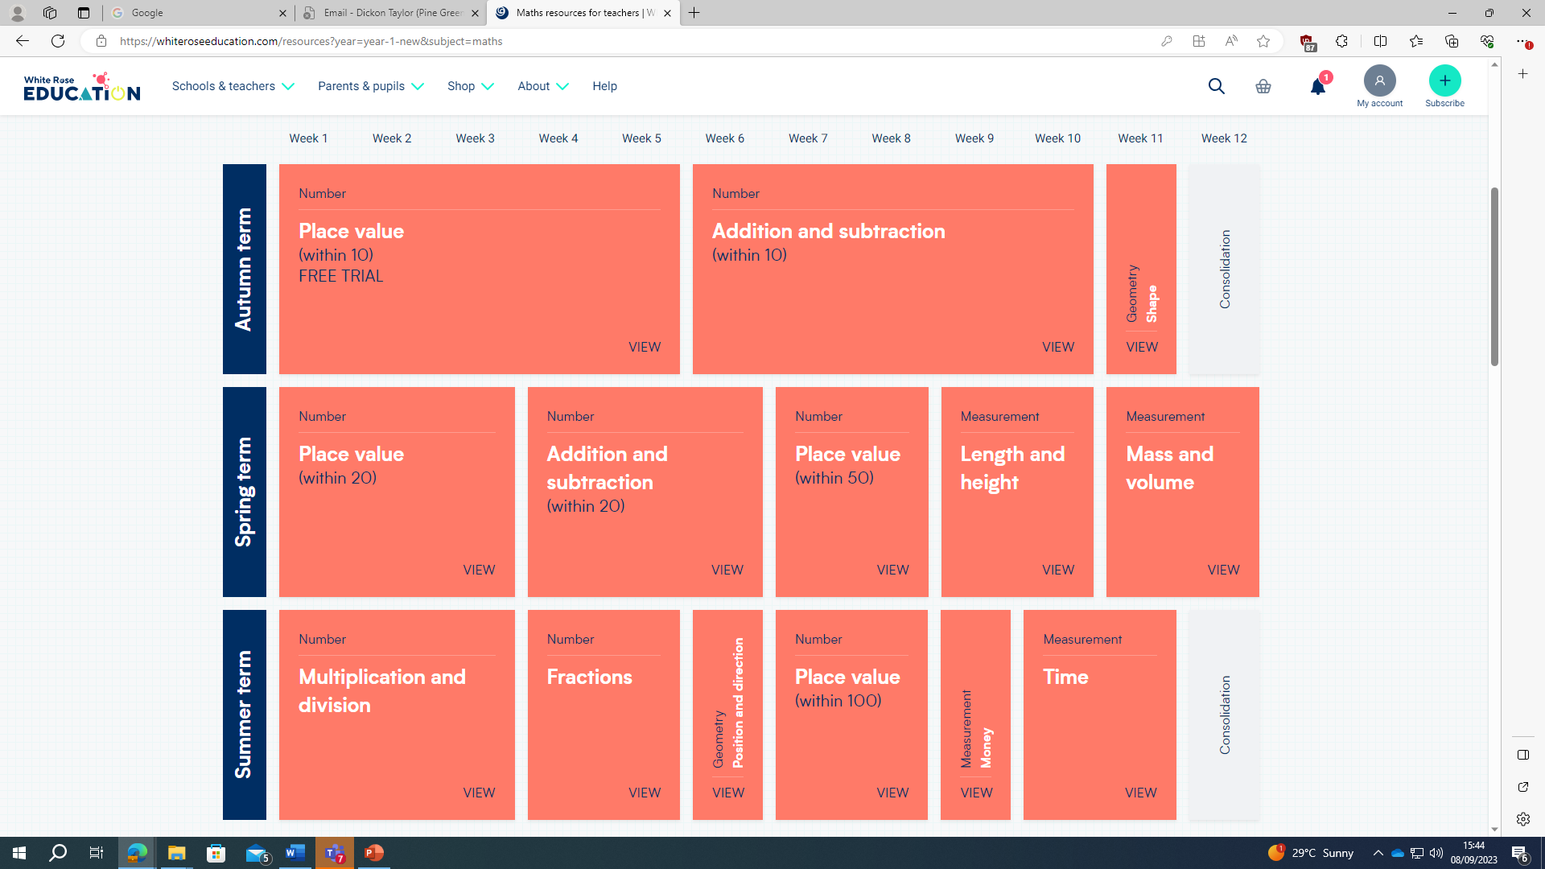
Year 1 White Rose Maths Scheme of Work

