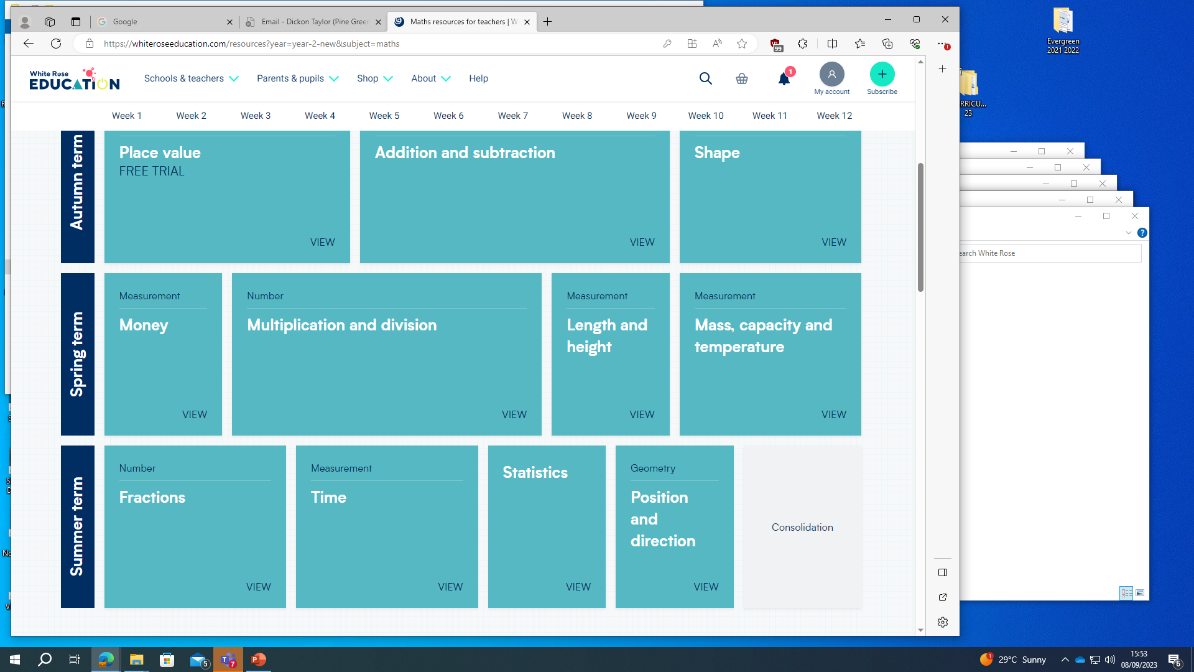Year 2 White Rose Maths Scheme of Work