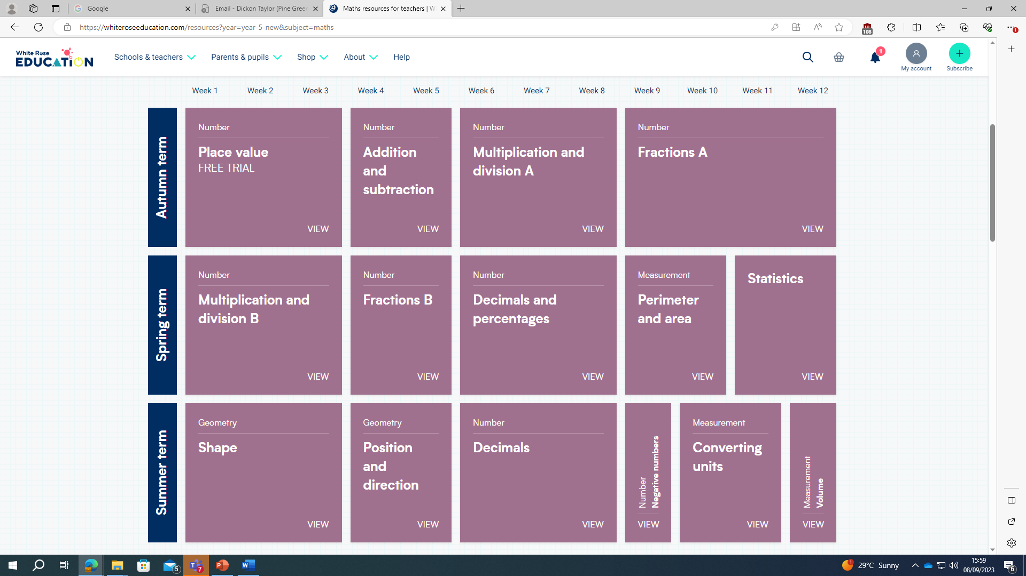
Year 5 White Rose Maths Scheme of Work

