

Attendance Policy 2026/27

Approved by | Date
Academy Council / Trust Board | September 2025
Last reviewed on | August 2026
Next review due by | September 2027

Contents
1. Aims and attendance culture
2. Legislation and guidance
3. Definitions
4. Roles and responsibilities
5. Recording attendance
6. Daily attendance and escalation process
7. Unplanned absence and first-day response
8. Planned absence, medical appointments and leave of absence
9. Lateness and punctuality
10. Promoting good attendance and punctuality
11. Supporting pupils with poor attendance
12. Persistent absence, severe absence and legal escalation
13. Tier 2, dual registration and commissioning schools
14. Supporting pupils who are absent or returning to school
15. Safeguarding, children missing education and elective home education
16. Attendance monitoring, analysis and reporting
17. Removing a pupil from roll
18. Monitoring arrangements
19. Links with other policies
Appendix A: Daily Attendance and Escalation Process
Appendix B: Attendance codes
Appendix C: EWO/FPN referral evidence checklist
Appendix D: Attendance Leaflet for Parents

1. Aims and attendance culture
Regular and punctual attendance is essential to pupils’ safeguarding, wellbeing, personal development, learning and future opportunities. At Evolve Academy, attendance is everybody’s responsibility and forms part of safeguarding, behaviour and student engagement.
This policy sets out how Evolve Academy will promote good attendance and punctuality, identify absence early, support pupils and families to overcome barriers, and escalate concerns where support is not successful, not appropriate or not engaged with.
- Set high expectations for attendance and punctuality across all provisions.
- Promote positive attendance through relationships, belonging, rewards and recognition.
- Reduce absence, including persistent absence and severe absence.
- Ensure pupils have access to the full-time education to which they are entitled.
- Act early where patterns of absence, lateness or lost learning time emerge.
- Work with parents, carers, commissioning schools, the local authority and external partners to remove barriers to attendance.
- Treat poor attendance as a possible indicator of safeguarding, welfare, SEND, SEMH, contextual or family need.

2. Legislation and guidance
This policy is informed by current statutory and local guidance, including:
- Department for Education statutory guidance: Working together to improve school attendance.
- School attendance parental responsibility measures.
- The Education Act 1996.
- The Education Act 2002.
- The Education and Inspections Act 2006.
- The School Attendance (Pupil Registration) (England) Regulations 2024.
- The Education (Penalty Notices) (England) Regulations 2007, as amended.
- The Equality Act 2010.
- Keeping Children Safe in Education.
- Mental health issues affecting a pupil’s attendance: guidance for schools.
- Children Missing Education statutory guidance.
- Lambeth Education Welfare Service processes for referrals, notices to improve, SALI and fixed penalty notices.

3. Definitions
Term | Meaning
Parent | Any person with parental responsibility, any natural parent, or any person who has day-to-day care of the child.
Persistent absence | Attendance below 90%, meaning the pupil has missed 10% or more of possible sessions.
Severe absence | Attendance below 50%.
L code | Late arrival before the register has closed.
U code | Arrival after the register has closed. This counts as an unauthorised absence for the session.
Tier 2 / dual registration | Pupils who attend Evolve as part of a placement or shared registration arrangement where the home or commissioning school may retain responsibility for formal attendance/legal processes.
Senior Attendance Champion | The designated senior leader responsible for leading, championing and improving attendance across the academy.

4. Roles and responsibilities
Attendance is a shared responsibility across the academy. The following roles set out the core expectations.

Academy Council / Trust Board
- Sets high expectations for attendance and punctuality.
- Monitors and challenges attendance data and improvement activity.
- Ensures attendance processes are effective and that support is prioritised for pupils who need it most.
- Holds the Headteacher to account for implementation of this policy.

Headteacher
- Has overall responsibility for the implementation of this policy.
- Monitors school-level attendance data and reports to governance.
- Ensures attendance is communicated as a whole-school priority.
- Authorises, where appropriate and in line with local authority processes, the use of statutory attendance interventions.
- Ensures pupils with SEND, SEMH needs or EHC plans are supported through appropriate attendance approaches and that the local authority is informed where attendance falls because of needs-related barriers.

Attendance Lead
- Leads, champions and improves attendance across Evolve Academy.
- Maintains oversight of attendance systems, analysis and intervention.
- Uses Trackers, SIMS, Call Log and Action Log to identify trends and monitor impact.
- Coordinates with the DSL, DST, Admin Team, Learning Advisors, class staff and EWO.
- Ensures persistent absence, severe absence, lateness and safeguarding-linked attendance concerns are reviewed and escalated.
- Supports the development of attendance contracts, reintegration plans and personalised attendance plans.

Designated Safeguarding Lead / DST
- Ensures attendance concerns are considered alongside safeguarding, welfare, contextual risk and vulnerability.
- Reviews Purple Button attendance-related safeguarding escalations.
- Coordinates contact with social workers, early help, youth justice, health professionals and other agencies where appropriate.
- Ensures CME, MARF and home-visit processes are considered where thresholds are met.

School Office / Admin Team
- Records and monitors daily attendance information on SIMS.
- Receives and records absence messages from parents/carers.
- Produces and supports missing pupil lists and follow-up information.
- Completes Primary first-day response calls and supports wider first-day response as required.
- Maintains accurate records of contact, reasons for absence and outcomes.

Learning Advisors / Class Staff / Tutors
- Take accurate registers within the required registration window.
- Identify missing pupils and pass concerns immediately to Admin/DST.
- Promote good attendance and punctuality with pupils.
- Complete first-day calls for allocated Secondary AP, Secondary SEMH and Tier 2 pupils where required.
- Record outcomes on the Call Log and pass concerns to the Attendance Lead/DST.

Parents and carers
- Ensure their child attends every day and on time.
- Notify the academy of absence by 8.30am on the first day of absence and on each subsequent day unless otherwise agreed.
- Provide accurate and up-to-date contact details, including at least two emergency contacts where possible.
- Arrange medical and dental appointments outside the school day wherever possible.
- Provide medical evidence where requested and appropriate.
- Engage with attendance meetings, support plans, attendance contracts and local authority processes.

Pupils
- Attend school every day and on time.
- Attend every timetabled session and remain on site unless authorised to leave.
- Engage with support offered to improve attendance, punctuality and learning routines.

5. Recording attendance
Evolve Academy keeps an electronic attendance register on SIMS and records all pupils on the register using the appropriate national attendance and absence codes. The academy will take the attendance register at the start of each morning session and once during the afternoon session.
- Any amendment to the register will show the original entry, amended entry, reason for amendment, date of amendment and the name/position of the person making the amendment.
- Every entry on the attendance register will be retained for 6 years after the date on which the entry was made.
- Attendance codes must be entered accurately and promptly. SIMS remains the official attendance record.
- Operational tracking through the King Tracker, Call Log and Action Log supports leadership monitoring but does not replace the statutory register.

Provision registration times
Provision | Expected arrival / registration | Late mark | Register closes / U code
Primary | 8.50am to 9.00am | After 9.00am | After 9.20am
SEMH | 8.55am to 9.05am | After 9.05am | After 9.25am
Secondary AP | 9.00am to 9.10am | After 9.10am | After 9.30am
Tier 2 | 9.05am to 9.15am | After 9.15am | After 9.35am
Pupils who arrive after the register closes will receive a U code for the session. A U code counts as an unauthorised absence and may contribute to attendance escalation and legal thresholds.

6. Daily attendance and escalation process
The academy’s Daily Attendance and Escalation Process sets out the operational expectations for registers, first-day response, recording and escalation.
Time / stage | Action | Responsible staff
8.55am–9.25am | Registers taken accurately. Missing pupils identified and concerns passed to Admin/DST immediately. | Learning Advisors / Class Staff
9.25am–9.30am | Registers received and entered onto SIMS. Absence reasons recorded. Missing pupil list generated. Vulnerable/high-risk pupils identified. | Admin Team
After 9.30am | Missing pupil list generated and prioritised for first-day response calls. | Admin Team / Attendance Lead / Learning Advisors
Throughout day | Call Log, SIMS notes and Action Log updated. Safeguarding concerns escalated through DSL/DST and Purple Button where required. | All relevant staff

7. Unplanned absence and first-day response
Parents/carers must notify Evolve Academy by 8.30am on the first day of an unplanned absence and each subsequent day of absence unless a different arrangement has been agreed. Notification should be made by telephone or via the published academy absence email/contact route.
Where no reason has been received, Evolve Academy will make first-day contact. The purpose is to establish the reason for absence, confirm the pupil’s safety and identify whether the absence should be authorised or unauthorised.
Cohort | First-day response lead | Expectation
Primary | Admin Team | Admin Team completes first-day response calls. Primary staff support where operationally possible.
Secondary AP | Learning Advisors | Allocated staff phone pupils/families directly, record outcomes and escalate concerns.
Secondary SEMH | Learning Advisors | Allocated staff phone pupils/families directly, record outcomes and escalate concerns.
Tier 2 | Learning Advisors / Attendance Lead | Allocated staff contact families and, where relevant, ensure home/commissioning school is informed.
All first-day response activity must be recorded. Detailed notes should be entered on SIMS first. Key operational information should also be recorded in the Call Log to support follow-up, quality assurance and escalation.
Call Log fields
Date, time, pupil name, called by, call type, outcome, key notes, follow-up required, next action date and responsible staff.

8. Planned absence, medical appointments and leave of absence
Parents/carers should arrange medical and dental appointments outside the school day wherever possible. Where this is not possible, pupils should miss the minimum time necessary and attend before or after the appointment where appropriate.
- Parents/carers must notify the academy in advance of planned appointments.
- The academy may request evidence of appointments, including appointment cards, letters, prescriptions or other appropriate evidence.
- Where attendance is below expected levels or patterns of illness absence are a concern, the academy may request medical evidence before authorising further illness absence.
- Unverified absence may be recorded as unauthorised where the academy is not satisfied with the explanation provided.

Leave of absence during term time
The Headteacher will only grant leave of absence during term time where the request meets the specific circumstances set out in the School Attendance (Pupil Registration) (England) Regulations 2024. Leave of absence is granted at the Headteacher’s discretion, including the length of time authorised.
- Family holidays during term time will not usually be authorised.
- Requests should be submitted as far in advance as possible and, where possible, at least three weeks before the requested absence.
- The Headteacher may require evidence to support any request.
- Unauthorised leave may result in referral to the local authority and/or a fixed penalty notice where thresholds are met.

9. Lateness and punctuality
Punctuality is essential. Late arrival leads to lost learning time and can create safeguarding concerns where pupils’ whereabouts are unknown. Lateness will be monitored through SIMS, the King Tracker and punctuality analysis.
Concern |  | Response
Late before register closes |  | Recorded as L. Patterns will be monitored and may result in parent contact, morning routine support, breakfast club, travel checks, punctuality rewards or behaviour consequences.
Late after register closes |  | Recorded as U. This is an unauthorised absence for the session and may trigger attendance meetings, EWO discussion and legal thresholds where patterns persist.
Repeated lateness |  | Action may include attendance contract, parent meeting, punctuality report, mentoring, detentions/reflection, EWO referral and/or fixed penalty notice consideration where appropriate.
Number of lates | Timeframe |  | Action
3 lates | Within 2 weeks |  | Pupil placed on punctuality / attendance monitoring with parent contact.
6 lates | Within 4 weeks |  | Parent meeting arranged and attendance contract considered.
Ongoing lateness | Persistent or beyond 6 lates |  | EWO referral, notice to improve, fixed penalty notice or legal escalation considered where thresholds are met.

10. Promoting good attendance and punctuality
Evolve Academy promotes good attendance through a balance of high expectations, positive relationships, visible recognition and timely support.
- Weekly and termly recognition for pupils with strong or improving attendance.
- Provision-level celebration of attendance and punctuality.
- Certificates, assemblies, displays and positive communication home.
- Punctuality rewards where pupils improve morning routines and reduce lost learning time.
- Attendance information shared with pupils and parents in language that explains days, sessions and learning missed, not only percentages.
- Attendance culture aligned with behaviour rewards and the academy values: We care, We empower, We excel, We evolve.

11. Supporting pupils with poor attendance
Evolve Academy will use a support-first approach wherever appropriate. Poor attendance is often a symptom of wider barriers and must be understood before escalation decisions are made. Support and intervention may include:
- First-day response and welfare calls.
- Parent/carer meetings, including online meetings where appropriate.
- Attendance contracts and personalised attendance plans.
- Morning check-ins, breakfast club and travel support discussions.
- Mentoring, key adult support and reintegration planning.
- Counselling, therapeutic support, SALT-informed strategies and SEMH support.
- SEND review, reasonable adjustments and liaison with the local authority where an EHC plan is in place.
- Social care, early help, youth justice, school nursing, CAMHS or other external agency liaison where appropriate.
- Home visits, attendance panels and EWO involvement.

12. Persistent absence, severe absence and legal escalation
Persistent absence and severe absence are central priorities within Evolve Academy’s attendance strategy. Pupils below 90% and below 50% attendance will be reviewed regularly through the King Tracker, CEO Dashboard, attendance meetings, safeguarding oversight and EWO liaison.
Attendance concern | Possible response
95%–90% | Monitor attendance, parent communication and attendance warning letter where appropriate.
Below expected levels / 10 sessions absence | Stage 1 concern letter, attendance monitoring and medical evidence requested where appropriate.
Continued concern / patterns over multiple weeks | Stage 2 meeting, attendance contract, EWO discussion and targeted support plan.
Below 75% / persistent U codes | SALI consideration, home visits, attendance panel and fixed penalty notice consideration where appropriate.
Below 50% / no contact / safeguarding concern | Severe absence review, DSL/DST escalation, EWO/legal pathway, court panel consideration, MARF/CME referral where appropriate.

Fixed penalty notices and notices to improve
The academy will work with the local authority and follow the national framework and local code of conduct when considering penalty notices, notices to improve and other legal interventions. Decisions will be made on an individual, case-by-case basis, taking into account support offered, engagement with support, safeguarding, SEND, equality considerations and whether a legal intervention is the most appropriate route.
- The national threshold for considering a penalty notice is 10 sessions of unauthorised absence in a rolling period of 10 school weeks.
- A first penalty notice is £80 if paid within 21 days or £160 if paid within 28 days.
- A second penalty notice for the same parent in respect of the same child within 3 years is £160 if paid within 28 days.
- A third penalty notice cannot be issued to the same parent for the same child within 3 years; alternative legal action will be considered.
- Notices to improve will normally set out the attendance concerns, support offered, opportunities for further support, improvement period and consequences if attendance does not improve.

13. Tier 2, dual registration and commissioning schools
Some pupils attend Evolve Academy through Tier 2, respite, alternative provision, dual registration or commissioning arrangements. Attendance for these pupils must be recorded, monitored and communicated clearly.
- Evolve will record attendance accurately and share attendance information with the home or commissioning school as agreed.
- The home or commissioning school retains responsibility for the child and for initiating formal attendance/legal processes unless another arrangement is formally agreed.
- Evolve will escalate concerns promptly to the home school, EWO and relevant professionals where attendance falls below expected levels.
- Warning letters, meeting notes and attendance reports should be copied to the home school where appropriate.
- Weekly reporting should identify Tier 2 attendance separately, including Primary Tier 2 and Secondary Tier 2 where data allows.

14. Supporting pupils who are absent or returning to school
Evolve Academy will provide targeted support for pupils who are absent or returning after a lengthy or unavoidable period of absence.
Barrier / situation | School response
Complex barriers to attendance | Meet with parents/carers and relevant professionals to understand barriers and agree a targeted plan. Consider TAF/early help, EWO, social care, youth justice or other partner involvement.
Mental or physical ill health | Work with the family, health professionals and local authority as appropriate. Consider reasonable adjustments, phased reintegration, part-time timetable where lawful and time-limited, and ongoing review.
SEND / SEMH / EHC plan | Review attendance alongside the pupil’s needs. Inform the local authority where attendance falls or barriers relate to the pupil’s EHC plan or SEND needs.
Disadvantage / social care / contextual vulnerability | Coordinate with DSL/DST, social worker, virtual school, early help, youth justice or other agencies where appropriate.
Return after lengthy absence | Hold reintegration planning meeting, identify learning/welfare gaps, agree timetable, key adult, check-ins, parent communication and review date.

15. Safeguarding, children missing education and elective home education
Attendance is a safeguarding matter. Any unexplained absence, sudden change in attendance pattern, repeated unauthorised absence or inability to contact home may indicate risk and must be escalated promptly.
- Immediate escalation is required where there is no contact from home after repeated attempts, unknown pupil whereabouts, a vulnerable pupil absent, social care involvement with low attendance, repeated unauthorised absence, significant change in attendance pattern or travel concerns.
- Staff must inform the Attendance Lead and DSL/DST immediately. Purple Button safeguarding escalation should be initiated where required.
- The academy will consider home visits, contact with emergency contacts, social worker/youth justice contact, MARF, police welfare check, EWO referral and CME referral where appropriate.
- Where a parent/carer indicates an intention to electively home educate, the academy will follow local authority processes, offer a meeting to discuss the decision and consider safeguarding, SEND and welfare factors before any action is taken.

16. Attendance monitoring, analysis and reporting
Attendance and punctuality are monitored daily, weekly, half-termly, termly and annually. The academy uses SIMS as the statutory register and uses the King Tracker and CEO Dashboard to support operational oversight and leadership reporting.
- Whole-school attendance and punctuality.
- Primary and Secondary attendance.
- Primary AP, Primary SEMH, Primary Tier 2, Secondary AP, Secondary SEMH and Secondary Tier 2.
- AP, SEMH and Tier 2 provision-level trends.
- Year group and key stage trends.
- Persistent absence and severe absence.
- Pupil Premium, gender, SEND, EHC plan and vulnerable cohorts.
- Late-before-register and late-after-register / U-code patterns.
- Top non-attenders and priority punctuality pupils.
- Impact of interventions, rewards and escalation.
Weekly attendance figures will be shared with SLT. Leaders will use data to identify pupils, groups and cohorts requiring support, to monitor whether interventions are making a difference, and to adapt the attendance strategy where required.

17. Removing a pupil from roll
A pupil may only be removed from the academy roll in accordance with statutory requirements and with Headteacher authorisation. The academy will notify the local authority when a pupil’s name is added to or removed from the admission register outside normal transition points and will follow Children Missing Education procedures where required.

18. Monitoring arrangements
This policy will be reviewed annually, or earlier where statutory guidance, local authority procedures, Trust requirements or academy processes change. The policy will be reviewed by the Senior Attendance Champion / Attendance Lead and approved through the relevant governance route.

19. Links with other policies
- Child Protection and Safeguarding Policy
- Behaviour for Learning Policy
- SEND Policy / SEN Information Report
- Supporting Pupils with Medical Conditions Policy
- Pupil Mental Health and Wellbeing Policy
- Exclusions and Suspensions procedures
- Records Management / Data Protection procedures

Appendix A: Daily Attendance and Escalation Process
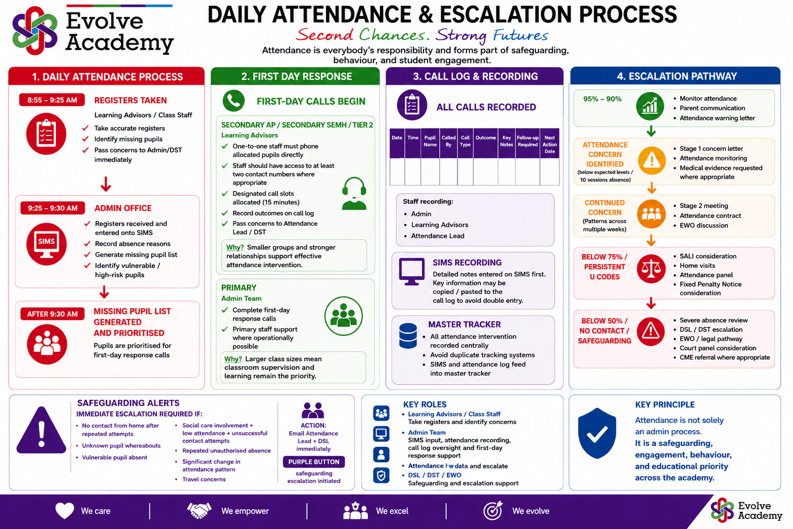

Appendix B: Attendance codes
The following codes are based on the national attendance and absence codes used in the School Attendance (Pupil Registration) (England) Regulations 2024 and DfE guidance.
Code | Definition | Scenario
/ | Present AM | Pupil is present at morning registration
\ | Present PM | Pupil is present at afternoon registration
L | Late arrival | Pupil arrives late before register has closed
K | LA arranged education provision | Pupil attends education provision arranged by the local authority
V | Educational visit/trip | Pupil is on an approved educational visit or trip
P | Sporting activity | Pupil participates in an approved sporting activity
W | Work experience | Pupil attends approved work experience
B | Other approved educational activity | Pupil attends another approved educational activity
D | Dual registered | Pupil attends another setting where they are also registered
C1 | Regulated performance/employment abroad | Approved regulated performance or employment abroad
M | Medical/dental appointment | Pupil attends medical or dental appointment
J1 | Interview | Interview with prospective employer or educational establishment
S | Study leave | Leave granted for public examination study
X | Not required to attend | Non-compulsory school age pupil not required to attend
C2 | Part-time timetable | Pupil is not in school due to lawful temporary part-time timetable
C | Exceptional circumstances | Leave of absence due to exceptional circumstances
T | Parent travelling occupationally | Mobile child travelling with parent for occupational purposes
R | Religious observance | Day exclusively set apart for religious observance
I | Illness | Unable to attend due to illness, including physical or mental health
E | Suspended/excluded | Suspended or excluded and no alternative provision made
Q | Lack of access arrangements | LA has failed to make access arrangements to enable attendance
Y1 | Transport not available | Transport normally provided is not available
Y2 | Widespread travel disruption | Widespread disruption caused by emergency
Y3 | Part of premises closed | Pupil cannot be accommodated in the open part of premises
Y4 | Whole site unexpectedly closed | School is unexpectedly closed
Y5 | Criminal justice detention | Pupil in police detention, remanded or detained under sentence
Y6 | Public health guidance/law | Attendance prohibited by public health guidance or law
Y7 | Other unavoidable cause | Unavoidable cause not covered by other Y codes
G | Holiday not granted | Absent for holiday not approved by school
N | Reason not yet established | Reason not established before register closes
O | Absent in other/unknown circumstances | No reason established or school not satisfied reason is authorised
U | Arrived after register closed | Late after register closed but before end of session
Z | Prospective pupil | Pupil has not yet joined admission register
# | Planned closure | Known planned whole-school closure

Appendix C: EWO/FPN referral evidence checklist
Before referral to Lambeth Education Welfare Service or a Fixed Penalty Notice referral, staff should ensure the evidence trail is complete and proportionate.
- Case discussed with the allocated EWO where required.
- Attendance certificate / printout prepared and signed where required.
- Attendance letters and notices to improve attached.
- Call Log and contact attempts attached.
- Evidence of meetings with parent/carer attached.
- Evidence of school attendance panel / attendance contract attached where applicable.
- Court warning letter attached where applicable.
- Home visit records attached where applicable.
- Safeguarding actions recorded and DSL/DST informed where relevant.
- Referral submitted within required local authority timescales.
- For FPN referral: confirm the threshold of 10 sessions of unauthorised absence in a rolling 10-school-week period and check whether previous FPNs have been issued in the 3-year period.

Appendix D: Attendance Leaflet for Parents
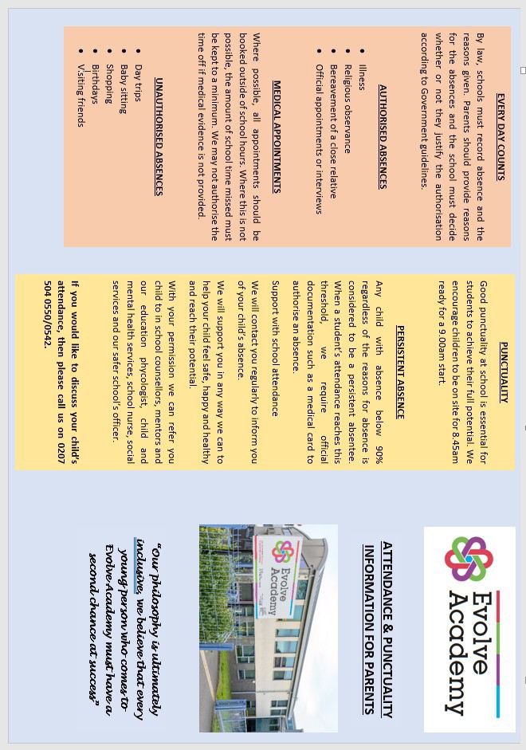

Appendix D: Attendance Leaflet for Parents
