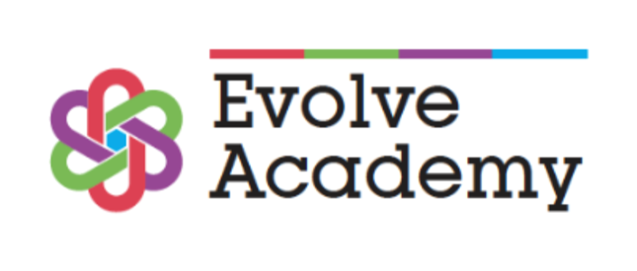

**British Values Policy**

**Review Date:** August 2025 **Review Period:** Annually

**Next Review Date:** August 2026  **Author**: Assistant Headteacher

Contents

Introduction…………………………… ……………………………………………………………………………………..2

Democracy……………………………………………………………………………………………………………………..2

Rule of Law………………………………………………………………………………………………………………….…3

Individual Liberty …………………………………………………………………………………………………………..3

Mutual Respect ……………………………………………………………………………………………………………...3

Tolerance of Those with Different Faiths and Beliefs ………………………………………………………3

Conclusion……………………………………………………………………………………………………………………..3

**Introduction**

Schools have a duty to “create and enforce a clear and rigorous expectation to promote the fundamental British Values of democracy; the rule of law, individual liberty and mutual respect and tolerance of those with different faiths and beliefs.”  
  
At Evolve Academy, British Values and the Rights Respecting Schools approach are interwoven throughout our curriculum and culture. By embedding the United Nation Convention Rights of a Child (UNCRC) articles into our teaching of democracy, rule of law, individual liberty, mutual respect, and tolerance, we ensure that pupils not only understand their rights and responsibilities but also learn to respect and uphold the rights of others in modern Britain.”

**Democracy**

The school has an active and elected Student Voice (Student Council) , giving pupils the opportunity to contribute to decision-making and understand how democracy works in practice.  
- As part of our Rights Respecting Schools programme, pupils learn about their rights and responsibilities, linking directly to democratic principles.  
- Through assemblies, tutor time, and curriculum projects, students regularly engage in discussions around fairness, decision-making, and representation.  
- Pupils are encouraged to exercise their voice through feedback activities such as surveys, student panels, and Student Voice meetings.

*This aligns with Article 28, the right to education, and Article 29, which highlights that education should develop respect for human rights, responsibilities, and the law. It also reflects Article 40, which ensures fair treatment for children in conflict with the law.*

**Rule of Law**

- Pupils are supported to understand the importance of rules and laws in school and wider society. This is reinforced through our behaviour policy, restorative conversations, and positive behaviour management.  
- Our approach emphasises rewards and recognition, including weekly rewards assemblies, praise, and positive points, to model fairness and justice.  
- When sanctions are required, they are applied fairly and consistently. Where needed, personalised support programmes are created with pupils and families to ensure that restorative practice underpins consequences.  
- Pupils learn about justice and the rule of law through assemblies, visiting speakers, and our PSHE/PD curriculum.

- We work with our Safer Schools Officer to address behaviours that could be criminal outside of school, such as criminal damage or bullying linked to race, gender, or sexuality. This helps pupils understand legal consequences and the importance of respecting the rights of others

-

*This links to Article 12, ensuring children’s voices are heard, and Article 13, guaranteeing freedom of expression. It also reflects Article 14, which gives children freedom of thought, belief, and religion, and Article 31, which ensures the right to leisure, play, and cultural participation.*

## Individual Liberty

- Pupils are given many opportunities to share their opinions, develop confidence, and make choices about their learning and wider participation.  
- Our mentoring programmes and interventions ensure that every student has the support they need to succeed and exercise their freedom to achieve.  
- Pupils benefit from a wide range of enrichment opportunities, including cultural trips, outdoor learning, sports, and creative activities, giving them the liberty to explore new experiences and interests.  
- We provide safe spaces and trusted adults, ensuring that pupils understand their rights, responsibilities, and the boundaries within which individual freedoms can be safely exercised.

*This supports Article 2 of the UNCRC, ensuring all rights apply without discrimination, and Article 29, which requires education to encourage respect for others. It also links to Article 30, which protects the rights of children from minority groups to enjoy their own culture, practice their religion, and use their language.*

## Mutual Respect

- Respect is a cornerstone of our ethos: every pupil is valued, celebrated, and supported.  
- Weekly rewards assemblies highlight academic achievements, positive behaviour, and personal growth.  
- Pupils’ talents and skills are showcased through school events, trips, and creative projects, reinforcing pride and respect for each other.  
- We encourage community service and charitable giving, with pupils actively supporting local and national causes.  
- Staff model respectful behaviour consistently, and pupils are expected to mirror this in their interactions with peers and adults.

*This reflects Article 14 of the UNCRC, which ensures freedom of thought, belief, and religion. It also supports Article 30, which ensures children from minority or indigenous groups have the right to enjoy their culture and practice their religion.*

## Tolerance of Those with Different Faiths and Beliefs

- Evolve Academy welcomes pupils from a wide range of cultural, faith, and community backgrounds.  
- Our Personal Development curriculum and Equality & Diversity programme teaches pupils to respect difference, challenge prejudice, and value inclusivity.  
- Through assemblies, cultural events, and guest speakers, pupils explore and celebrate a variety of world views, traditions, and practices.  
- Discrimination of any kind is not tolerated. Incidents are dealt with swiftly, fairly, and used as opportunities for restorative education.  
- Pupils learn that difference should be celebrated, not feared, and are encouraged to be considerate, responsible, and inclusive members of society.

*This links to Articles 2, 12, 13, 14, 29 and 30 of the UNCRC. Article 2 ensures all rights apply to every child without discrimination, including religion and belief. Articles 12 and 13 protect children’s rights to express their views and share ideas about faith and culture. Article 14 gives children the right to freedom of thought, belief, and religion. Article 29 highlights that education must encourage respect for cultural identity and the values of different civilisations. Article 30 ensures that children from minority groups have the right to enjoy their culture, practice their religion, and use their language.*

## Conclusion

By embedding British Values into all aspects of academy life, Evolve Academy ensures that pupils are prepared not only for academic success but for life in modern Britain. They leave us with a strong sense of justice, democracy, and respect, equipped to contribute positively to the communities they are part of.