

MARKING & FEEDBACK POLICY

Approved by: | R Stewart and C Maddock | Date: August 2026
Last reviewed on: | 19th August 2026
Next review due by: | 22/08/2027

Contents
1. Aims 1
2. Objectives 1
3. Method 1
4. Guidelines for Marking 2
5. Literacy 4
6. Monitoring… 4
7. Evaluation……………………………………………………………………………………………………..... 4
8. Appendix A 5
9. Appendix B 7
10. Appendix C 9

- Aims
The explicit aim of the Evolve Academy Marking and Feedback Policy is to:
- Improve the ‘quality’ of marking
- Raise achievement – through targeted, relevant, student-specific feedback
- Include a variety of marking methodologies
- Ensure the students (and teachers) understanding of the learning
- Meet the needs of every student at Evolve Academy
- Support parental involvement and understanding (increased involvement, possible exemplars of student’s work sent home, or, displayed in generic form on Evolve Academy website)
- Ensure all staff and students are aware of the marking and feedback policy
- Accelerate learning outcomes
- Support a framework in line with the whole Academy's vision
- Enable subject leads and teachers to plan more effectively for the next stage of the teaching and learning cycle – using diagnostic feedback obtained through this process
- Ensure students are made aware of their current achievements and future targets and the interventions in place to help them to achive this.

- Objectives
- Staff, Parents, Senior Leadership Team (SLT) and the Evolve Academy Council (Governing body) to work together to meet the aims of the Academy.
- To provide an environment in which each student's social and emotional skills can be nourished and nurtured.
- To create and maintain a safe, caring and happy environment within the Academy.
- To provide a curriculum that meets the statutory requirements and is ‘fit for purpose’ for all Evolve Academy students.
- To use ongoing assessment, based on sound knowledge of students’ abilities and needs, to plan the learning targets and experiences for each student.
- To provide materials and learning experiences that are appropriate to the age of the student.
- Method
These aims will be achieved through:
- Ongoing formative assessment of student learning and progress carried out during lessons
- Termly teacher assessments of students’ progress and achievement, both formative and summative
- The annual review process
- Monitoring and evaluation of student progress to identify areas for improvement
- Strategic planning, informed by assessment outcomes, to improve resourcing, curriculum and professional development.
- Starter activities including ‘Hook’ activities, and recap activities reinforce knowledge and provide immediate feedback e.g., low-stakes quizzes.
- Classwork to be monitored regularly by Subject Leads and Teaching and Learning Lead as per the published QA Calendar. Or where teaching is taught remotely, the Digital Learning Coordinator.
- Good work and effort will be rewarded in a variety of ways from positive points recorded on the Sleuth MIS system, certificates, or phone calls home, etc.
- Classrooms have a copy of the Marking Policy Poster displayed on the classroom walls.

- Guidelines for marking
All marking should be completed in Purple pen using WWW (what went well) comment. This should be evaluative or descriptive, letting the students know what they have completed and done well. E.g., Good use of adjectives “colossal” and “extravagant”, correct punctuation used and various sentence structures.
All marking should also have an EBI (even better if) comment. This should tell the students what they could do to improve their work and what they need to do to improve their levels as well as give students strategies for progress. This should be reflected through DIRT marking. There should also be references to targets to move the student forward. These should be linked with success criteria, moving students through relevant assessment steps to raise attainment.

Digital marking should also follow the same format. WWW and EBI typed into the document itself or typed into the comments box at the side of the page.
Comment boxes should also be used, where possible, to comment on the standard of work, literacy, and to ask challenging questions.

Frequency of book marking
This should take place at least every fortnight for core subject and once every three weeks for non core subjects, once at the beginning of term, once in the middle and once at the end of term in all subjects. Once a fortnight, learners are given time to reflect and feedback on their work. This can range from 2 minutes or 20 minutes for learners to reflect on their work. This could involve having a 1:1 discussions or whole class, this should include support staff too.

DIRT Marking
- Directed/dedicated
- Improvement and
- Reflection
- Time

Students should be given appropriate opportunities to self or peer-assess and respond to the marking of their work. Students can respond in green pen or be given a sticker/stamp/small reflection sheet to acknowledge their DIRT.

4.1 Curriculum

Learners work, over time will demonstrate the development of detailed knowledge and a set of skills. The work will be of high quality throughout and will clearly show good progress and embedded knowledge. These characteristics will be evidenced through:
- Schemes of work/weekly plans
- learning objective of lesson
- individual targets for each student (AFL) – on Target Sheets
- ICT and resources
- Set texts
Assessment is an integral part of our planning process. Teachers’ curriculum planning is informed by:
- Rigorous baseline testing on joining the school
- On-going observation, marking and students’ self and peer assessment
- Formal Mock Examinations
4.2 Progress and Learning
Learners work across a range of sources, shows clear and consistent progress overtime which builds on previous learning.
- Ticks within work - to acknowledge good work
- Positive and purposeful commentary
- Linked to specific subject/exam Success Criteria
- Written comments will be in a language students can readily understand
- Marking and assessment will be age/ability-appropriate
- All students will know their Academy Target Grade for each subject. This should be displayed in the front of their book/folder.

4:3 Ambition
Learners' work across a range of sources is at least good and reflects the ambition of the school to provide demanding work that stretches all individuals (including SEND) based on their ability.
- Evidence of group work,
- Independent learning,
- Relating/forming connections to other subjects within the academy curriculum.

4:4 Quality of feedback
Feedback to learners will be clear - regarding how learners can improve their knowledge, understanding and skills. As such, it will demonstrate the teachers’ deep understanding of their subject. It will also be evident that feedback and a logical student-teacher dialogue has happened in the lesson/book (or folder) and this is extended through written two-way feedback
Feedback will demonstrate:
- It is detailed with clear links to students’ subject targets
- Students will be given appropriate time in lessons to improve upon feedback written in purple pen coded by WWW and EBI. This will be during planned, routine Directed Improvement Reflection Time (D.I.R.T.). For digital work, they may highlight their response in purple.
- Students will be expected to act upon the feedback received so that misconceptions and misunderstandings and errors can be addressed and corrected. For example, students could make the improvements on the body of work – bracketing or ‘framing’ the corrected/improved work. Alternatively, they could redraft or make improvements to a certain section of their work and write it under ‘Students Response’ – ‘framing the work by Green marker ‘corners’ so that it is explicit and clear.
- Teachers will monitor that the student has responded to marking and acknowledge this using purple pen, for example, “Thank you for editing/improving your work. Excellent choice of adverbs”.
- There is evidence that self and peer assessment is done well and that peers’ comments have an impact on progress. The is will be indicated SA or PA in the margin.
- Verbal feedback will be indicated in the margin with ‘VF’ plus a concise comment.

4:5 Different Types of Feedback
There are several types of feedback that teachers can use. We acknowledge that marking and feedback is the class teachers’ responsibility, however, Evolve Academy staff aim to encourage students to take ownership by checking, correcting and re-drafting their work, in order to:
- Recap knowledge activities - every lesson – e.g., low-stakes quizzes
- Respond to ‘WWW’ and ‘EBI’ comments in their books/folders and online.
- Knowledge tests/quizzes
- Whole-Class Feedback
- Verbal Feedback (‘VF’)
- Peer and Self-Assessment. (PA and SA)

5 Literacy

Literacy marking should also be completed in purple pen using codes (see Appendix A) written into the margins and errors circled- differentiation by allowing students to spot where the mistake is and correct it. Literacy marking should not repeat the correction of syntax, grammar, or spelling more than a few times – to prevent overwhelming the student. . If marking digitally, work can be highlighted in purple and comments written in the comments box.

- Monitoring

It is the professional responsibility of classroom teachers to ensure that all students receive feedback regularly and keep clear and appropriate records in their markbooks (paper or electronic).
- The quality of marking and feedback will be monitored by the Teaching and Learning Lead and Subject Leads in accordance with the calendared QA Cycle. This may involve looking at books at Work Scrutiny sessions and through Learning Walks.
- There is a rota in place for staff to share good practice through Work Scrutiny - involving up to five members of staff: three teachers and two LA’s. The generalised outcomes of work scrutiny will be shared with the relevant subject areas and individuals (via the Go4Schools MIS system) and may inform part of the Performance Management appraisal process. The same process will take place for digital work scrutiny; however, this may take place as a virtual work scrutiny.
- All staff must utilise Go4Schools Data Sheets for their classes. These records should show the results, assessment tasks and the resulting interventions for each student. These will form the basis for reporting attainment and progress to parents and relevant Line Managers. Teachers should also use this information to inform their lesson planning.

- Evaluation
The academy curriculum policy will be reviewed in response to;
- The content of the policy in the light of changes within and outside school.
- It’s relevance to the student’s needs.
- The levels of achievement of students across the school
- The use and range of resources available in the academy.

Appendix A and B – Posters for Display
Appendix A
Guidelines Staff

To help your learners make progress you must mark learners work according to the policy below.
Learning Objectives met? | YES |  | NO |  |  | Grade
WWW: - What Went Well
What you have done well in the piece of work.
EBI:- Even Better If
What could you do better to improve this piece of work? What you need to do to improve your levels
Student Feedback:-What do you need help with? What are you pleased with? What are you concerned about?
Student Feedback: -After receiving this feedback what are you going to do next? Give an example?

Learner’s work should be marked in Purple pen. The learners MUST reply to your comments to show they have read them. Learners should use GREEN pen to reply.

Marking & Literacy across the Curriculum (Staff)
You will also use the following symbols to support your marking.
D+T: Date & Title Missing – You need to add a date and title when you see this symbol.
POW: Presentation of work is poor – Redo work to the correct standard.
CL: Capital Letter – You need to use a capital letter when you see this symbol.
P: Punctuation – There is punctuation missing.
Sp: Spelling – There is a spelling mistake. Any spelling mistakes need to be written out in the margin of the learners’ books.
Np: New paragraph – You need to start a new paragraph.
/ /: Where the new paragraph should be

VF: Verbal Feedback – The Teacher/Student has given you verbal feedback.
LR: Learner Response – You must give your teacher a written or verbal response.
SA: Self Assessed – Student has self-assessed their work.
PA: Peer Assessed – Another student has assessed the work.

Appendix B

Guidelines for Students
To help you with your learning and for you to make progress the teacher marks your work like this:

Learning Objectives met? | YES |  | NO |  |  | Grade
WWW: - What Went Well
What you have done well in the piece of work.
EBI: - Even Better If
What could you do better to improve this piece of work? What you need to do to improve your levels
Student Feedback: -What do you need help with? What are you pleased with? What are you concerned about?
Student Feedback: -After receiving this feedback what are you going to do next? Give an example?

When I have marked your work, you MUST reply in the Student Feedback Box or initial the comments to show you have read and understood them. Always use GREEN pen to reply.

Guidelines for Students Exemplar
To help you with your learning and for you to make progress the teacher marks your work like this:

Learning Objectives met? | YES | X | NO |  |  | Grade | 3
WWW: - What Went Well
What you have done well in the piece of work.
You have describd what selective breading is and have explained why farmers may want ot use selective breeding.

EBI: - Even Better If
What could you do better to improve this piece of work? What you need to do to improve your levels
Can you explain some of the characteristic that a farmer may want to select when breeding either roses or tomoatoes.

Student Feedback: -What do you need help with? What are you pleased with? What are you concerned about?
I am happy with the feedback but I would like some understanding how selectrive breeding occurs in plants as I am not very confident with plant reproduction.
Student Feedback: -After receiving this feedback what are you going to do next? Give an example?
In a rose the characteristics that a faremer may want to select are the flower size, the colour of the petals, whether they flowers scent smells nice and whether or not there are prickles on the stems

When I have marked your work, you MUST reply in the Student Feedback Box or initial the comments to show you have read and understood them. Always use GREEN pen to reply.

Appendix C - How to Mark Digitally
- Method 1-Virtual learning platform e.g., Google Classroom
- Method 2-In school via ‘Student Work’ area on the computer
Method 1- Virtual Learning platform
- PLT is currently using Google Classroom for delivering remote teaching and learning. Google Suite is equipped with generic software, Doc, Slide and Sheet, which has similar features to Microsoft Word, Excel and PowerPoint. Therefore, teachers and students are already familiar with some basic features in these applications.
- Marking policy can easily be implemented on Google Classroom either during a live lesson or after a student has submitted the work.
- When teaching a live lesson, the teacher can make comments on a student's work in real time and the student can also respond in real time. This is a very good way of formatively assessing during a lesson.

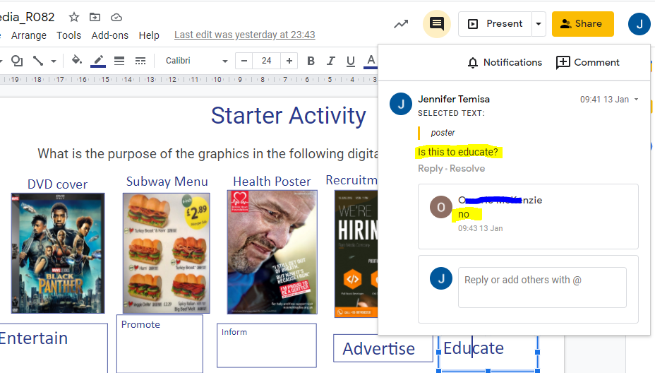
Example1: This example shows commenting on the work during a live lesson and the student responding to the feedback.\
- The task was carried out using Google Slide (PowerPoint equivalent). Comments can be added by highlighting the slide or selecting a section of text or an image on the slide and clicking on the comment icon.

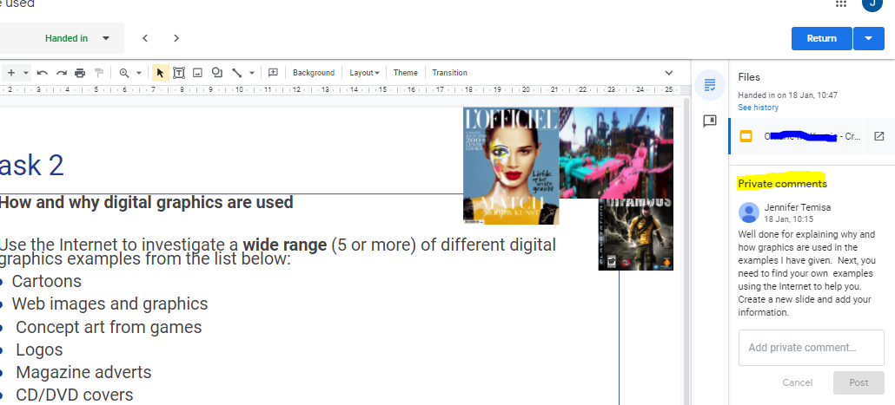
Example 2: Comments can also be added to the whole document as ‘Private comments’ and should appear on the student’s Classwork page in Classroom. This example shows feedback given at the end of a task during the lesson

- Below are how comments shows up in the classwork page in Classroom. If the student responds to the feedback, it will also show a trail of responses between the teacher and student.

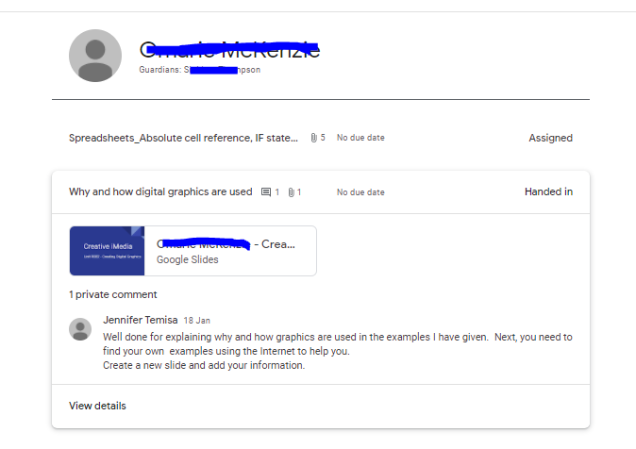

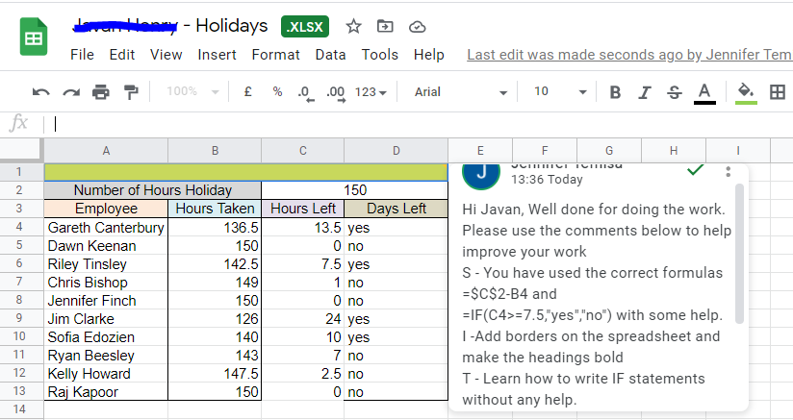
Example 3: Here the student completed a spreadsheet task and the SIT marking policy has been used to give feedback.

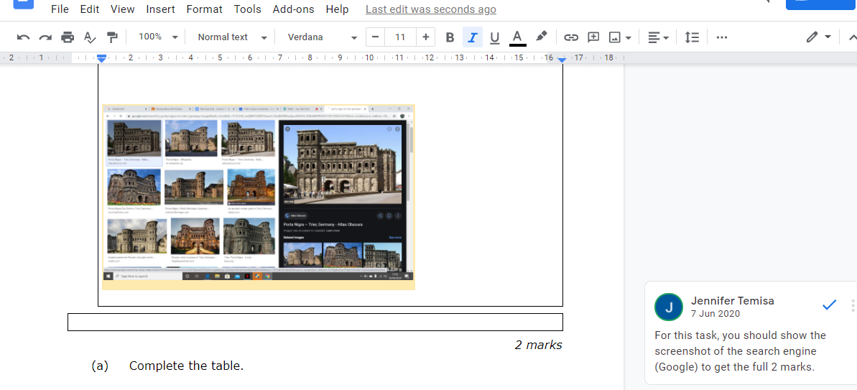
Example 4 - Exam questions with grading criteria
- Here the exam paper was uploaded to Google Classroom and set as an assignment for students to complete. The comment added tells the learner the grade achieved for that particular question and what to do to achieve full marks.
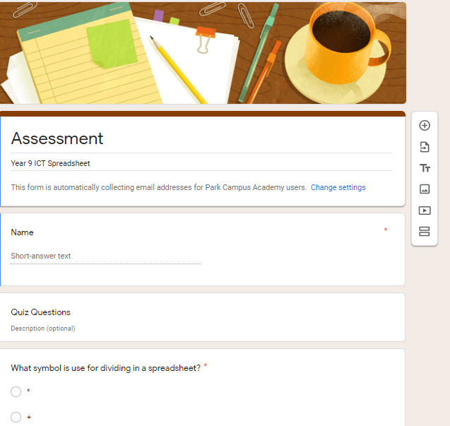
Example 5 - Google Forms can be used to assess students and if set as multiple-choice questions, the grade will be generated automatically.
- The teacher can download the results into a spreadsheet for analysis.

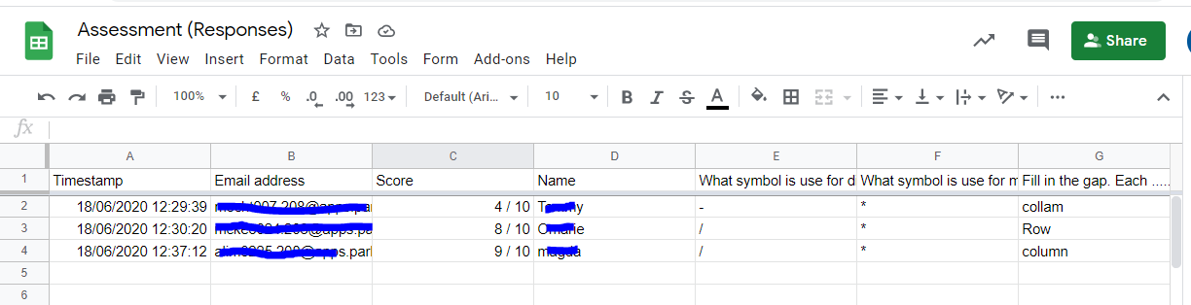
- Below is the responses from the assessment download as a spreadsheet file

Method 2 -In school via ‘Student Work’ area on the computer
- When students are in a ‘brick and mortar’ classroom and they complete work in class, the work is saved to their ‘Documents’ folder, which can be accessed via the Student Work drive.
- If a student completes work using any of the Microsoft Applications (Word, Excel, PowerPoint or Publisher), the teacher can add a comment digitally to the work.
- When the student opens the work in the next lesson, the comments should appear by the left margin of the document and the student would be able to respond to the feedback given.

How to add comments
Example 1 - Comments in Microsoft Word: Click on the Review tab > New Comments
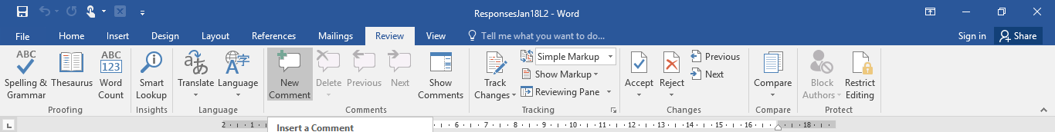
- The comment box appears to the right and then the teacher can add a comment.
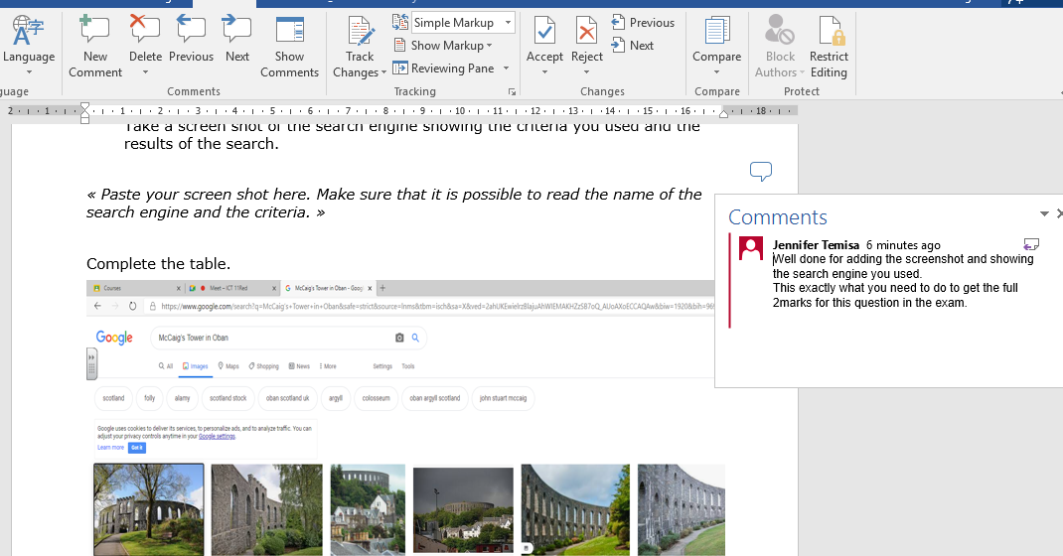
- Another way of adding comments is to right click on the mouse, bring up the side menu and click on New Comments.
Example 2 - Comments in Microsoft PowerPoint.
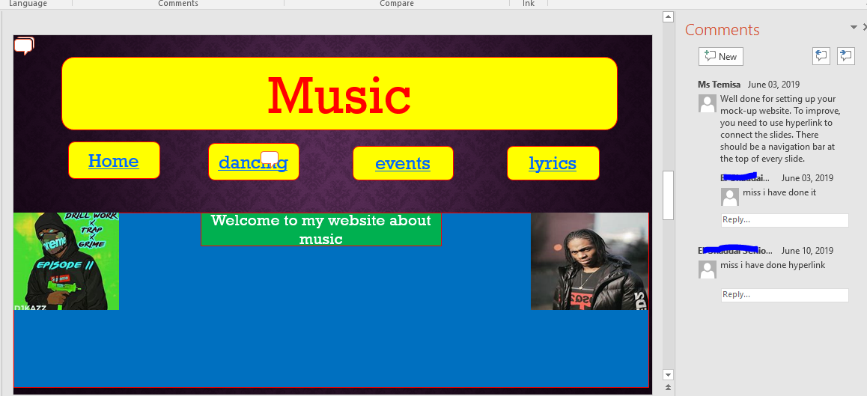
Below is an example of using the Comments features in PowerPoint to give feedback and the student actually responded to the feedback.

Date:
Learning Objective:
What went well?  Learning objective met  Learning objective partially met  Learning objective not met | Even Better If:
Now demonstrate your knowledge:

Guidance:
Date:
Learning Objective:
What went well?  Learning objective met  Learning objective partially met  Learning objective not met | Even Better If:  Must refer to what the child needs to improve on if they wrote or understood something incorrectly.  If they have done everything correctly what do they need to do next?
Now demonstrate your knowledge:
This is where you can write a challenge question for your pupil to which they can respond to show that they have read and understood your feedback.

Example:
Date: 19.11.2025
Learning Objective: To count to 10.
What went well?  Learning objective met  Learning objective partially met  Learning objective not met | Even Better If:  You remember that 9 comes after 8.
Now demonstrate your knowledge:
What numbers come after 8 to 10? 8 9 10

