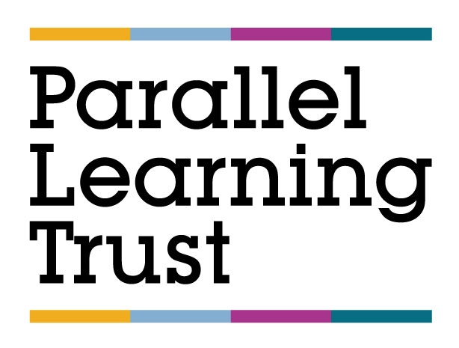

Remote Learning FAQs

January 2021

1. Frequently Asked Questions (FAQ)
Q1. Do schools have a legal duty to provide remote education?
Yes. In October 2020, the Government issued a Temporary Continuity Direction
Q2. Does the Academy have a Remote Learning Policy?
Yes. The Remote Learning Policy can accessed from the ‘Remote Learning’ link on the Academy’s website homepage.
Q3. What remote learning platform is used by the Academy?
Remote learning is delivered via Google Classroom.
Google Classroom is all-in-one hub for the collaborative classroom. Is equipped with generic software, Doc, Slide and Sheet, which has similar features to Microsoft Word, Excel and PowerPoint. It allows teachers to host video and audio calls, share documents, conversations, files and notes, collaborate on virtual whiteboards and issue and mark assignments.
Q4. Will pupils be taught broadly the same curriculum as they would if they were in school?
Every effort will be made to ensure that curriculum quality, breadth and balance are not sacrificed where pupils are required to learn remotely. We know our learners well and recognise the fact that the vast majority of their individual and varying needs require support from staff when they are learning on-site. In order to keep them engaged and interested in learning at home -our aims are to reinforce the basic skills of English and Maths .We have included elements of the other subjects as well –which ensure a level of continuity between pupils learning on-site and those learning at home.

We have set a Remote Learning timetable which reflects the normal academy timetable. Pupils need learning routines and consistent expectations when working at home. Every effort will be made to ensure the curriculum provision meets the individual needs or our remote learners
The principles and qualities underpinning effective teaching and learning are fundamentally the same, irrespective of whether learning takes place remotely or in the classroom.
Q5. How many hours a day will pupils be expected to engage in remote learning?
The minimum expectations:
KS1 (Y-2) = 3 hours a day
KS2 (Y3-6) = 4 hours a day.
We have set work that goes above the minimum level required.
As part of the lesson, teachers will use a variety of internal and external resources which they will make available to pupils.
Q6. What are the Academy’s expectations of pupils?
In a broad sense, pupils are expected to fully engage and participate in the remote learning provision. In terms of a Code of Conduct, this is covered in Appendix 3 of the Remote Learning Policy i.e.
- Arrive on time to all their online sessions.
- Turn off their camera/webcam facility unless the teacher asks them to turn it on.
- Under no circumstances, record the lesson or share any images from the lesson on any platform.
- Keep their microphone muted unless the teacher asks them to speak and mute themself when they have finished.
- Only use the ‘chat’ function if directed to by the teacher and only for the purpose they specify.
- Gain permission from the teacher if they need to leave the session for any reason.
Q7. What are the Academy’s expectations of parents/carers?
In a broad sense, to support their child as much as possible.
In terms of a Code of Conduct, this is covered in Appendix 3 of the Remote Learning Policy i.e.
- Support their child’s personal organisation so that they attend sessions punctually, in accordance with their timetable.
- Encourage their child to participate fully in online sessions and to complete independent work set by their teachers.
- Ensure that no element of an online session is recorded by their child or family members.
- Avoid making any comments, or sharing any material, on social media that could identify their child, academy or staff.
- Ensure that their child takes care of any equipment that they have been loaned by the Academy and uses it only for the purposes for which it was intended.
Q8. What are the Academy’s expectations of staff?
In a broad sense, to replicate, as much as possible, the same educational experience as face-face teaching inside of school.
In terms of a Code of Conduct, this is covered in Appendix 3 of the Remote Learning Policy i.e.
- Send session/ meeting invites for their groups in advance
- In advance, upload resources relevant to the lesson.
- Sign into GC before the lesson is due to begin, ensuring there are no issues in terms of access, content etc.
- Ensure settings are configured so that only they can present during the lesson and share their screen.
- Ensure that e-mails are closed and only those programs that are necessary for the lesson are open.
- At the start and end of each lesson, open the camera/webcam facility to personalise the lesson.
- Where teaching from home, blur the background (or choose a background) to protect personal privacy, wear suitable professional clothing and try to teach from a place in the house that is quiet, with minimal disruption.
- At the end of each session select ‘end the meeting’ (not ‘leave the meeting’) so that pupils cannot continue the meeting unsupervised.
- When teaching pupils online, ensure that all communication is through MS Teams. Never share personal details or contacts with pupils or communicate through social media or other channels. Private ‘chat’ with pupils is prohibited.
- Ensure that they model high professional standards at all times.
- Monitor attendance and inform the SLT of pupils not attending/engaging.
- Provide follow up work to the session.
- Provide feedback e.g. verbal (through the audio facility) and written (through the ‘chat’ and ‘assignment’ facilities).
Q9. Will pupils’ attendance be monitored?
Yes. Parents will be contacted if their child misses a live session.
Q10. How will the Academy check that pupils are engaging with their work?
This will be checked in the following ways:
- Attendance to live sessions.
- Participation in live sessions.
- Completion of set tasks/assignments.
Q11. How will the Academy check pupils’ work and progress?
This will be checked in the following ways:
- Through the audio facility i.e. verbal answers to questions from the teacher.
- Through the ‘chat’ facility i.e. short, written responses to questions.
- Through the ‘quiz’ and ‘assignment’ facility.
- Through additional learning platforms -Mathletics/ Lexia
Q12. Will pupils be set additional work outside of the remote learning day?
The Academy appreciates that pupils are working at a computer or alterative digital device for over 4 hours a day there is a need for a sensible balance.
Q13. What support does the Academy provide to pupils who do not have access or have limited access to suitable digital devices at home?
The Academy has distributed laptops to pupils.
Where pupils have no access to a suitable digital device, they are encouraged to attend school.
Hard packs are sent home to all pupils –irrespective of whether or not they have digital devices at home. Resources-pens, paper etc are also provided if necessary.
Q14. How is the Academy supporting pupils with special educational needs and disabilities (SEND)?
Pupils with an EHCP are encouraged to attend school, however, for students with EHCPs, whose parents have chosen to keep them at home, clear guidance on individual EHCP outcomes has been provided. This outlines each student’s targets and offers advice on how to work towards meeting the outcomes set through the EHCP process.Ongoing appropriate guidance and support will be provided by SLT.

