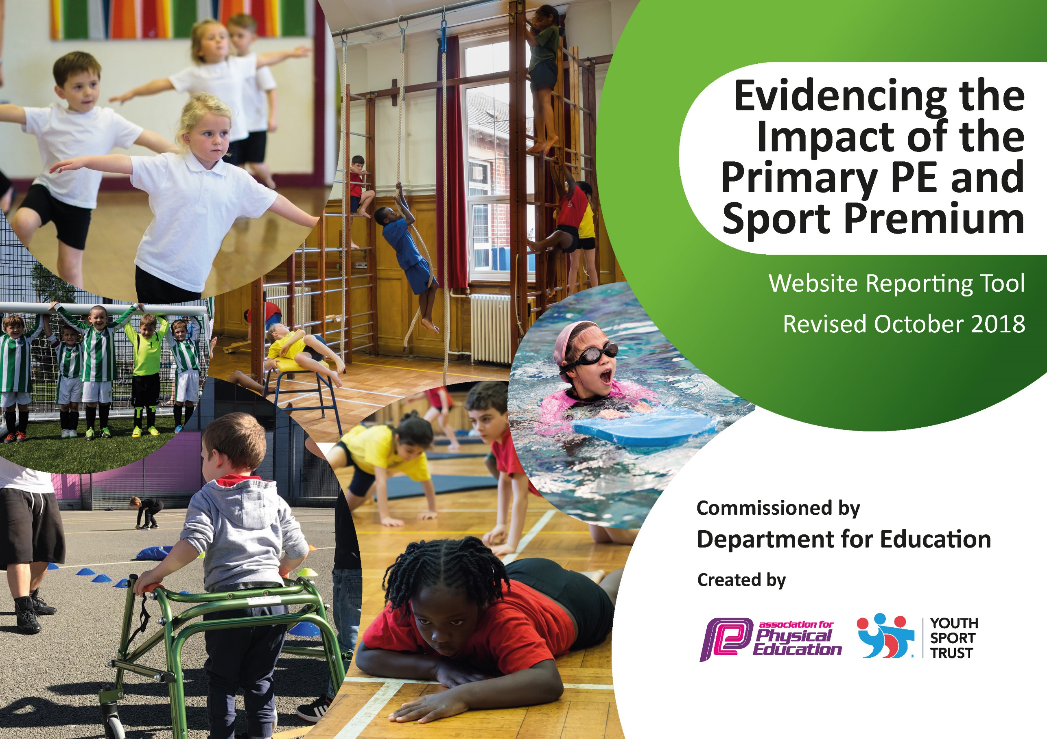
Evaluated Year 2019/20 Fairfield Primary School
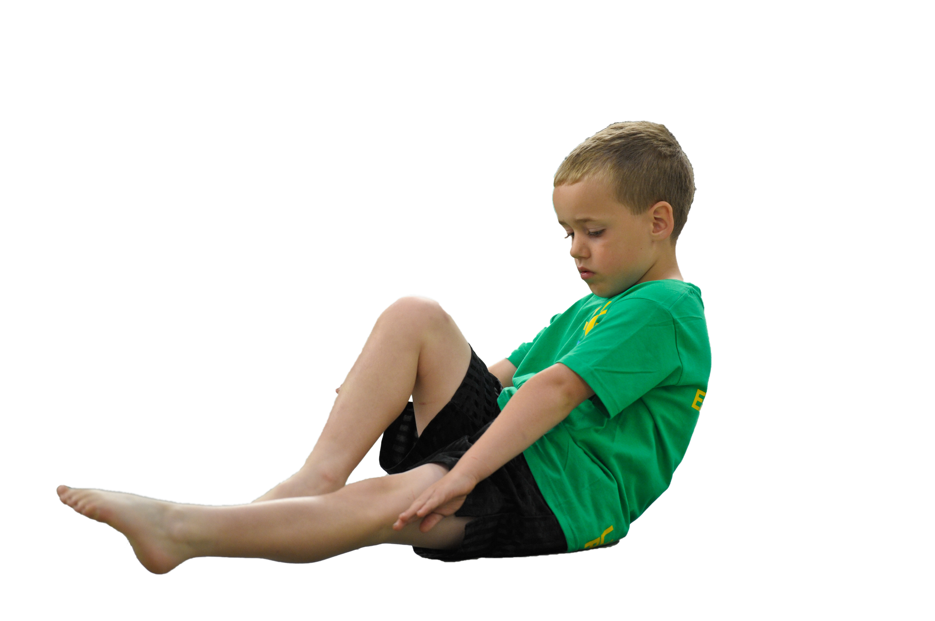
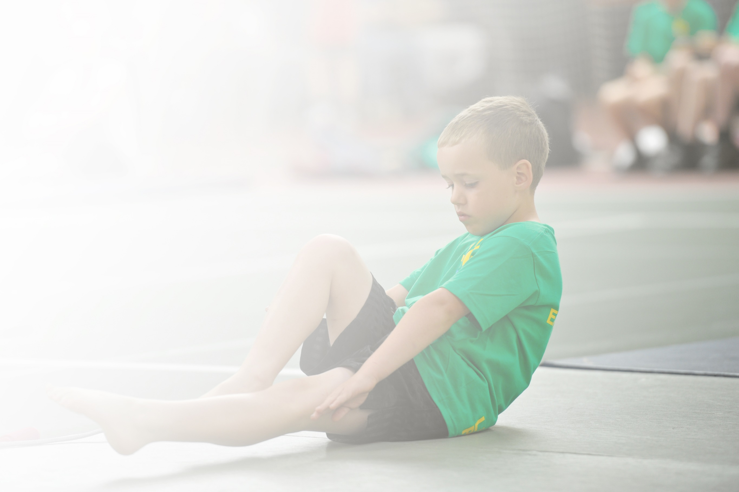
Schools must use the funding to make additional and sustainable improvements to the quality of Physical Education, Sport and Physical Activity (PESPA) they offer. This means that you should use the Primary PE and Sport Premium to:

- Develop or add to the PESPA activities that your school already offer
- Build capacity and capability within the school to ensure that improvements made now will benefit pupils joining the school in future years

Please visit gov.uk for the revised DfE guidance including the 5 key indicators across which schools should demonstrate an improvement. This document will help you to review your provision and to report
your spend. DfE encourages schools to use this template as an effective way of meeting the reporting requirements of the Primary PE and Sport Premium.

We recommend you start by reflecting on the impact of current provision and reviewing the previous
spend. Under the Ofsted Schools Inspection Framework, inspectors will assess how effectively leaders use the Primary PE and Sport Premium and measure its impact on outcomes for pupils, and how effectively governors hold them to account for this.

Schools are required to publish details of how they spend this funding as well as on the impact it has on pupils’ PE and sport participation and attainment by the end of the summer term or by 31 July 2019 at the
latest.
We recommend regularly updating the table and publishing it
on your website throughout the year, as evidence of your
ongoing review into how you are using the money to
secure maximum, sustainable impact. To see an
example of how to complete the table please
click HERE.

Support for review and reflection - considering the 5 key indicators from DfE, what development needs are a priority for your setting and your students now and why? Use the space below to reflect on previous spend, identify current need and priorities for the future.

Key achievements to date: | Areas for further improvement and baseline evidence of need:
Level 2 Sportshall athletics 5th place 2019  Year 6 football Cockermouth School competition Champions 2019  Level 2 Quick Sticks Hockey Regional Champions 2019  28 Children participate in Country Cross Country Competition. One Child finished 3rd and selected to compete in National Cross Country competition representing Cumbria. Year 5 girls team County Champions February 2019.  Level 2 Quicksticks Regional Champions February 2019  Year 6 Tag rugby Champions March 2019  Level 1 Year 4 tennis runners up March 2019  Rotary Football Competition Champions May 2019  Year 3 Mass participation Cross Country competition 52 children involved May 2019  Year 3 Mass participation rounders competition 52 children involved June 2019  Girls Cricket Competition June 2019  Level 1 Cricket Competition runners up June 2019  Cross Country Tri- Series finished 3rd overall with wins in individual categories over the series.  Touch rugby competition champions winning all categories Year 3/4 Boys, 5/6 Boys and Also 1st and 2nd Teams in the KS2 girls competition.  Level 3 County Quick Sticks Champions July 2019  ‘Active Education’ Cumbria County Winners 2019  ‘Healthy School of the Year’ National Winners 2019 | We have had an extremely successful year and to continue this further we now wish to focus on embedding the understanding of ‘personal best’ for our children. Working in partnership with Chris Wright Services we will continue to apply the 5 Steps to 5 Stars Programme for teaching Athletics. Through this we will generate a tracking system on our school server so that children can record their own personal achievements. We will be moving to celebrating this amongst the school in assemblies and linking this development to our ‘house points system’ with a conclusive academic year event- Sports Day. Throughout the year, coaches and teachers will award points to classes engaging in half termly intra competitions. We hope that the close monitoring and celebration of these results can be aided by purchasing iPads.  Using the iPads we will also aim to raise the profile of PE amongst our school community by live streaming sports events that will be delivered by our Sports Council. Evidencing our high quality coaching and the progression of skills within physical education will be documented from Year 1-6. We aim to involve parents and guardians of the progression of their child’s skills by using the Class Dojo app to share their learning and encourage links to local clubs and our own ‘After School Sports Development Club’ for our students. Furthermore, considering moving forward from the current global pandemic we are looking to further utilise our school field with facilities that allow more children to engage in physical education and look at the potential possibility as acting as a host school for intra-school competitions.

Meeting national curriculum requirements for swimming and water safety | Please complete all of the below:
What percentage of your current Year 6 cohort swim competently, confidently and proficiently over a distance of at least 25 metres?  N.B. Even though your children may swim in another year please report on their attainment on leaving  primary school. | %
What percentage of your current Year 6 cohort use a range of strokes effectively [for example, front crawl, backstroke and breaststroke]? | %
What percentage of your current Year 6 cohort perform safe self-rescue in different water-based situations? | %
Schools can choose to use the Primary PE and Sport Premium to provide additional provision for swimming but this must be for activity over and above the national curriculum requirements. Have you used it in this way? | Yes/No

Action Plan and Budget Tracking
Capture your intended annual spend against the 5 key indicators. Clarify the success criteria and evidence of impact that you intend to measure to evaluate for students today and for the future.

Academic Year: 2019/20 | Total fund allocated: £ | Date Updated: July 2020
Key indicator 1: The engagement of all pupils in regular physical activity – Chief Medical Officer guidelines recommend that primary school children undertake at least 30 minutes of physical activity a day in school |  |  |  | Percentage of total allocation:
 |  |  |  | 6%
School focus with clarity on intended impact on pupils: | Actions to achieve: | Funding allocated: | Evidence and impact: | Sustainability and suggested next steps:
Develop play provision.  Sports equipment  Active Families based on parent’s feedback.  1K a Day | Outdoor timber trail to be extended in KS2. Timetabled sessions that link with the climbing wall and football provision. Gravel pit to be used by all KS1 children and KS1 play structure to be fitted. Playtime boxes to be monitored and kept full with purposeful equipment.  Purchase necessary high quality equipment to ensure sessions are effectively delivered.  Timetabled sessions that are devised with families personal targets as a key focus for each session.  Active families continues on Saturdays in conjunction with Wright Sports Services/Chance Camp.  Continue whole school involvement in 1K a day. | £500  £500  £0 | All new equipment installed in both KS1 and KS2 sites. Equipment has developed active playtimes and more children are able to benefit from the facilities. Equipment has been organised to restock the playtime boxes for the Autumn term.  New hockey balls, rounders bats and rugby balls have been purchased.  Due to Covid-19 this provision did not go ahead. This will be reviewed for Summer 2021.  The whole school have continued to carry out 1K a day using the track installed last year. | Safety and risk monitored monthly by C Parker and R Barton. 10 year guarantee.  With consideration of sustainability, fewer items will be rotated through the boxes to offer variety and children’s interest.  High quality equipment purchased with extended guarantees.  N/A  1K a day track remains clear and has a guarantee.
Key indicator 2: The profile of PESSPA being raised across the school as a tool for whole school improvement |  |  |  | Percentage of total allocation:
 |  |  |  | 13%
School focus with clarity on intended impact on pupils: | Actions to achieve: | Funding allocated: | Evidence and impact: | Sustainability and suggested next steps:
Fully implement and utilise IPEP program, Maths of the day and 5-a-day across whole school.  Introduce 5 Steps to 5 stars programme to all classes.  Inter-house competitions are financially viable and can be developed to enhance in-school, inter-house competition.  Ensure continued use of Sports leaders for daily provision for all KS2 children. | Continue to schedule focused staff meetings where year group partners can monitor children’s progress and amend planning for the sequential terms.  PE sessions timetabled for each year group cross referenced with class overviews and whole school timetable for competitions ( Chris Wright Services, Allerdale and Cockermouth School Competitions) to ensure sustainability.  Work alongside Chris Wright to monitor Athletics progress and collect summative data for progression using the new scheme.  Develop league table and update Sports Board.  Complete in house competitions and share and record league tables. Develop a league in 2019/20 and link with Sports Day to monitor intra-school competition and whole school results.  Continued Sports Leader programme with new children trained to provide provision for KS2. Link with KS1 pupils in Summer 2 for transition session with the Sports Leaders on the KS2 yard. | £1000  £300  £200  £500 | IPEP - this has been used thought the year with staff using IPEP assessments linking to the taught lessons. Maths of the Day is utilised through integration into maths lessons and additionally monitored by the maths leaders.  5 Steps to 5 stars has not been initiated as this linked to summer athletics and school has been closed.  Introduction of PE Sports Board with termly updates of upcoming competitions, termly sports news and a celebration of personal sporting achievements.  Sports Leaders have been trained by E. Hodge and provide lunchtime sessions. Summer 2 plans for transition suspended due to Covid-19. | Ensure staff utilise lessons linked to IPEP. However, we have had some mixed feedback on assessment and the impact of assessment. In 2020 this needs a review to ensure assessment is effective and linked to all of the topics/lessons taught.  Maths of the day is utilised well throughout the school and a good investment with positive outcomes.  5 Stars to 5 Steps to be introduced with staff training needed to ensure effective implementation (due to new staffing in year groups involved).  E .Hodgson will provide training for upcoming Sports Leaders when they attend in year 6. We will look for Year 6's to develop training of the Year 5 students in the Summer 2021 term.

Key indicator 3: Increased confidence, knowledge and skills of all staff in teaching PE and sport |  |  |  | Percentage of total allocation:
 |  |  |  | 6%
School focus with clarity on intended  impact on pupils: | Actions to achieve: | Funding  allocated: | Evidence and impact: | Sustainability and suggested  next steps:
Provide additional CPD opportunities for staff for Gymnastics and core skills.  To further implement Maths of the Day inside and outside of the classroom. | Core sports i.e. High 5, Quick sticks, Quick cricket, Sportshall Athletics, Tag rugby to be explored and enhanced during twilight sessions to develop staff awareness and understanding of how the sport is played providing an opportunity to refresh knowledge prior to the upcoming competitions in the school timetable. KS1 staff member to attend UDANCE training.  Be a host school for CPD sessions with schools from our consortium.  Staff to continue recording MOTD in children’s books and lessons to be shared with parents on class dojo and on the school website. | £500  £500 | E. Todhunter and S. Robinson attended gymnastics training and shared this knowledge with R.Edminson and D.Turke. K Mossom attended UDANCE training which led to a whole class participation event.  Maths of the Day recorded and monitored throughout book scrutinies and staff feedback positive for continued use. | Members of Year 1, 2, 3 and 4 have now been exposed to gymnastics training.  Hopeful that following the restrictions implemented by Covid-19, if team sports can resume, staff will attend CPD sessions for the core sports. Potential for webinar tutorials to be shared with staff.  PE Leads to link formally with Maths Leads and set expectations for Maths of the Day activities recorded in books. Evidence of Maths of the Day to be added to the school website.
Key indicator 4: Broader experience of a range of sports and activities offered to all pupils |  |  |  | Percentage of total allocation:
 |  |  |  | 66%
School focus with clarity on intended  impact on pupils: | Actions to achieve: | Funding  allocated: | Evidence and impact: | Sustainability and suggested  next steps:
Additional achievements:  Provide coaching in all areas of School Games sports.  Grand-day Out  Sports Development linked with CPD for staff  Swimming  UDance Competition | Review provisions provided by Connor Cooke- targeting all School Games Sports as well as Football.  A suggested £1 contribution to cover the cost of transport is required to ensure that the Grand Day Outs can take place.  Specialist coaches will continue to work alongside staff in school. They will work alongside the children to develop skills and also identify those who will benefit from after school sports development club.  Swimming lessons offered to Years 4 and 5. Monitoring the attainment of children in Year 4 and potentially offering lessons to Year 3 children in Spring 1.  Children who are unable to swim in Year 6 will attend lessons with the Year 5 children.  KS2 children to compete in dance competition against other schools in Allerdale. Mass participation. | £1000  £1000  £6000  £3000  £400 | Connor now covers a wide range of sport that is evidenced in our coaching calendar working towards our upcoming events.  Grand Day Out postponed due to weather.  The introduction of Sports Development Club has been accepted well and children have been selected for A Teams using this training. Staff have an active part in sessions working alongside a coach, reducing previous issue where coaches have replaced the teacher.  Additional swimming lessons have been budgeted for Year 6 children who cannot swim. All swim sessions have not been carried out in Summer Term.  Children in Year 2 have participated in UDANCE competition. Opportunity for the children received well by all parents in developing the children’s social skills and wellbeing. | Workington Reds (via coach Conor Cooke) provide in school coaching for lessons linked directly to the PE Curriculum progression document. Funding dependant - we will look to continue to utilise this throughout 2020/2021 in relation to our in school lessons and external competitions.  New date to be reviewed  Sports development Club will continue. Summer 2 look to deploy children to class sessions and lead alongside the class teacher. Timetable considerations required.  Swimming lessons to continue in the next academic year following the same structure as last year.  Next UDANCE date to be confirmed and Staff Training to be held mid-November. Link with parents and PTA for voluntary contributions.
Key indicator 5: Increased participation in competitive sport |  |  |  | Percentage of total allocation:
 |  |  |  | 9%
School focus with clarity on intended  impact on pupils: | Actions to achieve: | Funding  allocated: | Evidence and impact: | Sustainability and suggested  next steps:
Maintain 75%+ of all children to participate in a competitive sport and target reluctant participants from 2018/2019 monitoring. | INSET DAY: participation records with staff and coaches who are responsible for organising competitions as they will choose, select and take their own class to competitions.  Up to date coaching and competition calendar issued to staff.  Participate in Allerdale, Cockermouth and Wright Sports Services Multi Skills and Football competition in addition to Level 2 Sports. | £0  £0  £1600 | Excellent success with most staff now taking their own classes to competitions and organising their own competitions by working closely with the coaches to select teams.  Coaching calendar and PE Hall timetable issued to staff on a termly basis.  Competition participation for all events offered.  75%+ participation maintained with exception of Summer term competitions due to Covid-19. | Continued distribution of coaching calendars and class teacher taking lead. Use of Val Wright as a consistent volunteer for all Cockermouth School competitions.  Hall timetable monitored to accommodate coaching sessions.  Continued participation and links with the consortium to ensure effective competition schedules and inclusion sports.

