Friends of Fairfield - Event Form 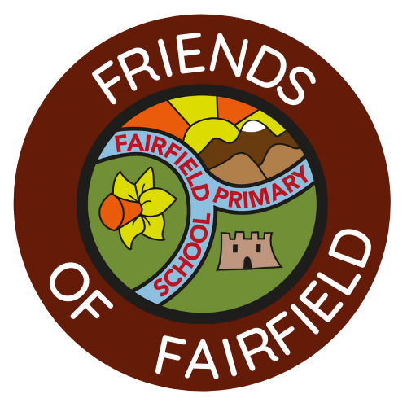

Name
Name of event
Idea | What is your event idea, why you want to do it and what you think it would bring to the community or school?
Ideal date | Tell us when you would like to host this event
Budget | How much do you think you would need from our funds to be able to host this event?
Resources | What help will you need? We would expect you to manage this event but we will be on hand to help in any way you need.
Potential fundraising target | How much do you think you will be able to raise from this event - please take into account what budget you would need to run the event
How will we measure the success | It’s important to us that we can measure the success of each of our events. Please tell us how you think you can measure the success of your event - from attendees to donations or community engagement.

