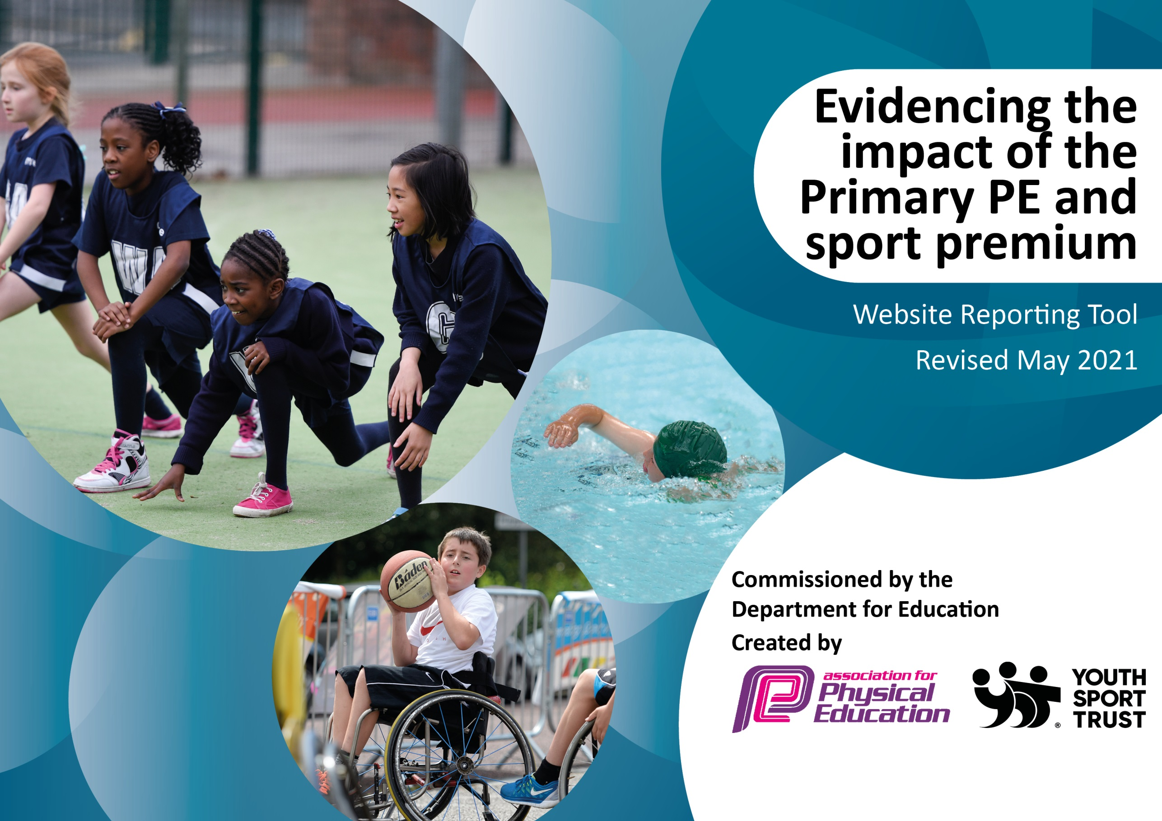

It is important that your grant is used effectively and based on school need. The Education Inspection Framework (Ofsted 2019 p64) makes clear there will be a focus on ‘whether leaders and those responsible for governors all understand their respective roles and perform these in a way that enhances the effectiveness of the school’.

Under the Quality of Education criteria (p41) inspectors consider the extent to which schools can articulate their curriculum (INTENT), construct their curriculum (IMPLEMENTATION) and demonstrate the outcomes which result (IMPACT).

To assist schools with common transferable language this template has been developed to utilise the same three headings which should make your plans easily transferable between working documents.

Schools must use the funding to make additional and sustainable improvements to the quality of Physical Education, School Sport and Physical Activity (PESSPA) they offer. This means that you should use the Primary PE and sport premium to:

- Develop or add to the PESSPA activities that your school already offer
- Build capacity and capability within the school to ensure that improvements made now will benefit pupils joining the school in future years
- The Primary PE and sport premium should not be used to fund capital spend projects; the school’s budget should fund these.
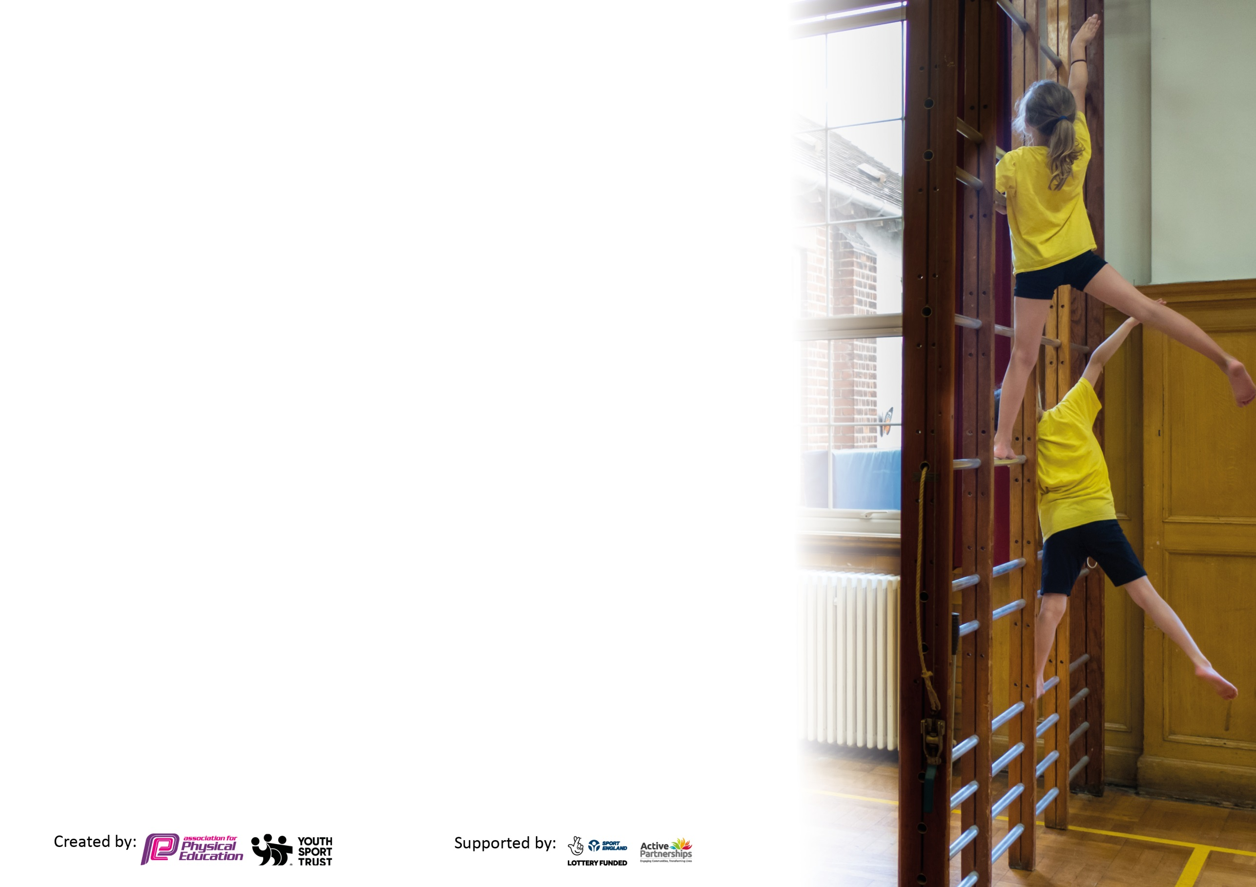
Please visit gov.uk for the revised DfE guidance including the 5 key indicators across which schools should demonstrate an improvement. This document will help you to review your provision and to report your spend. DfE encourages schools to use this template as an effective way of meeting the reporting requirements of the Primary PE and sport premium.

We recommend you start by reflecting on the impact of current provision and reviewing the previous spend.

Schools are required to publish details of how they spend this funding, including any under-spend from 2019/2020, as well as on the impact it has on pupils’ PE and sport participation and attainment by the end of the summer term or by 31st July 2021 at the latest.

We recommend regularly updating the table and publishing it on your website throughout the year. This evidences your ongoing self-evaluation of how you are using the funding to secure maximum, sustainable impact. Final copy must be posted on your website by the end of the academic year and no later than the 31st July 2021. To see an example of how to complete the table please click HERE.

Please note: Although there has been considerable disruption in 2020 it is important that you publish details on your website of how you spend the funding - this is a legal requirement.
Support for review and reflection - considering the 5 key indicators from DfE, what development needs are a priority for your setting and your pupils now and why? Use the space below to reflect on previous spend and key achievements and areas for development.

N.B. In this section you should refer to any adjustments you might have made due to Covid-19 and how these will influence further improvement.
Key achievements to date until July 2022: | Areas for further improvement and baseline evidence of need:
Year 3 and 4 Rounders Whole class Mass Participation Cockermouth School June 2022  Year 6 Cockermouth Athletics May 2022  6 Cockermouth Cross Country May 2022  Year 3 mass participation Cross Country (all pupils) Cockermouth School May 2022  KS1 Panathlon Team April 2022  County Cross Country Champions Year 6 Boys 2022  County Cross County Champions Year 5 Girls 2022  Runners-Up in County Cross Country Year 6 Girls 2022  Runners-Up in County Cross Country Year 5 Boys 2022  3 Finalists in Year 6 County Gymnastics Competition (2 girls and one boy) 2022  Cockermouth Quick Sticks Hockey Champions 2021  Year 6 football Cockermouth School competition Champions 2019  Level 2 Quick Sticks Hockey Regional Champions 2019  28 Children participate in Country Cross Country Competition. One Child finished 3rd and selected to compete in National Cross Country competition representing Cumbria. Year 5 girls team County Champions February 2019.  Level 2 Quicksticks Regional Champions February 2019  Year 6 Tag rugby Champions March 2019  Level 1 Year 4 tennis runners up March 2019  Rotary Football Competition Champions May 2019  Year 3 Mass participation Cross Country competition 52 children involved May 2019  Year 3 Mass participation rounders competition 52 children involved June 2019  Girls Cricket Competition June 2019  Level 1 Cricket Competition runners up June 2019  Cross Country Tri- Series finished 3rd overall with wins in individual categories over the series.  Touch rugby competition champions winning all categories Year 3/4 Boys, 5/6 Boys and Also 1st and 2nd Teams in the KS2 girls competition.  Level 3 County Quick Sticks Champions July 2019  ‘Active Education’ Cumbria County Winners 2019  ‘Healthy School of the Year’ National Winners 2019  Level 1 Year 6 Netball Winners 2019  Yr 5/6 Netball achieved second place in participation event 2019  Yr 4 Quicksticks runners up 2019  Quicksticks winners in participation event 2019  Football Competition Years 5&6 2nd Place 2020  Cockermouth School Football Comp Years 3&4 1st Place 2020  U Dance Festival Year 2 mass participation event  Girls Rugby at Keswick Grounds Years 5 and  6, two events placing 1st and 2nd  Due to COVID-19 all 2020/2021 competitions were cancelled | - Continue to develop participation in sports to support reduction in childhood obesity.  - Work harder to develop links with local sports clubs.  - Continue to embed the understand the understanding of ‘Personal Best’ by continuing with challenges.  - Invite a renound sports athlete into school to deliver sessions, coaching and assemblies to aspiring young athletes.

Did you carry forward an underspend from 2019-20 academic year into the current academic year? YES/NO * Delete as applicable
Total amount carried forward from 2020/2021 £10, 428.04
+ Total amount for this academic year 2021/2022 £19, 100
= Total to be spent by 31st July 2022 £29, 528.04
Meeting national curriculum requirements for swimming and water safety.

N.B Complete this section to your best ability. For example you might have practised safe self-rescue techniques on dry land which you can transfer to the pool when school swimming restarts.
Due to exceptional circumstances priority should be given to ensuring that pupils can perform safe self rescue even
if they do not fully meet the first two requirements of the NC programme of study.
What percentage of your current Year 6 cohort swim competently, confidently and proficiently over a distance of at least 25 metres?  N.B. Even though your pupils may swim in another year please report on their attainment on leaving primary school at the end of the summer term 2021.  Please see note above. | %
What percentage of your current Year 6 cohort use a range of strokes effectively [for example, front crawl, backstroke and breaststroke]?  Please see note above. | %
What percentage of your current Year 6 cohort perform safe self-rescue in different water-based situations? | %
Schools can choose to use the Primary PE and sport premium to provide additional provision for swimming but this must be for activity over and above the national curriculum requirements. Have you used it in this way? | Yes

Action Plan and Budget Tracking
Capture your intended annual spend against the 5 key indicators. Clarify the success criteria and evidence of impact that you intend to measure to evaluate for pupils today and for the future.

Academic Year: 2021/22 | Total fund allocated: £ | Date Updated:
Key indicator 1: The engagement of all pupils in regular physical activity – Chief Medical Officers guidelines recommend that primary school pupils undertake at least 30 minutes of physical activity a day in school |  |  |  | Percentage of total allocation:
 |  |  |  | %
Intent | Implementation |  | Impact
Your school focus should be clear what you want the pupils to know and be able to do and about  what they need to learn and to  consolidate through practice: | Make sure your actions to achieve are linked to your intentions: | Funding allocated: | Evidence of impact: what do pupils now know and what can they now do? What has changed?: | Sustainability and suggested next steps:
Provide opportunities for all inclusive sport.  Purchase high quality PE equipment to replenish PE stores.  1K a day  5 – A – Day and Active Learning  Host All Inclusive Panathlon | We will be continuing to develop links with Nat Pattinson to deliver Wheelchair Basketball session.  An audit of all PE equipment will be carried out, PE stores organised and accessible and new stock ordered to allow students to use high quality equipment for all sessions across our revised curriculum.  Whole school involvement will continue for 1K a day.  Subscription to  5- A – Day and  Active Maths  for all teaching staff.  Our school with host an all inclusive competition where children with SEN needs will be able to participate and compete in sport. | £514.01  More to add  £328.00  £1425.00  £0 | We have had Wheelchair basketball for all Year 1 children.  Organised a KS2 Panathlon (Cancelled due to Covid 19)  Attended a KS1 Panathlon  New Equipment ordered and some in reserve for future.  This is done by KS2 children daily.  Cancelled due to COVID outbreak – though entered a KS1 Panathlon in Workington in 2022.
Key indicator 2: The profile of PESSPA being raised across the school as a tool for whole school improvement |  |  |  | Percentage of total allocation:
 |  |  |  | %
Intent | Implementation |  | Impact
Your school focus should be clear what you want the pupils to know and be able to do and about  what they need to learn and to  consolidate through practice: | Make sure your actions to achieve are linked to your intentions: | Funding allocated: | Evidence of impact: what do pupils now know and what can they now do? What has changed?: | Sustainability and suggested next steps:
Increase the knowledge and profile of PESSPA among staff.  Ensure continued use of Sports leaders for daily provision for all KS2 children.  Fully implement and utilise IPEP program in line with our revised Curriculum Overviews and Progression of Skills Document. We will offer CPD sessions to support staff and delivery.  Lower KS2 and KS1 classes begin to access the 5 Steps to 5 stars programme in addition to Upper KS2. | Direct and inform staff of the views and visions of PESSPA and build strategies to put PE at the heart of school life by using resources to enhance and support PE lessons.  Chris Wright Sports Services will deliver Play Leaders training to Upper KS2 pupils.  Link with KS1 pupils in Summer 2 for transition session with the Sports Leaders on the KS2 yard.  Sessions timetabled for each year group cross referenced with class overviews and whole school timetable for competitions (Chris Wright Services, Allerdale and Cockermouth School Competitions) to ensure sustainability.  Work alongside Chris Wright to monitor Athletics progress and collect summative data for progression using the scheme. | £0  £392.00  £0 (Paid for last year)  £360 | Information cascaded to staff.  Year 6 all trained as Sports leaders and deliver sessions to children during lunch in Summer 2022 term.  IPEP utilised and plans downloaded for future use. We have not used this for assessement.  CPD offered to staff for anything they desire. Funding utilised for Gymnastics and a Phunky Foods lead on.  Athletics coaching by Wright Sports Services for athletics Summer 2 to incorporate 5 Steps to 5 stars.

Key indicator 3: Increased confidence, knowledge and skills of all staff in teaching PE and sport |  |  |  | Percentage of total allocation:
 |  |  |  | %
Intent | Implementation |  | Impact
Your school focus should be clear | Make sure your actions to | Funding | Evidence of impact: what do | Sustainability and suggested
what you want the pupils to know | achieve are linked to your | allocated: | pupils now know and what | next steps:
and be able to do and about | intentions: |  | can they now do? What has
what they need to learn and to |  |  | changed?
consolidate through practice:
Establish confidence in gymnastics teaching across the school.  Lesson observations carried out by PE leads. Cross year group teaching to take place and PE mentors to become common practise to support the knowledge gap between KS1 and KS2 sports. | Whole school staff training provided by an external coach and coaching sessions delivered to selected year groups.  Support staff with any knowledge gap in sports taught in PE. Enhance staff and pupil knowledge of School Game rules for sports I.e. High 5, Quicksticks etc | £60  £0 | Purchase subscription for British Gymnastics – this offers an education pack and CPD training for staff.  Observations taken place in line with monitoring calendar. Observation of external coach Tom Walton completed.
Key indicator 4: Broader experience of a range of sports and activities offered to all pupils |  |  |  | Percentage of total allocation:
 |  |  |  | %
Intent | Implementation |  | Impact
Your school focus should be clear | Make sure your actions to | Funding | Evidence of impact: what do | Sustainability and suggested
what you want the pupils to know | achieve are linked to your | allocated: | pupils now know and what | next steps:
and be able to do and about | intentions: |  | can they now do? What has
what they need to learn and to |  |  | changed?
consolidate through practice:
Develop new provision to expose children to new sports such as Climbing and Water Sports  Enhance Forest School Provision  Develop opportunity for all children to enjoy an outdoor walking experience in our local environment.  Swimming  Phunky Foods  Challenge 24 | This year we will begin to introduce water sports and climbing into our PE curriculum and be offering sessions to children in Years 2, 4, 6. We will be using local providers for this provision.  Provide funding support to enhance Forest School Provision for EYFS, Year 1, 3, 5.  Provide opportunities for a ‘Grand Day out’ for all year groups. Whinlatter and surrounding hills.  Year 4 and 5 participate in 2 week intensive swim program at Cockermouth Swimming pool.  Initiative to support staff CPD develop child/parent awareness of healthy foods/eating.  Initiative for all Year 6 to complete:  10K walk  Overnight camp  New hobby -10 hours practise/commitment  4 hours ‘good deed’ in the community. | £2447.34  (to be added)  To be added  £237.45 (More to be added)  (busses etc to add)  £1350- 2 weeks provided for Years 4 and 5  (£2700)  £36.02  £0 | In school coaching across school provided and competitions entered.  Competitions entered with successes listed above.  Clip and Climb arranged for 52 Year 2 children (3 weeks each)  Canoeing arranged for 59 Year 4 children.  Ghyll Scrambling arranged for 62 Year 6 Children.  Budget provided to forest schools to replenish equipment needed.  Grand Day out arranged for the whole school Year 1-6 to Whinlatter and Surrounding Peaks. EYFS also arranged independent walk up Binsy.  Swimming provided for Year 4 and 5. (Year 4 ‘extra swimming, over and above curriculum)  This was attended by a limited amount of families after school. It did work well in school with Year 6.  This did not happen – linked to Risk Assessment re safe camping | Ideas to extend this use, linked in with DT curriculum.

Key indicator 5: Increased participation in competitive sport |  |  |  | Percentage of total allocation:
 |  |  |  | %
Intent | Implementation |  | Impact
Your school focus should be clear | Make sure your actions to | Funding | Evidence of impact: what do | Sustainability and suggested
what you want the pupils to know | achieve are linked to your | allocated: | pupils now know and what | next steps:
and be able to do and about | intentions: |  | can they now do? What has
what they need to learn and to |  |  | changed?
consolidate through practice:
Maintain opportunities for all children to participate in a competitive sport and target reluctant participants from 2020/2021 monitoring.  Allerdale Sports Partnership  Cockermouth School Partnership  Coaching:  Wright Sports Services  Reds in the community  Street Tag  Chance Camp Gifted and talented events  County Gymnastics competition  County Cross Country competition  National Cross Country Representation  Replacement School kit  Coach to events | Monitor participation of all students and attend all competitions provided for the school. Reviewing records of participation and engaging reluctant pupils in competitive sport.  Continue records with staff and coaches who are responsible for organising competitions as they will choose, select and take their own class to competitions. Termly monitoring of the children who have and who have not participated in a competition via an online tracking document.  Up to date coaching and competition calendar issued to staff and on School Web Page.  Participate in Allerdale, Cockermouth and Wright Sports Services Multi Skills and Football competition in addition to School Games competitions.  In school Coaching  In school Coaching  School wide event  We selected 8 children from Years 3 and 4 to take part in an exclusive gifted and talented event.  X 3 pupils enter County Gymnastics competition  Entered for Years 4, 5, 6  3children selected to represent County – funds supported through school  New kits that have short sleeves and fits a wide range of children in school.  Cost of travel | £675.00  £1,111.45  £1080  £552  £50  £360  £16  £378  £75  £2000 approx  £100 | Monitor participation of all students and attend all competitions provided for the school. Reviewing records of participation and engaging reluctant pupils in competitive sport.  We did continue records with staff and coaches and have participated in Allerdale, Cockermouth and county competitions (Most listed in Coaching/competition calendar, additional opportunities added as they have been released throughout the year.)  Also we have extended our calendar to include:  Common Wealth Games code breaker to develop Capital Culture for athletics  Street Tag – extending opportunities for the Fairfield children and community to walk and gain points for activity. -Prizes awarded.  Triathlon - Keswick mountain festival – 20 entries for the triathlon for children age 6-11!  Full reports provided to parents and on record in school.  Cross Country Champions Year 6 Boys 2022  County Cross County Champions Year 5 Girls 2022  Payment for £25 per athlete for County representation.  Kits to fit children Years 1-6. | Develop further opportunities for KS1 and EYFS.

Signed off by
Head Teacher:
Date:
Subject Leader:
Date:
Governor:
Date:

