 | Autumn 1 | Autumn2 | Spring 1 | Spring 2 | Summer 1 | Summer 2
Year 1 | Memories  Think like an artist (Modigliani) - Sketching | Dinosaur Roar  Mixed Media – Dinosaur in landscape | City Life  Collage - cityscape | The Lady with the Lamp | Old MacDonald  Sketching & Painting – still life | Crash! Bang! Wallop!
Year 2 | Westward Ho! Paint and collage – Pirate art | London’s Burning  Mixed Media – London’s Burning skyline | Mighty Monarchs | Beneath the Canopy  Think like an artist – Rousseau  Explore Tiger painting and camouflage, patterns etc. Children create large scale art piece depicting Tiger/other animals camouflaged in jungle | Mix it Up!  Various | Coast to Coast  3D sculpture – Paper mache. Children explore using everyday materials to create creatures from beneath the sea Create large underwater scene using all children’s work  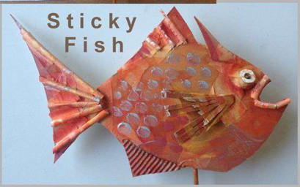  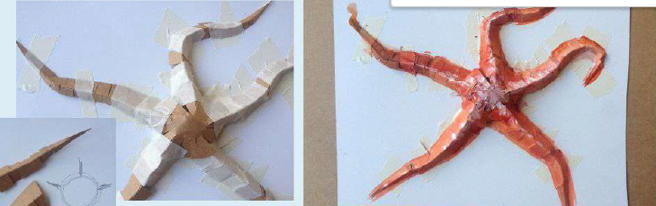
Year 3 | Ready, Steady, Cook! | Time Team  Drawing/Painting  Explore stone age art and why these images were used.  Create own stone age art | What a Wonderful World  Think like an artist (Picasso & Cubism) – What is cubism? Explore art work and analyse colours, techniques, look at Picasso work, express likes and dislikes in Sketch books. Design and make Picasso art work using collage technique. | Tomb Raiders  3D art –  Ancient Egyptian Art including tomb art and hieroglyphics – making Death Masks paper mache and mod roc | Secret Garden | Eco-Warriors
Year 4 | Doctor, Doctor | Toga-tastic  Mosaics Ancient Roman  Explore examples, express likes and dislikes, play with images – convey story or create image to represent the person making – link with roman numerals, design Sketch books and make |  | On the Street where you live  Think like an artist (Banksy) – explore street art work and analyse, experiment in sketch books, make graffiti | Rhythm & Rhumba  Think like an artist (Kandinsky) – Study art work and analyse, explore techniques and colours in sketch books, explore art through music to create piece | Eureka!  3D Sculpture paper mache – Greek pots – Explore stories told, colours shapes, design and make pots (papier mache)
Year 5 | Raiders or Traders | Cosmic  Retro-Futurism – Space art – explore and generate ideas, sketch book development, exploration of techniques create own art work. | Extreme Earth | Magic & Mayhem  Wax resist – Batik – Explore, ideas in sketch book, explore technique wax resist on paper before designing batik  Romero Britto | Mysterious Maya | Terrible Tudors  Portraiture – Explore messages hidden behind portraits .e.g power etc. Holbein explore and create own version
Year 6 | Blitzed Britain | Pulse  Think like an artist (DaVinci) - Explore art work and analyse line, tone, shading, techniques, look at DaVinci examples, express likes and dislikes in Sketch books. Explore creating own heart picture. | Darwin’s Discoveries  Mixed Media – sketching, watercolour etc. – observational drawing – flora and fauna of the Galapagos Islands | Crime & Punishment | Art Attack  Think like an artist (various artists)  Monet, Georgia O’Keefe, Warhol, Escher | Ticket to the World  Printing – exploring art from other cultures

