

Fairholme Primary School
Peacock Avenue, Bedfont, Feltham, Middlesex, TW14 8ET
Telephone: 020 8890 2584
office@fairholme.hounslow.sch.uk www.fairholme.hounslow.sch.uk

Headteacher: Mrs G Harris
Dear Parent/Carer,
Year 6 SATS Breakfast Club

SATS week will begin on Monday 11th May and assessments will take place up to and including Thursday 14th May (please see timetable below); we would like to invite all of the year 6 children to breakfast club each day that SATs are taking place - Monday through to Thursday - starting at 8.10am; this will be free all week.

This is always a lovely time for the children to be able to meet as a group each morning to have some time to eat and chat together with their friends and to feed their brains ready for the assessments ahead.

During SATS week in particular, please do try to encourage children to get a reasonably early night so they are wide awake and ready for the school day. It’s also really important that during this week, the children take advantage of having some down time and getting some fresh air and exercise at home.

If your child would like to attend SATS breakfast club, please fill out the form below and return it to school by Wednesday 6th May at the latest.

We would like to take this opportunity to wish all of our students the very best of luck.

Kind regards,

Year 6 Team

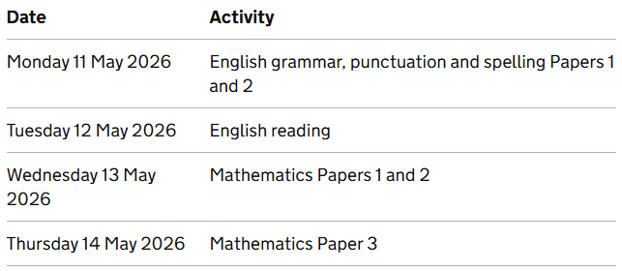

Year 6 SATS Breakfast Club

I wish / I do not wish my child to attend the SATS breakfast club.

Name of Child ___________________________________ Class : Saffron / Sapphire

Signed Parent/Carer _______________________________

