Healthy Play Time Snack Ideas

Healthy Eating

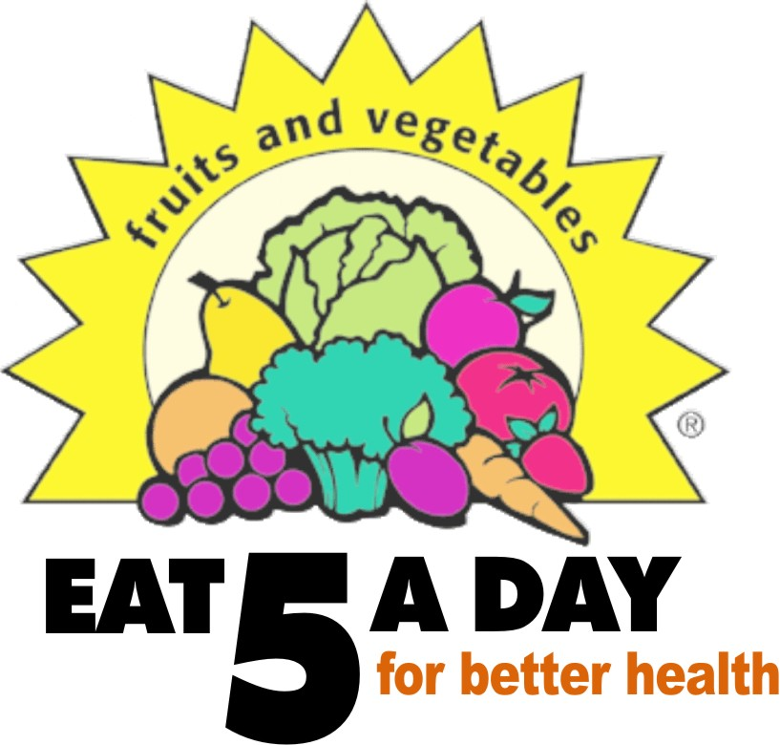
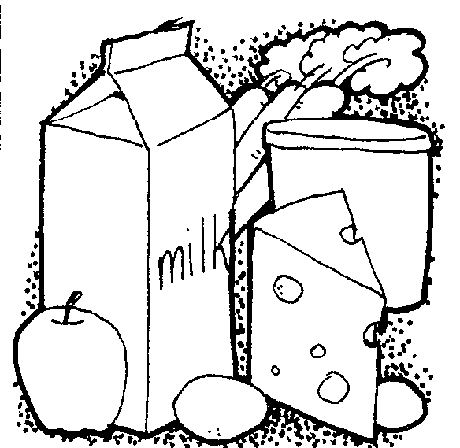
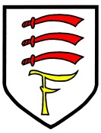
Healthier alternatives to sweet snacks
- Chunks of melon, strawberries, grapes or whatever you have to hand. Look out for fruit that’s in season, it’s likely to be cheaper
- Fruit loaf, banana bread, fruit muffins
- Dried – how about just a few pieces of mango, banana, pineapple, cranberries or raisins?

Healthier savoury snack ideas
- Pumpkin and sunflower seeds
- Pitta and lower fat dips like salsa or reduced fat hummus
- Rice cakes with lower fat cream cheese and cucumber
- Celery sticks filled with lower fat cream cheese

A guide to snacks, drinks and lunches at Fairholme School
September 2016
Healthy Packed Lunch Ideas | Have a look at some healthy lunch ideas on the Children’s Food Trust web site  http://letsgetcookingathome.org.uk/get-cooking/perfect-packed-lunches
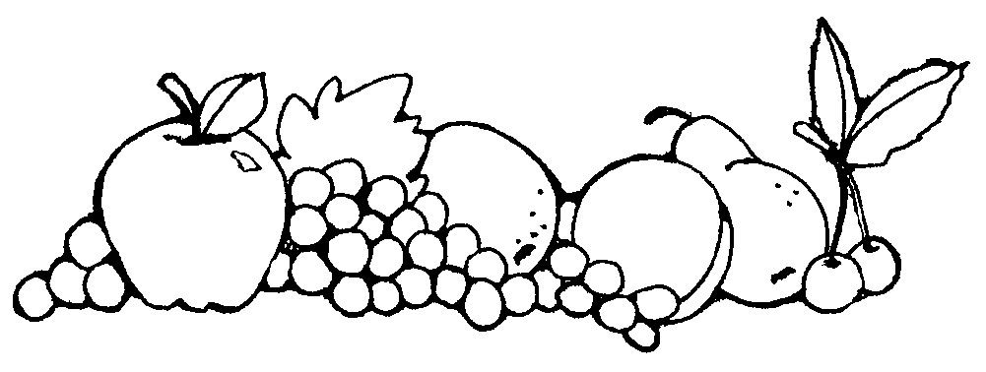
Vegetable pizza slice
Hummus and carrot sticks
Pot of low-fat rice pudding
Cup of grapes, cherries or berries
Cheese and tomato sandwich
Hard-boiled egg
Pot of low-fat yogurt
Medium-sized piece of fruit (e.g. apple, banana, pear)
School dinners and packed lunches

We provide all children in Reception, Year 1 and Year 2 with a FREE school dinner – they do not bring packed lunches. Our varied and healthy menu includes sandwiches as well as cooked options every day. We hope as many older children as possible will also take up school dinners. Children in Years 3 to 6 may bring a healthy packed lunch to school if necessary. The dinners are cooked on site in our kitchens and cost £2.20 for children in Years 3 to 6 (free for younger children). A copy of the current menu is available from the school office and on our web site. Each day, there are different choices, including meat and vegetarian dishes, and we also offer a halal option. There is water available for children in the dinner hall, or they can bring their drink bottle into lunch with them.

If you are in receipt of certain benefits, your child will be entitled to free school meals beyond the age of seven – please complete a form from the school office. This also helps the school with Pupil Premium funding – so even if your child is younger and is provided with a free school meal, please complete the form if you are entitled to the benefits listed (the school does not receive extra funding for children who have a Universal Free School Meal). We are a cash-less school, and all school dinners must be paid for through Parent Pay.
“No chocolate, crisps or sweets – save these as a special treat!”
Healthy snacks and drinks at play time

Children in Nursery, Reception, Year 1 and Year 2 receive free fruit at play time. Children in Years 3-6 (Key Stage 2) may bring a healthy snack to eat at morning play time – this could be a piece of fruit, vegetables or a cereal bar. Please avoid nuts, chocolate, biscuits, crisps and other snacks with high levels of sugar or fat. We encourage all children to bring a water bottle, filled with water or diluted fruit squash. During the day, the children are able to fill their bottle, at play time and lunch time, with fresh water from our special water coolers. It is really important your child has a bottle so that they can collect water from the cooler – for hygiene reasons, we do not have cups available. Please ensure your child’s bottle is labelled with their name.

A Healthy Fairholme Family

We are committed to teaching children about healthy lifestyle choices at Fairholme School, and work hard to promote healthy diets and exercise.

