

10th September 2021

Fearnville Newsletter

**Welcome Back!**

It’s been lovely to see all of the children and families this week. The children have come into school so sensibly and look incredibly smart in their new school uniforms. A big thank you to parents for purchasing and picking these up over the summer holidays. It’s good to be back!

**Gates**

Thank you to all parents for continuing to use the gates for morning drop offs. This procedure will be reviewed at October half term in line with up to date Covid guidance from the DfE. We will notify you of any changes when necessary.

## **Fearnville Primary School**

## Fearnville Drive

## Bradford

## BD4 8DX

Tel: 01274 664661

Email: [office@fearnville.bradford.sch.uk](mailto:office@fearnville.bradford.sch.uk)

Website: www.fearnville.bradford.sch.uk



**New Faces**

We have three new members of the Fearnville team to introduce you to.

Mr Ballantine joins Mrs Bowe and Mrs Brook on the Senior Leadership Team as Executive Headteacher. Mr Ballantine is also the Executive Headteacher at Lapage Primary so will split his time across the two schools.

We have two new teachers who have also recently joined the team, Mrs Instrall is in Year 4 and Mr Rajan is in Year 5.

Please be sure to give them all a warm welcome.

**Special Educational Needs**

Are you worried about your child’s progress?

Do you think your child needs some extra support?

Are you worried your child might be struggling at school?

If so, please contact 01274 664661 to make an appointment with our SENCo, Mrs Adam, who would be happy to help.

**PE**

Children can wear a PE kit to school on the following days:

Year 1: Tuesday

Year 2: Thursday

Year 3: Thursday

Year 4: Tuesday

Year 5: Monday

Year 6: Wednesday

Our PE kit consists of black tracksuit bottoms or shorts with a white top. Children must come appropriately dressed, we have spares available for them to wear if not.

Children in Year 5 will also require a swimming costume and towel for their swimming lessons.

**Swimming**

Year 5 will be the year group attending swimming at Sedberg this academic year as they missed out on their entitlement in Year 4 due to Covid. Unfortunately, we only have been allocated one slot a week so we have had to organise it slightly differently.

Y5 Ankara will go swimming every **Friday afternoon from now until February half term.**

Y5 Vienna will go swimming **Friday afternoon from February half term until the end of the academic year.**

**Arbor App**

We will be continuing to use Arbor to collect dinner money for school. It’s really important that you set this up on your device to ensure you keep up to date with payments as we move closer towards being a cashless school. The office has sent out an email today which has the link for you to set this up along with instructions on how to use it. If you require any support with this, please contact the Office who would be happy to help. Thank you for your co-operation with this.

**Child Protection**

If you have any concerns about a child in our school, please ensure you report this to one of our friendly Designated Safeguarding Leaders who deal with the concern accordingly.

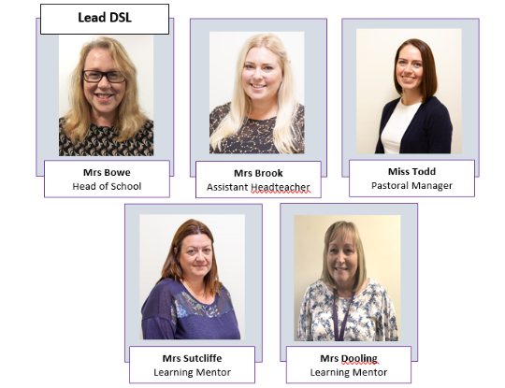

 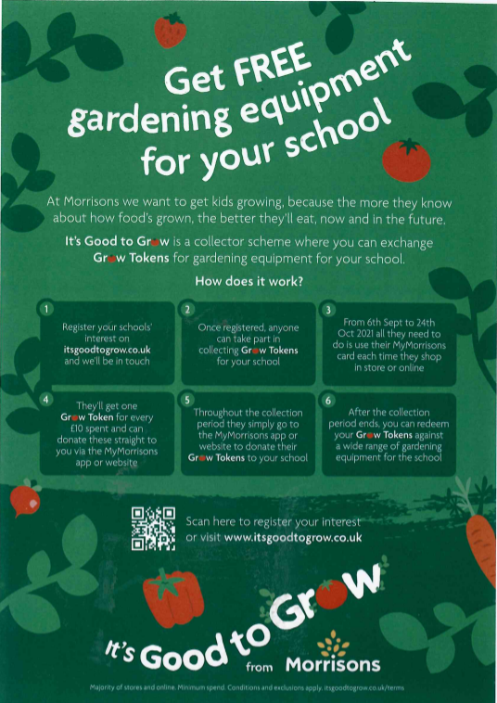

**We have Nursery places available!**

Children can start Nursery as soon as they turn 3.

We offer morning, afternoon or full-time sessions. Contact 01274 664661 to put your child’s name down.

**Dates for your diary…**

13th September- Jeans for Genes Day

7th October- School Photo Day

22nd October- Finish for half term

1st November- School reopens

**Apps**

We’d like to remind parents to be vigilant when monitoring their children’s usage on social media apps such as TikTok, Snapchat, Intagram, Twitch, Roblox and Minecraft. Although these sites are popular and fun, unfortunately some undesirable people use them as a gateway to start communication with children which can become extremely dangerous.

**Information From The Office**

If you would like your child to receive milk at school (this is available to any children up to and including Year 6) please send £12.60 into school with the accompanying letter by Friday 17th September. If your child is entitled to Free School Meals, they will receive milk free of charge.

Next week you will receive a data collection sheet. Please ensure your information is up to date and you review your child’s listed medical conditions.