Fearnville Primary School

Attendance Policy & Procedures

Title of Policy | Attendance Policy & Procedure
Date of adoption | Dec 2018
Originator | Nurture Trust
Date of review | Dec 2021
Additional information | Headteacher  Andrea Gray  Deputy Headteacher  Sarah Bowe  Named Governor  Chair of Governors  Gareth Logan

Attendance Policy & Procedures

Nurture Academies Trust aims to improve outcomes for all children by strengthening community, teaching and learning and safeguarding.
Excellent attendance is essential for the exceptional educational and social development of all children and young people. To safeguard all of our children in our schools we are
committed to working with families and community partners to ensure that all children are able attend school regularly.
The law states that:
• ‘Parents are responsible for making sure that their children of compulsory school age receive a suitable full-time education.’ (Section 7 of the Education act 1996).

Parents / carers can only allow children to miss school if either:
• they’re too ill to go in
• advance permission is obtained from school

Our aims:
• For Nurture Schools to have overall attendance of 97% or better
• For the percentage of children with attendance of 98% and above in our group of schools to increase
• To reduce the % of children whose attendance is below 95%

Nurture Schools together will:
• Apply this policy consistently
• Promote/ celebrate good and improved attendance within our schools
• Communicate clear messages in school and the wider community about the importance of good attendance and how to achieve it
• Work in partnership with parents, the local authority, health professionals, police and community groups to ensure that poor attendance is tackled quickly and families are supported so that all of nurture schools children receive the daily education which they are entitled to
• Make first-day contact with parents to obtain reasons for all pupil absence and where these cannot be provided/contact cannot be made follow Safeguarding procedures
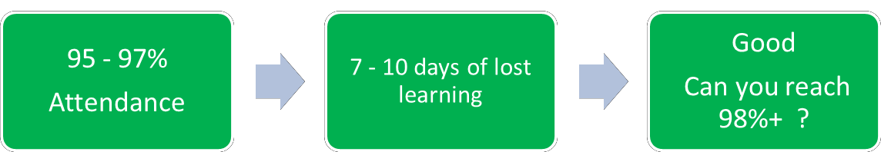
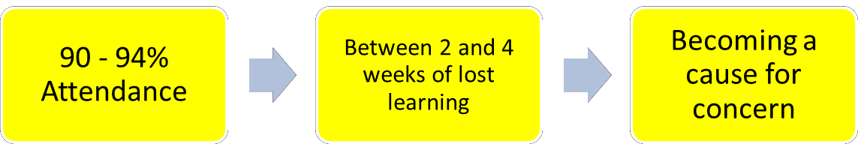
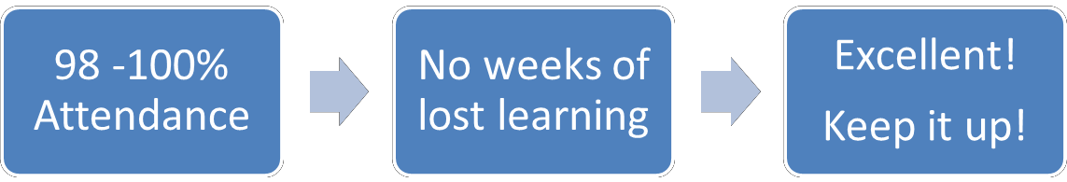
What Does Excellent Attendance Look Like

A Guide to Lost Learning through Absence
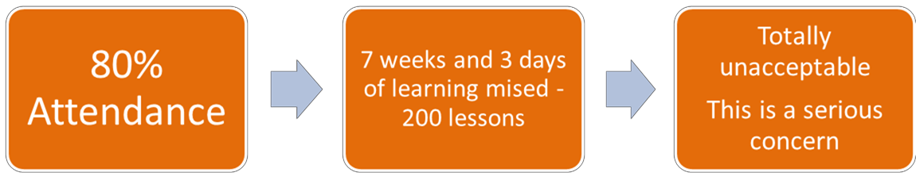

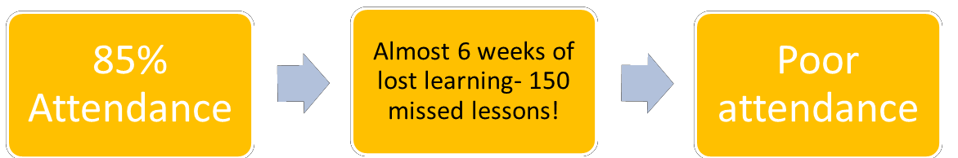
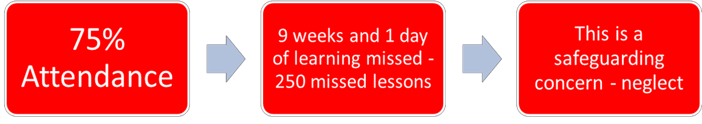
Leave of Absence During term time
Nurture Schools together will:
• Ensure that parents are aware that they do not have a right to take their children out of school for leave of absence
• Provide opportunities to meet with all families who seek permission for leave; discussing potential reasons and making them aware of the impact that absence has on achievement and social development
• Ensure that families make any applications for leave in writing using the local authority form.
• Not authorise leave in term time unless there are the most exceptional circumstances which have been agreed by the head teacher and supported with evidence
• Share and seek information regarding requests for leave and decisions made with other schools which younger/older family members attend.
• Ask parents for destination and return dates
• Explain to parents that if they take extended leave in term without the permission of the school OR take additional days in excess of the agreed number of days, the school will request that Children’s Services may issue a Penalty Notice under Section
444 of the Education Act 1996. The Penalty Notice is for £60 per parent per child if
paid within 21 days and £120 per parent per child if paid after 21 days but within 28 days. Failure to pay the Penalty Notice will result in a prosecution in the Magistrates Court
• Consistently follow locally agreed procedures and national guidance relating to those
young people deemed to be ‘Children Missing Education’

Religious Observance
Nurture Schools recognise the importance of religious observance. We will therefore endeavour to use the flexibility available from occasional days to enable parents and pupils to celebrate religious occasions.

Illness and Medical Appointments
Nurture Schools will:
• Encourage parents to make medical and dental appointments out of school time
• Seek proof of appointments which cannot be made out of school hours
• Ask parents to provide medical evidence where there are attendance concerns
• Follow Public Health England guidance regarding number of days absence for specific conditions
• Regularly monitor levels of absence due to illness for individual pupils
• Support parents of children with regular illness absence through referrals and signposting to advice from health professionals
Lateness and Punctuality
Nurture Schools together will:
• Close registers 30 minutes after the start of the session, in line with DfE guidance.
• Monitor lateness and set targets with parents of children who are persistently late to reduce this
• Contact all families who do not inform school that their child will be late after the register closes and seek reasons
• Recognise improved punctuality and the positive contribution that it is making to a child/children

Unauthorised Absences

There are many absences that are not for an acceptable reason. The head teacher may decide whether an absence is authorised or not.
Nurture Schools together will:
• Not authorise absences for pupils with less than 95% attendance unless there are the most exceptional circumstances
• Contact the parents of the pupils who regularly have unauthorised absence to improve attendance. Families may be referred to the Education Social Work Service / Early Help who may use legal interventions to improve attendance
• When a pupil has more than 10 sessions unauthorised absence in a six week period, this may result in a warning being given by Children’s Services of the possible issue of a Fixed Penalty Notice. Any unauthorised absence in the following 4 weeks will result in a Penalty Notice being issued. The Penalty Notice is for £60 per parent per child if paid within 21 days and £120 per parent per child if paid after 21 days but within 28 days. Failure to pay the Penalty Notice will result in a prosecution in the Magistrates Court.

This policy should be read in conjunction with:

Fearnville Primary School Safeguarding / Child Protection Policy

Guidance on School Attendance Department for Education Sept 2018

Children Missing Education Guidance for Schools Bradford Council Sept 2017

Keeping Children safe in Education Part1 and Annex A DfE Sept 2018

